[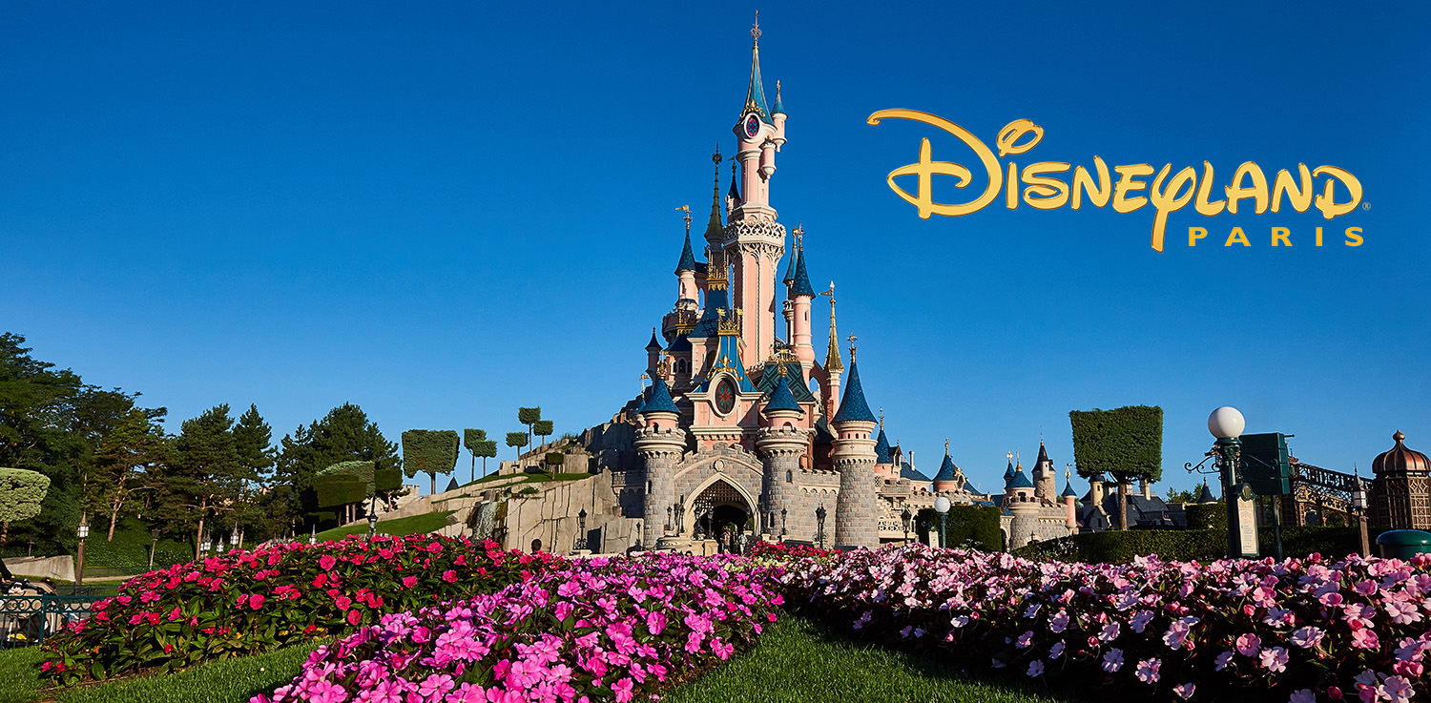](https://jonesinternational.co.uk/tours/disneyland-paris-five-day-holiday/)

[Disneyland Paris – Five Day Holiday – Jones International](https://www.google.com/url?sa=i&rct=j&q=&esrc=s&source=images&cd=&ved=2ahUKEwi39omp3affAhXKooMKHQqgBicQjhx6BAgBEAM&url=https%3A%2F%2Fjonesinternational.co.uk%2Ftours%2Fdisneyland-paris-five-day-holiday%2F&psig=AOvVaw1jwRDdWDSJ-bpoo7g0A9mr&ust=1545165781909845)

**Disneyland Paris**

* + - 1. Entertainment resort opened in 1992.
      2. The 2nd Disney park to open outside the US and one of the biggest attractions in France and Europe.
      3. Has a Ratatouille: The Adventure ride, where riders become mice running in a kitchen.
      4. Popular rides:
         1. It’s a Small World (Has a design of the Eiffel Tower in front)
         2. Big Thunder Mountain

**YOUR PART IN THE TOUR: A person working a ride at Disneyland Paris. Welcome our group to the ride (Thunder Mountain) and help us load into the imaginary roller coaster. (set up come chairs) Make sure our seat belts are all on and we are secure. Tell us to stay seated and to have fun! You can choose to join us on the ride and lead us through the movements of the roller coaster if you would like.**