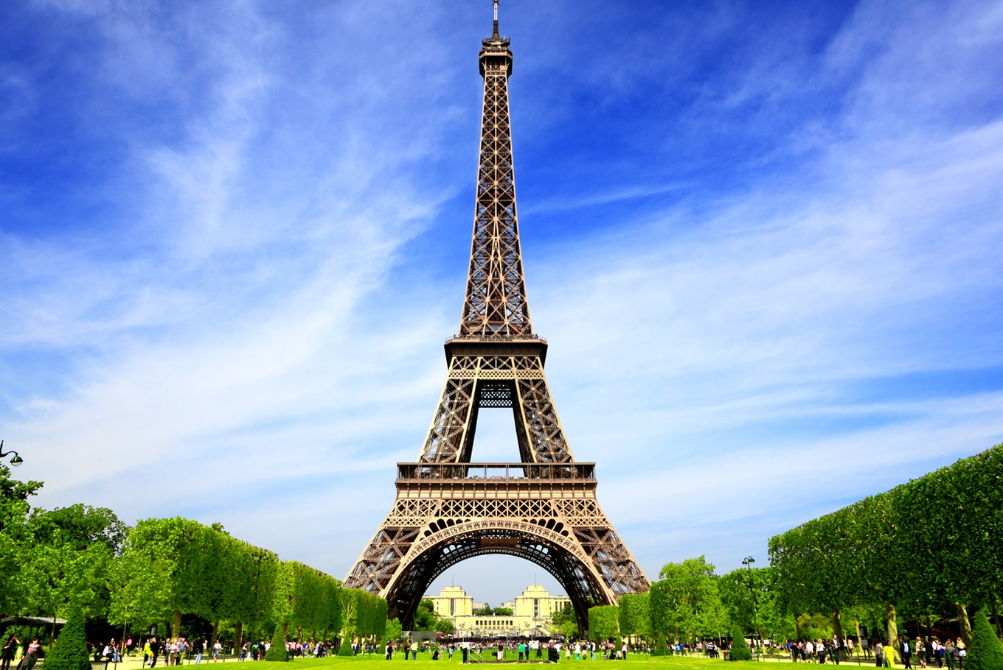

https://www.thejakartapost.com/travel/2017/12/08/why-its-actually-illegal-to-take-pictures-of-eiffel-tower-at-night.html

**The Eiffel Tower**

* + 1. Eiffel Tower
       1. The most visited monument in the world.
       2. Took over 2 years to build, 934 feet, made of iron.
       3. Was created to be the entrance to the World Fair in 1889, where inventors and artists from all over the world would come to show their newest creations.
       4. Named after engineer, Gustave Eiffel.
       5. At night, it lights up with 20,000 twinkling bulbs for 5 minutes every hour.

**YOUR PART IN THE TOUR: Create the Eiffel Tower structure with your bodies. Be ready to “twinkle” (see above fact about the tower lighting up at night) when the tour guide indicates.**