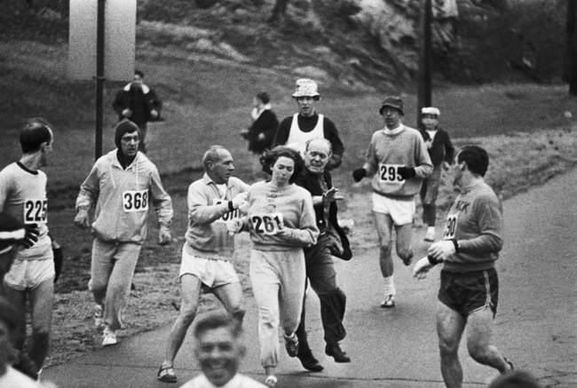

http://thelistlove.com/10-powerful-photographs-from-womens-history/