**Star Wars: The Audio Experience (sample for script writing)**

**CHARACTERS**

**LUKE**

**LEIA**

**DARTH VADER**

**YODA**

**NARRATOR**

**STORM TROOPER 1**

**STORM TROOPER 2**

**MUSIC***:* TRACK 1“Star War’s Theme” *–*

*loud.*

TRACK 1 at 0:31*- Fade to ½ volume* (lines begin)

**NARRATOR**: Well I’d like to introduce a new Radio Drama that’s been created… Star Wars: The Audio Experience… here comes the first episode.

**MUSIC**: TRACK 1 “Star War’s Theme”-*fade out*

**NARRATOR**: A long time ago, in a galaxy in far, far away, there was Leia.

**LEIA**: Hey!

**NARRATOR**: Luke.

**LUKE**: Hello.

**NARRATOR**: Vader.

**VADER**: *Chssssss* Hey *Chsssss*

**NARRATOR**: and Yoda.

**YODA:** Old I am.

**NARRATOR**: A conflict Rose above all.

**VADER**: Luke…Chssss…I am…Chsss…dang it where’s my Inhaler?

**NARRATOR**: Vader couldn’t find his inhaler, and Luke was bent on killing them all.

**SOUND EFFECT: Light saber** (Machine Sounds-Track 52)-*repeat over and over until Luke says “Sounds cool.”*

**LUKE**: Ah!!!! Father, I love you, but still wanna kill yoooooooooooooooooooooooooou!

**LUKE**: (*Blood curdling SCREAM*) My leg!

**LEIA**: Stop Fighting! All of you stop it!

**YODA** Young you are, much to learn you still have.

**VADER**: He’s right…. *Chsss* we shouldn’t fight.

**LUKE**: Sounds cool.

**SOUND EFFECT:** Light Saber sound effect

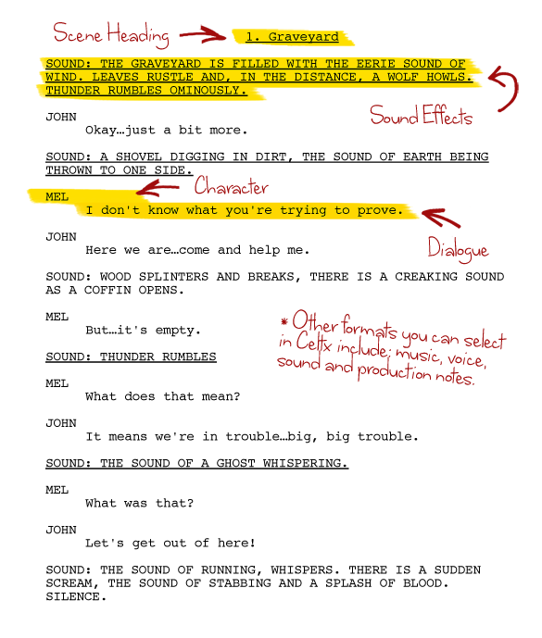

*** Notice how the sound effects are underlined and the characters names are in all capitals.

***You do not need to use this same font.

**You may choose either formatting option found in this packet. The elements that you must have no matter what are:**

* Character’s name in all capitals.
* A new line anytime dialogue shifts from one character to another. (Anytime someone else is speaking, skip down to the next line on the page.)
* Easy to read and understand by group members and peers.
* 12 point font