# Lighting Equipment

**PLUGS**

1. There are three types of plugs.
   1. The one you see in your house is the **Edison Plug**.  It is the most common, but since it is not very sturdy and cannot handle much power, you won’t see it in many theater lights.
   2. The **Stage Pin Plug** (a.k.a. “three pin” or “stage plug”) is sturdy and can handle lots of power.  If you use these of plugs, you should tape them together with gaffer’s tape.  (All other tape will melt or burn.)
   3. The **Twist-lock Plug** are the best, but also the most expensive.  They are as durable as the stage pin plug, but they twist and lock into place so there is no taping involved.

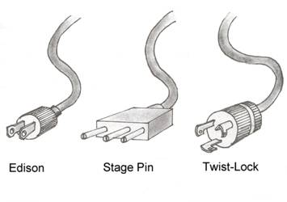

*(from Technical Theater for Nontechnical People, by Drew Campbell.)*

# Dimmers and Channels

1. The lighting instrument has what is called a connector (as most electrical devices have an Edison connector that you plug into an outlet) the connector on a lighting instrument plugs into the dimmer. The **dimmer** is the electrical source, which regulates the amount of voltage conducted to the lighting instrument.
2. Each dimmer has an assigned number that must be noted when it is 'circuited'. These numbers are permanent and correspond to the place the instrument is hung. "**Channel** control is an electronic patching system in which one or more dimmers can be assigned to a control channel, which in turn controls the intensity level of those dimmers." The channels are also numbers. Patching allows the designer to organize the instruments in a way that makes more sense. For instance all of the front light can be channels 1-10; top light could be 11-20; etc. Channels are then patched into cues in a similar manner. All of the lights that are on before the show begins are in cue 1 (This is also known as the "pre-show".) Cue 2 is usually identical except the house lights fade to 50% intensity instead of 100%. Cue 3 might fade to black and bring up the prayer light. And so on. There can be movement within a cue; lights can fade up/down over a set amount of time.

# Lighting Instruments

## **BASIC INSTRUMENT PARTS**

1. The bulb within the instrument is actually called a **lamp**. Do not touch it with your bare hands. The oil from your fingers will burn and cause the light to explode when it is turned on.  (I could give a more detailed explanation of this phenomenon, but it’s not important. Just don’t touch them.)
2. A **C-clamp** is the device used to mount the light on the hanging pipes. It is shaped like a C (go figure) and has a bolt on the side. Loosen the bolt to turn the instrument left and right.  Just be careful not to twist it off.
3. The C-clamp attaches to a U-shaped **yoke**, which goes over the instrument and attaches at either side. (See illustration below)
4. The front of the instrument has a color frame holder. Some instruments have a latch you must pull open to slide the frame in, while others have just a slot.

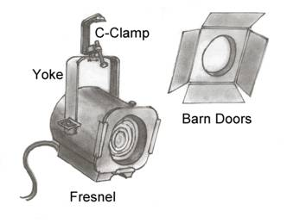

*(from Technical Theater for Nontechnical People, by Drew Campbell.)*

### Soft-edged lights

1. Soft-edged lights mix together well and provide nice effects, but it is important to remember that they will spill onto proscenium arches, speakers, etc.  **Barn doors** can help give a little control, but cannot make a sharp edge.
2. The **fresnel** is named after it’s inventor, Augustin Fresnel – a French man who did a lot of optical formulas.  He’d be a good addition to your history of theater unit.  Fresnels are the most popular soft-edged light because they are cheap and blend easily.  The beam from these instruments is adjustable, allowing for **flooding** or **spotting**.
3. For large, smooth washes of light, use a **strip light** (a.k.a. **border light**).  These are long, narrow enclosures with a row of lamps set into them, which provide large amounts of unfocusable light and have several colors.  For example, you may have all the blue lights up, all the red, or all the green.  Or, you may bring all three colors up at once and the colors mix together to make white light.

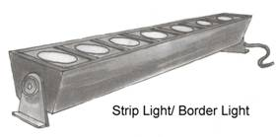

*(from Technical Theater for Nontechnical People, by Drew Campbell.)*

1. **Scoops** are used to light large areas or used as work lights. They are inexpensive, but the light goes everywhere.
2. **PAR cans** give off a very bright and intense light.  They cannot be focused, but they make good sunlight.  These are more popular in rock-and-roll type shows.

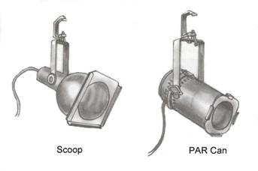

*(from Technical Theater for Nontechnical People, by Drew Campbell.)*

### Hard-edged lights

1. The most popular type of hard-edged lights is the **ellipsoidal reflector spotlight**, sometimes known as a **Leko**, which is simply a brand name.  These instruments can be hard or soft-edged, but it’s easier to use fresnels for soft-edges simply because they are less costly than ellipsoidals.
   1. Ellipsoidals contain reflectors that allow greater focusing ability.  They also have **shutters**, which can be pushed into the light to create a sharp ledge.  **Templates** (a.k.a. gobos) can also be used to create a pattern in the light.  Fresnels can’t do that.
   2. Ellipsoidals with a long **focal length** have narrower beams of light than those with shorter focal lengths.

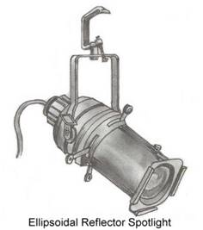

*(from Technical Theater for Nontechnical People, by Drew Campbell.)*

1. **Zoom ellipsoidals** have an adjustable focal length, but are much more expensive and tend to have a dimmer beam.

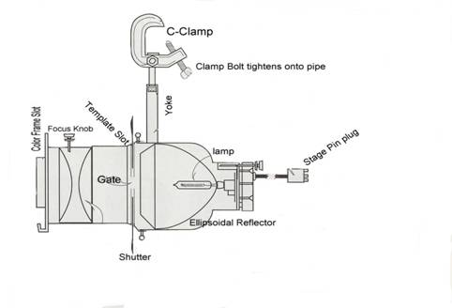

*(from Lighting and the Design Idea, by Linda Essig.)*

### Follow Spots

1. **Follow Spots** give off a hard-edged circle of light.  You can make the circle bigger or smaller by adjusting the **iris**.  Like ellipsoidals, follow spots have shutters to make hard edges.  Follow spots can dim by using the **douser**, or be colored with **color frames**.
   1. The **throw distance** determines how far the light will go from the spotlight.  For big distances (those close to 100 feet) you need an **HMI** lamp.  They come with a **ballast** that keeps the lamp burning.  The big disadvantage with these is that they cannot be turned on if they are hot.  In other words, you can only start it up once and must leave it running until the end of the production.

### Color

1. **Color filters** (sometimes referred to as gels) fit into the front of the instruments and color the light. Filters come in large sheets that you may cut to fit your instruments.
   1. Installing color filters:  First, find a frame that fits the instrument you want to put a filter in.  Second, cut the filter to fit the frame.  Slide the filter into the frame.  Some frames have a hole in them to stick a brad in.  This keeps the filter from slipping out before it gets into the color frame holder.  Finally, slide the frame into the slot on the front of the instrument.  Be sure the instrument is facing up or the frame will fall out the bottom.
2. **Diffusion filters** are white and are used to spread the light out.  Some are made to soften the light and others spread it over large areas.