### History of Lighting Quiz (Answer Key)

#### Name:______________________

1. Name the seven time periods we’ve discussed, in chronological order.

1. ANCIENT GREECE
2. ANCIENT ROME
3. MIDDLE AGES
4. RENNAISANCE TO THE 17th CENTURY
5. 18th CENTURY
6. 19th CENTURY
7. 20th CENTURY

2. In what time period was gas-lighting introduced?

ANSWER: 19th Century

3. What was the main source of lighting used in Ancient Greece?

##### ANSWER: THE SUN

4. What did Ancient Greeks use as “dimmers”?

##### ANSWER: The Clouds

5. What time period would the following instrument have been used in?

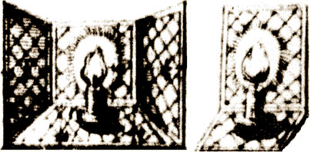

ANSWER: RENNAISANCE

6. Identify the following lighting instrument and list what time period it would have been used in?

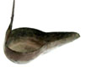

ANSWER: OIL LAMP—17th CENTURY

7. In 1550, Leone de Somi used full illumination for HAPPY scenes, but for TRAGEDY scenes it was much darker.

8. In which time period did electricity begin being used in lighting?

##### ANSWER: 19th CENTURY

9. Explain what footlights are.

ANSWER: The lights at the front, side, or back of a stage that are nearly on a level with the feet of the performers. (Or something along those lines)

10. The ROMANS were probably the first to use torches at evening performances.