**Early Lighting Instruments:**

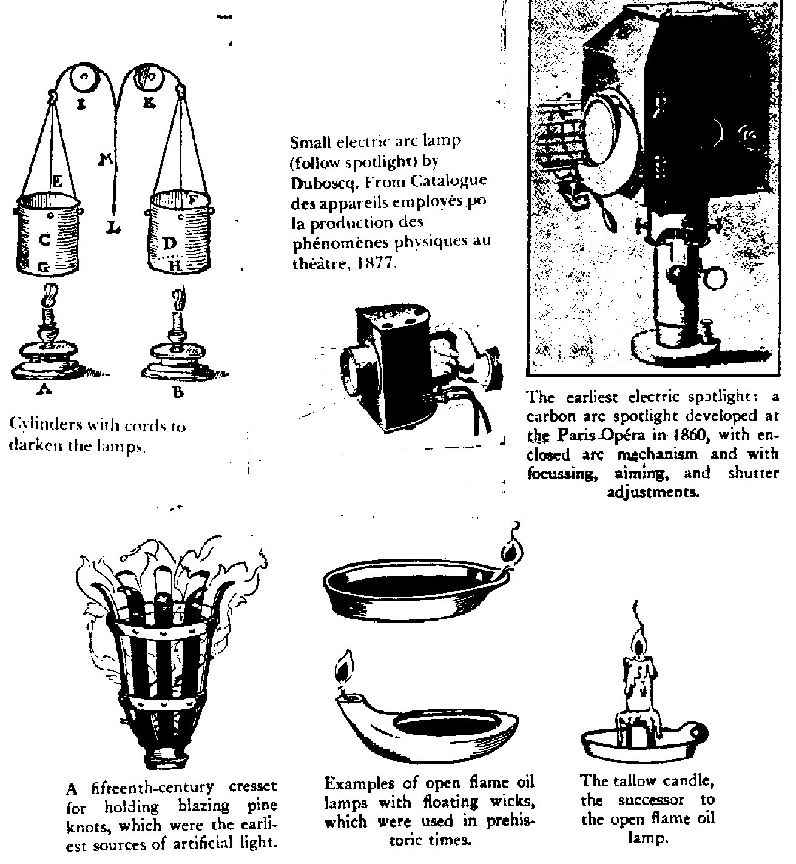

**Modern Lighting Instruments:**

***(NOTE:*** These images are taken from W. Oren Parker and R. Craig Wolf, ***Stage Lighting: Practice and Design.*** New York: Holt, Rinehart, and Winston, 1987.)

***The Plano-Convex Lens Spotlight*** 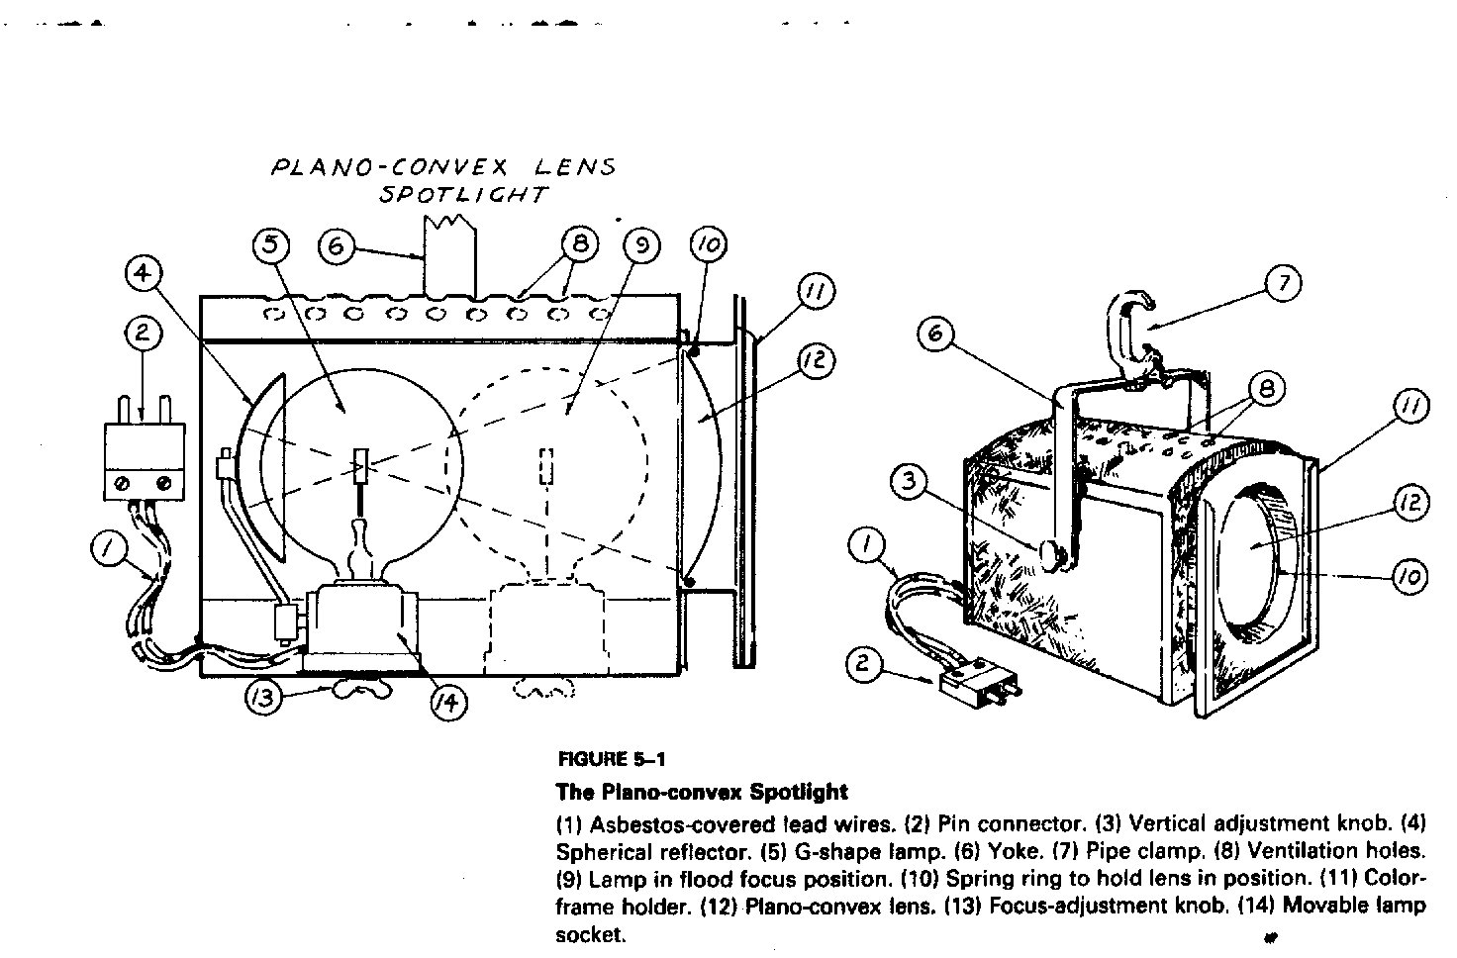

# The Ellipsoidal Reflector Spotlight

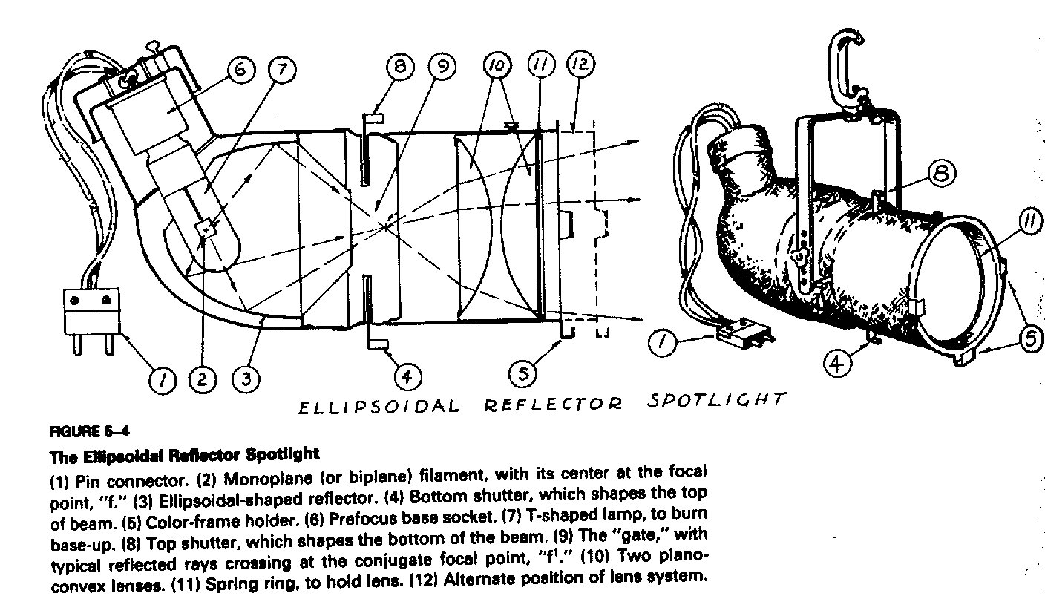

The Fresnel lens spotlight

