### History of Lighting Quiz

#### Name:______________________

1. Name the seven time periods we’ve discussed, in chronological order.

2. In what time period was gas introduced?

3. What was the main source of lighting used in Ancient Greece?

4. What did Ancient Greeks use as “dimmers”?

5. What time period would the following instrument have been used in?

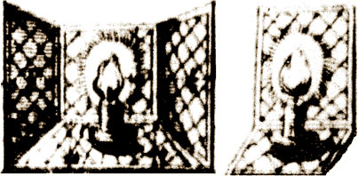

6. Identify the following lighting instrument and list what time period it would have been used in?

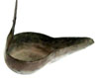

7. In 1550, Leone de Somi used full illumination for ______ scenes, but for _______ scenes it was much darker.

8. In which time period did electricity begin being used in lighting?

9. Explain what footlights and sidelights are.

10. The _______ were probably the first to use torches at evening performances.