Basic Stage Lighting
by Jason Purdie

Objective:
Students will demonstrate their understanding of basic lighting by creating basic lighting designs, and programming and running a light board for a 5-minute scene.

Class Level:
Beginning

Prior Experience:
Students will have an interest in lighting/technical theatre prior to this class but will probably have very little or no first-hand experience.

National Standards:
TH:Cr1.1.HSI
b. Explore the impact of technology on design choices in a drama/theatre work.
TH:Pr5.1.HSII
b. Apply technical elements and research to create a design that communicates the concept of a drama/theatre production.

Main Concepts:
History of Lighting, Lighting Equipment and Instruments, Light Qualities, Light Functions, Basic Electricity and Circuitry, Hanging and Focusing Lights, Channels and Dimmers, and Running Light Boards.

Lesson Plans

Lesson 1: A History of Stage Lighting
Students will demonstrate their understanding of basic lighting history by taking a written quiz.

Lesson 2: Understanding Lighting Equipment and Instruments
Students will demonstrate their knowledge of lighting equipment and instruments by playing “The Light is Right” game.

Lesson 3: The 4 Qualities of Light
Students will demonstrate their understanding of the qualities of light by watching movie clips and writing their responses.

Lesson 4: The 4 Functions of Light
Students will demonstrate their understanding of the 4 functions of light by watching a short scene and writing their responses.

Lesson 5: Hanging and Focusing Lighting Instruments, Part 1
Students will demonstrate their ability to hang and focus lighting instruments by practicing to hang and focus lighting instruments.

Lesson 6: Hanging and Focusing Lighting Instruments, Part 2
Students will demonstrate their ability to hang and focus lighting instruments by hanging lights for a 5-minute scene.

Lesson 7: Channels, Dimmers and the Light Board
Students will demonstrate their understanding of channels, dimmers and light boards by practicing lighting cues and taking an oral quiz.

Lesson 8: Running a Light Board
Students will demonstrate their understanding of running a light board by running the light board for a 5-minute scene.

LESSON 1: A Brief History of Stage Lighting

Objective:
Students will demonstrate their understanding of basic lighting history by taking a written quiz.

Materials Needed:
Pictures of different lighting instruments/types from each time period (can be found at http://www.stage-lighting-museum.com/html/history-1/it-ren.html).

Seven pieces of paper with the title of a different time period (Ancient Greece, Ancient Rome, The Middle Ages, The Renaissance to the 17th Century, 18th Century, 19th Century, and 20th Century.) written on each paper.

“A History of Stage Lighting” Packet, which includes a timeline (the info in this packet can be found online at http://www.bartleby.com/65/sc/scenedes.html, and http://novaonline.nvcc.edu/eli/spd130et/histlighting.htm).

History of Lighting quiz.

LESSON DIRECTIONS:

Anticipatory Set/ Hook: As students enter the classroom they will be given tickets by an “usher” that read “Admit One: Ancient Greek Theatre.” Other ushers will guide them to their seats. The ushers can be students that you have previously asked to help. The classroom will be completely dark except for the light coming in from outside the classroom. When everyone is seated, the door to the classroom will be shut and the room will be completely dark. Someone will announce, in a very loud theatrical voice, that “Agamemnon will now begin!” Students from an intermediate or advanced acting class will perform a very short scene from Agamemnon in complete darkness. When the scene is over the ushers who were helping out will be assigned to clap so everyone knows the scene is over. The teacher will bring up the lights

Step 1: Transition—The teacher will turn on the lights and ask the students how they liked the show, and how it could have been improved upon. Hopefully one of the students will comment on how some light would have helped, if not, then the teacher will ask them if lighting would have been helpful to the scene.

Step 2: Instruction—Explain to them how in Ancient Greek Theatre cues seem to have been written into Greek plays - the festivals played from sunup to sunset, and many of the lines refer to times of day. The sun was the first major source of lighting instrument, and clouds were the first dimmer.

Step 3: Transition/Checking for Understanding—Uncover a bulletin or chalk board that has your seven pieces of paper with the title of a different time period written on each paper posted on the board. Have pictures of different lighting instruments/types sitting on a table facing down. Have a student come and pick up a piece of paper and match the lighting instruments/types with the time period posted on the board.

Step 4: Instruction/Discussion—When all the pictures have been posted on the board under the different time periods, hand out the Theatre Lighting History timeline to each student. Go over the time line with them and discuss their thoughts on what they think about the lighting changes that have occurred throughout the ages.

Step 5: Checking for Understanding—Ask for volunteers to, one at a time, come up and switch the lighting pictures on the board to their appropriate time periods.

Step 6: Assessment/Discussion—Hand out the lighting history quiz to the students and tell them they have 20 minutes to take the quiz. When time is up, have the students exchange papers with each other and grade them as you tell them the answers. As you go through the answers to the quiz discuss any questions they have.

Assessment: Students can be assessed through their responses to the written quiz, as well as through the matching game played during the lesson.
A History of Stage Lighting

Ancient Greek
Greek plays were performed in daylight, and the dramas were frequently designed to take advantage of the position of the sun. Also, theater sites were well placed to gain the best effects of the natural light.

Ancient Roman
The Romans were probably the first to use torches and lamps at evening performances.

The Middle Ages
Information about medieval lighting is uncertain although it seems likely that torches, both moving and stationary, were utilized.

The Renaissance to the Seventeenth Century
Nicolo Sabbattini and Leone de’ Sommi wrote on the use of lighting in the 16th century; in addition, they developed footlights and techniques for colored lights and for the dimming of lights. From the Renaissance period until the triumph of gas lighting in the mid-19th cent., great use was made of lamps, candles, and torches. Although they caused much work, odor, and smoke, ingenious effects were produced.

The Eighteenth Century
Lighting became a problem only when the theaters were entirely enclosed. At that time lights (torches, candles, oil lamps) and reflectors surrounded the stage, and footlights came into use. Later chandeliers and candelabras became fashionable. Much use was made of colored lights made with mirrors reflecting colored water; shadows were painted on the flats. The auditorium itself was not darkened for the performance.

The Nineteenth Century
The 19th century brought extensive changes in lighting and scene design. Gaslight was first introduced (1817) in England. Although it was responsible for many theater fires, gaslight had, by 1849, the advantage of being centrally controlled. Sir Henry Irving, at the end of the century, was first to darken the auditorium completely. He also was first to experiment with the color and intensity of gaslight. The first spotlight was the limelight (1816); it was followed by the arc light (1846). With the invention (1879) of the incandescent bulb, light became the primary scene painter. Through the efforts of Adolphe Appia, modern stage lighting was born.
The concept of the invisible “fourth wall” forced the acting area to be located behind the proscenium arch, thus eliminating the need for a wide apron and glaring footlights.

The Twentieth Century
After 1912 lights were placed in the auditorium to allow for more natural angles of illumination for both the actor and the set. The projector lamp, a spotlight that could be dimmed, was invented in 1914; after 1919 colored “gels,” or gelatine, were placed over the lights. By 1922 stage lighting had become a scientific study.

A Lighting Timeline

Lighting cues seem to have been written into Greek plays - the festivals played from sunup to sunset, and many of the lines refer to times of day.

The sun was the first major source of lighting instrument, and clouds were the first dimmer (!).

The Romans moved pageants into the Great Halls.

1545:
Sabastiano Serlio -- colored light liquids in bottles (red wine, saffron (yellow), ammonium chloride in a copper vessel (blue).
Brightly-polished barber basin and a round bottle as a lens

3 qualities of light: distribution, intensity, color

1550:
Leone de Somi - full illumination for happy scenes, but tragedy much darker (candles, crude oil lamps, torches, and cressets (hanging lamps).
Stagehands walked around and snipped wicks, the audience was lit
Candles were of tallow and fat

1573:
Inigo Jones (or click here) (English - stage designer) returns from Italy with knowledge of the Proscenium Arch and footlights, and comes up with ideas for masques

1580:
Theatro Olimpico is the first permanent theatre in Italy

1618:
Theatro Farnese in Parma - the first theatre with a permanent proscenium arch and curtains

1628:
Joseph Furstenbach
Footlights (floats) and sidelights

1638:
Nicola Sabbatini - writes book on theatre - suggests system of dimmers lowering metal cylinders over the candles
Giacomo da Vignola - ideal lighting angle is along the diagonal of a cube
(1930's - Stanley McCandless writes it in book)

17th century (1600's)
Paris - many chandeliers
Gas becomes used

1783:
Candles ruled the day till the invention in 1783 in France of the kerosene lamp with adjustable wick
Followed closely with a glass chimney - could make individual float lights
Used for 100 years

1791:
Illuminating gas produced in quantity - William Murdock - each building could produce its own
However, gas required constant attention and wasn't easy to control

1803:
Limelight probably invented, but not widely used till 1816 in Philadelphia
Invented by Henry Drummond - heating a piece of lime with a flame of oxygen and hydrogen (for a followspot or to indicate sunlight). A green-ish tint.
Was used as the first spotlight in Paris Opera houses

1845:
Drury Lane Theatre is the first to use gas in England)

1809:
Electric Arc - discovered by Sir Humphrey Davey (or Humphry Davy, depending on who is spelling it) - took 90 years to be fully accepted.

1816:
First limelight theatre -- Chestnut Street Theatre in Philadelphia
Greater control of and more brightness (colorsilk cloth or woven cotton).
Increased heat and many fires caused, and had gas smell and green-ish tint.

1878-1898:
Henry Irving (and click here) (England) initiated lighting rehearsals, transparent laquers of colored class to limelight with electricity to incandescents, footlights of different colors and broken into sections, and wanted to dim the house lights

Electricity!

1841:
First incandescent lamp patent - Edison - not practical

1846:
The first electric carbon arcs used as spotlights at the Paris opera - inefficient -- not a serious threat to limelight

1879:
The Jablachkoff candle - the first useful lightbulb - "electric candle" - used at Paris Hippodrome - a carbon arc (invented 40-50 years earlier, but limelight was too ingrained, even well into the 1920's.
The first practical electric spotlight

1881:
Savoy Theatre in England - the first completely electric theatre

1882:
A big push - electric theatre at the exposition in Munich, Germany -- with a saltwater dimmer to control the new power source - went like wildfire...

As technology develops and advances at a more rapid rate, so did development of more effective lighting equipment

Edison - first practical lightbulb

Incandescent to tungsten -halogen lamps
Laquer to gels.

Electric lighting went from the marquee to the outer lobby to the inner lobby to the house to the stage

Early Lighting Instruments:

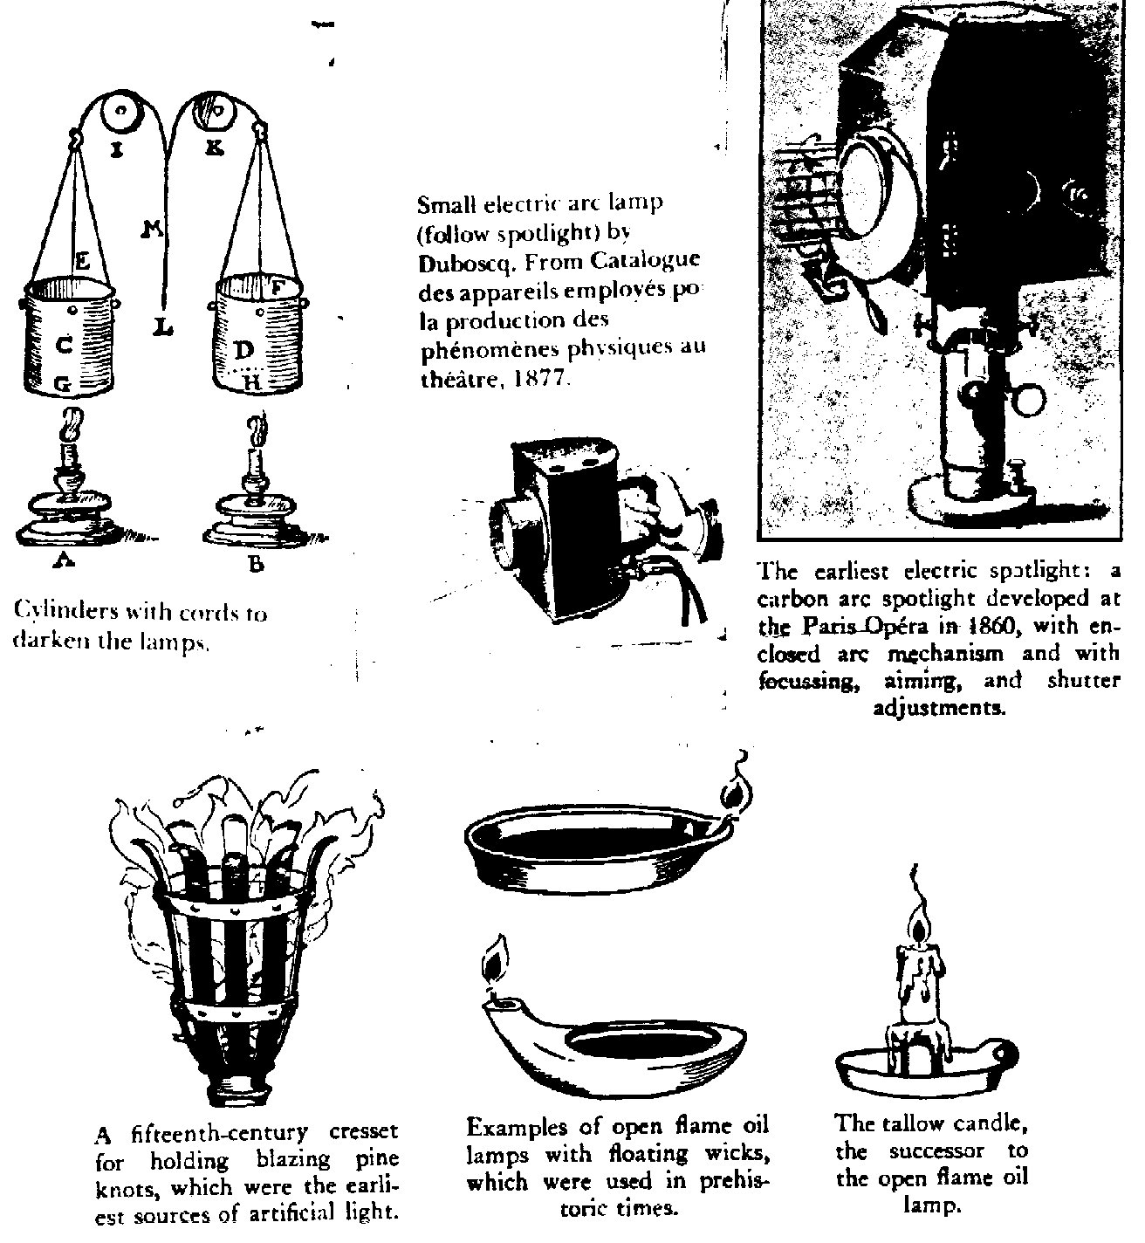

Modern Lighting Instruments:
(NOTE: These images are taken from W. Oren Parker and R. Craig Wolf, Stage Lighting: Practice and Design. New York: Holt, Rinehart, and Winston, 1987.)

The Plano-Convex Lens Spotlight 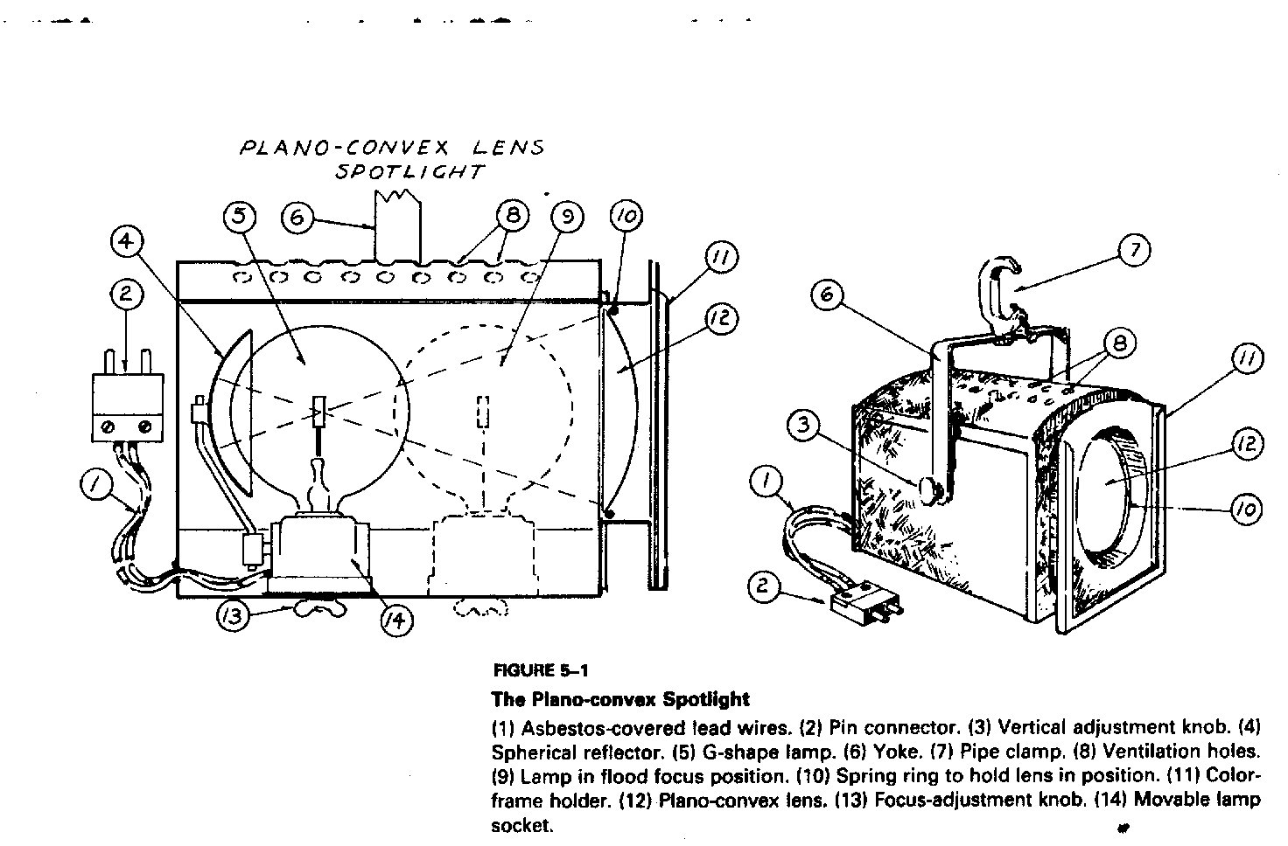

The Ellipsoidal Reflector Spotlight
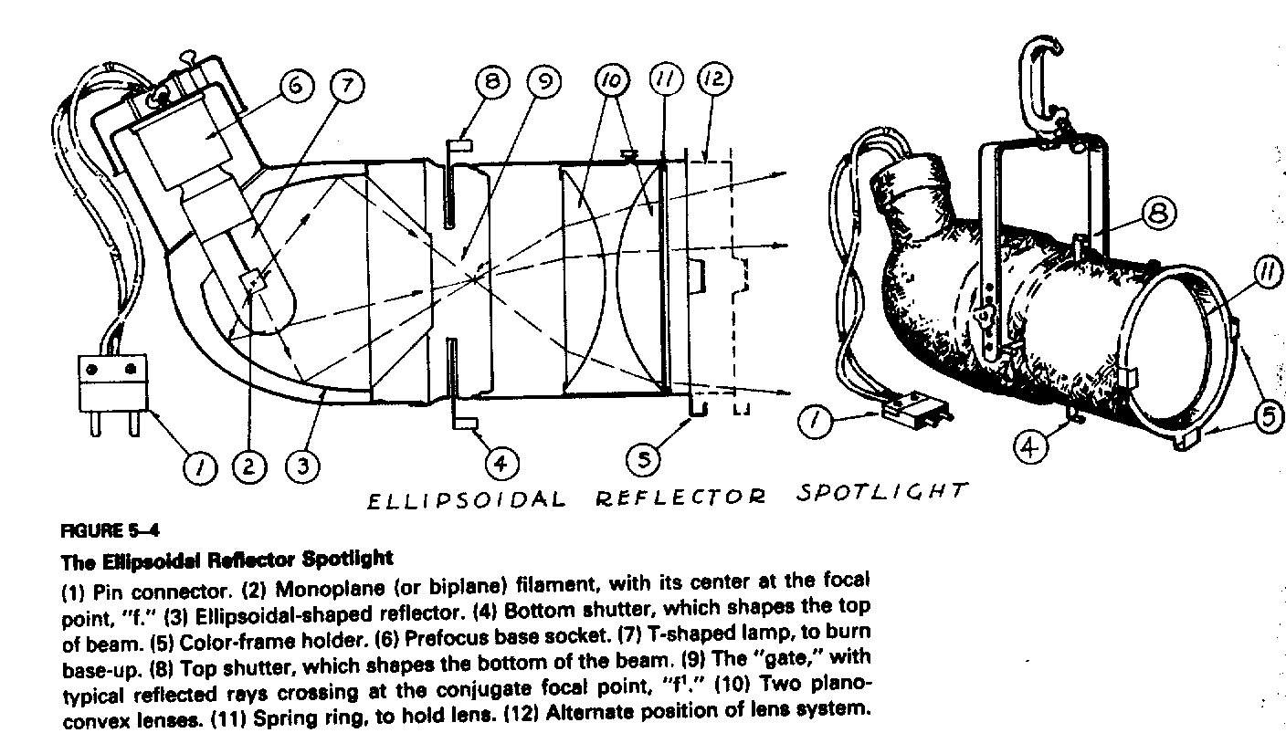
The Fresnel lens spotlight

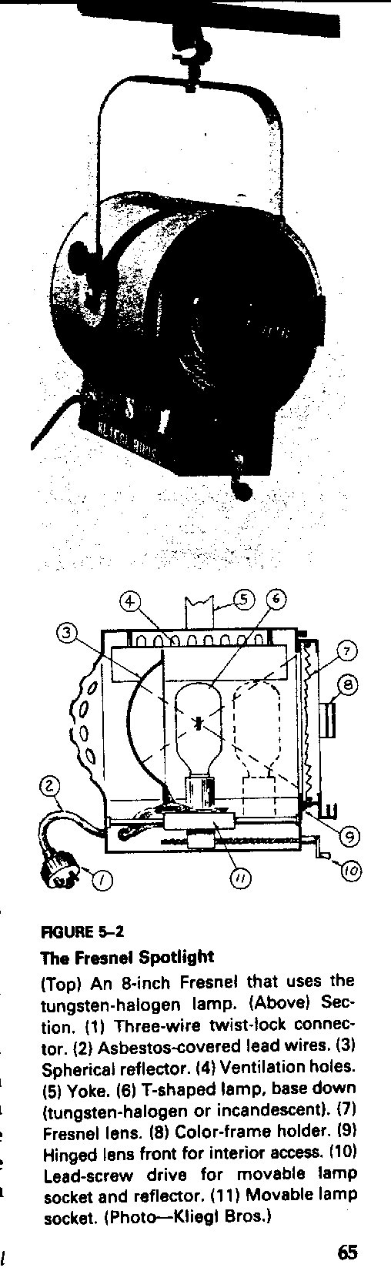

History of Lighting Quiz

Name:______________________

1. Name the seven time periods we’ve discussed, in chronological order.

2. In what time period was gas introduced?

3. What was the main source of lighting used in Ancient Greece?

4. What did Ancient Greeks use as “dimmers”?

5. What time period would the following instrument have been used in?

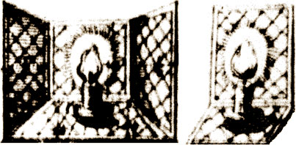

6. Identify the following lighting instrument and list what time period it would have been used in?

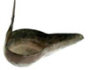

7. In 1550, Leone de Somi used full illumination for ______ scenes, but for _______ scenes it was much darker.

8. In which time period did electricity begin being used in lighting?

9. Explain what footlights and sidelights are.

10. The _______ were probably the first to use torches at evening performances.

History of Lighting Quiz (Answer Key)

Name:______________________

1. Name the seven time periods we’ve discussed, in chronological order.
- ANCIENT GREECE
- ANCIENT ROME
- MIDDLE AGES
- RENNAISANCE TO THE 17th CENTURY
- 18th CENTURY
- 19th CENTURY
- 20th CENTURY

2. In what time period was gas-lighting introduced?
ANSWER: 19th Century

3. What was the main source of lighting used in Ancient Greece?

ANSWER: THE SUN

4. What did Ancient Greeks use as “dimmers”?

ANSWER: The Clouds

5. What time period would the following instrument have been used in?

ANSWER: RENNAISANCE

6. Identify the following lighting instrument and list what time period it would have been used in?

ANSWER: OIL LAMP—17th CENTURY

7. In 1550, Leone de Somi used full illumination for HAPPY scenes, but for TRAGEDY scenes it was much darker.

8. In which time period did electricity begin being used in lighting?

ANSWER: 19th CENTURY

9. Explain what footlights are.
ANSWER: The lights at the front, side, or back of a stage that are nearly on a level with the feet of the performers. (Or something along those lines)

10. The ROMANS were probably the first to use torches at evening performances.

LESSON 2: Lighting Equipment and Instruments

Objective:
Students will demonstrate their knowledge of lighting equipment and instruments by playing “The Light is Right” game.

Materials Needed:
Lighting Instruments:
Lamps, Scoops, Fresnels, Par CANs, Ellipsoidals, Striplights, and Follow Spot.

Lighting Equipment
C-Clamps, Safety Cables, Gobos, Gels, Gel frames, and wrenches.

Other Materials:
Copies of the “Lighting Safety” and “Lighting Instruments and Equipment” handouts for each student and slips of cardstock paper with the names of all lighting instruments and equipment written on them (for “The Light is Right” game).

LESSON DIRECTIONS:

Anticipatory Set/Hook: Have the lighting instruments and equipment on display out on the stage as the students come in. Also have the batten lowered.

Step 1: Instruction—Give a copy of the “Lighting Safety” handout and go over it with them. Have each student read a rule until you’ve gone through all the rules (take time to discuss each rule if necessary).

Step 2: Instruction—Start by talking about plugs. Show students the three types of plugs, and explain to them that the Edison plug is the most common type of plug, but it is not very sturdy and cannot handle much power. Therefore, you won’t see many Edison plugs in theatre lights. Show them the Stage pin plug (which is also referred to as the “three pin” or “stage plug”). Explain to them that this plug is sturdy and can handle a lot of power. Show them the final type of plug, called the Twist-lock plug. Explain that this plug is as sturdy as the Stage Pin Plug, and they actually twist and lock (hence the name) so you don’t have to do any taping when using this type of plug.

Step 3: Instruction—Give a copy of the “Lighting Instrument and Equipment” handout to each student. Remind them that all of the handouts they get in class are supposed to be put in their binders, and that the binders will be turned in at the end of the semester for a grade (and then given back to them, of course).
Modeling—Put on your gloves. Show them a lamp for one of the lights and explain to them that the bulb within the instrument is actually called a lamp. Remind them to never touch a lamp/bulb with their bare hands because the oil from their fingers will burn and cause the light to explode when it is turned on. (I could give a more detailed explanation of this phenomenon, but it’s not necessary—just don’t touch them.) Give them a quick demonstration of how to change a lamp. Tell them that they are never to change a lamp unless they are supervised or certified. Explain to them what the Lamp Housing is.

Guided Practice—If you feel extremely daring, let a few kids put on some gloves and change a lamp.

Instruction—Show and explain the other basic instrument parts: (here are some suggestions of what you can say, but feel free to use whatever wording you want and cover whatever else you feel necessary)
- A C-clamp is the device used to mount the light on the hanging pipes. It is shaped like a C (go figure) and has a bolt on the side. Loosen the bolt to turn the instrument left and right. Just be careful not to twist it off.

Modeling—Show them how to twist the bolt without twisting it off.
- The C-clamp attaches to a U-shaped yoke, which goes over the instrument and attaches at either side. A safety cable is required to attach each light to the batten, as an added safety precaution.
- The front of the instrument has a color frame holder. Some instruments have a latch you must pull open to slide the frame in, while others just have a slot.

Step 4: Show and explain the different lighting instruments: (here are some suggestions of what you can say, but feel free to use whatever wording you want and cover whatever else you feel necessary)
- Soft-edged lights mix together well and provide nice effects, but it is important to remember that they will spill onto proscenium arches, speakers, etc. Barn doors can help give a little control, but cannot make a sharp edge.
- Fresnels are the most popular soft-edged light because they are cheap and blend easily. The beam from these instruments is adjustable, allowing for flooding or spotting. The Fresnel is named after it’s inventor, Augustin Fresnel – a French man who did a lot of optical formulas.
- For large, smooth washes of light, use a strip light (a.k.a. border light). These are long, narrow enclosures with a row of lamps set into them, which provide large amounts of unfocusable light and have several colors. For example, you may have all the blue lights up, all the red, or all the green. Or, you may bring all three colors up at once and the colors mix together to make white light.
- Scoops are used to light large areas or used as work lights. They are inexpensive, but the light goes everywhere.
- PAR cans give off a very bright and intense light. They cannot be focused, but they make good sunlight. These are more popular in rock-and-roll type shows.
- The most popular type of hard-edged lights is the ellipsoidal reflector spotlight, sometimes known as a Leko, which is simply a brand name. These instruments can be hard or soft-edged, but it’s easier to use Fresnels for soft-edges simply because they are less costly than Ellipsoidals.
- Ellipsoidals contain reflectors that allow greater focusing ability. They also have shutters, which can be pushed into the light to create a sharp ledge. Templates (a.k.a. gobos) can also be used to create a pattern in the light. Fresnels can’t do that.
- Ellipsoidals with a long focal length have narrower beams of light than those with shorter focal lengths.
- Follow Spots give off a hard-edged circle of light. You can make the circle bigger or smaller by adjusting the iris. Like ellipsoidals, follow spots have shutters to make hard edges. Follow spots can dim by using the douser, or be colored with color frames.
- Color filters, usually referred to as gels, fit into the front of the instruments and color the light. Filters come in large sheets that you may cut to fit your instruments.

Modeling—Installing color filters: (Again, more dialogue)
- First, find a frame that fits the instrument you want to put a filter in. Second, cut the filter to fit the frame. Slide the filter into the frame. Some frames have a hole in them to stick a brad in. This keeps the filter from slipping out before it gets into the color frame holder. Finally, slide the frame into the slot on the front of the instrument. Be sure the instrument is facing up or the frame will fall out the bottom.
- Diffusion filters are white and are used to spread the light out. Some are made to soften the light and others spread it over large areas.

Step 5: Guided Practice—Give everyone an opportunity to put a gel into a gel frame and then into the light. Let them put a Gobo into an Ellipsoidal. Let them practice opening and closing the shutters on the Ellipsoidal and making other adjustments. Let them practice using the follow spot (moving it, adjusting shutters, etc).

Step 6: Have everyone stop what they are doing and gather around. In preparation for the following game, the lighting instruments and equipment will be separated so that half of them are one side of the stage, while the other half is on the other side of the stage.

Directions—Explain the rules of “The Light is Right” game. Split the students up into two groups. Have prepared a stack of card stock slips of paper with the names of lighting instrument and equipment names on them. Give one group of students half of the slips of paper and give the other half to the second group of students.

Explain to them that each group will have 30 seconds to put the right name next to the right instrument and be back standing by me. If any of the names are by the wrong, tell them so (without revealing which ones are wrong), and then give them another 30 seconds to go and fix what they think is wrong. Do this until they have everything right. Let one group at a time go. While one group is going, have the other group go away where they can’t see what is going on. When both groups have done the game for both sides of the stage, you are finished with the game.

Assessment: Students can be assessed through their guided practice with the instruments, as well as their ability to play “The Light is Right” game.
L i g h t i n g S a f e t y

1. Know location of fire extinguishers and first aid kits.

2. Be alert to possible safety hazards and report them to your supervisor immediately.

3. Wear suitable clothing and proper shoes.

4. Report all injuries or accidents immediately to your supervisor, no matter how slight.

5. No student or employee will report to work under the influence of alcohol or non-prescription drugs.

6. Do not engage in “horseplay.”

7. Know your job and how to do it safely.

8. Be aware of your surroundings and know what others are doing around you.

9. Remove contents of pockets before using the lift, catwalks, or ladders.

10. Heavy gloves should be worn when handling wire rope and other rough materials.

11. Stage lighting units become very hot with use. Wear gloves for focusing.

12. The stage and shops must be swept at the end of each working day. Keep fire exits and fire fighting equipment free from obstruction.

13. Know how to use a fire extinguisher and what its requirements before and after use are.

14. Never work on stage or in the shop alone. When working on hazardous equipment always work in pairs.

15. The use of ladders with broken or missing rungs or steps, broken or split side rails or other faulty or defective construction is prohibited.

16. Portable ladder feet shall be placed on a substantial base and the area around the top and bottom of the ladder shall be kept clear.

17. Portable ladders in use shall be tied, blocked, or otherwise secured to prevent their being displaced.

18. No other work should happen on stage in the area where lighting units are being hung, unhung, or focused.

19. All lighting instruments must have a safety cable attached and all bolts properly tightened.

20. The plug of each lighting instrument must be inspected. At any signs of damage they must be replaced immediately.

21. Stage cables must be inspected regularly. At any signs of damage they must be replaced immediately.

22. Do not touch the glass on a stage lamp with your fingers. Oils will be deposited on the lamp and lead to lamp failure. If touched, clean lamp with alcohol.

23. Do not exceed the maximum allowable lamp wattage for a lighting instrument. Over wattage will damage the instrument.

24. All circuiting of lighting equipment will take place with the power off both dimmer and non-dimmer circuits.

25. Test each lighting instrument and cable before each use.

26. Wash hands and forearms after each work call. The cords on most lighting units are covered with a fiberglass material that can irritate the skin.

Lighting Equipment

PLUGS
- There are three types of plugs.
  - The one you see in your house is the Edison Plug. It is the most common, but since it is not very sturdy and cannot handle much power, you won’t see it in many theater lights.
  - The Stage Pin Plug (a.k.a. “three pin” or “stage plug”) is sturdy and can handle lots of power. If you use these of plugs, you should tape them together with gaffer’s tape. (All other tape will melt or burn.)
  - The Twist-lock Plug are the best, but also the most expensive. They are as durable as the stage pin plug, but they twist and lock into place so there is no taping involved.
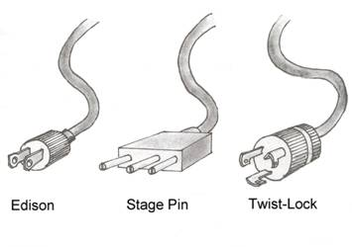
(from Technical Theater for Nontechnical People, by Drew Campbell.)

Dimmers and Channels
- The lighting instrument has what is called a connector (as most electrical devices have an Edison connector that you plug into an outlet) the connector on a lighting instrument plugs into the dimmer. The dimmer is the electrical source, which regulates the amount of voltage conducted to the lighting instrument.
- Each dimmer has an assigned number that must be noted when it is 'circuited'. These numbers are permanent and correspond to the place the instrument is hung. "Channel control is an electronic patching system in which one or more dimmers can be assigned to a control channel, which in turn controls the intensity level of those dimmers." The channels are also numbers. Patching allows the designer to organize the instruments in a way that makes more sense. For instance all of the front light can be channels 1-10; top light could be 11-20; etc. Channels are then patched into cues in a similar manner. All of the lights that are on before the show begins are in cue 1 (This is also known as the "pre-show".) Cue 2 is usually identical except the house lights fade to 50% intensity instead of 100%. Cue 3 might fade to black and bring up the prayer light. And so on. There can be movement within a cue; lights can fade up/down over a set amount of time.

Lighting Instruments

BASIC INSTRUMENT PARTS
- The bulb within the instrument is actually called a lamp. Do not touch it with your bare hands. The oil from your fingers will burn and cause the light to explode when it is turned on. (I could give a more detailed explanation of this phenomenon, but it’s not important. Just don’t touch them.)
- A C-clamp is the device used to mount the light on the hanging pipes. It is shaped like a C (go figure) and has a bolt on the side. Loosen the bolt to turn the instrument left and right. Just be careful not to twist it off.
- The C-clamp attaches to a U-shaped yoke, which goes over the instrument and attaches at either side. (See illustration below)
- The front of the instrument has a color frame holder. Some instruments have a latch you must pull open to slide the frame in, while others have just a slot.

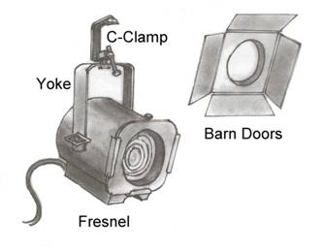
(from Technical Theater for Nontechnical People, by Drew Campbell.)

Soft-edged lights
- Soft-edged lights mix together well and provide nice effects, but it is important to remember that they will spill onto proscenium arches, speakers, etc. Barn doors can help give a little control, but cannot make a sharp edge.
- The fresnel is named after it’s inventor, Augustin Fresnel – a French man who did a lot of optical formulas. He’d be a good addition to your history of theater unit. Fresnels are the most popular soft-edged light because they are cheap and blend easily. The beam from these instruments is adjustable, allowing for flooding or spotting.
- For large, smooth washes of light, use a strip light (a.k.a. border light). These are long, narrow enclosures with a row of lamps set into them, which provide large amounts of unfocusable light and have several colors. For example, you may have all the blue lights up, all the red, or all the green. Or, you may bring all three colors up at once and the colors mix together to make white light.
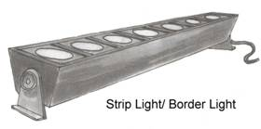
(from Technical Theater for Nontechnical People, by Drew Campbell.)

- Scoops are used to light large areas or used as work lights. They are inexpensive, but the light goes everywhere.
- PAR cans give off a very bright and intense light. They cannot be focused, but they make good sunlight. These are more popular in rock-and-roll type shows.
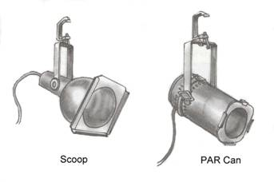
(from Technical Theater for Nontechnical People, by Drew Campbell.)

Hard-edged lights
- The most popular type of hard-edged lights is the ellipsoidal reflector spotlight, sometimes known as a Leko, which is simply a brand name. These instruments can be hard or soft-edged, but it’s easier to use fresnels for soft-edges simply because they are less costly than ellipsoidals.
  - Ellipsoidals contain reflectors that allow greater focusing ability. They also have shutters, which can be pushed into the light to create a sharp ledge. Templates (a.k.a. gobos) can also be used to create a pattern in the light. Fresnels can’t do that.
  - Ellipsoidals with a long focal length have narrower beams of light than those with shorter focal lengths.

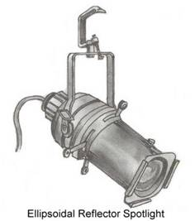

(from Technical Theater for Nontechnical People, by Drew Campbell.)

- Zoom ellipsoidals have an adjustable focal length, but are much more expensive and tend to have a dimmer beam.
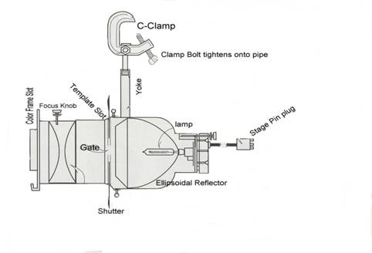
(from Lighting and the Design Idea, by Linda Essig.)

Follow Spots
- Follow Spots give off a hard-edged circle of light. You can make the circle bigger or smaller by adjusting the iris. Like ellipsoidals, follow spots have shutters to make hard edges. Follow spots can dim by using the douser, or be colored with color frames.
  - The throw distance determines how far the light will go from the spotlight. For big distances (those close to 100 feet) you need an HMI lamp. They come with a ballast that keeps the lamp burning. The big disadvantage with these is that they cannot be turned on if they are hot. In other words, you can only start it up once and must leave it running until the end of the production.

Color
- Color filters (sometimes referred to as gels) fit into the front of the instruments and color the light. Filters come in large sheets that you may cut to fit your instruments.
  - Installing color filters: First, find a frame that fits the instrument you want to put a filter in. Second, cut the filter to fit the frame. Slide the filter into the frame. Some frames have a hole in them to stick a brad in. This keeps the filter from slipping out before it gets into the color frame holder. Finally, slide the frame into the slot on the front of the instrument. Be sure the instrument is facing up or the frame will fall out the bottom.
- Diffusion filters are white and are used to spread the light out. Some are made to soften the light and others spread it over large areas.

The Light is Right Game

Instructions:

- You will need to have enough slips of card stock paper to write names of all your lighting instruments and equipment. Prepare these beforehand.
- Split your class into two groups (you can split into more than 2 groups if you have a large class).
- Give one group half of the card stock slips of paper with instrument and equipment names on them, and give half of the slips to the other group.
- Explain to the students that each group will have 30 seconds to put the right name next to the right instrument and then come back and stand by you.
- If any of the names are by the wrong item, tell them so (without revealing which ones are wrong), and then give them another 30 seconds to go and fix what they think is wrong. Do this until they have everything right.
- Let one group at a time go. While one group is playing, have the other group go away where they can’t see what is going on.
- When both groups have done the game for both sides of the stage, you are finished with the game.
LESSON 3: The 4 Qualities of Light

Objective:
Students will demonstrate their understanding of the 4 qualities of light by watching movie clips and writing their responses.

Materials Needed:
The main auditorium/stage of your school (all lighting and sound equipment needs to be available for use), 2 or 3 advanced tech students, a projector, a laptop computer, a DVD player, the movies, The Lord of the Rings: Return of the King and The Age of Innocence, on DVD, a microphone (preferably cordless), a sound effect CD with drum roll and trumpet fanfare sound effects on it, a CD with a song of your choice, a couple chairs (any chairs will do), a flashlight, 2 copies of a scene from The Nerd script, and enough copies of the “4 Qualities of Light” handout for each student.

LESSON DIRECTIONS:

Anticipatory Set/Hook: The audience will be led into the auditorium and seated front and center in the audience. There will be some kind of light show going on, and then we will hear a drum roll sound effect play. You will walk out to the middle of the stage and stand, facing the audience (your students). You will have a cordless microphone. You will have a projector screen to the side of you. A couple or few of your advanced or intermediate tech students will be running the sound and lights from the booth. You will have rehearsed this portion of the lesson with the advanced/intermediate students beforehand. After a few seconds the lights will completely blackout. You will proceed to strike some stereotypical acting pose during this blackout (the pose is optional). After a few more seconds, a single light will abruptly come up on you with the song of your choice playing in the background. You will announce that you are going to be talking about the 4 qualities of light. Through the projector the following words will be displayed, “The 4 Qualities of Light,” along with your pre-recorded voice saying, “The 4 qualities of light.” Then we will hear a fitting sound effect (trumpet fanfare or something). You will announce that the first quality of light that you will be discussing is entitled “distribution.” On the projector will be displayed the word, “Distribution,” along with your pre-recorded voice saying, “Distribution.” Again, we will hear a trumpet fanfare sound effect.

Step 1: Instruction—Explain that “distribution” has to do with 3 different things.
- The direction that the lights approach the actor.
- The shape and size of the area that the light is covering.
- The quality of light—its diffusion or clarity.

In explaining number 1 (direction of light), point out that the light shining on you is approaching you from the left, and then point up and to your right and another light will come on from that direction.
Talk about the importance of direction—that the lights are pointed in very specific directions in order to create or get rid of shadows and to ensure that the actors are well lit at all places on stage where they will be, etc.

Step 2: Move on to number 2 (shape and size). All the lights will blackout except for a very narrow beam on you. Explain how one can use the lights to light small or large areas. Then the lights will change to form a shape around you, and you can proceed to talk about how lights can be used to create shapes on the set.

Step3: Then move on to number 3 (quality of light). As you explain what this is, the lights will change to a more diffused light and then to a light of more clarity (as the lights change, talk about the differences in the lighting). When the light is more diffused, ask the students how that light could affect a scene (and do the same for the light of more clarity).

Step 4: Announce that you are moving on to the second quality of light, which is “Intensity.” On the projector the word, “Intensity,” will be displayed along with your pre-recorded voice saying, “Intensity,” with the trumpet fanfare sound effect. Ask the students what they think “intensity” would signify in terms of lighting. Discuss this for a bit and then say, “Yes! So lights can be very bright,” (lights change to extreme brightness on you) “or very dark.” Lights change to a very dark setting. Feel free to say anything more that you want to about intensity if you feel the need.

Step 5: Instruction—Announce that you are moving on to the third quality of light, which is “Movement.” On the projector the word, “Movement,” will be displayed along with your pre-recorded voice saying, “Movement” with the trumpet fanfare sound effect. Ask the students what they think “movement” would signify in terms of lighting. Discuss with them how “movement” can be divided into 3 major categories.
- The timed duration of the light cues.
- The movement of onstage lights, such as a lantern or candle.
- The movement of an offstage light source, such as a followspot or kinetic/moving lights.

Step 6: Instruction—Explain number 1 (timed duration of lights) and then give an example.
Ask for two volunteers to come up on stage. Give them each a scene from the script of the play, The Nerd, and quickly explain to them that they are going to do a quick scene transition from the play. Show them where to stand and then explain to them that they will say the two ending lines of the first scene (show them in the script) and then have the lights will blackout. Explain that during the blackout they need to get in different positions on the stage (show them where to go), and that once they are in position, the lights will come up. Explain that when the lights come up they are to say the first two lines from the next scene in the script (show them which lines). When they are ready, have them do what you have explained to them. Thank the students and ask them to take their seats. Discuss?

Step 7: Instruction—Explain number 2 (movement of onstage lights) and then ask for a new volunteer to join you up on stage.
When the student is up on stage, have the lights go dim and give the student a flashlight. Ask him or her to turn on the flashlight and pretend to be searching for something or someone. Explain that this is an example of movement in lighting and that other examples could be a lantern or candle that an actor or actress carries across stage. Thank the student, get the flashlight back from him or her, and then ask them to remain on stage. Place the student where they are needed on stage.

Explain number 3 (movement of an offstage light source) and explain that an example of this could be a followspot. The lights will go off and a followspot will turn on to light the student on stage. Join the student in the spot light and ask him or her to take their seat.

Step 8: Instruction—Announce that you are moving on to the third quality of light, which is “Color.” On the projector the word, “Color,” will be displayed along with your pre-recorded voice saying, “Color,” with the trumpet fanfare sound effect. Ask the students how they think that color could be used in lighting, and how it could affect the play. Discuss. Have the lights change to red, and ask how this makes them feel. Do the same for a few other colors of your choice. Discuss how color can be used in different plays and for different moments.

Step 9: Checking for Understanding—Ask for a volunteer to tell you what these aspects of lighting were entitled (4 qualities of light). When you’ve got the right answer, ask one at a time for volunteers to tell you what a quality of light is until they’ve named all 4 qualities.

Assessment: Show clips from a couple movies (The Lord of the Rings: Return of the King and The Age of Innocence) and ask them to write down, for each clip, what qualities of light they observed (specifically) and how they affected them.

Pass out the “4 Qualities of Light” handout, and tell them to keep it in their class binder.
The 4 Qualities of Light

Reference: J. Michael Gillette. Theatrical Design and Production, 4th edition. Mountain View, CA: Mayfield Publishing Company. 1999. Chapter 12: Lighting Design

- Distribution: (a) The direction that the lights approach the actor. (b) The shape and size of the area that the light is covering. (c) The quality of light—its diffusion or clarity.

  - Factors determining the distribution of the light:
    - Where the light is focused
    - The type of light
    - The focus (spot or flood) of the light
    - The use of "masking" devices: shutters, barn doors, etc.
    - The direction (angle) of the light
    - Where the instrument is placed

- Intensity: Intensity is the actual amount, or level of brightness, of light that strikes the stage or actor. Intensity can range from total darkness to painfully brilliant white light.

  - Factors determining the intensity of the light:
    - Type of instrument
    - Wattage of the lamp
    - Length of throw
    - Size of the pool of light
    - Color of the gel
    - Amount of electricity reaching the lamp (dimmer level)
    - Reflective quality of the make-up, costume and setting

- Movement: Movement is any change in the intensity, color, direction, distribution, or texture of the light. Such a change is a light cue.
      - The timed duration of the light cues.
      - The movement of onstage lights, such as a lantern or candle.
      - The movement of an offstage light source, such as a follow spot or kinetic/moving lights.

- Color: The color of the light reflected by the performer and the background.

  - Factors determining the color of the light:
    - Color of the gel
    - Color temperature of the lamp
    - Intensity of the lamp (dimmer level)
    - Color of the costume, make-up and setting

LESSON 4: The 4 Functions of Light

Objective:
Students will demonstrate their understanding of the 4 functions of light by watching a short scene and writing their responses.

Materials Needed:
The main auditorium/stage of your school (all lighting and sound equipment needs to be available for use), 5 or 6 flashlights, 3 actors for scene performances, and enough copies of the “4 Functions of Light” handout for each student.

LESSON DIRECTIONS:

Anticipatory Set/Hook: Have some mood music playing in the background. Have the students come in and take their seats. When class begins, ask the students to please be quiet. When everyone is quiet, wait for a few seconds and then blackout the room. After a moment, bring the lights on the stage up, and acting students will be in place to do a scene for the class. Throughout the scene the two main characters will be mostly in darkness or very dim light. Have an extra actor, who doesn’t ever say anything or have any kind of importance in the scene, sitting at a table to the right of the main characters and have them lit brightly so as to pull the focus to them.

Step 1: Transition—When the scene is finished, bring up the house lights and ask the students if they noticed any problem with the lighting. After you feel that you’ve had enough answers from them, move into a discussion on selective focus and then visibility.

Instruction—Explain to them that selective focus means to direct the audiences attention to a specific place, and that by making one spot of the stage brighter than the rest of the stage, the audience is forced to look at the brightest spot.

Checking for Understanding/Discussion—Refer back to the scene they just saw and ask them how selective focus could have been used better to bring out the true focus of the scene. Ask them why “selective focus” is important. Ask them how the lights can help us know what the focus in the scene is?

Instruction—Refer back to the light quality of “movement” and tell them that the follow spot is an example of “movement” and also of “selective focus.”

Step 2: Transition—Have one of your actors from the previous scene come out and stand on the stage. Bring down the house lights, blackout the stage, and ask the students to be quiet and listen. The actor on stage will have prepared a short monologue from any show of your choice, and they will perform the monologue in the dark. When they are finished, have the lights on stage brought up to full, and make sure the actor on stage is very well lit. Ask the students to listen closely and observe whether they understand or hear the monologue any better this time. After the actor finishes, bring up the house lights.

Discussion—Ask them if one performance of the monologue was easier to understand or hear than when it was with the lights out. They will, of course, tell you that the well-lit monologue was easier to understand because lessons always go just as planned. But if by chance they don’t give you the right answer, you still need to discuss with them why having an actor well lit helps the audience to hear them and understand them better. Refer to the theatre adage that “if you can’t see’em, you can’t hear’em.” Ask them why that would be the case. Ask them what other aspects of a production could be affected by visibility. Explain that sets, costumes, props, etc. could all be affected by visibility. Ask them why that is.
Instruction—Explain that if these aspects are not lit well, then the audience won’t know exactly what they are, or they will not be able to see them in enough to detail for the conceptual ideas of the design to come across.

Step 3: Transition—Ask for volunteers come up to the front of the class. Bring down the house and stage lights, and shine a flashlight on them one at a time, from different angles, and talk about how the use of light changes their appearance. Give every student that wants to the chance to both shine the flashlight on people and to be the person being shined upon. While shining the flashlight on each individual person, ask the class to tell you how the different angles of lighting are affecting them, and for what kind of show they could use this type of lighting.

Instruction—Explain that this function of light is called “modeling.” Tell them that the primary quality of light that is used in “modeling” is “direction, but that all of the other qualities of light affect modeling as well.

Checking for Understanding/Discussion—Ask them why modeling would be important and how it could effect/enhance a show.

Step 4: Transition—Bring down the house lights again, and bring up dramatic lighting on the stage. Have your actors do a short bit of the scene from “A Christmas Carol” where Scrooge has a change of heart at the end and starts giving presents to people. Light the scene dark and dramatically (and possibly with a color that says anything but happiness). Start the scene where Scrooge thinks he is going to die, but when the scene changes from to Scrooge being happy keep the lights the same.

Checking for Understanding/Discussion—Ask the students if they noticed any problems with the scene, in terms of lighting. Explain how this function of light is called “mood.” Ask them what types of moods you could create with lighting, and how they think it could be created. Ask them what types of environments you could create with lighting and what kind of moods these environments convey (again, ask them how they might go about creating these environments).

Step 5: Directions—Pass out the “4 Functions of Light” handout, and tell them to keep it in their class binder. Remind them to bring their gloves to class next time.

Assessment: Have the students pull out a piece of paper and put their name on it. Tell them that the actors will do one final scene, and that as the scene is being performed you want them to write down one or more ways you could use each function of light to light this scene. Have them turn it in before they leave class.
The 4 Functions of Light

Reference: J. Michael Gillette. Theatrical Design and Production, 4th edition. Mountain View, CA: Mayfield Publishing Company. 1999. Chapter 12: Lighting Design

- Visibility: The simple ability to see what is occurring on stage. Any lighting design will be ineffective if the audience has to strain to see the characters, unless this is the explicit intent.

- Selective Focus: Directing the audience's attention to an area of the stage or distracting them from another.

- Modeling: Altering the perception of shapes onstage, particularly three-dimensional stage elements.

- Mood: Setting the tone of a scene. Harsh red light has a totally different effect than soft lavender light.

What is the relationship between the functions and the qualities of light?

    - Visibility is determined by the intensity, color, and direction of the light.

    - Selective Focus is determined by the intensity and distribution of the light.

    - Modeling is determined by the distribution of the light.

Mood is determined by the intensity (Comedies are bright), color (Comedies are warm), and distribution (Comedies are evenly lit and have very few shadows) of the light.

LESSON 5: Hanging and Focusing Lighting Instruments, Part 1

Objective:
Students will demonstrate their ability to hang and focus lighting instruments by practicing to hang and focus lighting instruments.

Materials Needed:
Lighting Instruments:
Lamps, Scoops, Fresnels, Par CANs, Ellipsoidals, Striplights, and Follow Spot.

Lighting Equipment
C-Clamps, Safety Cables, Gobos, Gels, Gel frames, and wrenches.

Other Materials:
Copies of the “Hanging and Focusing” handout for each student and slips of cardstock paper with the names of all lighting instruments and equipment written on them (for “The Light is Right” game).

LESSON DIRECTIONS:

Anticipatory Set/Hook: Have the lighting instruments and equipment on display again. When the students arrive, tell them that for a review they are going to play another quick game of “The Light is Right.” Split them into two groups again, and this time just have each group do all the instruments and equipment at once instead of breaking it up into two games like last time.

Step 1: Transition/Discussion—Go over the “Lighting Safety” document with them again.

Step 2: Instruction—Show them and talk to them about the different lighting positions—various places where lights are hung:
- The pipes hanging above the stage are called battens. When they are specifically used for lighting instruments, they are called electrics. The one closest to the front of the stage is called the first electric. Battens are lowered by the fly system. No one but certified students are to use the fly system, or touch it for any reason at all. If ever you hear someone yell, “Batten Coming Down! Are we clear?!” that means that you need to move from underneath the battens, and then yell back, “We’re all clear!” After that, the batten will be lowered. If you ever hear someone yell, “CLEAR THE STAGE!” that means you run as fast as you can off of the stage and get as far away from the stage as possible.
- Vertical lighting positions are called booms. They are sometimes on a tree on the sides of the stage, or hanging on the sidewalls of the theater.
- Lighting positions above the audience are called beams or coves. If you have a balcony, you may have a beam across the front of it called the balcony rail.

Step 3: Modeling—Show them the procedure for hanging lights on the batten.
- Hook the C-Clamp onto the electric. Remember that if you are leaning into the electric, you will want to face the opening of the clamp away from you so that you may push the C-Clamp towards the electric, where-as, if you are leaning away from the electric you want to hook the C-Clamp from the far side of the electric so that you may pull yourself into the electric.
- Tighten the C-Clamp snug with your fingers.
- Attach the Safety Cable.
- Tighten the C-Clamp bolt with your wrench. Don't over tighten!
- Un-wrap the pigtail and let it hang.
- Point the unit in the general direction as indicated by the Light Plot.
- Double check that the unit is right side up.
- Tighten the various bolts so the unit is snug. This is how you lock the unit. (Show them how to “lock” the unit). However, don't "lock" the unit until you are told to do so by the designer.
- Pull all the shutters.
- Plug the unit into the specified circuit. If you don't know which circuit to plug into yet, let the pigtail dangle. This reminds us that the unit still needs to be plugged in.
Remind them that the lights get extremely hot, so wait to turn them on until you absolutely have to. Show them which spots on the instrument are hottest and the spots that are cooler and best to handle the light.

Step 4: Guided Practice—Give each student the opportunity to hang a light just as you showed them to.

Step 5: Explain to them that for focusing lights, they will do much of their work on a ladder, but for today they will be working on the ground. Explain to them and show them the basic procedures and terminology for focusing lights:
- Prepare, prepare, prepare. Take the time before you start to figure out what you are doing.
  - Get all the lights hung in the right place, get all the color cut and put in, and plug the instruments in to the right dimmers.
  - Make sure you have all the ladders you need, enough wrenches for everybody, and spare lamps to fix the burnouts.
  - Make sure you have enough people. Focusing takes at least four people: someone on the ladder or catwalk, someone to hold the ladder, someone to run the light board, and someone to tell everybody what to do (generally the designer).
- Keep it quiet.
  - Lots of people, including me, like to work with the radio on. Focusing, however, is a time for quiet. The designer will need to talk to the technician and people are usually doing things high in the air. For safety and clarity, keep the music off and conversation to a minimum. Above all, no power tools should be in use. Focusing is best done when nothing else is going on in the theater. Sometimes the painters can work while you are focusing, but they should know that you may have to move scenery around to get to the instruments.
- When you get to the instrument, prepare it for focusing.
  - If it’s an ellipsoidal, pull all the shutters out.
  - If it’s a fresnel, pull it to full spot.
  - Take the color out.
  - Loosen the three adjustment bolts: the one on the side of the C-clamp, and the ones on the side of the yoke. As you get used to the process, these first actions will become second nature to you.
- When you start to focus the instrument, first get it pointed in the right direction.
  - With the designer directing you from the stage, point the instrument in the proper direction. Many designers will simply stand in the right place and tell you to “hit me.” Look at the beam of light coming from your instrument – there is a bright spot near the center. This is called the hot spot, and you should put it right on the designer’s face. After all, the face is what you want to see most clearly. Above all, listen to the designer.
- Lock it off.
  - Once the instrument is in the right spot, tighten the bolts. Do this before you move the shutters or put in the color. Otherwise the instrument will move, and you’ll have to go back to the previous step.
- Insert the template, set the shutters or adjust the spot/flood knob.
- Again, follow the designer’s instructions. Once the designer is satisfied, drop the color in. Then, move on to the next instrument. It’s helpful if the light board operator turns the next instrument on “at a glow,” or at a very low level. This makes it easy for you to see which one it is. Continue this way until you are done.
- You will also want to make sure that there are no dark spots, or shadows, or abrupt color changes in the lighting. Have someone walk in all areas of the light, and watch and see if the they cross through any dark spots, shadows or abrupt/noticeable color changes. If you see any of these problems you will need to make adjustments to the lights, and possibly add more lights or colors, until the problem is fixed.
- Take breaks.
  - Focusing is hard work and it is easy to get wrapped up in the work so make sure you rest every couple of hours.
- Other things to know:
  - When your teacher tells you to cut the light at a certain point he wants you to use the shutters to cut the light off at a certain point. You adjust the shutters by pulling them out or pushing them in. (Demonstrate this.)
  - When your teacher asks you to flag the light it means to swing your hand back and forth in front of the light. You are asked to do this so that your teacher can see where the light spot is.
  - When your teacher asks you to run the barrel he wants you to loosen the hand screw on the lamp housing and to pull down the barrel until he tells you to lock it. (Show them how to do this.)
Step 6: Guided Practice—Give each student the opportunity to practice focusing a light, under your supervision. Act as the designer and call out things for them to do. If you run out of time before all students get a chance to practice, let those who did not get to practice know that they will get a turn at the beginning of next class.

Step 7: As the students leave class give them each a copy of the “Hanging and Focusing” handout.

Assessment: Students can be assessed through their practicing to hang and focus lighting instruments.

HANGING LIGHTS

- Hook the C-Clamp onto the electric. Remember that if you are leaning into the electric, you will want to face the opening of the clamp away from you so that you may push the C-Clamp towards the electric, where-as, if you are leaning away from the electric you want to hook the C-Clamp from the far side of the electric so that you may pull yourself into the electric.
- Tighten the C-Clamp snug with your fingers.
- Attach the Safety Cable.
- Tighten the C-Clamp bolt with your wrench. Don't over tighten!
- Un-wrap the pigtail and let it hang.
- Point the unit in the general direction as indicated by the Light Plot.
- Double check that the unit is right side up.
- Tighten the various bolts so the unit is snug. This is how you lock the unit. (Show them how to “lock” the unit). However, don't "lock" the unit until you are told to do so by the designer.
- Pull all the shutters.
- Plug the unit into the specified circuit. If you don't know which circuit to plug into yet, let the pigtail dangle. This reminds us that the unit still needs to be plugged in.
- Lights get extremely hot, so wait to turn them on until you absolutely have to. And be careful where you touch the lights—remember where the cooler spots are.

FOCUSING

When you start to focus the instrument, first get it pointed in the right direction
- With the designer directing you from the stage, point the instrument in the proper direction. Many designers will simply stand in the right place and tell you to “hit me.” Look at the beam of light coming from your instrument – there is a bright spot near the center. This is called the hot spot, and you should put it right on the designer’s face. After all, the face is what you want to see most clearly. Above all, listen to the designer.

Lock it off
- Once the instrument is in the right spot, tighten the bolts. Do this before you move the shutters or put in the color. Otherwise the instrument will move, and you’ll have to go back to the previous step.

Insert the template, set the shutters or adjust the spot/flood knob

NEXT LIGHT
Again, follow the designer’s instructions. Once the designer is satisfied, drop the color in. Then, move on to the next instrument. It’s helpful if the light board operator turns the next instrument on “at a glow,” or at a very low level. This makes it easy for you to see which one it is. Continue this way until you are done.

No Dark Spots
You will also want to make sure that there are no dark spots, or shadows, or abrupt color changes in the lighting. Have someone walk in all areas of the light, and watch and see if the they cross through any dark spots, shadows or abrupt/noticeable color changes. If you see any of these problems you will need to make adjustments to the lights, and possibly add more lights or colors, until the problem is fixed.

Take breaks
- Focusing is hard work and it is easy to get wrapped up in the work so make sure you rest every couple of hours.

Other things to know
- When your teacher tells you to cut the light at a certain point he wants you to use the shutters to cut the light off at a certain point. You adjust the shutters by pulling them out or pushing them in.
- When your teacher asks you to flag the light it means to swing your hand back and forth in front of the light. You are asked to do this so that your teacher can see where the light spot is.
- When your teacher asks you to run the barrel he wants you to loosen the hand screw on the lamp housing and to pull down the barrel until he tells you to lock it.

OTHER IMPORTANT INFO

- The pipes hanging above the stage are called battens. When they are specifically used for lighting instruments, they are called electrics. The one closest to the front of the stage is called the first electric.
- Battens are lowered by the fly system.
  - No one but certified students are to use the fly system, or touch it for any reason at all.
  - If ever you hear someone yell “Batten Coming Down! Are we clear?!” that means that you need to move from underneath the battens, and then yell back “We’re all clear!” After that the batten will be lowered. If you ever hear someone yell “CLEAR THE STAGE!” that means you run as fast as you can off of the stage, and get as far away from the stage as possible.
- Vertical lighting positions are called booms. They are sometimes on a tree on the sides of the stage, or hanging on the sidewalls of the theater.
- Lighting positions above the audience are called beams or coves. If you have a balcony, you may have a beam across the front of it called the balcony rail.
LESSON 6: Hanging and Focusing Lighting Instruments, Part 2

Objective:
Students will demonstrate their ability to hang and focus lighting instruments by hanging lights for a 5-minute scene.

Materials Needed:
Lighting Instruments:
Lamps, Scoops, Fresnels, Par CANs, Ellipsoidals, Striplights, and Follow Spot.

Lighting Equipment
C-Clamps, Safety Cables, Gobos, Gels, Gel frames, and wrenches.

Other Materials:
2 ladders, and a certified student to run the light board.

LESSON DIRECTIONS:

Anticipatory Set/Hook: Have the battens down and ladders set up. As the students come in tell them to put on their gloves.

Step 1: Guided Practice—If there were any students that did not get to practice hanging and focusing last time with the battens down, let them practice at this point. When they are done, move on to the next step.

Step 2: Direction—Explain to them that they will each get a chance to focus lights from up on the ladder, and to hold the ladder for someone else.
Discussion—Go over with the students all of the information they learned last class time.

Step 3: Guided Practice/Checking for Understanding/Assessment—For the rest of the class period, you will be walking them through focusing lights and making sure that they understand what they are doing. Again, you will act as the designer, and as the designer, you will go through the following things with them. You don’t need to go through it word for word, just do it as if you were the designer and it was an actual hanging and focusing session: (this is stuff from last lesson)
- When you start to focus the instrument, first get it pointed in the right direction.
  - With the designer directing you from the stage, point the instrument in the proper direction. Many designers will simply stand in the right place and tell you to “hit me.” Look at the beam of light coming from your instrument – there is a bright spot near the center. This is called the hot spot, and you should put it right on the designer’s face. After all, the face is what you want to see most clearly. Above all, listen to the designer.
- Lock it off.
  - Once the instrument is in the right spot, tighten the bolts. Do this before you move the shutters or put in the color. Otherwise the instrument will move, and you’ll have to go back to the previous step.
- Insert the template, set the shutters or adjust the spot/flood knob.
- Once the designer is satisfied, drop the color in. Then, move on to the next instrument. It’s helpful if the light board operator turns the next instrument on “at a glow,” or at a very low level. This makes it easy for you to see which one it is. Continue this way until you are done.
- You will also want to make sure that there are no dark spots, or shadows, or abrupt color changes in the lighting. Have someone walk in all areas of the light, and watch and see if the they cross through any dark spots, shadows or abrupt/noticeable color changes. If you see any of these problems you will need to make adjustments to the lights, and possibly add more lights or colors, until the problem is fixed.
- Other things to know:
  - When your teacher tells you to cut the light at a certain point he wants you to use the shutters to cut the light off at a certain point. You adjust the shutters by pulling them out or pushing them in. (Demonstrate this.)
  - When your teacher asks you to flag the light it means to swing your hand back and forth in front of the light. You are asked to do this so that your teacher can see where the light spot is.
  - When your teacher asks you to run the barrel he wants you to loosen the hand screw on the lamp housing and to pull down the barrel until he tells you to lock it. (Show them how to do this.)

Step 4: With about 10 minutes left in class, have them stop and help you clean up. As they are cleaning up ask them if they have any questions or concerns.

Assessment: Students can be assessed through hanging lights for a 5-minute scene.

LESSON 7: Channels, Dimmers and the Light Board

Objective:
Students will demonstrate their understanding of channels, dimmers and light boards by practicing lighting cues and taking an oral quiz.

Materials Needed:
Projector Screen, Projector, VCR/DVD Player or Laptop, “Confessions of a Light Board Operator” on DVD or Video, enough copies of the “Light Board Rules,” “Running Lights For A Show,” and copies for each student of the “apple cord” scene from The Nerd, and oral quiz questions

LESSON DIRECTIONS:

Anticipatory Set/Hook: After the students have all taken their seats, turn off the lights and start the “Confessions of a Light Board Operator” movie up on the projector screen. This is a short movie that you will have prepared, filmed and edited that humorously depicts what can go wrong if one breaks the rules of being a light board operator, as later discussed in this lesson. (An alternative to this movie would be performing a short skit showing the same types of scenarios.) When the movie is finished, tell the students, “These are the kinds of light board operators we are going to train you not to be” (or something along those lines).

Step 1: Transition—Have them follow you back or up to where your light board is located. When you get to the light board, explain to them some of the rules of the light board (the rules that are necessary for them to know at this time). Of course, these are my own rules. Feel free to use these rules or substitute your own rules.
- No food or drink in the light booth.
- No pushing buttons unless you have been certified on the light board, and have prior authorization to be using the light board.
- If you are a beginning level student, do not push any buttons on the light board unless you are with your teacher or a certified and authorized student.
- If you don’t know what a button does, don’t push it.
- Only certified students, or students being certified, can create cues.
- No one, under any circumstances, is to erase or clear cues, except for Mr. Purdie (substitute your own name or students may be very confused and want to know who Mr. Purdie is).
- Only certified/authorized students are allowed to turn the light board on and off.
- If you are running lights for a show, you must pay attention at all times. Don’t let yourself get distracted by anything or anyone. You should really only ever be communicating with the stage manager while the show is going on, and this should be kept to only that which is absolutely necessary.
When you have finished going over the rules with the students, hand out a copy of the rules to them and tell them to keep it in their class binder.

Step 2: Checking for Understanding/Discussion—Review with them the basics of Dimmers and Channels, if necessary. Here is the basic review.
  - The lighting instrument has what is called a connector (as most electrical devices have an Edison connector that you plug into an outlet) the connector on a lighting instrument plugs into the dimmer. The dimmer is the electrical source, which regulates the amount of voltage conducted to the lighting instrument.
  - Each dimmer has an assigned number that must be noted when it is 'circuited'. These numbers are permanent and correspond to the place the instrument is hung. "Channel control is an electronic patching system in which one or more dimmers can be assigned to a control channel, which in turn controls the intensity level of those dimmers." The channels are also numbers. Patching allows the designer to organize the instruments in a way that makes more sense. For instance all of the front light can be channels 1-10; top light could be 11-20; etc. Channels are then patched into cues in a similar manner. All of the lights that are on before the show begins are in cue 1 (This is also known as the "pre-show".) Cue 2 is usually identical except the house lights fade to 50% intensity instead of 100%. Cue 3 might fade to black and bring up the prayer light. And so on. There can be movement within a cue; lights can fade up/down over a set amount of time.

Step 3: Instruction—Sit at the light board and have the students gather around you. Explain to them that the only buttons on the light board that they need to worry about at this time are the “CUE” button, the “GO” button, the “BACK” button, and the numeric key pad. (Of course these instructions can easily vary or be completely different based upon what light board you will be using.) Tell them that these buttons should be the only ones that are required to execute each cue during a show. Explain to them that when they are running the show, they will actually only need to press “GO” when it is time for the cue. Tell them that you will get to the other aforementioned buttons later on in the lesson. Explain to them that each light change that happens on stage is called a cue, and that these cues need to be written (by the stage manager and light board operator) in the play script exactly where they happen in the play. Tell them to pay close attention to the next instructions and exercise. Remind them that the light board is only to be turned on and off by the teacher or a certified/authorized student. Explain to them that there are many cues already stored in the computer/light board and that is one of the main reasons why you are so careful about who uses the light board and how it is used. Much of the time there will be a show going on and they will have their cues stored and ready to go. So, basically, just follow the rules and don’t mess around…ever.

Step 4: Instruction—Give each of them a copy of the “Headset Responses” handout. Ask for volunteers to each take turns reading a paragraph on the handout.

Modeling—When they are finished reading the handout, sit down at the light board and ask for a volunteer to be the Stage Manager. Go through the following basic dialogue with the volunteer:
YOU: Okay. So you are the stage manager and I’m the extremely responsible, rule-keeping light board operator. We’re running a show. You give me the warnings, and I’ll respond and do what you say. Understand?
STUDENT: Yes. (Of course.)
YOU: Great! Ready?
STUDENT: Yes.
YOU: Okay. Let’s do it. Give me the first warning whenever you’re ready. Make sure and follow the time instructions as well.
(Slight pause.)
STUDENT: Warning Light Cue 20.
YOU: Light board warned.
(30 seconds pass.)
STUDENT: Standby Light Cue 20.
YOU: Light board standing by.
(Another 30 seconds pass)
STUDENT: Light Cue 20 Go.
(You will execute the cue with amazing ability)

Ask for another volunteer to be the stage manager, and then go through the dialogue again with the following variation(s).
YOU: Okay. Give me the first warning whenever you’re ready.
(Slight pause.)
STUDENT: Warning Light Cue 20.
YOU: (Say nothing.)
STUDENT: Spot A are you there? Did you hear the warning?
YOU: Light board warned.
(30 seconds pass.)
STUDENT: Standby Light Cue 20.
YOU: Light board standing by.
(Another 30 seconds pass.)
STUDENT: Light Cue 20 Go. (Make sure you are listening closely in case the student tries to throw you off by not saying,“Go.”)
(You will execute the cue with amazing ability.)

Checking for Understanding/Guided Practice—Ask for a volunteer to be the coveted light board operator. Go through the dialogue with this volunteer being the operator and you being the stage manager. When you are finished, repeat the same thing with a few more students. Ask if anyone has questions or if they all feel comfortable with this portion of the lesson. Resolve concerns and questions if necessary.

Step 5: Instruction—Explain to them that if they accidentally skip over a cue somehow, that the fastest way to solve this is to push the “BACK” button. That should get them back to the right cue. Also explain to them that they can get to any cue, regardless of order, by first pressing “CUE”, then entering the numeric cue number, and then pressing “GO”. This option should only be used as a last resort. Walk and talk them through these recovery options a few more times, and then ask them if they are all clear on what to do. If they are, then move on.

Step 6: Instruction—Explain to the students that next class period they will each have turn to run the lights for a 5 minute mini-play/scene, and that it will be part of their final grade for the lighting unit. Explain that it is the same scene for each student. Remind them that their 2-4 page reports will be due a week from next class period, and that they need to pay close attention to the scene during that class. Remind them to look over the “report rubric” that they were given before next class period so they know what to pay attention to when taking notes on the scene next time. Tell them that this will help them a great deal in writing their reports.

Step 7: Instruction—Give them each a copy of the scene they will be running lights for. Explain to them that the actors are going to do the scene for them right now and that you are going to help one of them run the lights for the scene. Also, explain to them that they need to write down the cues where they go in their scripts as the scene is going along (Cue 1, Cue 2, Cue 3, etc.). There will be 10 cues. Ask for a volunteer to run the lights.

Step 8: Guided Practice/Checking for Understanding—The actors will go through the scene (pausing as needed) while you help the volunteer run the lights. You will also need to help anyone who has questions or problems with writing the cues down in their script. When the scene is over, look over everyone’s script and make sure that the cues they wrote in are all correct. Have everyone sit down away from the light board.

Assessment: Have one student at a time come and sit at the light booth. Ask them the following questions:
- What is a dimmer?
- What is a channel?
- Which buttons on the light board do you need to be familiar with at this point?
- What do each of those buttons do?
- Should you ever push any other buttons besides these before you are certified?
- If you were running lights for a show and the stage manager said to you, “Standby Light Cue 20,” how would you respond?
- If the stage manager said, “Warning Light Cue 20,” how would you respond?
- What about “Light Cue 20 GO”?
- After the stage manager says, “Warning Light Cue 20,” how much time will there be before he or she gives you the “Light Cue 20 GO” command?
- When is your 2-4 page report due?

After each student has taken the quiz, you are finished. If there is any time remaining, tell the students that they are more than welcome to practice cues on the light board with you for the rest of class
LIGHT BOARD RULES

- No food or drink in the light booth.

- No pushing buttons unless you have been certified on the light board, and have prior authorization to be using the light board.

- If you are a beginning level student, do not push any buttons on the light board unless you are with your teacher or a certified and authorized student.

- If you don’t know what a button does, don’t push it.

- Only certified students, or students being certified can create cues.

- No one, under any circumstances, is to erase or clear cues, except the Drama Teacher.

- Only certified/authorized students are allowed to turn the light board on and off.

- If you are running lights for a show, you must pay attention at all times. Don’t let yourself get distracted by anything or anyone. You should really only ever be communicating with the stage manager while the show is going on, and this should be kept to only that which is absolutely necessary.

RUNNING LIGHTS FOR A SHOW

Headset Responses:

"Warning Cue 20" or "Warning Light Cue 20" indicates that the light board operator should be aware that light cue 20 is coming up next and that it will be executed within the next minute. The proper response is "Light board warned”. If the stage manager does not hear a response he or she will ask something along the lines of "Spot A are you there? Did you hear the warning?”.

"Standby Cue 20" or "Standby Light Cue 20" indicates that the light board operator should be ready to execute this cue within the next 30 seconds. The proper response is "Light board standing by" or "Spot A standing by". There is no chatter during a standby.

"Cue 20 Go" or "Light Cue 20 Go" indicates that the cue is to be executed right then. If you don’t hear the word GO you don’t do anything. Check with the stage manager at the beginning of the show and ask if he or she will be expecting a response to "go". Usually a response is not necessary except on very long cues (5 minute fades). If a response is asked for, the correct response is "Cue 20 complete".

Recovering:

Everyone is going to make a mistake at some point during a show. The mark of a good techie is the ability to recover quickly and with as little effort as possible. This sentiment does not excuse careless behavior or inattention to detail—it does excuse honest mistakes. There are things that can happen frequently and you need to practice recovering from:

- Jumping a cue - When you hit the Go button too hard and it double jumps a cue, or when you anticipate a GO command that doesn’t come, you need to be able to go back QUICKLY! Knowing the location of the BACK button is the fastest way to recover from this situation.
- Not hearing a GO - Say you’re sorry and hit the GO button unless the stage manager tells you it is too late to do the cue. Ask what he or she would like you to do (go to the cue after that?). Make sure you know how to go to a different cue than the one next in line. (Be aware of any links to any other cues.)
- An actor skips two pages of the script and you have cues in there somewhere. Ask the stage manager what cue she or he would like you to go to. If you need to sneak in a lamp and you have plenty of time consider manually executing the cue through the A and B fader, much slower than it would normally have executed.
- The board crashes from a power outage and the actors are still going. Do nothing! Let the certified/authorized student or teacher who is with you take over at this point.
LESSON 8: Running a Light Board

Objective:
Students will demonstrate their understanding of running a light board by running the light board for the same 5-minute scene.

Materials Needed:
Lists of what order students will be running scenes (one for each student), grading rubric.

LESSON DIRECTIONS:

Anticipatory Set/Hook: Have music playing in the background, and have the actors warming up for the scenes, while the students come in and take their seats.

Step 1: Students will hand in their 2-4 page double spaced reports. Hand out to students the list of what order they will be running the scene.

Step 2: Performances—Each student will run lights for the scene. You will sit in the booth so you can observe each student as they run lights for the scene, and you will fill out a grading rubric for each of them. (Before each student runs lights for the scene, they will go over the light board with you and identify all of its controls and their individual functions.)

Assessment: Students can be assessed according to how well they run the light board during the scene and by their final 2-4-page reports.

Light Board Operation Rubric:

10 | Responses: Were the student’s responses to the Stage Managers warnings accurate and clear? Did he respond promptly?
10 | Timing: Did the student execute the lighting cues at the right times?
20 | Light Board Operation: Did the student know which buttons to push? Did he remember the basic operations of the light board? Did the cues in the scene run smoothly? Did the student have any difficulties running the scene?
10 | Professional Attitude: Did the student keep all the rules that were discussed in class? Did he take the exercise seriously? Was he or she focused on what they were doing the entire time?
50 | TOTAL POSSIBLE POINTS

2-4 Page Report Rubric:

60 | Aspects of Each Lesson: Did the student discuss elements from each lesson in this unit (except lighting history)? Did the student show an understanding of how each element worked within the scene and what the element did for the scene? Did the student show a solid understanding for each element they discussed? (10 points for each unit)
20 | Personal Experiences & Observations: Did the student share their experiences and observations about the aspects in which they worked hands on in preparing or executing the scene? Did they talk about what aspects in lighting they would like to learn more about?
10 | Well Written: Is it a well-structured and written paper? Is it clear and understandable—easy to follow?
90 | TOTAL POSSIBLE POINTS

