**UNIT TITLE:**

**Re-telling Shakespeare**

**UNIT AUTHOR:**

Jean Yellowhorse

**UNIT OBJECTIVE:**

Students will be able to demonstrate their understanding of Shakespeare’s stories and themes by re-telling one of his plays in a dramatic stylized adaptation for the rest of the class.

**NATIONAL STANDARDS:**

**TH.CR.2.8.a.** Articulate and apply critical analysis, background knowledge, research and historical and cultural context to the development of original ideas for a theatrical work.

**TH.CR.2.8.b.** Share responsibilities and leadership roles to develop collaborative goals when preparing or devising theatrical work.

**TH.CR.3.7.c.** Demonstrate effective physical and vocal traits of characters in an improvised or scripted theatrical work.

**TH:Pr4.1.8.a.** Explore different pacing to better communicate the story in a drama/theatre work.

**TH:Pr5.1.8.a.** Use a variety of acting techniques to increase skills in a rehearsal or drama/theatre performance.

**TH:Pr6.1.8.a.** Perform a rehearsed drama/theatre work for an audience.

**TH:Re7.1.8.a.** Apply criteria to the evaluation of artistic choices in a drama/theatre work.

**TH:Re8.1.8.a.** Recognize and share artistic choices when participating in or observing a drama/theatre work.

**TH:Re9.1.8a.** Respond to a drama/ theatre work using supporting evidence, personal aesthetics, and artistic criteria.

**TH:Cn11.2.8.a.** Research the story elements of a staged drama/theatre work and compare them to another production of the same work.

**TH:Cn11.2.8.b.** Identify and use artifacts from a time period and place to develop performance and design choices in a drama/theatre work.

**ENDURING UNDERSTANDINGS & ESSENTIAL QUESTIONS:**

**EUs:** Theatre artists work to discover different ways of communicating meaning. Theatre artists refine their work and practice their craft through rehearsal. Theatre artists share and present stories, ideas, and envisioned worlds to explore the human experience. Theatre artists discover connections between Shakespeare’s plays and modern ideas.

**EQs:** How do theatre artists transform and edit their initial ideas? Why are strong choices essential to interpreting a drama or theatre piece? In what ways can research into theatre histories, theories, literature, and performances alter the way a drama process or production is understood? How do past theatre performances and texts relate to modern audiences? Why have Shakespeare’s works survived for hundreds of years?

**BIG IDEA:**

Shakespeare is relatable.

**LEVEL:**

Junior High Honors Drama (8th and 9th grades) – Specifically created for a Shakespeare-focused class.

**LENGTH:**

Created for 45-minute class periods.

**LESSONS:**

Author’s Note: This unit of curriculum has a daily “Take Action” Bell Ringer writing activity for each class period.

**LESSON #1:** Introduction to Assignment

**OBJECTIVE:** Students will be able to demonstrate their understanding of the purpose of the assignment by writing a short journal entry from a prompt.

**LESSON #2:** Choosing a Play

**OBJECTIVE:** Students will be able to demonstrate their understanding of collaboration by choosing a Shakespeare story to re-tell as a group.

**LESSON #3:** Discovering the Theme

**OBJECTIVE:** Students will demonstrate their basic understanding of theme by creating a “Three Panel Shakespeare” comic based around their decided theme of their play.

**LESSON #4:** Deciding on a Concept

**OBJECTIVE:** Students will demonstrate their understanding of brainstorming as a group to choose a concept by discussing various concept ideas in their group and documenting their discussion.

**LESSON #5:** What’s important?

**OBJECTIVE:** Students will be able to demonstrate their understanding of their group’s Shakespeare story by creating an outline of the important plot points of their play.

**LESSON #6:** Outlines and Concepts

**OBJECTIVE:** Students will be able to demonstrate their understanding of how to incorporate a concept with a story by creating an outline of their group’s retold story.

**LESSON #7 & #8:** Rehearsal Stations I & II

**OBJECTIVE:** Students will be able to demonstrate their understanding of effective rehearsal practices by completing a rehearsal station worksheet while working their group’s performance.

**LESSON #9:** Using the Work (Rehearsal Day)

**OBJECTIVE:** Students will be able to demonstrate their understanding of effective rehearsal by rehearsing on their own and providing a written account of what they were able to accomplish.

**LESSON #10:** Preview Day

**OBJECTIVE:** Students will be able to demonstrate their understanding of giving and receiving feedback by watching another group’s performance and providing verbal feedback and vice versa.

**LESSON #11:** Finishing Touches

**OBJECTIVE:** Students will be able to demonstrate their understanding of incorporating feedback they have been given into their performance.

**LESSON #12-#15:** Performance Days

**OBJECTIVE:** Students will be able to demonstrate their understanding of Shakespeare’s stories and themes by re-telling one of his plays in a dramatic stylized adaptation for the rest of the class.

**LESSON #1:** Introduction to Assignment

**OBJECTIVE:** Students will be able to demonstrate their understanding of the purpose of the assignment by writing a short journal entry from a prompt.

**TEXTS, TECHNOLOGIES, and MATERIALS:**

* The following comic to be displayed on the projector at the beginning of class:
  + 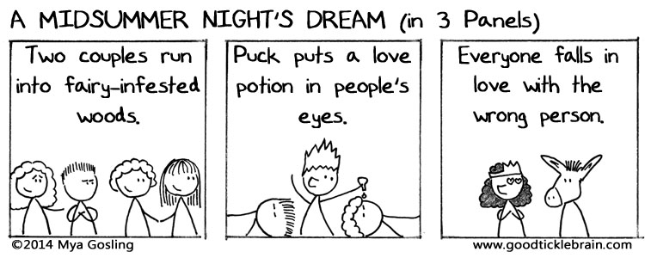
* The following video EDITED (There IS some swearing and a tad bit of violence in this video link. For purposes of showing in class it must be edited.): <https://www.youtube.com/watch?v=dihWoH1j0nI>
  + [Edited Video](https://drive.google.com/file/d/0B-nwBKuJZH7NMHFDRUl4ZlZJdHM/view?usp=sharing) (Google Drive)
* A copy of the “Shakespeare Re-Telling Instructions” handout for each student

**DAY PLAN:**

**“Take Action”:** What time period do you think it might be interesting to set a Shakespeare play in?

**Lesson Plan:**

Before class starts display the comic shown above on the projector. This will help them start to think about simplifying Shakespeare’s stories.

* + There are many of these three panel Shakespeare comments by the same artist. Any will work as long as the students are fairly familiar with the story. (When this was originally taught we had already taken time to talk about *A Midsummer Night’s Dream* as a class.)

Discuss the Take Action, what are some of the time periods that you put down?

* + Why do you think those time periods would be interesting for Shakespeare?
  + If someone put the modern time period, ask them how a man writing 500 years ago could really connect with them today?

Show the following video (or another one that fits): <https://www.youtube.com/watch?v=dihWoH1j0nI>

* + NOTE: There IS some swearing and a tad bit of violence in this video link. For purposes of showing in class it must be edited.
  + This video presents a few different types of Shakespeare adaptations in movies.
  + Have them reflect on the video:
    - Which adaptations did you find interesting?
    - What made it interesting?
    - These are only a few of the adaptations that exist. Why do you think so many adaptations of Shakespeare’s work exist?

Their goal for this coming assignment is to create their own adaptation of one of Shakespeare’s plays. They can choose any of the plays that they wish. (If there are any restrictions on plays, let them know at this point.)

Give each student a copy of the “Shakespeare Re-Telling Instructions” and take time to go over the purpose and requirements of the assignment with them.

Have students choose their group.

* + If there has been previous group work in the class, invite them to mix it up and not work with the same people. If the instructor feels they can’t do that, assign them to groups.

For today students will only have time to get into groups and choose a few plays to look at as a group.

For now, students can just look at quick summaries if they are not sure which play they want to use but they will need to read a more fleshed out version of the story in a future class.

* + Options for resources in class:
    - If the school has Chromebooks in the classroom, student groups can grab one for their group to start looking for Shakespeare’s stories.
    - Depending on the school it may be an option to go to a computer lab or the library to find the summaries or stories.
    - If the drama classroom has versions of Shakespeare’s stories available for student use, that option would be best.

**Closure:** Bring all the students back together and explain that they are going to complete a journal entry. Have the following questions written on the board:

* Why do you think that we are doing this with Shakespeare’s plays?
* Why would we want to perform the stories of these plays without the original text?
* What do we have to gain from this exercise?

Have students take out a blank piece of paper (and put their name on it!) and write their answers in complete sentences. They only need to write one paragraph, but they need to answer all three of the questions.

**Shakespeare Re-Telling Instructions**

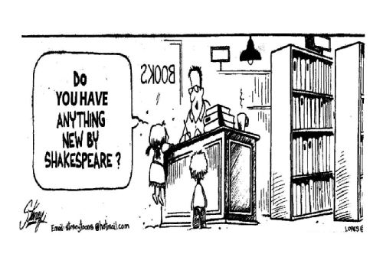

Once your group has chosen a play: read the play in its entirety in some way. This means they can read the original text, a story version of the play, or a very complete, detailed synopsis. The version you read MUST have all of the plot points included.

The next step will be choosing a setting. (You will not be allowed to set your adaption in the Renaissance.) Think outside the box! You can choose ANYTHING. We want to make Shakespeare applicable to any world and show that it IS applicable to any time period or world without having to force it.

Once you have chosen a setting: casting, adapting, and rehearsing will be begin!

You will create a shortened version of the ENTIRE play. (The final performance will be **7-10 minutes**)

**What your rehearsal/creative process needs to include:**

* Read the play in its entirety in some form.
* Have each group member read an act of the play on their own and come back to share new discoveries with their group.
* Identify the theme.
* Choose a concept.
* Create an outline of your performance. This is not a presentation. It is a performance!! You are not required to create a full script but you will need to at least create a clear outline of what is going to happen and what each person is doing.
* Participate with your group in structured rehearsals.

**What the final product needs to include:**

* Participation of all group members.
* The important points of the story. (We’ll discuss this in greater detail)
* At least five actual quotes from the play (these need to be quotes of *substance*)
* A setting that is discussed, thought through as a group, and agreed upon by all group members.
* Props and costumes (if you so choose)

**LESSON #2:** Choosing a Play

**OBJECTIVE:** Students will be able to demonstrate their understanding of collaboration by choosing a Shakespeare story to re-tell as a group.

**TEXTS, TECHNOLOGIES, and MATERIALS:**

* The following comic:
  + 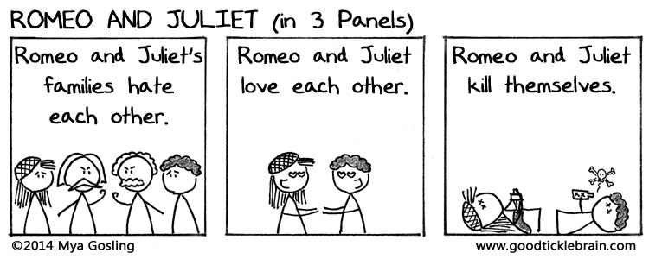
* Regular sized paper or craft supplies with which to make small posters.

**DAY PLAN:**

**“Take Action”:** Which plays did your group choose to look at? Which one do you think that you would like your group to do? Why?

**Lesson Plan:**

Let students know that by the end of the day their group should have chosen a play to use for their re-telling.

* + Let them know that they have the option of changing it before they start rehearsing if they discover they don’t want to work with their original choice.

This is a good time to talk to them about how the creative process works.

* + Most students will have tons of ideas for a concept and want to jump ahead to planning a concept before reading the play as a group. While it is great that they have so many ideas, try to stop them from jumping ahead.
  + While it is great that they are having so many ideas, they can’t work on those ideas and be sure they will be effective until they know their play inside and out.

Project the following questions for them to consider while they work as a group to decide on their story.

* + Questions to ask about the plays you are looking at:
    - What do we like about this story?
    - Is it one that we could re-tell with the group that we have?
    - What ways could we re-tell this story? Can we come up with anything off the top of our head?

Let them know they have exactly ten-fifteen minutes to continue where they left off yesterday looking at multiple Shakespeare plays, discussing the stories, and choosing one. (Depending on the class they may not need that much time. When this was originally taught the groups in the class had decided within five minutes.)

Students need to have one decided on by the end of the time limit given to them.

* + NOTE: No two groups should have the same play. While students are discussing and choosing in groups it’ll be up to the teacher to bounce from group to group and confirm that no two groups are choosing the same play.

Once the time limit for choosing is up, bring students back together and explain to them what they are going to do next. Before the end of class, each group will need to work together to create a small poster (on a normal sized sheet of paper) that demonstrates what play they have chosen.

* + The poster should have the title of the play they have chosen very clearly and easy to see.
  + The poster needs to show some creativity.
  + They can draw pictures, create the title as word art, have some quotes from the play (if they can find some really quickly), ideas they are already having for how to present the story, etc.
  + Students should make sure the names of everyone in their group are listed on the back of their poster.

For groups who choose a play and finish their poster quickly: they should begin reading a version of the play as a group. (As mentioned in lesson #1.)

* + Explain that the first step in this process is getting to know the play and before they can come up with a concept they need to read the play.
  + They MUST begin with reading the play before doing anything else so that everyone in the group is familiar with the play.

**Closure:** Using magnets, have each group put their poster on the whiteboard for everyone to see clearly. Take the last minute or two of class to allow everyone to view each other’s posters like a museum.

* Assign students to read the version of the Shakespeare play they have access to at home if they weren’t able to read through an entire summary today! They will need to be familiar with it for tomorrow’s activities.

**LESSON #3:** Discovering the Theme

**OBJECTIVE:** Students will demonstrate their basic understanding of theme by creating a “Three Panel Shakespeare” comic based around their decided theme of their play.

**TEXTS, TECHNOLOGIES, and MATERIALS:**

* The following comic:
  + 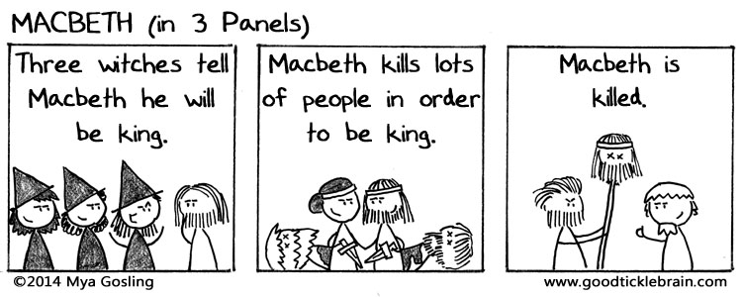
  + A stop watch or other timing device.

**DAY PLAN:**

**“Take Action”:** What play did your group choose? What made you choose this play?

**Lesson Plan:**

Intro of “Theme”: Snowball activity:

* Write “theme” on the white board before the start of class.
* Have students take out a blank piece of paper and write for 30-60 sec everything they already know about theme. They should *not* write their name on this piece of paper.
* Hopefully most of them have a basic understanding of what a theme is or have at least learned about themes before in English classes.
* After they have written, invite students to crumple up their piece of paper and toss it to some area of the room (specifically chosen by the teacher).
* Once each student has thrown their paper, have each student go and retrieve a paper ball that is not their own to read and share with the class.
* Write the following definition on the board: the subject of a talk, a piece of writing, a person's thoughts, or an exhibition; a topic. (dictionary definition)
* Go around the room and have each student read what is written on the paper they picked up. Have that student identify if what is written agrees with the basic definition given on the board or does not.

By the end of the day students should have decided on a theme for their play.

* Although there isn’t really a right answer to the question: What is the theme? (Most of Shakespeare’s works have multiple themes especially depending on who produces them) The theme should be well thought out and have meaning to the audience who views the piece. For example: *Comedy of Errors* is not just there to be funny, what is a more meaningful theme?
* Another way to help them understand:
  + What’s the point of the story?
  + What is it about ________ that people enjoy? (They must enjoy it, theatres keep performing it!)

Theme Activity: Half-life: this is a game that is meant to help students get to the bare bones of their play. What is the play really about? Once they can get the play to its simplest form, they should be able to discover the theme.

* Have students break up into their groups for their retellings. Make sure they spread out around the room. (They don’t need a huge space to work but it might be a good idea to have the room clear of tables and chairs if possible and depending on the room.)
* Students will improvise their entire play (on their feet, performing) in increasingly shorter times. No-one should be watching any other groups at this point because all the students should have their focus on their own story.
* Using a timing device, give them a heads up how much time they have and don’t give them any time to prepare, this should all be thinking on their feet.
  + 2 min.
  + 1 min.
  + 30 sec.
  + 15 sec.
  + 7 sec.
  + 3 sec.

Once they have done each of the time lengths, have students sit down with their group and discuss the following:

* What is really important in our story?
* What do we think the theme is?

Three Panel Shakespeare:

* Now that the students have seen a few different three-panel Shakespeare comics, they should have a good idea what they consist of.
* Each group needs to create ONE three-panel comic of their play.
* Although they only need to turn in one for their group, each member should help contribute to the comic by discussing what each of the panels should contain. (This should be based on what they just barely discussed.)
* Underneath their comic they need to write their chosen theme that they also discussed in the previous activity.
* This will need to be turned in by the end of the day and will be worth 20 pts.
* This assignment will help the instructor see if each group has a basic understanding of their play and the purpose of the story.

**Closure:** Have each group turn in their comic. Bring all the students back together and ask: What was the purpose of today’s activities?

* Both assignments should help students understand their play better AND help them to reach a theme. As they minimize their play as much as possible they should begin to see what the most important aspects of the play are. The most important aspects with help them with their adaptation and helps guide them to the theme they think stands out.

Homework! Remind the students that they don’t often get homework in the class so they need to do their best to make this happen. (This can be assigned a few days before based on the class dynamics so they have more time to complete it.) Each group should have at least five people in it. For homework, each student needs to take an act from their group’s play to read in the original text. (A great resource is *No Fear Shakespeare*: nfs.sparknotes.com)

* A really quick and easy way to organize this is to have each group stand in a line and have each student figure out what position they are in line (1st, 2nd, 3rd, etc.) The first person in line will take Act I, the second will take Act II, and so on.
* Suggest that students pull a quote from each of their scenes that they think might work in their performance. They don’t have to do this, but they *are* required to use at least five quotes from the original text and this would definitely help their group as they prepare their performance.
* This reading is due in Lesson #5

**LESSON #4:** Deciding on a Concept

**OBJECTIVE:** Students will demonstrate their understanding of brainstorming as a group to choose a concept by discussing various concept ideas in their group and documenting their discussion.

**TEXTS, TECHNOLOGIES, and MATERIALS:**

* The following comic:
  + 

**DAY PLAN:**

**“Take Action”:** What setting or time period do you think would be interesting/exciting for your group’s play?

**Lesson Plan:**

Display the above comic before class starts so that all the students have a chance to see it when they come in.

Upon completion of the Take Action and attendance, have the students turn to the person next to them and share their reactions to the comic, give them about half a minute to do so.

* Once they have had a chance to share, invite them to share anything really interesting they talked about with the class.
* Have students discuss the following at their tables:
  + Because Shakespeare is dead, we can’t really have anything NEW by him. But how can we make Shakespeare new?
  + Why is Shakespeare still being performed after all these years if all the stories are the same every single time?

Through the discussion, they likely have landed on the idea that even though Shakespeare’s stories don’t change, we can tell the stories differently.

* Make the following claim: even though Shakespeare’s stories were written hundreds of years ago, they are still completely relevant and relatable to our lives and experiences today which is why they can be told differently and still work.
* That’s the point of this unit, they don’t have to take the teacher’s or anyone else’s word for it. Their job is to experiment and prove it themselves.

Today students will be finalizing a concept for their re-telling of their chosen play.

Ask students: If you hear someone say they have a concept for a production or a play, what do you think they mean by “concept”?

* Explain to them that a concept is the idea behind the whole design of the show. This will help them develop a very basic understanding of a production concept.
* For example: If I wanted to produce Macbeth in the world of Star Wars, Star Wars would be my concept. Every part of the design would need to come back to the Star Wars world.
  + NOTE: For the purposes of this unit, the students will simply gain a simple understanding of a concept with the focus of their definition being on the setting or style of the story. The teacher should help them understand that as they move on in theatre, concepts will become even more complex and tend to delve into abstract ideas more than just the surface level of just a setting or world of the play

Explain the following guidelines for choosing a concept:

* Everyone in their group needs to agree on the chosen concept.
* Talk out the basics: What will this look like in practice? Will it work for all of the important parts of the story? Does the concept fit the story or do you have to make the story fit the concept?
* Try not to go with your very first idea (at least not without some tweaking). Brainstorming should be a process and should lead you to the final idea.

Let students know that they are going to have some time to discuss with their group what concept they would like to use for their play. There will be an order for their discussions and brainstorming projected at the front of the class. They need to follow this order.

* Have students split up into their groups.
* Project the following instructions on the board:
  + 1. Have each person in the group share what their answer was for the Take Action at the beginning of class. Everyone should have a chance to share their ideas.
  + 2. Have a scribe write down each person’s idea. (Feel free to use different scribes throughout, just one person doesn’t need to write the whole time.)
  + 3. Talk about each idea and answer the following questions about each possible concept (have the scribe take notes on the discussion for each question):
    - Does this concept fit our play? Why or why not?
    - Will it work for the whole story or just parts?
    - What do we like about it? What do we dislike about it?
  + 4. Once you have discussed each idea, decide as a group on the concept that works the best for your *story.*
  + 5. Write your chosen concept on the bottom of your brainstorming page and write down at least TWO justifications for why you chose this concept.
  + 6. Make sure each of your group member’s names are on the paper and turn it in.

**Closure:** Remind students to read the act of their play that was assigned to them a couple days before! They will be required to report on their reading the next day. Remind them about the *No Fear Shakespeare* resource. Most acts would only take about a half hour to read using that resource available to them.

**LESSON #5:** What’s important?

**OBJECTIVE:** Students will be able to demonstrate their understanding of their group’s Shakespeare story by creating an outline of the important plot points of their play.

**TEXTS, TECHNOLOGIES, and MATERIALS:**

* The following meme (displayed at the beginning of class):
  + 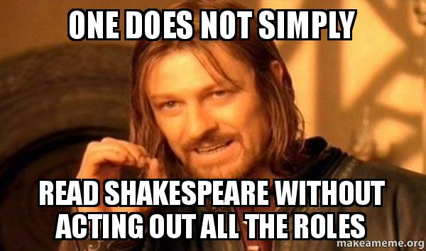

**DAY PLAN:**

**“Take Action”:** What do you like about the concept your group chose?

**Lesson Plan:**

Start the class by asking students how many of them were able to do the reading. Invite them to hold up their hands to show the percentage they were able to read. (Ex. Five fingers for 50%) Let them know they will need to turn in a written percentage later for points.

Take a minute to connect the meme above to the purpose of the reading:

* + What is the point of the meme?
  + How can reading the roles out loud help you understand the play?
  + How does re-telling Shakespeare’s plays help you understand them better?
    - Can you re-tell a play without knowing what happens in it?
  + How could you do this project *without* reading the play?

Today students are going to create basic outlines of their play! They will do more detailed outlines directly correlated to their production later but the outlines for today should be basic outlines with all the important plot points that they think they need to include in their performance from the original story. Once they have this outline they will be able to adapt it to their concept.

* Make sure to explain all the instructions before the class splits into their groups.
* Once they are in their groups the first thing they need to do is write down on a piece of paper: The names of the people in your group and the percentage of each act each person read. Once they have done this they should immediately turn it in so they can more on. Give them about two minutes to complete this.
* In your groups, discuss the Act you each read and share the quote you pulled from your assigned act if your group chose to do that.
  + Each person should take a few minutes to share with their group:
    - The important plot points in their act.
    - Something new they learned about the play.
    - The quote they pulled from their act that they think would be good to use in their retelling.
* Create an outline (written down) of all the important points of your play that you think need to be included in your adaptation. This will help you to form the outline for your story with your concept tomorrow. Today the outline is just about the play itself.

**Closure:** Bring the class back together and make sure that all the groups have turned in their reading percentages. They need to turn in their outlines. Take a few minutes to go over the rest of the unit with them and how it’s going to work. Talk through with them the process so they understand what will be expected and how long they have before they perform. Because this is about halfway through the unit, this time at the end of class would be a great opportunity to ask if they have any questions or confusion about their projects that have not been answer throughout class.

**LESSON #6:** Outlines and Concepts

**OBJECTIVE:** Students will be able to demonstrate their understanding of how to incorporate a concept with a story by creating an outline of their group’s retold story.

**TEXTS, TECHNOLOGIES, and MATERIALS:**

* The following meme (displayed at the beginning of class):



**DAY PLAN:**

**“Take Action”:** What are three important plot points in your play?

**Lesson Plan:**

Remind students, referring to the meme above, that their performance doesn’t need to be completely the same as their Shakespeare story as long as the same idea and the same theme is there. Help them remember the video shown on the first day of the unit. One of the movies included was “The Lion King” which is considerably different from the original story of *Hamlet*. The idea is to get the essence of the story. (Take an opportunity to discuss what the essence of a story might mean if they don’t seem to understand. Connect the idea back to the theme.)

Now that students have written a basic outline of their story, they are ready to really dig in and start creating their own version.

* Return the outlines they completed yesterday.
* By the end of today they should have done the following:
  + On a piece of paper write down the names of every group member and the name of your play (or what you are naming the adaptation).
  + Next, write down the theme of the play and the concept you have chosen.
  + Take the outline you created yesterday and (on the same paper you’ve just started) create a nice LEGIBLE outline of your version of the play using your chosen concept. You will turn this in at the end of class.
  + Cast the show. Keep in mind how few people there are in your group and cast accordingly.
    - During the casting process you may need to cut out some characters that you find may be less important for your version of the story.

**Closure:** Five minutes before the end of class have students turn in their outlines and come back to their seats. Talk them through how the next few days are going to go. The next two days will consist of stations they will rotate through to help them prepare their performance. The day following will be a day where they need to rehearse everything they have worked out thus far so they can run through their performance as many times as possible. There will be a preview day for another group to watch and give feedback, one day of tweaking, and then the performance days!

* At this point some students may be worrying a lot about the short amount of time they have to rehearse. Make sure they understand that the point of this exercise is less about having a perfect performance and more about introducing everyone in the class to a variety of plays and learning how applicable Shakespeare’s works can be. They are allowed to have notes in their hands, they are allowed to improvise a little, it can be a bit different every time they perform it (while keeping within the time limit), and the performance can be rough. But the story needs to be there. They will have plenty more to memorize later in the semester, for now just have fun with this and create the best performance you can in the short amount of time.

**LESSON #7 & #8:** Rehearsal Stations I & II

**OBJECTIVE:** Students will be able to demonstrate their understanding of effective rehearsal practices by completing a rehearsal station worksheet while working their group’s performance.

**TEXTS, TECHNOLOGIES, and MATERIALS:**

* The following meme to project at the beginning of class on the first day:
  + 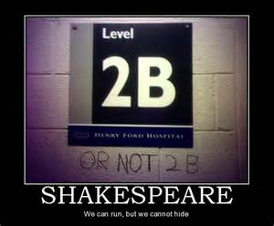
* The following comic to project at the beginning of class on the second day:
  + 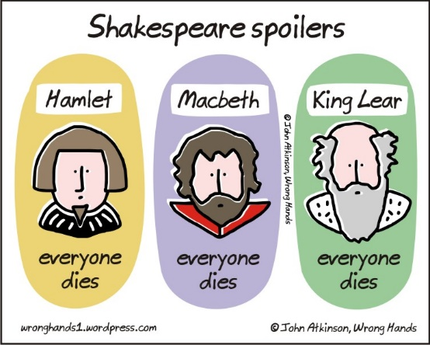
* Copies of the rehearsal station worksheet for each group.

**DAY PLAN:**

**“Take Action” #1:** What character(s) are you playing in your group’s performance?

**“Take Action” #2:** What was one thing you developed with your play yesterday?

**Lesson Plan:**

There will be five different rehearsal stations. (I did one per group, depending on class size there may be a need for more stations) Put the station numbers, along with a page listing the instructions around the room in a circle so they are easy to see and rotate through.

* Students will have 12 minutes at each station to complete the tasks and to complete the portion of the worksheet for that station. Everyone in the group should be involved at each station.
* Give each group a station worksheet (see end of lesson) and give them a minute or so to put the names of their group members and the title of their performance on the page.
* Assign each group on a station to start and let them know how much time they will have at each station. Give them something so they know when time is up at each spot, like a bell ringing or some kind of alarm. Once time is up at their station they will need to rotate to the next station in order, whichever one comes next.

Rehearsal Stations (with instructions to be displayed):

* **Station #1: Characters**
  + Make sure every person in your group knows the character(s) they are playing.
  + List on your paper who is playing which parts.
  + Walk through the outline you created yesterday and confirm that the actor/character assignments work out within the story.
  + If needed, make adjustments.
* **Station #2: Theme and Concept**
  + What is your Theme?
  + What is your concept?
  + Why did you choose the concept you did?
  + Talk through your outline and make sure every plot point works within your chosen concept.
  + Discuss what might need to be changed in the plotline of your story in order to help the story fit better within the concept.
  + If there is still time, start running through your story on your feet and make sure the concept works in practice.
* **Station #3: Story Structure**
  + Exposition: Also known as the introduction, this introduces the characters, their relationships, the setting, and any previous information needed for the story.
  + Point of Conflict: The point at which the main problem of the story begins or is introduced.
  + Rising Action: The exciting bits that build up to the climax. (For this choose one main part of the rising action)
  + Emotional Climax: The highest or most intense part of the story.
  + Falling Action: The less exciting bits that lead to the end. (For this choose one main part of the falling action)
  + Denouement: The part where everything is wrapping up. (again, choose one main point)
  + Resolution: How the story ends and all the complex bits get resolved.
  + 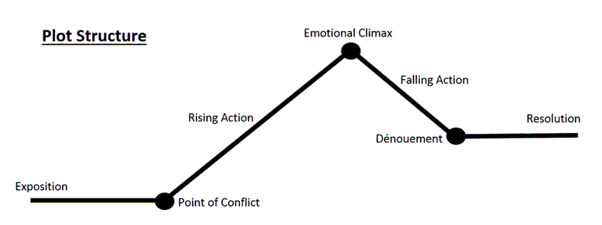
  + Using the definitions above, fill in each part of your groups story on your worksheet that correlates with each spot on the diagram.
  + Confirm that the story makes sense according to the plot structure diagram given. Make any changes if the story doesn’t flow.
  + Once completed, run through each of those seven points in your story on your feet.
* **Station #4: Outline and Length**
  + Run through your outline on your feet and time it. (You may use a phone to do so.) Write down your time on the worksheet.
  + If your performance is less than 7 minutes you need to add time. If it’s more than 9 minutes (at this point in the rehearsal process) you may need to cut some time. (Make sure you circle which you need to do on the worksheet.
  + In a group create a plan for what you will change in order to fix the time. List at least three parts of the story you will work on or edit out.
  + If you are more than 7 minutes but less than 9, congratulations! Write down three parts of the story you are going to focus on that you think need more work at this point in order to keep the time the same for each run.
* **Station #5: Body and Voice**
  + Discuss the following as a group:
    - Are we going to use different voices than our own to portray the characters?
    - Are we going to move differently depending on the character we are playing?
    - Start running through your story and play around with how you are going to move your body and how you are going to use your voice. (If you don’t get through the entire thing that’s okay, this is just so you can start to experiment.)

**Closure:**

Day 1: Students should finish their last rotation a minute or two before class ends. Have them turn in their worksheet so that no-one can lose it before tomorrow.

Day 2: Students should have about ten or fifteen minutes left in class. Have them take everything they have worked on over the past two days and put it all together. They should rehearse their full story together with voice, body, the additions they discussed, etc. Once they are done they need to turn in their completed worksheet.

**Rehearsal Stations**

**Group Members:**_________________________________________

**Title:**_________________________________________________

**Station #1:** Characters

_________________ will be playing _____________________________.

_________________ will be playing _____________________________.

_________________ will be playing _____________________________.

_________________ will be playing _____________________________.

_________________ will be playing _____________________________.

_________________ will be playing _____________________________.

**Station #2:** Theme and Concept

Theme: __________________________________________

Concept: ________________________________________

How does your chosen concept support the theme?

_______________________________________________________

What do you need to change in your story so that the story flows better within your chosen concept?

_______________________________________________________

_______________________________________________________

**Station #3:** Story Structure

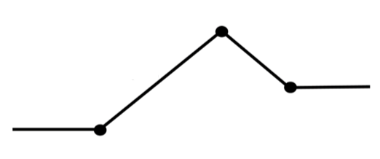



**Station #4:** Outline and Length

Time: _______________

We need to (circle one) **ADD SUBTRACT**  **KEEP**.

We will work these three plot points in order to do so:

1._____________________________________________________

2._____________________________________________________

3._____________________________________________________****

**Station #5:** Body and Voice

(Check the boxes once you have completed each task.)

* We discussed what voices we are going to use for our roles.
* We discussed how we will move our bodies in order to best portray the story.
* We ran through as much of our story as possible using the body and voices we discussed.

**LESSON #9:** Using the Work (Rehearsal Day)

**OBJECTIVE:** Students will be able to demonstrate their understanding of effective rehearsal by rehearsing on their own and providing a written account of what they were able to accomplish.

**TEXTS, TECHNOLOGIES, and MATERIALS:**

* The following meme to display at the beginning of class:
  + 

**DAY PLAN:**

**“Take Action”:** What was one thing you developed with your play yesterday?

**Lesson Plan:**

Today students are going to take everything they have worked on over the past couple days of rehearsal and smash it all together to create a fantastic performance!

* What is a fantastic performance?
* Take the final rubric (at the end of this unit) and walk through it with the class. This can either be printed out or simply projected.
* They should already have a basic idea of the expectations, but this should help them see the specifics of what is being looked for in their project.

Point out that, like the meme displayed, they are all doing what Shakespeare did as he created his works. They are being given the opportunity to be inventive and creative. After all, for the majority of his plays (if not all of them) Shakespeare took stories that were well know and re-created them. Not only that but he made them his own by inventing words and creating changes to the stories that made them relatable to the people at the time.

Remind students that they have today, one preview day, and one last day of rehearsal before they perform for the whole class.

* While today is a general rehearsal day, let them know that they will have to report at the end of class what they personally improved. Not what the group worked on, but what they individually did.
* Although today is a fairly open rehearsal day, they need to follow the guidelines given to them for their rehearsal. Project the following suggestions up front so everyone can see.
  + Run through your performance and focus on how your body and voice are telling the story.
  + Run through your performance and focus especially on the story line. Does the story make sense? If it doesn’t, focus on the parts that throw the story off and find ways to fix those parts.
  + Who in your group doesn’t have a very large part? How can you incorporate their characters into the story more?
  + What props or costumes will you need for your scene? Who will bring them? Can they all be incorporated in the next few days or should you try to simplify?
  + What part of your performance is NOT ready for an audience tomorrow? What can you do today to make it ready?

**Closure:** About five minutes before the end of class time, have the students pause and write down three things that they personally improved on for their group performance today. They can use just a piece of lined paper for this. Once they have completed the task, they need to turn in the paper.

**LESSON #10:** Preview Day

**OBJECTIVE:** Students will be able to demonstrate their understanding of giving and receiving feedback by watching another group’s performance and providing verbal feedback and vice versa.

**TEXTS, TECHNOLOGIES, and MATERIALS:**

* The following comic:
  + 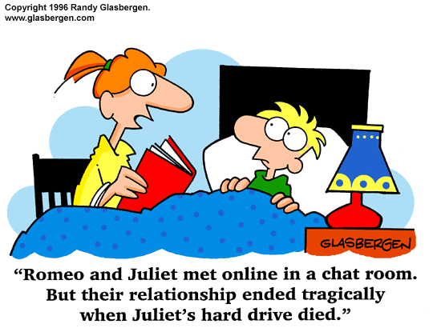
* Preview sheets for each person.

**DAY PLAN:**

**“Take Action”:**  What is a goal that you personally have for your group’s preview today?

**Lesson Plan:**

Display the comic above at the beginning of class.

* Take just 2-3 minutes at the beginning of class to apply the comic to what they are doing. This is very clearly a different version of *Romeo and Juliet* and it makes some changes. Juliet doesn’t actually die but her hard drive dies. Think about what in your performance is *exactly* like the original.
  + - Does it have to be? How could you tweak it a little bit based on your concept?
    - How is your version of the story going to connect with our class?

Explain that today is preview day. They will be performing their re-telling for another group. The layout of the day should look like this:

* Before they pair up, explain that the feedback they give each other today will be based on the rubric they will be graded with. Project these requirements with them. They should be familiar based on earlier lessons, but they will need a reminder.

Pass out the forms they need to use to give feedback. Let them know that the feedback they give to the other group should be based on the rubric information given to them on the projector:

* + *Basic Requirements:* The expectation in this category is that students followed the basic requirements of the project. Each group should have five quotes directly from the original text of their play and their performance should be within 7-10 minutes. Quotes are worth 4 points each and being within time is 5 points. If they are under time, take off a point for each minute under and if they are over by more than a minute, take a point off for each minute 30 seconds they are over.
  + *Theme:* The expectation in this category is that students understand the theme of the original story and the theme they identified comes through in their re-telling. (They previously identified their themes on the day of rehearsal stations, use the worksheets they filled out as a reference when grading.) Is the theme still clear even though the story is slightly different?
  + *Concept:* The expectation in this category is that the concept was well thought out and the story was adapted to fit the concept. Did the concept fit the storyline? What could have been worked on to create a stronger connection between the storyline and the setting/concept?
  + *Story:* The expectation in this category is that the group remained true to the original storyline even if multiple changes were made. Like modern adaptations of these plays, is the original story still apparent to the audience? Does the story make sense: does it have a beginning, a point of conflict, a climax, falling action, and a conclusion?

Groups pair up (if there is an odd number maybe one can go with two other groups or they can pair up with the teacher).

* They decide which group will go first.
* Before any feedback is given, both groups should perform to make sure there is ample time for both groups to be seen.
* Once both groups have performed there should be about 15 minutes left in the class.
* Once each group has spent five minutes giving the other group feedback, the last five minutes should be spent with their own group creating a plan for what feedback they will focus on during their rehearsal the next day.

**Closure:** Remind students that they have only one day more to prepare their performance to be done in front of the whole class. Tomorrow they will have the opportunity to put as much of the feedback into practice that they can.

**Shakespeare Retelling Preview:**

**Your Name: _____________________________**

**What play did you preview? ________________________________________________________________**

**What are two aspects of the performance you enjoyed?**

**________________________________________________________________**

**________________________________________________________________**

**What are two aspects of the performance they could improve?**

**________________________________________________________________**

**________________________________________________________________**

**Share your feedback with the group so that they can improve!**

**Shakespeare Retelling Preview:**

**Your Name: _____________________________**

**What play did you preview? ________________________________________________________________**

**What are two aspects of the performance you enjoyed?**

**________________________________________________________________**

**________________________________________________________________**

**What are two aspects of the performance they could improve?**

**________________________________________________________________**

**________________________________________________________________**

**Share your feedback with the group so that they can improve!**

**LESSON #11:** Finishing Touches

**OBJECTIVE:** Students will be able to demonstrate their understanding of incorporating feedback they have been given into their performance.

**TEXTS, TECHNOLOGIES, and MATERIALS:**

* The following comic (again, to be displayed at the beginning of class):
  + 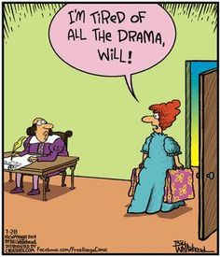

**DAY PLAN:**

**“Take Action”:** What is one item of feedback you received yesterday that you can incorporate into your performance?

**Lesson Plan:**

Remind students first thing that they are going to perform tomorrow! Right at the beginning of class the performances will start.

As such, today is their last day to rehearse. Again, give them the option to work independently with their group without rehearsal stations but give them a few questions they should be thinking about during their rehearsal today:

* What do you need to change or work on in order to feel ready to perform?
* What were at least TWO pieces of feedback that the other group gave you yesterday?
  + What do you need to do in order to improve on these things?
* What do you need to bring tomorrow for your performance? (costumes, props, etc.)? WHO is bringing those items?
* If you feel like you have worked through all these questions in your performance, take time to run through your whole performance and make sure it is within the time limit (7-10 minutes).

**Closure:** Let students know that they are going to have a few minutes at the beginning of class tomorrow to get into costume and re-group to make sure they are ready to go but then the performances will begin. Remind them of the expectations and the goal for this unit. With these performances they should be trying to prove that Shakespeare is relatable. The emphasis is on the story and the concept, not on the acting ability (because they haven’t really had the time to create a perfect polished performance). Remind them to have fun!

**LESSON #12-#15:** Performance Days

**OBJECTIVE:** Students will be able to demonstrate their understanding of Shakespeare’s stories and themes by re-telling one of his plays in a dramatic stylized adaptation for the rest of the class.

**TEXTS, TECHNOLOGIES, and MATERIALS:**

* Additional three panel Shakespeare comic strips, one per day, to display at the beginning of class.
  + Found at [goodticklebrain.com](https://goodticklebrain.com/shakespeare-index/#/three-panel-plays/) (use ones that correlate with the plays your class is re-telling)
* a feedback page for each student (show at the end of the lesson titled Student Notes)
* a teacher rubric for each group
* a stopwatch or something else to keep time

**DAY PLAN:**

**“Take Action” #1:** On a scale of 1-10, how ready do you feel to perform?

**“Take Action” #2:** How do you feel like this process has helped you to better understand

Shakespeare’s works?

**“Take Action” #3:** Which performance have you enjoyed the most thus far? Why?

**Lesson Plan:**

Each day of performance will follow the same basic outline:

* Give each student a Student Notes feedback page and have them put their name on it first.
* Identify the order that the groups are going to perform in: for our class we chose to perform them in the order that Shakespeare wrote each of the plays that were being re-told.
* On the first day of performances (if students seem to need it) give them about 5-10 minutes to re-group and make sure they are all set to perform.
* After each group performs, take time for the following:
  + Give students in the audience a chance to give verbal feedback.
  + Make sure students don’t jump into negative feedback. Help them *focus* on the actual questions they are writing down the answer to: What did they *enjoy* and what could be changed (not to improve the actual performance) so the concept fit the story better?
  + Give a couple of similar notes from your own rubric.

**Closure:** (End of last day) Congratulate students on a job well done. Give them a few minutes to fill out the last two questions on their feedback form. Take the opportunity at the end of class to wrap up the unit and discuss any of the following with students:

* What was something new you discovered about Shakespeare? (they should have already written an answer down!)
* How do you feel your understanding of Shakespeare has grown?
* Was it easy to put Shakespeare’s stories in a different context, why or why not?
* Do you think Shakespeare is applicable today?

Your Name: _________________________________

**STUDENT NOTES/FEEDBACK**

*(Students need to answer the following questions about each individual group)*

**Group #_______:**

**PLAY TITLE:**

**THEIR CONCEPT:**

**What is the point of their story? (theme)**

**What did you enjoy about their version of the story?**

**What do you think could have been changed so the concept better fit the story?**

**Group #_______:**

**PLAY TITLE:**

**THEIR CONCEPT:**

**What is the point of their story? (theme)**

**What did you enjoy about their version of the story?**

**What do you think could have been changed so the concept better fit the story?**

**Group #_______:**

**PLAY TITLE:**

**THEIR CONCEPT:**

**What is the point of their story? (theme)**

**What did you enjoy about their version of the story?**

**What do you think could have been changed so the concept better fit the story?**

*(Below to be answered after all the performances are done)*

**Now that we are done with all the performances, what is something NEW you discovered about Shakespeare?**

**List each person in your group and give them a rating on a scale from 1-10. A score of 1 would mean they didn’t contribute at all to the work of preparing and performing. A score of 10 would mean they went above and beyond and contributed a ton to the preparation AND performance. (Include a rating of yourself as well and please justify the score you give yourself.)**

**FINAL RUBRIC for SHAKESPEARE RE-TELLINGS**

Use the rubric below to give scores. The large empty boxes are for feedback notes for each category to identify why points were lost.

*Basic Requirements:* The expectation in this category is that students followed the basic requirements of the project. Each group should have five quotes directly from the original text of their play and their performance should be within 7-10 minutes. Quotes are worth 4 points each and being within time is 5 points. If they are under time, take off a point for each minute under and if they are over by more than a minute, take a point off for each minute 30 seconds they are over.

*Theme:* The expectation in this category is that students understand the theme of the original story and the theme they identified comes through in their re-telling. (They previously identified their themes on the day of rehearsal stations, use the worksheets they filled out as a reference when grading.) Is the theme still clear even though the story is slightly different?

*Concept:* The expectation in this category is that the concept was well thought out and the story was adapted in order to fit the concept. Did the concept fit the storyline? What could have been worked on to create a stronger connection between the storyline and the setting/concept?

*Story:* The expectation in this category is that the group remained true to the original storyline even if multiple changes were made. Like modern adaptations of these plays, is the original story still apparent to the audience? Does the story make sense: does it have a beginning, a point of conflict, a climax, falling action, and a conclusion?

Play Title:

|  |  |  |  |  |
| --- | --- | --- | --- | --- |
|  | Basic | Theme | Concept | Story |
| Students: |  |  |  |  |
| Total: /100 | /25 | /25 | /25 | /25 |