**Shakespeare Re-Telling Instructions**

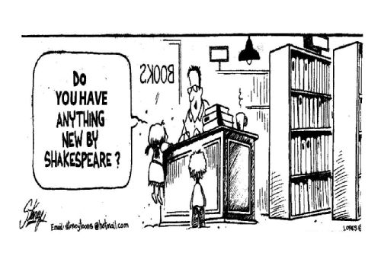

Once your group has chosen a play: read the play in its entirety in some way. This means they can read the original text, a story version of the play, or a very complete, detailed synopsis. The version you read MUST have all of the plot points included.

The next step will be choosing a setting. (You will not be allowed to set your adaption in the Renaissance.) Think outside the box! You can choose ANYTHING. We want to make Shakespeare applicable to any world and show that it IS applicable to any time period or world without having to force it.

Once you have chosen a setting: casting, adapting, and rehearsing will be begin!

You will create a shortened version of the ENTIRE play. (The final performance will be **7-10 minutes**)

**What your rehearsal/creative process needs to include:**

* Read the play in its entirety in some form.
* Have each group member read an act of the play on their own and come back to share new discoveries with their group.
* Identify the theme.
* Choose a concept.
* Create an outline of your performance. This is not a presentation. It is a performance!! You are not required to create a full script but you will need to at least create a clear outline of what is going to happen and what each person is doing.
* Participate with your group in structured rehearsals.

**What the final product needs to include:**

* Participation of all group members.
* The important points of the story. (We’ll discuss this in greater detail)
* At least five actual quotes from the play (these need to be quotes of *substance*)
* A setting that is discussed, thought through as a group, and agreed upon by all group members.
* Props and costumes (if you so choose)