**Science Unit:** Electricity (static, circuit, magnets)

**By**: Soren Barker

**Unit Objective:** Students will be able to demonstrate their understanding and mastery of the basics of electricity while relying on intuition, curiosity, and critical inquiry, making strong choices to effectively convey meaning and, developing personal processes and skills for a performance or design to create and convey meaning through the presentation of moving images that embody concept of electrical current that we discussed in the unit.

**For grade level:** 5th Grade

**Prior Experience:** The kids have some experience with a drama specialist. They are very high-energy. A couple of the students have a hard time working together, so we’ll be careful of that.

**Utah Core/ National Theatre Standards**

**Standard 4** Students will understand features of static and current electricity.

**Objective 1** Describe the behavior of static electricity as observed in nature and everyday occurrences.

**Objective 2** Analyze the behavior of current electricity.

**TH:Cr3.1.5.c** Participate in defined responsibilities required to present a drama/theatre work informally to an audience.

**THPr4.1.5.b** Use physical choices to create meaning in a drama/theatre work.

**ThCn10.1.5.a** explain how drama/theatre connects oneself to a community or culture.

**Big Ideas:** Electricity is all around us. We are driven by attractions and repulsions.

**Essential Questions:** Why is electricity important to understand? How can we use what we know about electricity to help the WORLD?! What does electricity have to do with Drama work?!

**Key Knowledge and Skills:** Students will be able to understand features of static and current electricity.Describe the behavior of static electricity as observed in nature and everyday occurrences.Analyze the behavior of current electricity. Participate in defined responsibilities required to present a drama/theatre work informally to an audience. Use physical choices to create meaning in a drama/theatre work. Explain how drama/theatre connects oneself to w community or culture.

**Authentic Performance Tasks:** Students will be asked tocreating an image or work of art that shows a big idea that we discussed in the unit.

**Lessons:**

Lesson #1: Intro to Unit

Lesson #2: basics of electricity

Lesson #3: magnets

Lesson #4: static electricity

Lesson #5: basic circuits

Lesson #6: review of everything taught

Lesson #7: Creating circuits with their bodies (assessment)

**Lesson #1: Intro to Unit**

**Lesson objective:** SWBAT- demonstrate understanding of Vocabulary and historical/scientific information by teaching each other, asking questions and answering simple assessment.

**Materials needed:** -print out the following, then cut them so that each section is free and able to be distributed to a group in the lesson.

-A Thomas Edison article of clothing.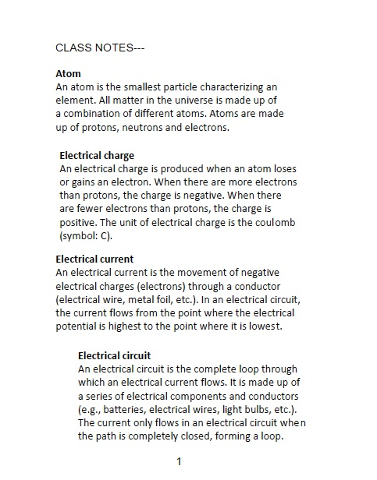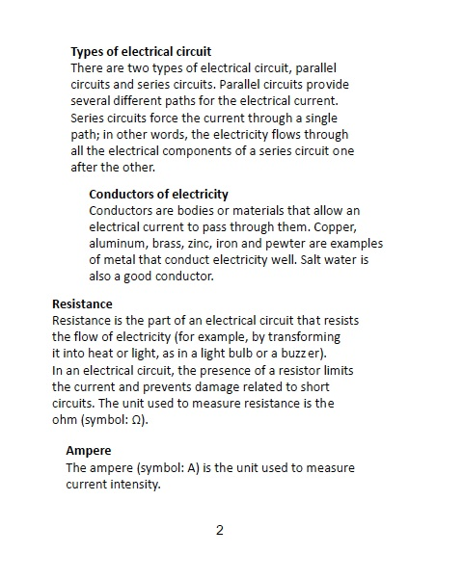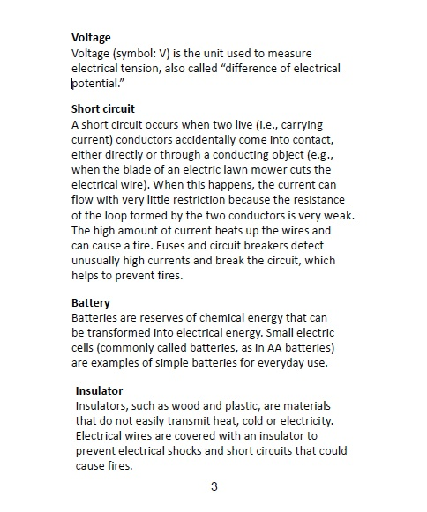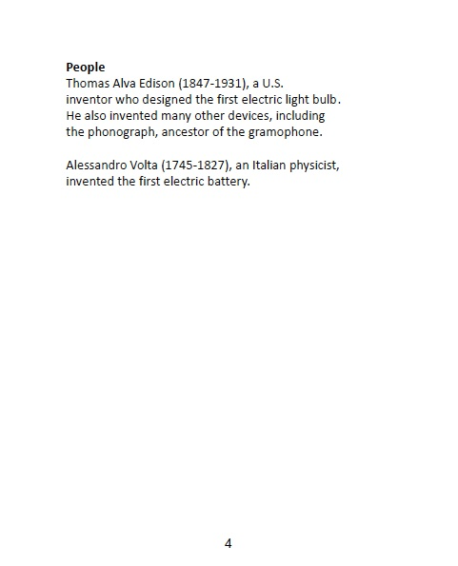

**Warm up/ Hook:**

* A good way to help students transition into this type of “students in role” work is to call role- but instead of just saying their names call out: “Doctor_____?” Once everyone has been accounted for you can use the following as a loose script to introduce them to the work we’ll be doing.
  + Welcome scientists! You are all here in this science lab because you applied for and got into the prestigious science center of electrical science. I understand that you are here to help better the world through electricity! Since you are fantastic and expert scientists I’m sure ***I*** don’t need to teach ***you*** what electricity is- So instead ***YOU*** get to do some scientific research and then teach ***US*** what you learned.
* Divide the class into 11 groups (that should be groups of two)
* Once the groups have been divided hand out a slip from the sheet you have printed off.
* Have them read and study the slip assigned to their group. This should take 3-5 minutes.
* Have each group pair up with another group- have the groups teach each other about their info.

Then have the group that learned the info teach the class what they learned- if they missed anything have the original group clarify.

The rest of the class should take note of the different parts and pieces involved in electricity!

**Transition:**

Set up that there will be a visiting expert coming to talk about electricity: Thomas Edison!

**Instruction:**

Explain that Mr. Edison will explain how he discovered / invented light bulbs. Tell the students that the visitor will talk for a bit, but then they should feel free to ask questions about the discovery process. Invite students to sit at their desks, set up a chair at the front of the class for the guest.

Put on some small article of character suggesting costume-POOF! You’re Thomas Edison! then give a brief report on his discoveries and process. The report should go something like this:

* I was an American inventor and businessman. I’ve been described as America's greatest inventor. I developed many devices that greatly influenced life around the world, including the phonograph, the motion picture camera, and the long-lasting, practical electric light bulb. I was even called "The Wizard of Menlo Park", I was one of the first inventors to apply the principles of mass production and large-scale teamwork to the process of invention, and because of that, I am often credited with the creation of the first industrial research laboratory.
* I was a prolific inventor, holding 1,093 US patents in my name, as well as many patents in the United Kingdom, France, and Germany. More significant than the number of my patents is the widespread impact of my inventions: electric light and power utilities, sound recording, and motion pictures all established major new industries worldwide. My inventions contributed to mass communication and, in particular, telecommunications. These include a stock ticker, a mechanical vote recorder, and a battery for an electric car, electrical power, recorded music and motion pictures.
* I died of complications of diabetes on October 18, 1931, in my home, "Glenmont" in Llewellyn Park in West Orange, New Jersey, which I had purchased in 1886 as a wedding gift for Mina. I was buried behind the home.
* My last breath is reportedly contained in a test tube at The Henry Ford museum near Detroit. Ford reportedly convinced my son Charles Edison to seal a test tube of air in the inventor's room shortly after his death, as a memento. A plaster death mask and casts of Edison's hands were also made. Mina died in 1947.

Have students ask questions. Encourage them to use the new vocabulary as much as possible.

**Modeling:**

Have students get sheets of paper and a writing implement. Have them brainstorm what kinds of inventions they think would help the world. Like Edison they should look at the world around them and imagine what could be improved through an invention. The following script should be helpful in framing this next section:

* Class! I am no longer channeling the Spirit of Thomas Edison. Whoa… That was crazy- right?! Now, what we are going to do is some creating and designing. Like TH.CR.3.5b talks about, we will “create technical elements that occur in rehearsal for a theatrical work. (e.g. lighting, sound, scenery, props, costumes, makeup, media)” But, in this case since you are scientists- yes, Doctor Jefferson you are a scientist- ok maybe you aren’t a certified scientist but, you are in this space and at this time! IT’S A THING!!! JUST GO ALONG WITH IT!!!!! You are going to follow the National Theatre arts standard TH.CR.1.5 c. and Depict how a character’s inner thoughts impact the story and given circumstances in a theatrical work. Imagine, if you will, that you are in the shoes of Mr. Edison- but, it is today- and you are a scientist! Think of something that you would invent that would make the world a better place! Now, draw it! Design it! Describe it!

**Practice:**

Monitor that students aren’t just goofing off- but are finding and recording ideas, images, explanations etc.

**Assessment:**

Ask for a couple of volunteers to share and idea or two. Do a couple vocabulary pop quiz questions- asking if they remember what voltage is, or some other concept from the vocab sheets.

**Lesson #2: Basics of Electricity**

**Lesson objective:** Students will be able to demonstrate understanding of basic circuits and electricity by creating a SIMPLE circuit with their bodies.

**Materials Needed**: A bag of cotton balls

**Warm up/ Hook:**

Hook: Tell them that the person who answers the most questions/ identifies the most examples of the following questions gets to be the line leader for the rest of the day regardless of normal scheduled routines! (Yes, this may seem harsh to the day’s line leader- but, life is hard and not always fair!)

These questions are meant to find out what students remember about electricity.

Ask:

* What is electricity?
* What is electrical current?
* What is an electric circuit?

Once they have identified these things tally up who answered correctly and announce the winner of this round.

* This will motivate the ones who didn’t participate to work harder to get an answer in.

Have them draw examples of electricity and electric circuits from their lives. The following script could be helpful:

* What examples of electricity and circuits do you recognize in your life? Can you draw on some of your experiences in this technologically saturated age and identify some of those things? I am so impressed with you! You all have done a wonderful job spotting the elements in your lives that use electricity!

**Transition**:

Tell students that they cannot see electricity because electrons, the charged particles whose movement through a substance creates electricity, are too small to be seen even with a microscope. When electrons flow through certain substances (like copper wire), they form an electrical current. Electrical current provides energy to power all kinds of things, from video games to refrigerators to cars!

**Instruction**: Act out an electric circuit, as follows: Ask students to join you in forming a circle. Tell students that you represent a battery and they represent a wire conductor. The circle represents a circuit. (Note: The word *circuit* comes from the Latin *circuitus*, which means "to go around.") Distribute an object -- like a ball, a book, or an eraser -- to each member of the circle, including you. Ideally, everyone should have the same object. Tell students that these objects represent electrons inside a wire conductor. Explain that a wire conductor is full of electrons.

Remind students that you (the teacher) are playing the part of the battery in this circuit, and explain that all batteries have a positive end, represented by your left hand, and a negative end, represented by your right hand. Pass your "electron" to the student on your right. The student receiving your electron should in turn pass the one he or she is holding to the right. Have students continue passing on electrons to the person to their right. Tell students that because electrons share the same negative charge, they repel one another, which keeps them moving along in the same direction. State again that the flow of electrons through a conductor is called electrical current.

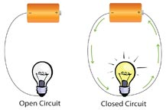

Draw the figure above upon the board and tell students that as long as the circle remains intact and the electrons continue to flow, their circuit is *closed*. To illustrate what happens when a circuit breaks, or *opens*, create a gap in the circle of students that is too wide across to pass electrons. The current will stop as a result.

Now have the students try to work together and have the circuit move as smoothly as possible. The following script may be helpful to you:

* Now, we’ve been messing around quite a bit! The cotton balls on the ceiling are evidence of that! So, now we are going to work together and make this as smooth as possible. Let’s try passing the balls to a beat. Here, I’ll count off- on “one” receive the ball in your right hand. On the “two” pass the ball to your left hand and into your neighbor’s hand. Ready? One- two one two one two one two… nicely done ladies and gentlemen.
* Now, I need a volunteer. Somebody with good projection and diction! Danny? You sure? Ok. You are now the scissors! You will not be in the circuit- you will select a portion of the circuit to cut and after the electrons are in a good rhythm and have been passed well pick a time to cut the line. When you do this slide your hands between where a pair of people would be passing a ball and say, “SNIP!”
  + When Danny does this we all have to stop! Ok?! Pay attention to Danny’s voice!
* Ok let’s try it, and as we do ***look for the connections between what we’ve learned today about closed and open circuits and this game****!*
* Well done! So why do you think we stopped passing when Danny said Snip- besides the fact that it’s the rule?

**Assessment**:

What did this game teach you about electricity and circuits? Are there any parallels between this game and real life? (Maybe when you are trying to talk to someone but they aren’t listening then the message is lost. etc.…)

**Source**: <https://utah.pbslearningmedia.org/resource/phy03.sci.phys.mfe.lp_electric/electric-circuits/>

**Lesson #3: Magnets**

**Lesson objective:** Students will be able to demonstrate an understanding of magnets and the dramatic concept of compel and repel- by participating in a pop quiz, and through actively engaging in activities.

**Materials Needed:**

Something to project a video on.

Something to access a video with.

5-6 magnets

**Warm up/ Hook:**

We’re going to play a game of attract and repel. Because we are a big class half of us will be able to participate at a time. We’ll start by walking neutrally around the room.

As you are walking, in your head choose someone you are now repelled by as you walk just keep as much space between you and the person you’ve chosen without making it super obvious.

* This video is Bill Nye the Science Guy! He’s going to talk about magnets!

Who knows what a magnet is? Magnets are…-You know what… I’m going to let Bill explain it. He does it better than me.

* As you watch this video I want you to pay close attention to the types of materials magnets can attract. Today we are going to draw connections between magnetic attraction and personal relations.

<https://www.youtube.com/watch?v=8PyqL9y7VZo>

Now ask them how what we did at the beginning was like the relationship two magnets have.

Then ask them how this type of game is a mirror or a shadow of real life:

Answers should get close to the following- but if they don’t then you should teach them the following: In theatre, and life, we have two main goals when we interact with others- to compel (attract) or to repel (repel).

**Transition:**

Remind children that magnets attract objects made with iron, and they have two poles, a north pole and a south pole.

**Instruction/ Modeling:**

Explain magnets! (This is best done when you have a magnet or two to demonstrate with)

Have them assume their roles as scientists and put on imaginary lab coats! This next section has quite a few places for them to have hands on experiences so they should approach these activities in role!

* + **The part of the script in bold is not to be said- but to be done.**
* The opposite poles of magnets will attract each other, while the like poles will repel. Magnets can pull through gases, like air, but some can also pull through solids and liquids.
* Magnets attract, or pull, objects made with iron, Nickel, or Cobalt.
  + **Invite children to use magnets to attract different objects. Paper clips, scissors, screws, nuts, and bolts are just a few common everyday objects that are magnetic. Guide children to understand that a magnet will not attract paper, rubber, wood, or plastic. Some children believe that any kind of metal is magnetic. Remind them that aluminum cans are metal, but do not contain iron. Therefore they are not magnetic. Steel is a metal that is made with iron, so steel objects like tools and silverware are usually magnetic.**
* Magnets are made of metals containing iron, cobalt, nickel, or steel that have been exposed to a magnetic field, which rearranges the metal’s molecules in a north-south pattern. This polarization results in the metal being magnetized.
  + **Children should know that magnets have two poles, a north pole and a south pole. The pole is where the pull of the magnet is the strongest.**
* Earth’s liquid iron core helps our planet act like a gigantic magnet. The area near Earth’s geographical North Pole and South Pole are where our planet’s magnetic pulling force is strongest.
  + **Help children realize that a compass needle is a rotating magnet that is always attracted to Earth’s North Pole.**
* Even though magnets can come in different shapes, strengths, and sizes, they all have a north and south pole. In fact, if you cut a magnet in half, you will still get two different poles. On a round magnet, one side is the North Pole while the other side is the South Pole.
  + **Remind children that when opposite poles are next to each other, they will attract. When like poles are near each other, they will repel, or push away from each other.** 
    - **You may want to demonstrate this concept using two magnets, and let students experiment with different shaped magnets to discover the north and south poles.**
* Magnets can pull through gases, like air, but they can also pull through solids and even liquids, depending on the strength of the magnet. A magnetic field is the area around the magnet where it can attract or repel things. A magnet will affect a magnetic object only when it enters its magnetic field. This is why a small magnet on one side of the room will not attract things on another side. The strength of a magnet is stronger as you get closer to it, and likewise its strength is weaker as you are farther away.

Encourage children to think about how they use magnets, how they work, and why they are useful.

**Assessment:**

POP QUIZ!!! What three things can a magnet stick to? (Iron, Nickel, Cobalt)

What are the ends of a magnet called? (North and south)

What happens when you put the north end up to the south end? (They stick)

Source:

<https://educators.brainpop.com/lesson-plan/magnets-background-information-for-teachers-and-parents-2/>

**Lesson #4: Static Electricity**

**Lesson objective:** Students will be able to demonstrate understanding of static electricity and the concept of objective/tactic by filling out a work sheet and by discussing the role objective and tactics had in their work today.

**Materials Needed:** Printed worksheets.

Enough Balloons for everyone.

Some wool cloth!

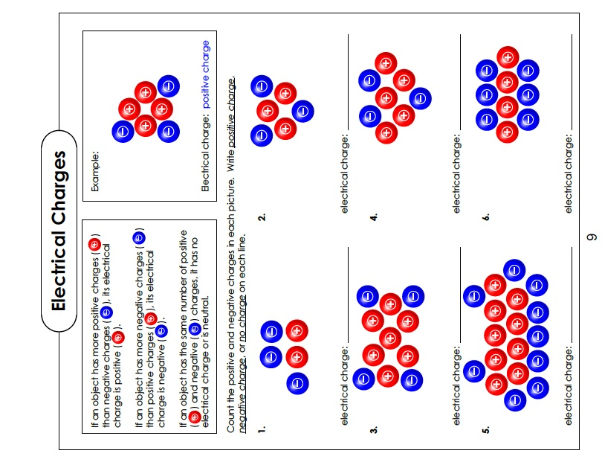

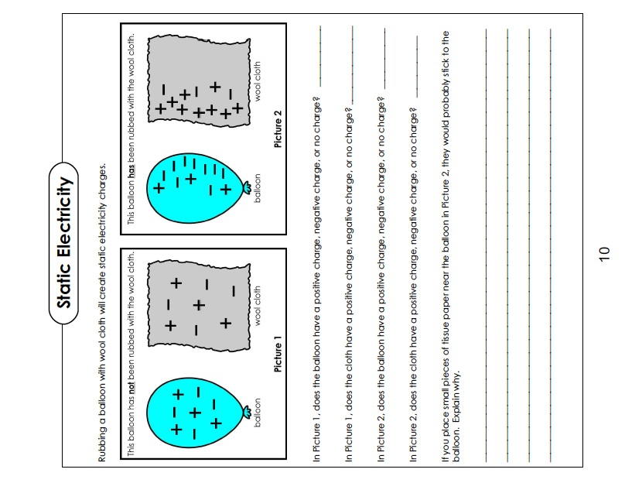

**Warm up/ Hook:**

Balloon Ninja!

Students will stand in a circle. Each student will have a balloon. Select a person to be “it,” this student stands in the middle and closes their eyes. The rest of the group rubs their balloons on their heads and build up static electricity. The goal or ***objective*** is for the rest of the group to get their balloon stuck to the person in the middle- the goal for the person who is it is to listen carefully and then (without opening their eyes or moving from their place in the middle) tag someone who is trying to place their balloon.

When a person is tagged the game starts over.

If everyone gets their balloons on the person who is it- then they try to take balloons off. Each person gets to take one. (but, it isn’t probable that they’ll get all the balloons on the person :-) ).

Point of that when everyone goes at once the odds of the person in the middle hearing and then randomly tagging someone goes up- what other strategies or ***tactics*** could they use?

**Transition:**

Explain that we’ll be talking about static electricity today. Ask about their knowledge of static electricity. The following script may be useful to you:

* Today we will be talking about static electricity! Who knows what static electricity is? Ah- yes the classic balloon hair trick- yes that is static electricity! Does anybody know why it does that to your hair? Ok, well, good thing I brought in these worksheets!!! We’ll learn why your hair does that- or why the balloons stuck to the person who was it and then you’ll demonstrate your understanding of this concept by filling out the sheets correctly.

Have them get back to their desks and then hand out the worksheets.

**Instruction:**

Go over worksheet one “Electrical Charges” explain how if an object has more positive charges than negative charges its electrical charge is positive. And visa versa. If there positive and negative charges are equal then it has no electrical charge/ it’s neutral. Have them fill out the first worksheet.

Go over Worksheet two. Go over the two images, and then have them fill out the questions.

**With Worksheet two pass out the wool cloth and have them take their balloons and try it out!**

What questions do they have about charges and static electricity? How could this possibly apply to drama? Similar to magnets this can connect to drama through attraction and following.

**Modeling**:

Mirror time. ***Have students look for connections between the following activity and the information they just studied about static electricity***

Have the students put on their imaginary lab coats because this game is an experiment! They will be annualizing the connections between the game and the static electricity information we just learned so they’ll need their science brains engaged!

Have students break into groups of two. Partner A is the leader, partner B is the Mirror. A’s ***objective***  is to move in a way that B can follow. B’s  ***objective*** is to follow so closely that I can’t tell who is leading and who is following.

Let this go for a bit, switch leader and follower.

Help them realize that if they move too fast they loose the illusion of a mirror and they loose the connection. What  ***tactics***  can they use to make the illusion stronger?

Then have groups come together with other groups- Have one leader lead the other three. Then add more groups to the big group. Continue adding until the whole class is following one student. Switch up the leader from time to time.

**Assessment:**

Have students sit and ask them- How this activity was like static electricity. What was your objective as the leader? What was your objective as the followers? What changed when there were more people?

Source: <https://www.swlauriersb.qc.ca/Schools/mccaig/Teachers/dstrina/BOOKLETELECTRICITYSTUDENT.pdf#page=9&zoom=auto,-13,567>

**Lesson #5: Basic Circuits**

**Lesson objective: SWBAT** demonstrate understanding of circuits and the importance of focusing and reacting by participating in activities and filling out the worksheets.

**Materials Needed:** Print out Worksheets.

**Warm up/ Hook:**

Play a game of Zap! (Like woosh or similar games- just different names for the actions)

In a circle (cause theatre games love circles…) One person starts by turning to the person on their right points at them and says “ZAP!” That person turns to their right, points, and says, “Zap!” This continues till everyone has done it.

Introduce the other rules!

-To reverse direction the receiving person puts their hands up and says, “Negative!” This reverses the polarity of the circuit!

-To skip a person say, “re-wire” and arch arms over the person their are skipping.

-To change direction back against a re-wire the receiving person says, “RE-re-wire!” and then arches back over the person skipped- the play then goes in the opposite direction unless…

-The person who did the original re-wire and just received the RE-re-wire says, “Rah-ziz-ziz-ZAP!” Then everyone in the circle says, “OOOOOOHHHH!!! You got burned!!!! And switches places in the circle.

-To throw the turn to someone on the other side of the circle say, “Short Circuit (Someone’s name)!” Then make like you’re throwing a football to the person- the receiving person then chooses which direction to continue play.

(More add-ons can be included like, “Buzzer!” everyone says, “BUUUZZZZZ!!!!” “Light bulb!” Everyone does jazz hands and says, “WOW!” “Faulty Switch!” Everyone switches places! “Resistor” Everyone goes in slow motion until someone says ,”Amp it up!” etc.)

**Transition:**

The following script may be helpful to you:

* What was your experience playing this game? Was it difficult trying to keep all the different variations clear? What are the connections you see between this variation of woosh and circuits/ electricity?

**Instruction:**

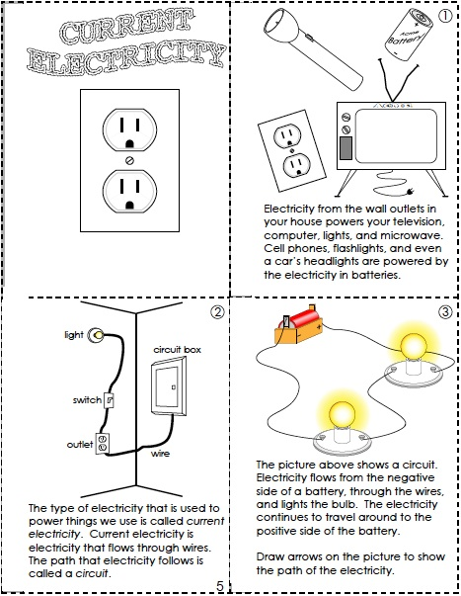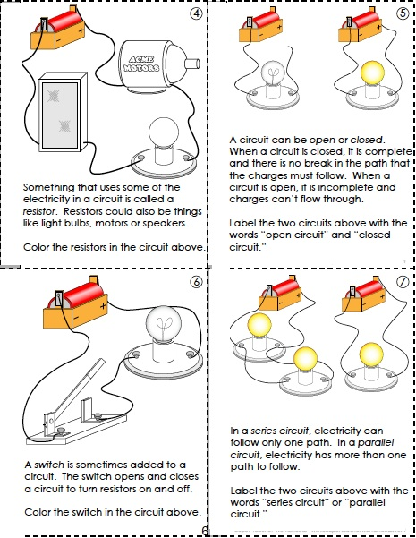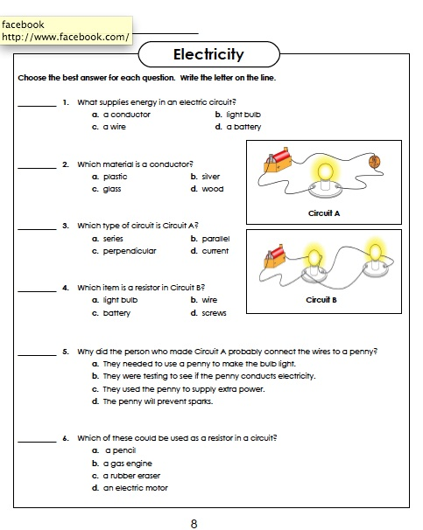

Explain and facilitate the filling out of the worksheets. The following script may be helpful:

* Did you know that electricity from the wall outlets in your house powers your television, computer, lights, and microwave. Cell phones, flashlights, and even a car’s headlights are powered by the electricity in batteries.
* The type of electricity that is used to power things we use is called *current electricity.* Current electricity is electricity that flows through wires.
  + Who knows what the path that electricity follows is called? That’s right! A circuit!
* Look at the image in the box labeled three. Remember that game we played when we were passing the electrons? Which way did we pass them? Why? That’s right! We passed them from the negative side of the battery (me) to around the circuit to the positive side. So, draw some arrows on the wires in the picture indicating the direction the current is flowing.
* Something that uses some of the electricity in a circuit is called a *resistor*.
  + Who can point to a resistor in the room? Nice, yes. The TV is a resistor. The lights too. Yes. Well done.
* Who remembers what a circuit is called when is doesn’t connect to itself? –an open circuit that’s right! Well done. And one that connects? –closed! Yes! Now look at box 5 and write down which one is open and which one is closed.
* Who knows how a switch works? Box 6 has a picture of a switch and as you can see the switch either opens or closes the circuit. When the switch in the picture is down what would that do? YES!!!!! It completes the circuit!
* We’re going to talk about more complex circuits. The picture in box 7 shows two circuits. One is a parallel circuit and one is a series circuit. In a parallel circuit the electricity can only flow through one path. Which one is the parallel circuit? The one with one light is the parallel one. Nice.
  + Pop question! If I were to smash on of the light bulbs in the series circuit- what would happen to the other one? Would it stay lit or would it go out? WHY?

Have students fill out the last sheet on their own. Check in and see if they are doing it right, and answer questions they may have.

**Modeling:**

Have the students put on their imaginary lab coats because this game is an experiment! They will be annualizing the connections between the game and the complex circuit information we just learned so they’ll need their science brains engaged!

We will be playing Columbian Hypnosis. The following script may be helpful to you:

* Scientists! You will be engaging in an experiment now. First I need you to find your own space in the room. Good.
* Now put your hand out flat, and bring it a few inches away from your face. The goal of phase one of these experiments is to keep your face the same distance away from your hand throughout.
* Start moving your hand away from your body- but, maintain the distance between your hand and face. Move and adjust to keep this constant.
* Try new ways of moving. Can you twist your hand and keep your face that close? Can you go high or low?
  + Now, pause and ask what it was like for them- difficult? Easy? Interesting?
* PHASE TWO!
* Partner up! Like the mirror game we played before this has a leader and a follower. Choose who is partner A and who is B. Nice. B will lead first! B your ***objective*** is to keep A safe, and to not to unreasonable movements with your hand. A your ***objective*** is to keep your face the same distance from B’s hand throughout. GO!
* How can you change your movement? Try something new!
  + Have the partners switch
    - Now pause and ask what is was like to be the leader and what it was like to be the follower.

**Practice:**

Explain that like the more complex circuits have multiple light bulbs and multiple ways to complete the circuit we’ll add more people to the game.

* We will be adding a C and D to groups! So partner up with another pair. Great! Now, A you lead B. B you lead C and D.
  + After this goes on for a bit, switch it up. Have B lead A and D and have C follow A.

**Assessment:**

Ask them what similarities there are between the games we played and the series circuits we studied. Imagine if A was leading B and C and D was following B. what if A lost C- would B and D know what to do? YES! They would because D was following B who was following A!

What did you learn? What ways does this type of work apply to drama? Are there connections between objective, tactics, focus and reacting and drama?

**Lesson #6: Review!**

**Lesson objective:** Students will demonstrate their ability to synthesize all that they’ve learned by completing the review.

**Materials Needed**:

**Warm up/ Hook**:

Electricity by Schoolhouse Rock!

<https://www.youtube.com/watch?v=c1A0_jO93eY>

**Transition**:

For this section have the students put on their imaginary lab coats because these games are experiments! They will be annualizing the connections between the games and the complex circuit information, static electricity, and circuit stuff we’ve been studying so they’ll need their science brains engaged!

Have students break into three groups. They will be leading themselves through rounds of the games we have done this unit. Your job is to facilitate and side coach if needed but they are capable scientists who have demonstrated that they are able to do these things.

**Instruction**:

Have them Play a game of Zap! (Like woosh or similar games- just different names for the actions)

In a circle (cause theatre games love circles…) One person starts by turning to the person on their right points at them and says “ZAP!” That person turns to their right, points, and says, “Zap!” This continues till everyone has done it.

Introduce the other rules!

-To reverse direction the receiving person puts their hands up and says, “Negative!” This reverses the polarity of the circuit!

-To skip a person say, “re-wire” and arch arms over the person their are skipping.

-To change direction back against a re-wire the receiving person says, “RE-re-wire!” and then arches back over the person skipped- the play then goes in the opposite direction Unless…

-The person who did the original re-wire and just received theRE-re-wire says, “Rah-ziz-ziz-ZAP!” Then everyone in the circle says, “OOOOOOHHHH!!! You got burned!!!! And switches places in the circle.

-To throw the turn to someone on the other side of the circle say, “Short Circuit (Someone’s name)!” Then make like you’re throwing a football to the person- the receiving person then chooses which direction to continue play.

(More add-ons can be included like, “Buzzer!” everyone says, “BUUUZZZZZ!!!!” “Light bulb!” Everyone does jazz hands and says, “WOW!” “Faulty Switch!” Everyone switches places! “Resistor” Everyone goes in slow motion until someone says ,”Amp it up!” etc.)

Now have them play a game of attract and repel. We’ll start by walking neutrally around the room.

As you are walking, in your head choose someone you are now repelled by (like the north side of a magnet facing the north side of another magnet) as you walk just keep as much space between you and the person you’ve chosen without making it super obvious.

Now, choose someone else in the room- this person is someone you are attracted to- try to stay near this person- in fact try to keep this person between you and the person you are repelled by.

Now act out an electric circuit, as follows: Tell students that one of them represents a battery and they represent a wire conductor. The circle represents a circuit. (Distribute an object -- like a ball, a book, or an eraser -- to each member of the circle, including you. Ideally, everyone should have the same object.

* Remind students that these objects represent electrons inside a wire conductor. Explain that a wire conductor is full of electrons. Explain that all batteries have a positive end, represented by your left hand, and a negative end, represented by your right hand. Pass your "electron" to the student on your right. The student receiving your electron should in turn pass the one he or she is holding to the right. Have students continue passing on electrons to the person to their right. Tell students that because electrons share the same negative charge, they repel one another, which keeps them moving along in the same direction.
* Ask them what the flow of electrons through a conductor is called: electrical current.
* Have them select “a pair of scissors” Someone with good projection and diction. They will not be in the circuit- they will select a portion of the circuit to cut and after the electrons are in a good rhythm and have been passed well pick a time to cut the line. When he/she does this he/she slides his/her hands between where a pair of people would be passing a ball and say, “SNIP!”
  + When the scissors does this the group has to stop!

**Assessment**:

What connections did you notice this time through the games that you didn’t notice last time? Are you ready for our final assessment next class?! Cause it’s coming. Be sure to go over vocab and concepts.

**Lesson #7: Creating circuits with their bodies (assessment)**

**Lesson objective**: Students will demonstrate a mastery of terms and features of static and current electricity by describing the behavior of static electricity as observed in nature and everyday occurrences and analyze the behavior of current electricity while participating in defined responsibilities required to present a drama/theatre work informally to an audience, using physical choices to create meaning in a drama/theatre work byexplain how drama/theatre connects oneself to a community or culture and doing a concept assessment.

**Warm up/ Hook**:

* Split into four groups these groups will be called houses! You are now Gryffindor, Ravenclaw, Huffelpuff, and Slytherin. We’ll have a friendly competition.

**Instruction:**

Have the four teams divide to the four corners of the room. Decide on a goal spot in the middle of the room that they can race to. Using the vocabulary from the first lesson we’ll have a race to give the correct answer. Announce the answer and the first group to race to the “goal spot” in the middle of the room gets to have a chance at guessing the vocab word. If they are wrong then the second fastest gets a chance to answer. Have each member of the teach take a turn racing to answer. Keep track of which team is winning and announce who is in the lead after each vocab term.

Now have the groups form a simple circuit with their bodies like the one with the cotton balls in the previous games but this time without cotton balls. This should be like slightly moving tableaux. The groups should have someone that is the battery, some wires, and a light, there should be no breaks in the circuit.

**Practice**:

Have them make more complex circuits and combinations. Open circuits, closed ones, Parallel, Series. Light bulbs buzzers, etc.

**Assessment**:

Take account of which group had the most right answers and declare a winner!