**WORLD BUILDING FOR DIRECTORS**

**BY: Camilla Hodgson**

**UNIT OBJECTIVE:**

Students will demonstrate their understanding of creating vivid worlds for the plays they are directing by leading the class on a walk-through of the world of their play.

**LEARNING LEVEL:**

Advanced Drama; this mini-unit can be taught to lead into a directing or design unit (scripts need to already be selected)

**PREVIOUS EXPERIENCE:**

Students have completed beginning and intermediate drama classes. The class this unit was created for originally was an advanced class with much understanding of acting and theatre history. The class had studied Ball’s *Sense of Direction* book. They were preparing for the performance of their 10-minute scenes they later directed.

**CLASS LENGTH:**

80-minute class periods

**NATIONAL STANDARDS:**

**HS Advanced TH:Cr3.1.III: b.** Synthesize ideas from research, script analysis, and context to create a performance that is believable, authentic, and relevant in a drama/theatre work.

**HS Advanced TH:Pr4.1.III a.** Apply reliable research of directors’ styles to form unique choices for a directorial concept in a drama/theatre work.

**BIG IDEAS:**

Unique worlds with specific rules and feels can be created for plays.

**ESSENTIAL QUESTIONS:**

How does a director create a vivid world for their play? How can imagination help a director?

**PERFORMANCE TASKS:**

Analyze song lyrics and illustrate the song in the form of an imagined world. Answer questions from E. F Skinner’s “Visit to a Small Planet” about their play for class and lead the class through the world of their play.

**LESSONS:**

**Lesson 1: Intro to Theatrical worlds**

Objective: Students will demonstrate their understanding of theatrical world by responding to and discussing elements of world building in various examples.

**Lesson 2: Mapping Out Worlds**

Objective: Students will demonstrate an ability to create vibrant worlds onstage through mapping out imagined spaces for songs based on questions in Elinor Fuchs’ “EF’s Visit to a Small Planet: Some Questions to Ask a Play.”

**Lesson 3: World building with play scripts**

Objective: Students will demonstrate an ability to create vibrant worlds onstage through script analysis and leading group walk-abouts through the world of their play.

**LESSON TITLE:** Lesson 1: Intro to Theatrical worlds

**EDUCATIONAL OBJECTIVE:** Students will demonstrate their understanding of theatrical world by responding to and discussing elements of world building in various examples.

**MATERIALS NEEDED:** Large paper, crayons, copies of the article “Elinor Fuch’s Visit to a Small Planet,” AV hookup, digital copies of tempest video, *Dogville* intro, example pictures (in lesson play)

The Tempest clip link: <https://www.youtube.com/watch?v=160_fRFWzlU&t=2s>

Dogville clip link: <https://www.youtube.com/watch?v=wQKZlps9W0k>

**HOOK:** Have students get out a paper and writing utensil. Instruct them to pay attention to all of the sensory details (colors, textures, mood, etc.) that are present in the play and write them down. Play the clip from *The Tempest*. Have the students share what words they thought of, what words came into their minds. Ask the students what methods were used to create these sensory details (lights, sound, backdrop, etc.) Repeat this process with the *Dogville* clip. Ask the students to describe also what the rules are in the world of the play in *Dogville*.

**TEACHING PRESENTATION:**

**Step 1: Discussion-** Show the students two more example pictures. One from *Orfeo and Euridice*, and another from *You Can’t Take it With You*. Have the students contrast the theatrical worlds that were creating in each play. Ask, “How does a director make the choice as to how to construct the world of their play?” Bring up the idea of how no matter what you decide to do with the play, you should have reasons that are drawn from the text of your script.

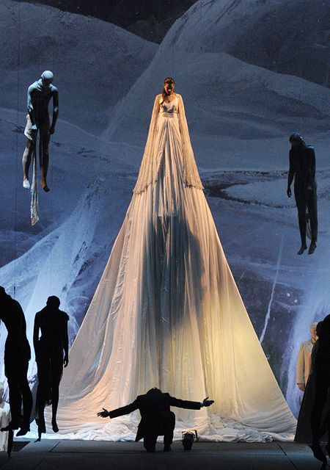

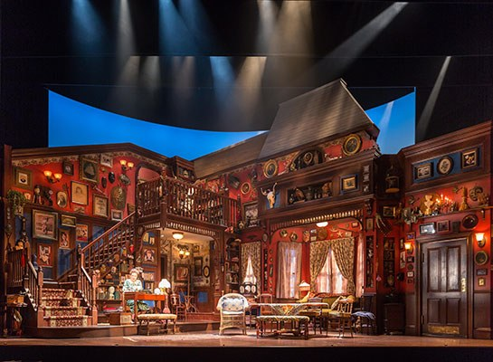

You Can’t Take It With You

Orfeo and Euridice

**Step 2: Writing brain storm-** Once you know what kind of world you are building onstage, you can figure out how you will create your world onstage. Lay out a large sheet of paper and crayons. Have the students come and write ideas of how a director can create a theatrical world onstage on the paper. While students are writing, hand out the copies of “EF’s Visit to a Small Planet: Some Questions to Ask a Play.” Have a student read off everything written on the sheet of paper.

**Step 3: Group Reading-** Read through the Elinor Fuch article as a class. Read “popcorn” style- a student will read a paragraph and then call another student’s name to read the next paragraph, and so on. Pause and discuss. Most of the article is just questions that you could use to analyze a text. Ask the students how they could use these questions as a director. How do these questions help to create a sensory feel? After the paragraph about time, pause and offer some examples of plays that have interesting non-linear time structures (like *Travesties*, *The Last Five Years*).

**CLOSURE:** Why is it important to ask these questions of a play? It is important to do this before you can make a world that actually makes sense. Have you ever seen a Shakespeare play that has a completely random concept that makes really no sense with the text? By knowing your play and going through these questions, you can make sure that everything you are doing connects.

**ASSESSMENT:** For full participation points, students must be contributing to discussion, writing down their ideas when instructed.

**LESSON TITLE:** Lesson 2: Mapping out worlds

**EDUCATIONAL OBJECTIVE:** Students will demonstrate an ability to create vibrant worlds onstage through mapping out imagined spaces for songs based on questions in Elinor Fuchs’ “EF’s Visit to a Small Planet: Some Questions to Ask a Play.”

**MATERIALS NEEDED:** Printer paper, crayons, Song lyric copies, “Selected Questions to Ask a Play” worksheet.

**HOOK:** Have participants move through the space. Call out different environments and climates for the participants to physically explore (lava, sand, sea, home interiors, grassy plains, warmth, cold, etc.). Gradually transition to more abstract concepts of time, mood, and tone (reversed time, leisurely-paced time, cyclical time, joy, existential peace, sorrow, delicate, course, etc.)

**TEACHING PRESENTATION:**

**Step 1: Guided Meditation:** Imagine you are in outer space. See around you. There are many planets in the distance. Let your gaze fall upon one that is appealing to you. Begin to move towards it in your mind. What does it look like? Move closer. Begin to notice more details. What colors are on your planet? Break the atmosphere and land. What does the ground feel like under your feet? Gaze about you. What textures are present? Feel them. Begin to walk about your planet? What is the climate like? What is the seasonal feel of the world? Is it wintery? Summery? What mood is present? What do you hear on your planet? Every planet will have characteristic sounds.

**Step 2: Discussion- “**What you did see?” Have a few people share what they saw/experienced, “How can this kind of thinking help you create theatre?”

**Step 3: Group text analysis-** Have the students get into groups of three. Have song lyrics spread out and let the groups pick out which song they want to analyze. Also hand out the “Some Questions to Ask a Play” worksheet. At least one group member should fill out the questions sheet to turn in.

**Step 4: Group world mapping-** When the students are almost through the questions, give them the instructions for drawing out their worlds. Imagine the song lumped up into a ball. Draw out your song as if it were a small planet. Use your answers on your sheet to guide what you will draw.

**Step 5: World Map presentations:** Have each group present their picture, and explain their choices.

**CLOSURE:** How could you use some of the techniques we used today as directors? For next time, we will be applying some of these techniques to your script for the play you are directing for class. Bring your script with you.

**ASSESSMENT:** Completion of thequestion sheet, pictures.

**LESSON TITLE:** Lesson 3: World Building with play scripts

**EDUCATIONAL OBJECTIVE:** Students will demonstrate an ability to create vibrant worlds onstage through script analysis and leading group walk-abouts through the world of their play.

**MATERIALS NEEDED:** A/V Hookup, Extra copies of article- EFs “Visit to a Small Planet.” , Downloaded youtube video: “Moonrise Kingdom—Where Story Meets Style” <https://www.youtube.com/watch?v=C_5lCnwDEo4>

**HOOK:** Show the students the “Moonrise Kingdom—Where Story Meets Style” video. Have them take notes of everything Wes Anderson does to create a vivid world in Moonrise Kingdom. Make a list on the board of everything the director does to create a world in this film. Make another list of how these methods could be applied to theatre.

**TEACHING PRESENTATION:**

**Step 1: Group Reading-** Finish reading the article *EFs Visit to a Small Planet* article as a class. In lesson 1 we stopped after the paragraph about time constructs.

**Step 2: Script analysis-** Give the students some time with their script and the article. You don’t have time to answer every question about your play. But pick a couple questions from each “section” (mood, time, social, etc.) You are looking especially for information that would help you guide your classmates physically through the world of the play.

**Step 3: Walk-abouts:** Have students volunteer to lead walk-abouts through the world of their play. With the information you now have, you will lead us in a walk-through of the world of your play. You will do this in the way that I did a walk-through warm-up with you in our last lesson. A space-walk where you describe the feeling, temperature, color, and mood of a space. Except you will use the world information you have gathered in your analysis of the play.

**Modification:** If students do not feel comfortable leading the walk-about right away, do the following: Get them started in a “space-walk.” Have them walk around the space of the room. Give them prompts like the warm-up from last lesson (physical space description such as a beach, temperature descriptions such as hot or cold, and more abstract feelings like sadness and peace.)

Then instruct them that when you tap them on the shoulder, the will then take over guiding the class through the space. The directions they give the class should be details about their play that they discovered through answering the questions in the article.

**CLOSURE:** Is there anything you discovered in your show that you would like to take with you and incorporate into your show? How might this work be useful to you in your future work as a director?