When we see, light bounces off of objects and reflects into our eyes. The wavelength of the light is what determines color, with long wavelengths being red and short ones being violet.

Various colors change the way things look on stage – for example, if you shine blue light on a red object, it will look purple. Let’s look at the color wheel for light (draw or display):

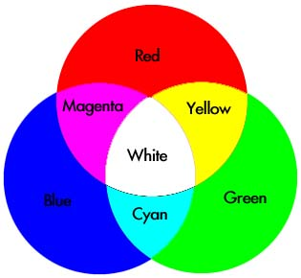

https://www.d.umn.edu/~mharvey/th1501color.html (This is a great resource!)

As different colors of light mix, they create different effects.

When red and green mix, they make yellow, blue and red are magenta, and blue and green are cyan.

As these lights hit colors on stage, they mix and reflect differently in people’s eyes.

Add the color wheel for pigment:

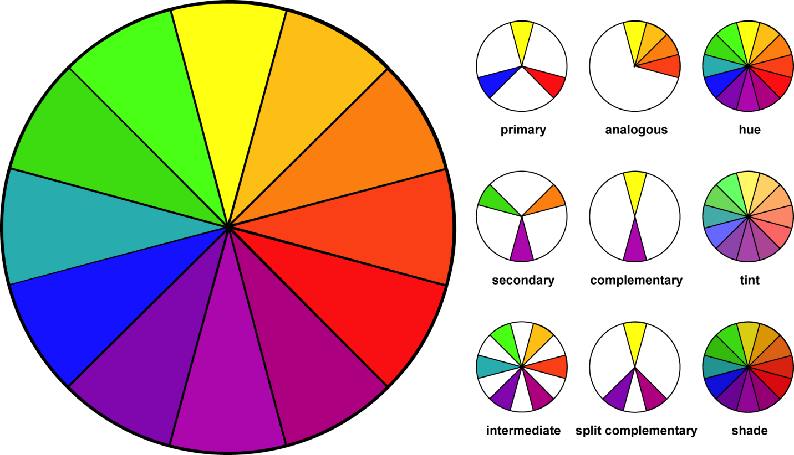

http://www.theworkingwardrobe.com/men_/the-working-man-simple-rules-for-color-coordination/

Explain the different circles on this diagram.

Complementary colors turn to grey – if you have a green wall on the set and shine red on it, it will turn a weird grey brown. Not attractive. This can be used to your advantage, however. In a production of Rodger and Hammerstein’s Cinderella at BYU, the lighting designer and costume designer worked together to create an effect that would help Cinderella change from a sad, drab young girl into a vibrant beauty, all with a 20-30 second fade of the lights from a complementary color to an analogous color, bringing out the colors of her costume and makeup. The audience was none the wiser to how she transformed in front of them, on stage.

Green is not flattering on people, except for Elphaba in Wicked. Use ambers for white people, and lavenders for black people. These tones best compliment skin colors.

The shadow of a light is the complementary color. This means that an amber light will have a blue shadow, which is why it is so effective to use amber and blue as a pair on stage. It gives full light, while supporting what we usually see.