***The Burial of the Count of Orgaz***

***(Spanish: El Entierro del Conde de Orgaz)*** is a painting by El Greco, a Greek painter, sculptor, and architect of the Spanish Renaissance. Widely considered among his finest works, it illustrates a popular local legend of his time. An exceptionally large painting, it is very clearly divided into two sections, heavenly above and terrestrial below, but it gives little impression of duality. The upper and lower sections are brought together compositionally.

**Theme**

The theme of the painting is inspired from a legend of the beginning of the 14th century. In 1312, a certain Don Gonzalo Ruíz, native of Toledo, and Señor of the town of Orgaz, died (his family later received the title of Count, by which he is generally and posthumously known). The Count of Orgaz was a pious man who, among other charitable acts, left a sum of money for the enlargement and adornment of the church of Santo Tomé (El Greco's parish church). He was also a philanthropist and a right-thinking Knight. According to the legend, at the time he was buried, Saint Stephen and Saint Augustine descended in person from the heavens and buried him by their own hands in front of the dazzled eyes of those present.

**History**

*Detail of the painting Detail of the painting, showing El Greco*

[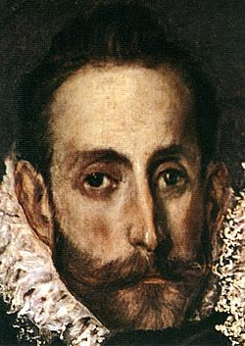](https://en.wikipedia.org/wiki/File:El_Greco_-_The_Burial_of_the_Count_of_Orgaz_(detail)_-_WGA10493.jpg)[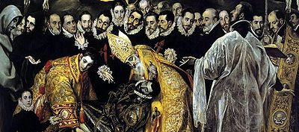](https://en.wikipedia.org/wiki/File:El_Greco_-_The_Burial_of_the_Count_of_Orgazdetal1.jpg)

The painting was commissioned by Andrés Núñez, the parish priest of Santo Tomé, for the side-chapel of the Virgin of the church of Santo Tomé, and was executed by El Greco between 1586–1588. Núñez, who had initiated a project to refurbish the Count's burial chapel, is portrayed in the painting reading.

Already in 1588, people were flocking to Orgaz to see the painting. This immediate popular reception depended, however, on the lifelike portrayal of the notable men of Toledo of the time. It was the custom for the eminent and noble men of the town to assist the burial of the noble-born, and it was stipulated in the contract that the scene should be represented in this manner.

El Greco would pay homage to the aristocracy of the spirit, the clergy, the jurists, the poets and the scholars, who honored him and his art with their esteem, by immortalizing them in the painting. *The Burial of the Count of Orgaz* has been admired not only for its art, but also because it was a gallery of portraits of the most eminent social figures of that time in Toledo. Indeed, this painting is sufficient to rank El Greco among the few great portrait painters.

**Analysis of the painting**

*[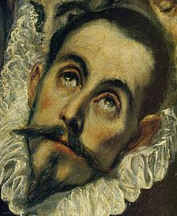](https://en.wikipedia.org/wiki/File:El_Greco_-_Count_Orgasz_-_face.jpg)Detail of the painting.*

The painting is very clearly divided into two zones; above, heaven is evoked by swirling icy clouds, semiabstract in their shape, and the saints are tall and phantomlike; below, all is normal in the scale and proportions of the figures.The upper and lower zones are brought together compositionally (e.g., by the standing figures, by their varied participation in the earthly and heavenly event, by the torches, cross etc.).

The scene of the miracle is depicted in the lower part of the composition, in the terrestrial section. In the upper part, the heavenly one, the clouds have parted to receive this just man in Paradise. Christ clad in white and in glory, is the crowning point of the triangle formed by the figures of the Madonna and Saint John the Baptist in the traditional Orthodox composition of the Deesis. These three central figures of heavenly glory are surrounded by apostles, martyrs, Biblical kings and the just (among whom was Philip II of Spain, though he was still alive).

Saints Augustine and Stephen, in golden and red vestments respectively, bend reverently over the body of the count, who is clad in magnificent armour that reflects the yellow and reds of the other figures. The young boy at the left is El Greco's son, Jorge Manuel; on a handkerchief in his pocket is inscribed the artist's signature and the date 1578, the year of the boy's birth. The artist himself can be recognised directly above the raised hand of one of the mourners immediately above the head of Saint Stephen.The men in contemporary 16th-century dress who attend the funeral are unmistakably prominent members of Toledan society.

The painting has a chromatic harmony that is incredibly rich, expressive and radiant. On the black mourning garments of the nobles are projected the gold-embroidered vestments, thus creating an intense ceremonial character. In the heavenly space there is a predominance of transparent harmonies of iridescence and ivoried greys, which harmonize with the gilded ochres, while in the Madonna's maforium (mantle) deep blue is closely combined with bright red. The rhetoric of the expressions, the glances and the gestural translation make the scene very moving.