Name: ­­­­­­­­­­­__________________________________

Lighting Reference Sheet

Fresnel

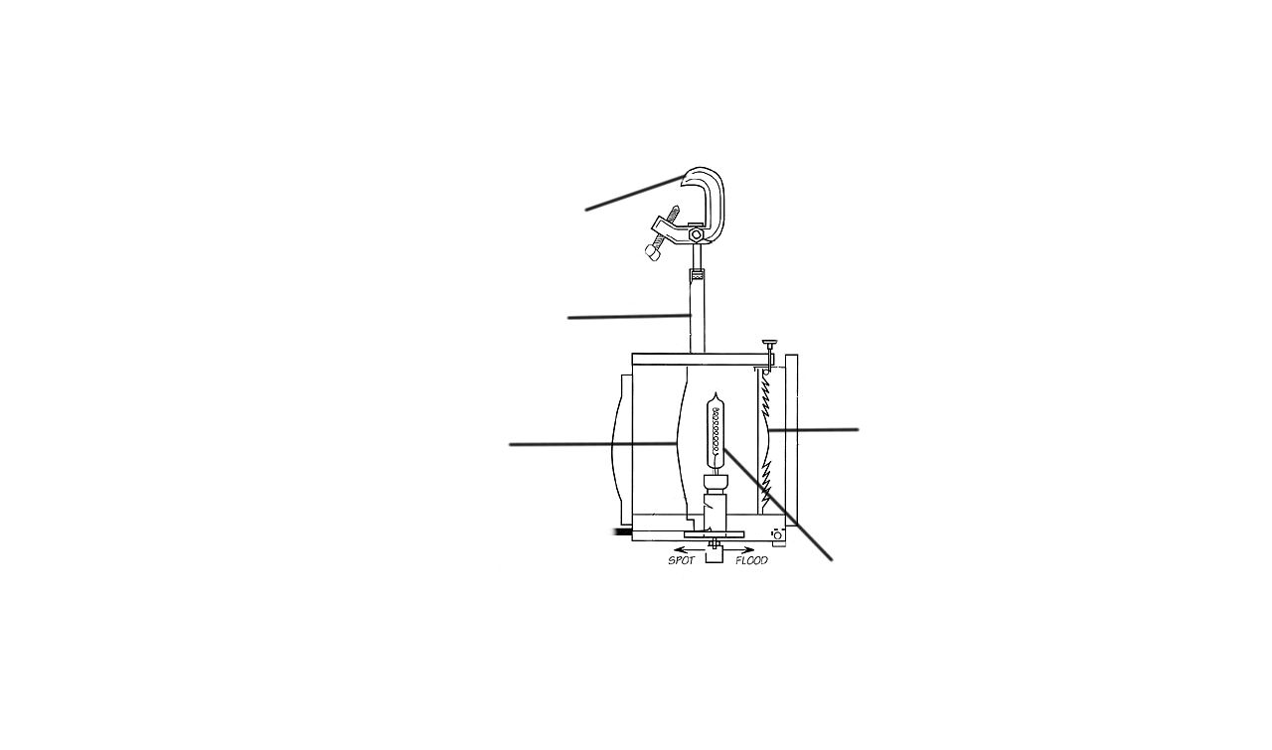

PAR Can – Label the diagram.

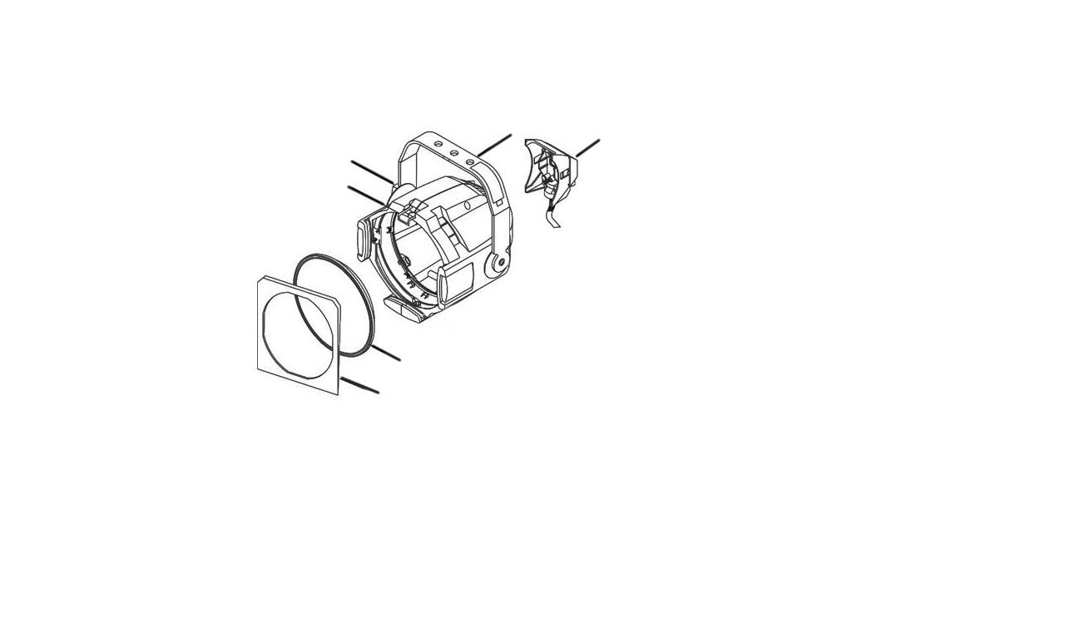

Source Four Ellipsoidal



What are the different types of cable connectors?

________________________ _________________________ _________________________

What are two-fers?

What does a dimmer doubler do?

Define “gel.”

Define “gobo.”