Step 3: Class Practice Analysis PowerPoint

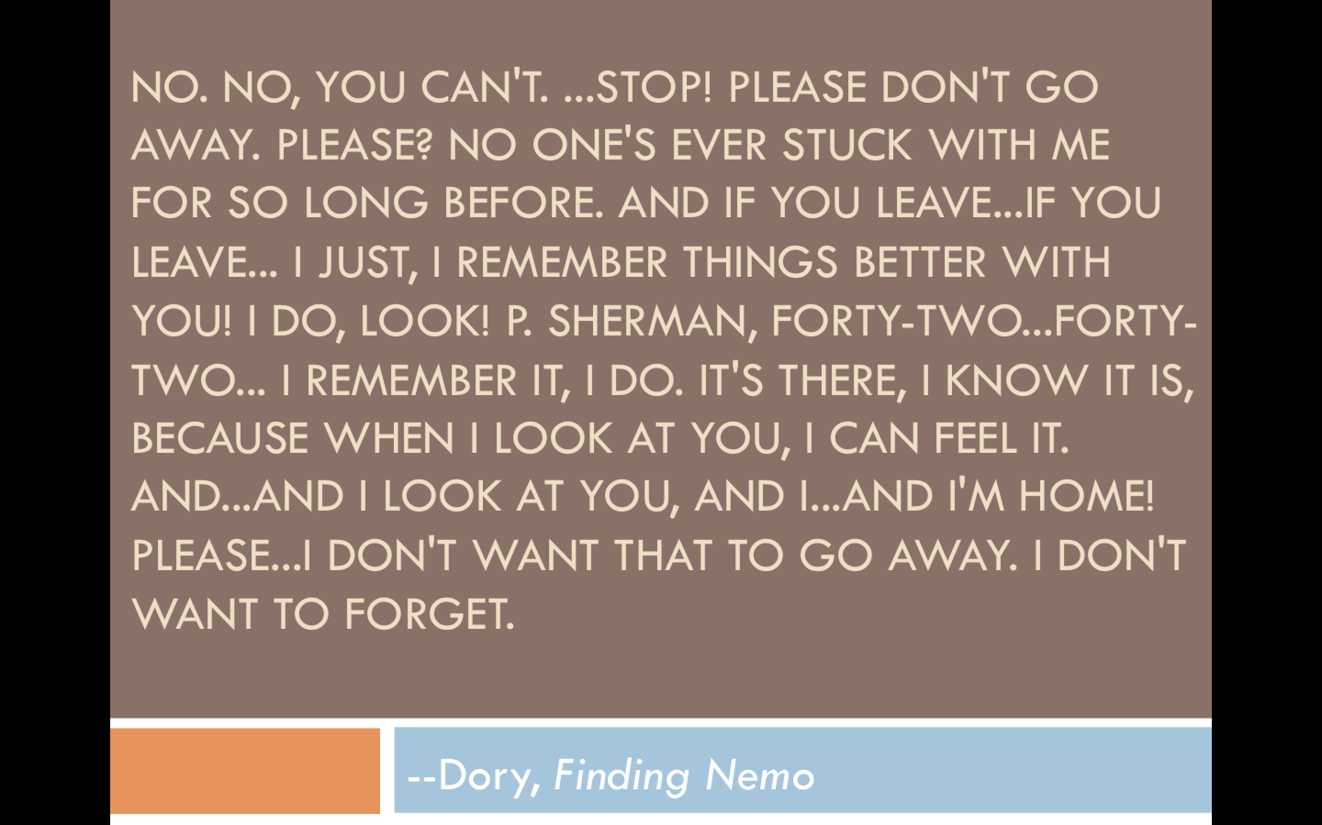

Part One:

(Maybe he's right. Maybe there is something the matter with me.

I just don't see how a world that makes such wonderful things could be bad.)

Look at this stuff

Isn't it neat?

Wouldn't you think my collection's complete?

Wouldn't you think I'm the girl

The girl who has everything?

Look at this trove

Treasures untold

How many wonders can one cavern hold?

Looking around here you think

Sure, she's got everything

I've got gadgets and gizmos a-plenty

Part Two:

I've got whozits and whatzits galore

You want thingamabobs?

I've got twenty!

But who cares?

No big deal

I want more

I wanna be where the people are

I wanna see, wanna see them dancin'

Walking around on those - what do you call 'em?

Oh - feet!

Flippin' your fins, you don't get too far

Legs are required for jumping, dancing

Strolling along down a - what's that word again?

Part Three:

Street

Up where they walk, up where they run

Up where they stay all day in the sun

Wanderin' free - wish I could be

Part of that world

What would I give if I could live out of these waters?

What would I pay to spend a day warm on the sand?

Bet'cha on land they understand

Bet they don't reprimand their daughters

Bright young women sick of swimmin'

Part Four:

Ready to stand

And ready to know what the people know

Ask 'em my questions and get some answers

What's a fire and why does it - what's the word?

Burn?

When's it my turn?

Wouldn't I love, love to explore that shore up above?

Out of the sea

Wish I could be

Part of that world