**Viewpoints**

Ashlyn Anderson, Jennifer Ansted, Nichole Clarke

**Proficiency Level:**

Proficient—Drama 1 students

**Class Length:**

Nine 80-minute lessons

**Unit Objective:**

Students will demonstrate their ability to interpret and respond to artistic mediums and their understanding of physical viewpoints by creating, rehearsing, and performing a 2-3 minute silent group scene in response to an artistic work.

**Prior Knowledge:**

Students have already completed units on improvisation and vocal viewpoints before beginning this physical viewpoints unit. They have a basic knowledge of group scene work and rehearsal.

**2014 National Core Arts Theatre Standards**:

* **TH:Cn10.1.I.a.** Investigate how cultural perspectives, community ideas and personal beliefs impact a drama/theatre work.
* **TH:Re8.1.I.c.** Justify personal aesthetics, preferences, and beliefs through participation in and observation of a drama/theatre work.
* **TH:Pr5.1.I.a.** Practice various acting techniques to expand skills in a rehearsal or drama/theatre performance.
* **TH:Cr3.1.I.a.** Practice and revise a devised or scripted drama/theatre work using theatrical staging conventions.

**Enduring Understandings:**

* **Connecting:** Theatre artists explore the way different people respond to the same work of art.
* **Responding:** Theatre artists’ interpretations of art are influenced by personal experiences and aesthetics.
* **Creating:** Theatre artists refine their work and practice physical choices through rehearsal.
* **Connecting:** Theatre artists allow awareness of interrelationships to influence and inform their work in rehearsal.
* **Performing:** Theatre artists make strong performance choices to effectively convey meaning.

**Essential Questions:**

* **Connecting:** What happens when theatre artists allow an understanding of themselves and the world to inform perceptions about theatre and the purpose of their work?
* **Responding:** How can the same work of art communicate different messages to different people?
* **Creating:** How do theatre artists transform and edit their initial ideas?
* **Performing:** Why are strong choices essential to interpreting a drama or theatre piece?

**Lesson 1: An Introduction to Viewpoints—Interpretation & Movement**

**Objective**: Students will demonstrate their ability to interpret a work of art by participating in a group discussion. Students will demonstrate their ability to respond physically to a work of art by participating in a simple devising activity.

**Standards:**

* **TH:Cn10.1.I.a.** Investigate how cultural perspectives, community ideas and personal beliefs impact a drama/theatre work.
* **TH:Re8.1.I.c.** Justify personal aesthetics, preferences, and beliefs.
* **TH:Cr3.1.I.a.** Practice a devised drama/theatre work using theatrical staging conventions.

**Materials:**

* *Swans Reflecting Elephants* by Salvador Dali
* Whiteboard and markers
* Student name tags

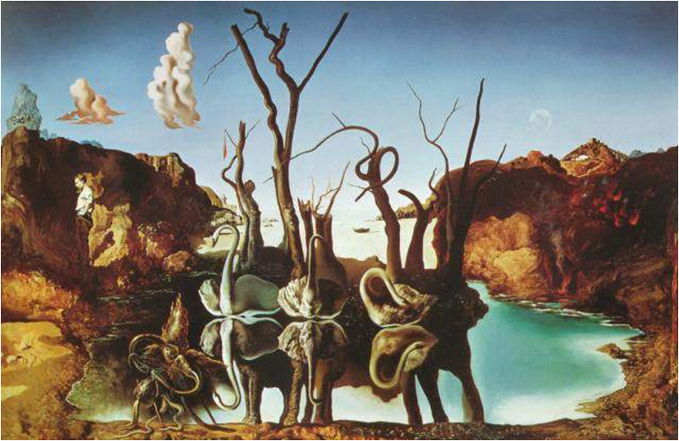

<http://learnlearn.net/Historie,religion,kunst/res/Default/ESS_PasteBitmap01659.png>

**Step 1:** Display Dali’s painting and pass out the Analysis sheets. Ask students to take 1-2 minutes individually to look closely at the artwork. What do they notice? After two minutes, invite them to turn to their partner and talk about their observations, as well as to fill out the observation part of the T chart on the Analysis sheet. Explain that observations are what you experience with your senses (see, hear, etc.) They are not interpreting.

After paired discussions, begin a whole class discussion about the painting. First ask for the observations that they made with their partners. Then ask the following questions. If they need help with these questions, make your own observations (ideas of observations are bulleted below the questions).

* What parts of this painting stand out to you?
  + The swans are reflecting elephants
  + There is a man in the background facing away from the animals
  + There is an unidentifiable creature in the bottom corner
* What do you notice about the use of color in the painting?
  + Vivid shades of orange, blue, and green
  + Dull shades of brown and gray
* What is interesting about shapes and lines in the painting?
  + Rough cliffs v. still lake
  + Curved lines in necks, trunks, trees, clouds, and lake’s edge
  + Straight lines in trees, man’s back, elephants’ legs, and cliff tops
* Where is the focus in this painting? What draws your eye to the focus?
  + Border between the cliffs and lake frames the swans and elephants

**Step 2:** Now we’re going to use our observations to make interpretations about the painting. Rather than just talking about what we *see* in the painting, we’re going to *bring out the meaning* of what the painting symbolizes or represents. Take a few minutes with your partner to decide on possible Interpretations one could have based on the observations that were made. Tell them to just write the major themes that they interpret in a few words, instead of paragraphs of explanations. (You may need to remind them what a theme is. Ask if anyone knows. Explain that a theme is an abstract concept like greed, love, etc. and not something tangible or concrete like clown or road trip.)

After a few minutes bring the class together and ask the pairs to share some of their interpretations and themes that they wrote down. Use the questions below to help start and guide conversation if needed.

* What do you think the swans and elephants represent?
  + Wisdom
  + Beauty
  + Strength
* What do you think the man or the creature symbolize?
  + Disagreeing with the reflection of wisdom in beauty
  + Trying to fit unsuccessfully
  + Falsehood
* What might be the meaning of this painting?

Throughout the analysis discussion, write the themes (students’ ideas about the meaning of the painting) on the whiteboard. For instance:

* Trying to fit in
* Rejection
* Reflection
* Things as they really are

**Step 3:** Ask the students, “From this list of themes, which interests you the most?” As a class, come to a consensus on which of the themes to explore further. Now that we have talked about different perspectives around a work of art, let’s see how differing perspectives contribute to making theatre.

“What experience have you had with [theme] in your life before?” Help all students get on the same page about what the theme means. For example, list synonyms of the theme as a class or talk about common occurrences of that theme in their lives or popular culture.

Invite the students to work in pairs. Explain these directions: Partner A will be given three minutes to tell a story to Partner B about the theme word. We encourage you to tell a story from your own life, but if the only one you can think of is a story you heard, you can tell that one as well. After three minutes, Partner A and Partner B switch roles. Encourage the students to use the whole three minutes without going too long or too short. They should go back and add new details if they finish early.

Ask the students if they have any questions before beginning. Give them a minute to silently think about their story before starting the activity. As students are telling, give them notifications when they have two minutes, one minute, and ten seconds left.

**Step 4:** Next, coach the students to choose physical gestures, movements, or expressions to retell their partner’s story without words. Students perform individually and silently, in silo spaces around the classroom. The whole class works at the same time, without any audience.

**Side-coaching:**

* Identify the main character from the story. Sit or stand in a posture that expresses that character.
* Move around the space as that character. How do they carry themselves? What pace do they move at? Do they walk in brisk lines or slow curves?
* What is the beginning of your story? Choose a physical position that represents the beginning of this story. Take ten seconds to explore options, and then freeze in the position once you have found it.
* Do the same for the story’s climax or most pivotal point.
* Do the same for the story’s ending.
* Practice these three positions in succession. What motions do you need to create to get from pose to the next?
* Now see if you can move between the story images using the posture or way that the main character might move.
* Add two more images to the story. You decide where in your story needs additional movement. Practice moving between these five images in succession. Practice moving as your character might.
* Choose a gesture that adds meaning to this story. Practice it. Repeat it in different ways. Find a place for it in your movement story. You may repeat it three times quickly in succession, or spread the repetition out throughout your story, slowly.

**Step 5:** Discuss and reflect.

* What were some of the different ways that [the theme] was explored? Why do we have multiple perspectives about [the theme]?
* How are your views about the painting or [the theme] shaped by your personal experiences? How might the painting or [the theme] mean something else to another viewer?
* How was it to try to physically retell someone else’s story? How did that challenge your perspective?
* What are the strengths and weaknesses of exploring [the theme] physically (without words)?
* If you were to revise this performance, what might you do differently?

**Step 6 (only if we have extra time to fill):** Have students perform their physical retellings for each other in small groups of about 6 students. Tell the students that they will learn more about creating physical theatre choices using the viewpoints. Tomorrow’s lesson will introduce the four viewpoints of time.

**Step 7**: Exit Card

Hand out index cards to the class or have them take out a piece of paper and answer the following questions:

1. How comfortable are you with creating physical movement based on a theme? (Have them choose from: Awkward, slightly comfortable, comfortable, confident.)
2. Briefly justify your answer to the above question.

Before they leave class, they must turn this exit card in.

Teacher note: before doing other things or moving on to the lesson plan for the next class, take a moment to write down an evaluation of the student’s physical performance. Answer the following questions

1. Did you see the beginning understandings of any of the viewpoints? If so, which ones?
2. Where their images and movements more literal or abstract?
3. Did any students stand out in any way? Why?

**Assessment:** Students will receive 6 participation points if they are actively engaged during the devising activity and participate in the art analysis discussion, either with a partner or the whole class. The analysis sheet and exit card are worth 2 point each. Proficiency will be 8/10 points.

Grading Procedures: Give student feedback on the themes they wrote down, but do not dock any points if the work is poor. This is only an assessment what they already know. If any concerns were written down on the exit cards, make sure to address that at the beginning of the next class.

**Analysis for Pre-Assessment Painting**

**Names:_______________________________________________________________________________**

**Description:** With a partner, write down observations that you both have while looking at the painting. Afterwards, write down possible themes that might be interpreted from the observations.

|  |  |
| --- | --- |
| **Observations** | **Themes** |
|  |  |

**Lesson 2: Viewpoints of Time—Tempo, Duration, Kinesthetic Response and Repetition**

**Objective**: Students will demonstrate their understanding of how the viewpoints of time can purposefully convey meaning by creating group scenes that retell a fairy tale using tempo, duration, kinesthetic response, and repetition.

**Standards:**

* **TH:Pr5.1.I.a.** Practice various acting techniques to expand skills in a rehearsal or drama/theatre performance.
* **TH:Cr3.1.I.a.** Practice and revise a devised or scripted drama/theatre work using theatrical staging conventions.

**Materials:**

* Whiteboard and markers
* Student name tags
* Copies of jigsaw learning materials for students
* Index cards
* YouTube video clip (Zero Fatalities)

**Housekeeping Items:** Discuss any concerns addressed in the exit cards from last time, if necessary.

**Hook:** Watch <https://www.youtube.com/watch?v=Se-PtyEoZtU>

Tell them we will return to talking about the clip after the next activity.

**Step 1:** Invite students to form pairs. Partner A holds her hand palm forward, fingers upright, about 6-7 inches away from the face of Partner B, who is then hypnotized and must keep his face constantly the same distance from the hand of Partner A. Encourage Partner A to move her hand: up and down, right and left, backwards and forwards, vertical to the ground, then horizontally, then diagonally. The hand must never do movements too rapid to be followed, nor come to a complete halt. After a few minutes, the two partners switch roles, the follower and the leader (“Columbian hypnosis” from *Games for Actors and Non-actors* by Boal).

**Step 2:**

Bring the class back together for a discussion:

* How did that feel? Which role did you prefer and why?
* How did the hands manipulate your movement?
* Did you experience a sense of “hypnosis” when your body was instinctively reacting, without having to consciously think about it?
* How did the video clip relate to the game?
  + Being so focused on a cellphone or your partner’s hand makes you lose awareness of other things, makes you react instinctively

That sense of “hypnosis” is called “focus.” With “soft focus,” you hold an unfocused consciousness or awareness of the whole room and group. The opposite, “hard focus,” is an intense concentration on only your most immediate surroundings or task, like your cellphone or friend you’re talking to. Because you’re so focused on one specific thing, you may not have the same awareness as you do with “soft focus.”

“Soft focus” is useful in theatre work because you can react instinctively because you’re not focusing “hard” on any one specific thing.

* Why else would “soft focus” be helpful to you as an actor?

**Step 3:** Write the following on the board as a reference for students:

The 4 Viewpoints of Time

Tempo

Duration

Kinesthetic Response

Repetition

These four items are called the Viewpoints of Time. Briefly define the other three (tempo, duration, and repetition) with the students.

Define “kinesthetic response” for the students: it is your body’s gut reaction to the “energy” in the room (someone or something else). Explain that the impulses they felt during Columbian Hypnosis are an example of kinesthetic response.  Other examples are flinching, laughter, or jumping in surprise. When their partners’ hands pull them closer or pushed them away, the students were experiencing kinesthetic response to their partners’ “energy.”

* What gives off energy in a theatre space?
  + Other performers, the set, lights, sound, etc.
* What are the ways we experience a kinesthetic response to these types of energies?

**Step 4:** Let’s try another exercise to practice kinesthetic response. We’ll play a game called “Circle, Clump, Line.” Encourage the students to practice “soft focus” because they’ll be much more successful. As a whole class, students wordlessly move into either a circle, clump, or straight line. They cannot signal to each other in any way, other than just to move their bodies to the next position. No one person determines if the next shape will be a circle, clump, or line; the whole group responds and decides together.

**Step 5:**

Discussion:

* When did you experience kinesthetic response in the game Circle, Clump, Line?
* How did having a soft focus help you be successful?
* How could you use kinesthetic response in theatre work?

**Step 6:** Now that I have taught you about kinesthetic response, it is your turn to teach each other the other three viewpoints of time: tempo, duration, and repetition.

Divide students into about 6 groups, about 6 students each. Assign partnerships to one of the three remaining viewpoints of time, so that each group has two students presenting on each of the three viewpoints of time. They will have ten minutes to study the viewpoint and prepare to teach it to the rest of the class.

Distribute copies of the jigsaw learning materials. Students may pick any of the three conversations to perform and use Anne Bogart’s definition for reference. They perform the scene twice, manipulating their viewpoint of time between the two scenes. Then they will explain their choices to the rest of the group and define the viewpoint.

**Step 7:** Ask if there are any questions. Circulate the room and provide help when groups of students need it.

“Listen for when I clap my hands. You’ll need to freeze and be quiet so I can give you more instruction.”

**Step 8:** After ten minutes, *clap hands* and give each of the student groups time to teach their viewpoint to their classmates.

**Step 9:** When they have finished sharing, *clap hands* and they will now work as a whole group (roughly six students) to create a short group scene (30-60 seconds) using all four viewpoints of time. They should select a fairy tale (either Little Red Riding Hood or The Three Little Pigs) they would like to retell through movement. Circulate the room as they work and supervise their decisions. Help them incorporate the viewpoints of time into their scenes.

**Step 10:** Pair up the student groups and have them perform their fairy tale scenes for another group. Ask the students to watch the scenes looking for ways their classmates used the viewpoints of time.

**Step 11:** (Write these questions on the board while students are working in groups). Ask the students to return to their seats. Pass out index cards and ask them to answer the following questions in writing. Ask them to turn in the exit card before they leave class. Stand at the door to collect the exit cards.

* Which viewpoint of time do you understand the best?
* Which viewpoint of time do you understand the least?
* How can we help you better understand viewpoints?

**Assessment:** Students will receive 5 participation points for their participation in the jigsaw activity, for both their teaching presentation and their respectful listening to other groups. Students will also receive 5 points for turning in a completed exit card. Proficiency will be 8/10 points.

**Teacher Note:** Make sure to write down any students that may need participation points dropped that day. (Playing on phone after they were asked not to, distracting others from working, etc.)

**Lesson 2: Viewpoints of Time—Jigsaw Learning materials**

Use these definitions from *The Viewpoints Book: A Practical Guide to Viewpoints and Composition* by Anne Bogart and Tina Landau to help you:

Tempo: The rate of speed at which a movement occurs; how fast or slow something happens on stage.

Duration: How long a movement or sequence of movements continues. Duration relates to how long a group of people working together stay inside a certain section of movement before it changes.

Kinesthetic Response: A spontaneous reaction to motion which occurs outside you; the timing in which you respond to the external events of movement or sound; the impulsive movement that occurs from a stimulation of the senses. An example: someone claps in front of your eyes and you blink in response; or someone slams a door and you impulsively stand up from your chair.

Repetition: The repeating of something onstage. Repetition includes (1) *Internal Repetition* (repeating a movement within your own body); (2) *External Repetition* (repeating the shape, tempo, gesture, etc., of something outside your own body).

Choose one of these conversations to perform with your partner. You will perform the conversation twice. Change your viewpoint of time between the two performances to help your classmates understand how that viewpoint of time can be used to enhance a scene.

Conversation 1

A: I want you to take this. B: Why?

A: It will help. B: But I don’t want it.

A: Now, please. Cooperate. B: But I have been.

A: So, keep it up. B: I can’t. I’m sick of it.

A: Do it! B: No!

Conversation 2

A: So? B: Take a deep breath and begin.

A: You first. B: No, you go ahead.

A: Really? B: Sure, I’ll follow you.

A: Now? B: Now.

**Lesson 3: Viewpoints of Space—Shape**

**Objective**: Students will be able to demonstrate their understanding of shape and how to create physical shapes by presenting group tableau scenes to the class based on a text.

**Standards:**

* TH:Re8.1.I.c. Justify personal aesthetics, preferences, and beliefs through participation in and observation of a drama/theatre work.
* TH:Pr5.1.I.a. Practice various acting techniques to expand skills in a rehearsal or drama/theatre performance.
* TH:Cr3.1.I.a. Practice and revise a devised or scripted drama/theatre work using theatrical staging conventions.

**Materials:**

* Copies of graphic organizer of the viewpoint of shape
* Student name tags
* Whiteboard and markers
* YouTube video clips

**Preparation:** Write the following quote from Waiting for Godot on the board, get YouTube videos ready to show.

**Quick Review:** Quick discussion and review about what was said on the exit cards.

Welcome class! Thank you for your fantastic work last time. We saw a lot of extremely creative choices being made. It is really fun for us to see how you all work as theatre artists. There were a few reoccurring questions on the exit cards that you wrote at the end of class, so we wanted to just clear up things have a quick review of what we learned last time.

1. What is the difference between tempo and duration?
   1. Think of a song. How is the tempo in a song different from the duration of a song? Now how can we translate that to movement?
2. What is the difference between tempo and repetition?
3. What is kinesthetic Response? What does it have to do with time?

A few of you asked to see a demonstration of the viewpoints of time by us, so we are going to quickly demonstrate them.

(This was written in direct reaction to the exit cards from our practicum. Change questions if needed.)

**Hook:**  Preparation for Final Assessment

On the board there is a written, “There’s man all over for you, blaming on his boots the faults of his feet.” ― [Samuel Beckett](https://www.goodreads.com/author/show/1433597.Samuel_Beckett), [*Waiting for Godot*](https://www.goodreads.com/work/quotes/2635502).

Graffiti board: Ask the students the following question, but tell them to come to the front and write on the board when they think of an answer.

1. What themes, concepts, or ideas does this quote say to you?

Tell them we’ll use this for a later activity.

**Step 1:** Break down of Shapes (10 minutes)

At this point, handout a graphic organizer that breaks down the Viewpoint of Shape. Explain that there is room to take notes if they want to. This graphic organizer will greatly help them to prepare for the written test towards the end of the unit.

Shape has many components. First there are lines, curves, and the combination of lines and curves.

* Watch from 00:00- 1:20  <https://www.youtube.com/watch?v=P0Ek3xK8HUo>
* Discuss:
  + How do we see lines, curves, and the combination of them? What effect does that have on the performance? What messages does it send to the audience?

Secondly, there are shapes that are round, angular, and a mixture between the two. Thirdly, shape can be stationary or moving through space.

* Watch 2:20-3:25 <https://www.youtube.com/watch?v=hI9t86hDNC0>
* Discuss:
  + How do we see round, angular and the mixture between the two here?
  + How do we see shapes being stationary or moving through space?
  + What effect does that have on the performance? What messages does it send to the audience?

**Step 2:** Break down of the forms that shape can have.

To explain the last and most important part of shape, I need a volunteer.

So, shape can be made in one of three forms.

1. The body in space. Have one of the volunteers make a shape in the space.
2. The body in relationship to the architecture.
   1. This one is trickier. Ask the volunteer if they can place themselves in such a way that they will make a shape with the architecture of the room. If the volunteer is unable to, ask the class if they can think of a way to do this. If no one really responds, have the volunteer lie on the ground, parallel to the ceiling. What effect does this have?
3. The body in relation to other bodies making a shape. Ask for another volunteer. Have the two volunteers stand close to each other.
   1. What effect does this shape have? What does it say to you?
4. Have the two volunteers face each other.
   1. How does this change the message/emotion? Or does it?
5. Have one volunteer stand upstage, another down stage. Now let’s compare this shape to the next. Have the down stage volunteer turn their back to the audience and do cat stretch (kneel down, bend body forward in relaxed position with arms and hands stretched out on the ground in front) in the direction of the upstage volunteer.
   1. Between to two shapes, which shape is more powerful or more meaningful to you? Why?
6. Ask for one more volunteer. Ask that volunteer to stand stage right, facing audience, looking at upstage volunteer.
   1. How does this change the shape or image?

Transition discussion:

1. What shapes were most meaningful to you? Why?
2. What are some potential ways that breaking down physical shapes like this can help us as actors?

Now that we have learned what different shapes look like, let’s try doing them ourselves.

**Step 3**: Quantum World (Shape form practice)

*(Goal of activity: to warm students up for final activity and to have them practice creating physical shapes.)*

Explain to the students that we are going to do an activity called the “Quantum World.” I love this game because I am kind of a science nerd. We are going to become quantum object. Some may have learned about the quantum world and quantum objects in some of their science classes, others may not have. A brief explanation of quantum objects is, “Quantum objects can exist in multiple states and places at the same time.” Quantum objects can also pop in and out of our observed reality. You all are going to walk around, being duplicates of the same emotionless and meaningless quantum object until the teacher calls out, “reality”. At this point, you must form yourself slowly into a whatever shape the teacher has called out, and then freeze as that object. This is when they pop into our observed reality as an emotional and meaningful human. When the teacher yells out Quantum world, you become that emotionless and meaningless object that is wandering around with all the other emotionless and meaningless objects once again.

1. Quantum World! Have students walk around the space. Explain that to the students as they are walking to begin thinking about a shape they could do with their body to show a line. Yell, “Reality!” Do this same activity for a few other shapes: curve, a combination of lines and curves, a round shape, an angular shape, and combination of round and angular. (You don’t need to do all of them)
   1. Explain that the shape they are making is the concept of a “shape in space.”
2. “Quantum World!” When the teacher calls out a name of a part of the architecture or the objects in the room, the students must find a way to use shape in relation to the architecture or the object.
3. “Quantum World!” Explain that this time, students must find a partner to create a shape with, but they don’t get to choose beforehand. They must make a shape with whomever they are around. Yell, “Reality!” While students are frozen, ask a partner or two to share what making a shape in relation to another person was like.

Transition Discussion:

*(Goal: To guide students in deconstructing their physical experience making shapes.)*

1. So what shapes are the easiest to make? Which ones are the hardest? Why is that?
2. How can our knowledge of physical shapes help us in rehearsals?
   1. Pictures are definitely something that the director is trying to create! Shapes make great emotional images.
   2. It can help us vary our movement during rehearsals, especially while blocking. So often actors are like magnets to furniture, or don’t know what to do and just stand there. This can help us to brainstorm different ways to move.
3. In theatre we usually aren’t just creating pictures and making shapes. We are usually working from some kind of source, very often, that source is a text. So let’s practice using text to inspire our shapes that we make.

**Step 4**: Create Shapes based on a piece of text.  (25 minutes)

*(Goal: To get the students to practice making shapes based on an interpretation of a text, to create a theatre piece collaboratively, and the practice performing)*

Divide students into groups of 6 (There should be two groups that have 5). Ask the students to think of what time they woke up that morning. Who thinks they woke up the earliest? Start with that students’ hour. Progressively call out hour after hour, assigning students to work with partners based on waking up at a similar time. (This could really be anything, just an opportunity to get students working with new people). Groups 1 and 2 will be with one student teacher, 3 and 4 with another, and 5 and 6 with another. Have them get into their groups. Explain that for this final project they will need to:

1. Decide on a theme for their project based on the themes that we wrote on the board at the beginning of class.
2. Work within their larger groups (i.e. groups 1 and 2) to create a flipbook of shapes based on the theme that their smaller group. This flipbook needs to have five cohesive images that represent the theme you have chosen.
3. Perform for one of the other groups.

Now divide into the larger groups!

Larger group Activity

*(Goal of larger groups: to help the groups work quickly and efficiently with time to do the task)*

Step 1: Tell the students to think about their theme individually for a second. What does this make you think of?

Step 2: Without discussion about each other’s thoughts, create a group image within your smaller groups. Remember this shape!

Step 3: Repeat step 2 four more times. Go through all five images of the flipbook before going on to the next step.

Step 4: Have the students return to their themes. How can they adjust their images to make a more cohesive flipbook? (Remind them the goal of the flipbook is to show the theme.)

Step 5: If there is time encourage students to explore the transitions between images. Are they all smooth? Are they quick and rough?

**Step 5**: Perform Flipbook Scenes for another group (I.e. group 1 performs for group 2 and vice versa.) (10 minutes)

**Assessment**: Each tableau scene will be given up to two points for a total of eight points. Students may earn an additional two participation points for being considerate and on task during the class discussion, presentations, and group work. Proficiency will be 8/10 participation points for the day.

**Teacher Note:** Make sure to write down any students that may need participation points dropped that day. (Playing on phone after they were asked not to, distracting others from working, etc.)

**Lesson 4: Viewpoints of Space—Spatial Relationships**

**Objective:** Students will demonstrate their ability to apply the viewpoint of spatial relationships to scene work by creating a short, wordless, movement-based scene based on a song.

**Standards:**

* TH:Re8.1.I.c. Justify personal aesthetics, preferences, and beliefs through participation in and observation of a drama/theatre work.
* TH:Pr5.1.I.a. Practice various acting techniques to expand skills in a rehearsal or drama/theatre performance.
* TH:Cr3.1.I.a. Practice and revise a devised or scripted drama/theatre work using theatrical staging conventions.

**Materials:**

* Review sheets
* Mystery Prize
* Spatial Relationships PowerPoint
* *Wedding Day at Troldhaugen* by Edvard Greig

**Preparation:** Set up powerpoint and song early so that you don’t need to spend a lot of time during the lesson setting it up.

Objective Written on Board- Viewpoint: Spatial Relationship

**Hook:** Review Activity

*(Goal: To review learned material, make them aware that there will be a written test on Viewpoints during lesson 8.)*

Welcome class! Today we’ll be starting off class with a game called Mystery! This game is going to help us review what we’ve learned so far. In lesson 8, we will be taking a written test on all of the viewpoints. We will spend the class period before then reviewing, do don’t be nervous. Today we are going to do a review on everything we have learned so far.

(Now to split the class into teams of 4) These will be your teams for the exciting game of Mystery!

Now, here’s how it works. Solve the mystery, and your entire group gets a grand mystery prize! The team to finish first with the correct answers will win the mystery prize!

(Give each group a Mystery Review handout) You have 10 minutes to fill out this paper to try to solve the mystery. When you are done with the handout, you must come explain to the teachers what your conclusion is. Be prepared to present your conclusions to the mystery to the entire class, as well as act them out physically. This will be explained more on the worksheet.

When that group is acting out each answer, discuss after each scene acted out. Discuss

* + - 1. How does that viewpoint of time effect the movement of the characters in the scene?

(When the first group gets done, have the entire class stop what they are doing. That group must present their answers to the entire class. Together with the class, the teachers will decided if they are correct. Award the mystery prizes to the deserving group. The mystery prize can be a gag gift, candy, or something ironic like a brand new toy car!)

**Step 1:** Discussing Spatial Relationships (10 minutes)

*(Goal: to teach them what spatial relationships look like in a production as well as have them discuss and discover how spatial relationships can communicate things to different characters. )*

Last time we talked about shapes that we can make with our bodies and in relation to other things like the architecture and other people. This can help us to make pictures on the stage with our bodies. Today we are going to talk about spatial relationship. Does anyone know what that means?

* According to Ann Bogart, the creator of the Viewpoints, spatial relationship is, “the distance between things onstage, especially 1) one body to another; 2) one body (or bodies) to a group of bodies; 3) the body to the architecture.

Let’s explore these things a little more. Let’s see how this applies to some real theatre. (Bring up slideshow with production photos on it.)

Brigadoon Pictures

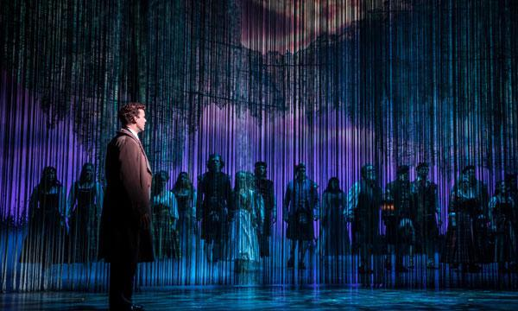

Ask:

1. In what way does this stage picture show spatial relationship? (one body to another, one body(ies) to a group of bodies, or body to the architecture.)
   1. Talk about how the bodies are relating to the architecture in this photo.
2. What is communicated to the audience through the spatial relationship of the man in front and the people behind the set drop.

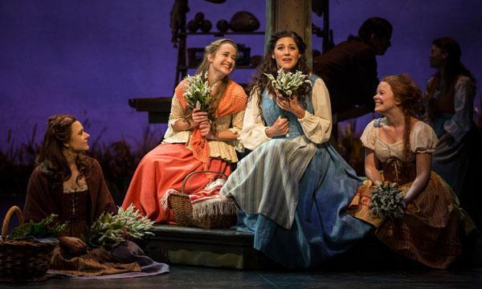

1. In what way does this stage picture bring show spatial relationship? (one body to another, one body(ies) to a group of bodies, or body to the architecture.)
   1. Discuss how this creates focus on the woman in blue.
2. How does the distance between these women tell us about their relationships?

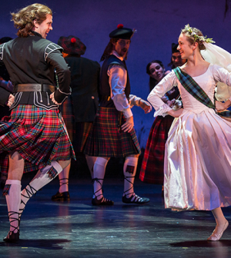

Ask

1. In what way does this stage picture bring show spatial relationship? (one body to another, one body(ies) to a group of bodies, or body to the architecture.)
   1. Talk about the power of triangles (a very powerful shape in making theatre pictures.
2. How might this picture be different if the man in the background was closer to the newly wed couple?

Last Ship Pictures

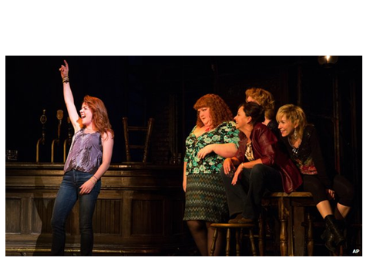

Ask:

1. In what way does this stage picture bring show spatial relationship? (one body to another, one body(ies) to a group of bodies, or body to the architecture.)
2. What does this tell us about the relationships between these characters?

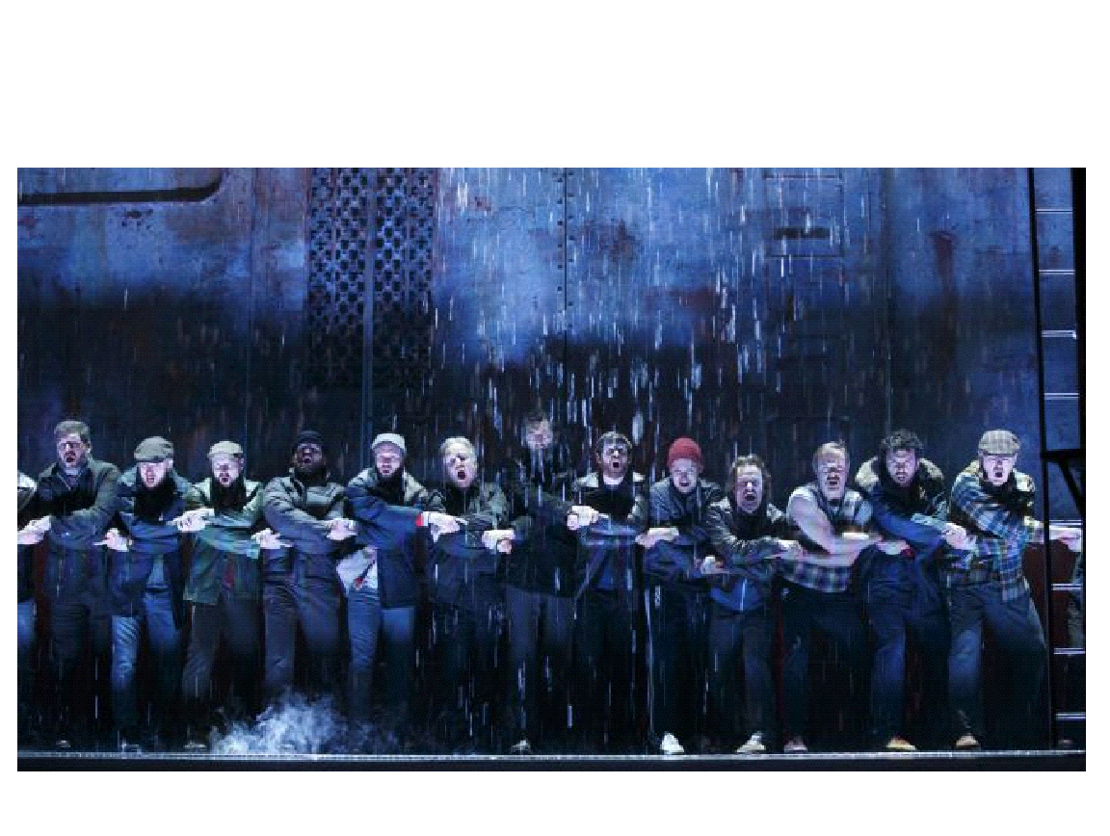

Ask:

1. In what way does this stage picture bring show spatial relationship? (one body to another, one body(ies) to a group of bodies, or body to the architecture.)
2. What is being conveyed through the spatial relationship here?

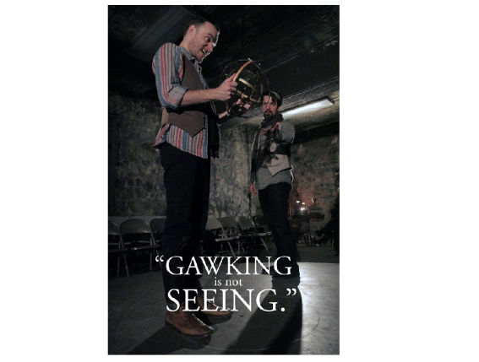

Ask

1. In what way does this stage picture bring show spatial relationship? (one body to another, one body(ies) to a group of bodies, or body to the architecture.)

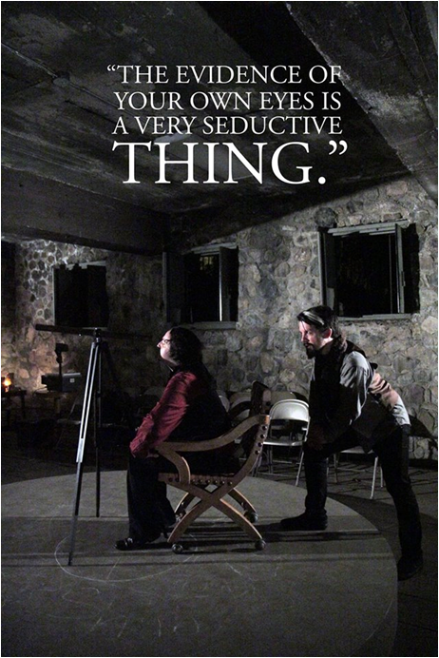Galileo-3-Davey-Morrison.jpg

Ask

1. In what way does this stage picture bring show spatial relationship? (one body to another, one body(ies) to a group of bodies, or body to the architecture.)

If you want two more to do- here are some more.

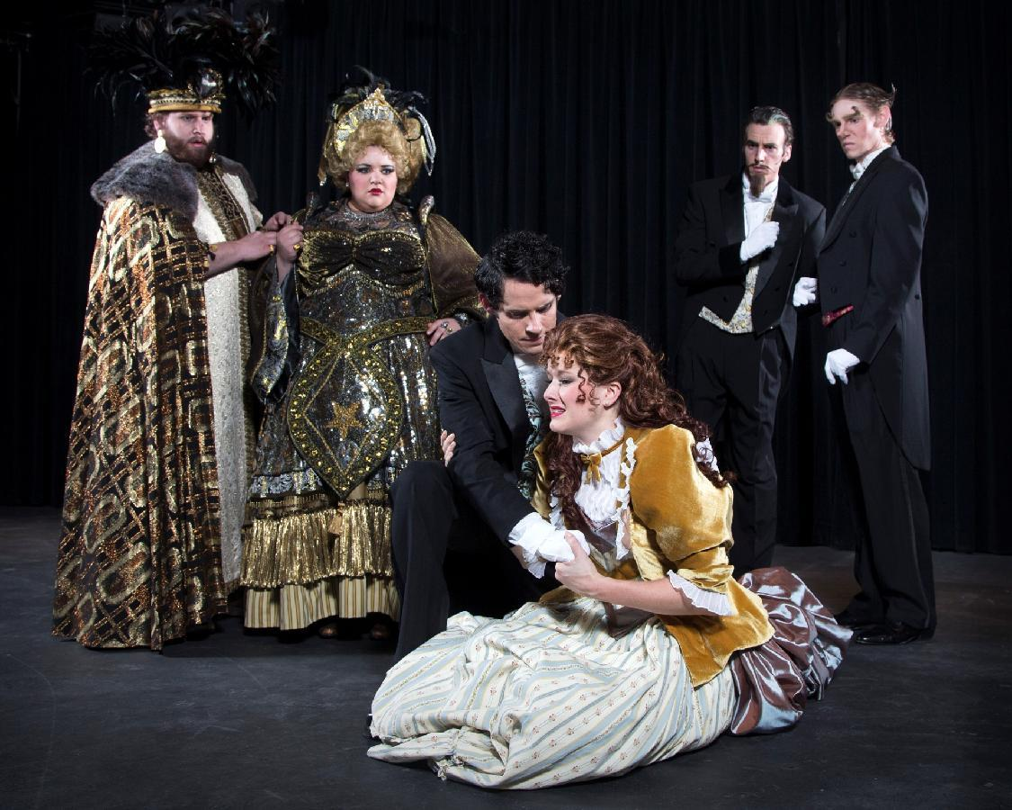

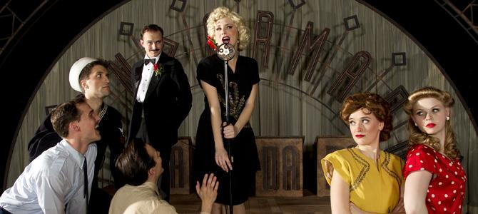

Transition Discussion

We’ve discussed what it looks like, but let’s talk about how to do it.

1. In what ways do we use spatial relationships in our everyday lives?
   1. Personal space
   2. Intimate (friends and significant others) space

Let’s explore up on our feet some ways of using spatial relationships to our advantage.

**Step 2:** Bombs and Shields (10 minutes)

*(Goal: To encourage students to use Spatial Relationships to achieve something, as well as to warm them up for the final activity)*

Explain that each person must identify 2 other people in the room and label them silently; 1 person is their ‘bomb’, the other person is their ‘shield’. Participants must keep this a secret and not let on to other players who has been identified as bomb and shield.

Once everyone has had a chance to identify their ‘bomb’ and ‘shield’, you have all players stand up. Then explain that when you say “go”, they are to start walking around the room making sure the keep their ‘shield’ between themselves and their ‘bomb’. They cannot stand still during this game, they must keep moving.  People will start moving very quickly.  Ensure the room is safe for running, or make a rule that there is no running.

After a few minutes, call “switch”; now the ‘bomb’ becomes your shield, and the ‘shield’ becomes your bomb. There will be several moments of chaos, and everyone tries to run and adjust their positions.

After a few more minutes, call ‘stop’. Then, before you debrief this game, you must allow the group time to talk about who was their ‘bomb’ and ‘shield’. Once everyone has chatted briefly, have the group sit down.

Transition Discussion:

1. In what ways did you try to use spatial relationships in this game?
2. Did you ever break social personal space rules? Why or why not?
3. In what ways did we see spatial relationships between people? (one body to another, one body(ies) to a group of bodies, or body to the architecture.)
4. If you are playing a character, how can you use spatial relationship to show your feelings about a person or a group of people?
   1. Can anyone think of specific examples from a film/TV show/ play? If you are playing a character, how can you use spatial relationship to achieve something (or to get something a character wants)?

As always, it is not often that you all will just be creating spatial relationships without being inspired by some kind of text or other piece of art. Since I showed you a lot of pictures from musicals, let’s see if we can’t find ways to interpret spatial relationship from a song.

**Step 3:** Create Scenes Based on a song (30 minutes)

*(Goal: to help students use spatial relationship based on some kind of stimulus.)*

(Divide the group into groups of 6) In your groups, you are going to create a short 30 second silent scene based on the song that we are about to listen to.

While the song is playing, write down or think about some themes that you hear in the song.

(Play *Wedding Day at Troldhaugen* by Grieg. Don’t tell them the name though! It may influence what themes they choose. This is best if played from an Ipod or something, but a link is below to a youtube video if needed. Listen to the first two minutes of the song.)

<https://www.youtube.com/watch?v=WVra2IotK-M>

Or see the downloaded version of the song with better quality. (play 4:07-4:47)

Wedding Day at Troldhaugen

Explain that they will be creating a 30 second silent scene that will be accompanied by this song.

Now get together as a group and each person share briefly their main themes of the song, and possible stories that they could tell in their scene. It is okay to have thought of something completely differently than others did. By the end of the conversation, have the group decide on one theme to focus on one theme. Take 5 minutes to do this.

* What does this song sound like to you?
* Does it remind you of any experiences from your life?
* What moods or themes do you hear?
* As a group, decide what story you want to tell in response to this song.

Once you have decided on a theme, take the next 10 minutes to create a 30 second scene based off that story. If there are not enough characters in the scene for everyone to have a character, think about how you can include background people to create scene pictures.

Oh yeah, and this scene must use spatial relationship and other things we have learned to convey the theme/story without words!

**Step 4/Assessment**: Perform! (20 minutes) (2-3 min. per group)

*(Goal: To discuss how things can be interpreted in different ways, or from different perspectives.)*

Each group is going to perform for the class. After each performance have a short discussion.

Teacher Note: Make sure to write some feedback on how they are using viewpoints. Up until this point in the unit, they have never received feedback on their work!

Ask audience

1. What did you interpret from their scene?
2. Why did you interpret that? (Use vocab- spatial relationship, shape, etc.)
3. How did this group use spatial relationship to convey meaning?

As an audience member what could convey a more appropriate meaning?

**Assessment:** Students will receive four participation points for participating and being actively engaged in the class discussion. They will also receive up to six points for their viewpoints performance in response to the song. Proficiency will be 8/10 participation points.

**Teacher Note:** Make sure to write down any students that may need participation points dropped that day. (Playing on phone after they were asked not to, distracting others from working, etc.) It might be a good idea to assess each of the scenes as you would the final, but give them full points for doing the assignment. This will help you to see where each of the students are at, as well as help give them feedback that will direct them towards the final.

**Lesson 4: Review Worksheet**

Names_____________________________________________________________________________

Read the following scenario and solve the mysteries below.

A serial killer is on the loose! A man was killed on Bulldog Blvd. last night. Videos from local businesses show that an unidentified person hid behind a tree in a gorilla costume and jumped out in front of the walking man. The man’s heart stopped and never started again. Five other murders happened that night and police believe they might be by the same killer. Fibers of the gorilla costume were found nearby each victim. The man has not been found, but left the gorilla suit in a garbage can near the last victim, who was found in the Provo High School theatre classroom, with a note that said, “I don’t understand why no one thought it was funny.”

Your job is to get into the mind of this vicious serial killer and figure out where he is currently.

1. What clue might we look for in this scenario that would represent the tempo of these murderous deeds?  (This part of the story will need to be demonstrated to the class)
2. What clue might we look for in this scenario that would represent the duration of the killing action? (This part of the story will need to be demonstrated to the class)
3. What clue might we look for in this scenario that would represent the kinesthic response the killer is looking for? (This part of the story will need to be demonstrated to the class)
4. What clue might we look for in this scenario that would represent the repetition the killer was doing?
5. What clue might we look for to determine the shape of the killer’s body at the moment of the killing? (This part of the story will need to be demonstrated to the class)
6. 2 part question. From what perspective is our story told currently? What would it look like told from a different perspective? (must choose a perspective and tell story from that perspective)
7. Now that you have gotten inside of the killer’s mind and assessed the situation, can you answer where the killer is now?

**Lesson 5: Viewpoints of Space—Gesture**

Teacher on roll: Nichole

**Objective:** Students will be able to demonstrate their understanding of behavioral and expressive gestures by participating in a game of charades that tests their ability to communicate differences in physical gesture.

**Standards:**

* **TH:Re8.1.I.c.** Justify personal aesthetics, preferences, and beliefs through participation in and observation of a drama/theatre work.
* **TH:Pr5.1.I.a.** Practice various acting techniques to expand skills in a rehearsal or drama/theatre performance.

**Materials:**

* Charades words on slips of paper in a bowl or hat
* Whiteboard and markers
* Timer
* bag of final assessment objects
* copies of the final assessment rubric

**Step 1:** Ask students to find a person with shoes most similar to their own. Assign students to work with partners based on having similar shoes. (This could really be anything, just an opportunity to get students working with new people).

Once in partnerships, one student becomes the sculptor and one is the model. In response to a stimulus word, sculptors will use their hands to model the statue. They touch the statues’ bodies, achieving the desired effect down to the smallest detail.

Explain the rules: sculptors cannot use their own bodies to show the image or expression they want to see reproduced. Students should complete the exercise without talking. The goal is “for the sculptor and the statue to understand each other, so that the sculptor’s gestures, *seen and felt,* may be easily translated by the statue” (“The Modelling Sequence” from *Games for Actors and Non-actors* by Boal).

Side-coaching:

* Find a part of your model’s body that you haven’t sculpted yet. Think of a more interesting pose!
* Remember, no talking! How can you make your gesture more specific to help your partner know what you’re thinking?

When the students are finished, encourage them to look around the room and see how different sculptors and statues interpreted the stimulus word.

Discussion questions:

1. What differences or similarities do you observe in your classmates’ response to [the word]?
2. How do different responses benefit theatre work?

At the end of this phase, partners switch roles as the sculptors and statues. Now, in this second phase, sculptors must move away from their statues, while still continuing to make the same sculpting gestures without touching their models. “The statues, who previously ‘saw’ and ‘felt’ these gestures, still ‘see’ them, but not longer ‘feel’ them; they must continue to respond as if they were feeling them.”

Expressive words to sculpt:

* Welcome
* Peace
* Agony
* Confidence

Side-coaching:

* Don’t allow yourself to get closer to your statue.
* Do not make ‘symbolic’ gestures like motioning your statue to move a certain way or telling them ‘No, that’s not it’. You must make realistic sculpting gestures.
* Try something new. Help your statue ‘see’ the gesture you’re imaging.
* Oops! Remember you cannot speak out loud during this exercise.

Again, when students are finished, invite them to look around the room and observe each other’s work.

**Step 2:** Have the students return to their seats. Ask them the following discussion questions:

*(Goal: to discuss how we use movement and gestures to communicate with one another.)*

1. Which role was more challenging: the sculptor or the statue? Why do you think so?
2. How did you adapt your gestures to be more successful?
3. When might you use gestures and poses like this in theatre?
4. How would communicating your personal interpretation of something be important in theatre work?

Now that we have practiced creating gestures, let’s talk about two different types of the viewpoint ‘gesture’. I strongly encourage you to take notes on this because I won’t be handing you the definition otherwise today.

“Gesture is ‘shape’ with a beginning, middle, and end. Gestures can be made with your hands, arms, legs, head, mouth, eyes, feet, stomach, or any other combination of body parts.”

Explain to the class that there are behavioral gestures and expressive gestures. Behavioral gestures are what we see every day, like in the grocery store or school: scratching, pointing, waving, sniffing.

Write these behavioral gestures on the board under the label ‘Behavioral’.

Behavioral gestures can further be broken down into private and public gestures, differentiating between the actions we perform by ourselves or in front of others.

Saluting and bowing would be public, behavioral gestures. You wouldn’t bow or salute by yourself in private.

What would a private gesture be?

Expressive gestures show an inner emotional state, like a desire, idea, or value. It is abstract and symbolic. You do not normally see expressive gestures in public places. It stands for emotions like joy, grief, or anger. We have discussed how themes are abstract concepts like greed, fear, love, etc. Expressive gestures are the gestures that can help us communicate abstract ideas and concepts non-verbally.

Ask: “What are some emotions, ideas, or values you can think of that we might use for expressive gestures?”

Write students responses on the board underneath the label ‘Expressive’.

Ask: “Were the gestures you sculpted more behavioral or expressive gestures? Why do you think so?

**Step 3:** Let’s practice creating gestures with different parts of our bodies. Everyone please find your own space in the room where you will not bump into others. Everyone stand and face forward, ready to work.

Select a word from off of the Expressive list on the board. Choose different body parts and have the students practice making gestures with that body part in response to the Expressive word. For example

* Practice expressive gestures for ‘freedom’ using just your shoulders and back.
* Practice expressive gestures for ‘pain’ using just your head and eyes.
* Explore expressive gestures for ‘happiness’ using your arms and hands.
* Explore expressive gestures for ‘exhaustion’ using just your legs and feet.

Side-coaching:

* Try not to use your other body parts!
* Keep on exploring. Try something new.
* Remember: gesture is a shape with a beginning, middle, and end. If you’re stuck, think of some of the shapes we practiced two days ago.
* Try not to use behavioral gestures! Remember expressive gestures are abstract, symbolic, and represent an inner state or emotion.

Have the students return to their seats. Ask,

What were some of the physical choices you made for those expressive words? What did you do? How did that feel?

**Step 4:** We will end class today playing a game of charades that will test your ability to create the viewpoint of the day: gestures.

Divide the class into two teams. They will play two games of charades in two rounds each. The first game is of behavioral words and the second game is of expressive words.

In the first round, the game is like Catchphrase, in that the team tries to guess the word based off of verbal clues (without using the word itself). In the second round, the team has to guess the word from gestures only, like charades. The same words are used in the second round as the first round so that students are familiar with the words.

Have students perform on volunteer basis. If necessary, ask students to come up based on the order they are sitting in. Set the timer for 1 minute each round. At the end of a round, count how many words the team guessed correctly and tally their points on the whiteboard.

**Step 5:** Distribute copies of the rubric (or project a digital copy) for them to reference. Give the foundational instructions and scaffolding for the unit assessment:

We have been practicing using physical viewpoints to create theatre in response to words, paintings, pictures, music, and so forth. For your final project for this unit, you and your group will create a short theatre scene using physical viewpoints in response to an object. These objects may be everyday items, but try to challenge yourself to see them in new ways. We have been talking about all the different perspectives and interpretations people bring to theatre work. See how you can bring a unique perspective to your assigned object.

Put the students in groups of about 6-7. Have them select their object out of a bag, without looking.

1. Write all group members’ names on the paper.
2. Make observations as a group about their object: shape, color, size, line, etc. What does it look like?
3. List 4-5 themes or interpretations from your object. What does it mean?
4. Select the one theme your group is most interested in working on for your final performance.

**Assessment:** Students will be given up to 5 participation points for being engaged and on task during the class discussion and charades game. They will get an additional 5 points for turning in the Objects worksheet. Students will be docked 2 points if the themes they write down are not abstract ideas but are instead settings, nouns, or literal things. (For example, road trip does not work as a theme) Proficiency will be 8/10 points.

**Teacher Note:** Make sure to write down any students that may need participation points dropped that day. (Playing on phone after they were asked not to, distracting others from working, etc.) Make sure to give feedback about their choice of theme on the object worksheet. Do they have a solid theme that is based in abstract ideas?

**Lesson 5: Viewpoints of Space—Gesture Charades words**

**Kneeling**

**Bowing**

**Saluting**

**Kissing**

**Hugging**

**Waving**

**Smiling**

**Sneezing**

**Knocking**

**Carrying**

**Tying a shoe**

**Bending**

**Shrugging**

**Waiting**

**Calling**

**Driving**

**Bicycling**

**Jogging**

**Exercising**

**Crying**

**Watching**

**Texting**

**Drawing**

**Writing**

**Studying**

**Dancing**

**Cleaning**

**Singing**

**Cooking**

**Shopping**

**Eating**

**Paying**

**Knocking**

**Sleeping**

**Forgiveness**

**Interested**

**Playful**

**Thankful**

**Courage**

**Comfortable**

**Joy**

**Surprised**

**Confident**

**Curious**

**Loved**

**Angry**

**Disappointed**

**Guilty**

**Confused**

**Shy**

**Lost**

**Indecisive**

**Tense**

**Alone**

**Tired**

**Scared**

**Bored**

**Pain**

**Sad**

**Desperate**

**Hungry**

**Ann Bogart’s Physical Viewpoints**

**Final Project**

**Description:** In groups, create a silent 2-4 minute scene based on a theme, and accompanied by music. Use all the viewpoints

**Step 1: Theme based on an object.**

* Complete the analysis worksheet based on the object assigned in class. Decide as a group on one theme to base the final project on. DUE _______________________________

**Step 2: Incorporated song**

* Choose a song that helps show the theme along with physical choices. Don’t base movement on the song, but instead base movement on the theme. Choose a song that would help to accompany this. DUE November 19th

**Step 3: Incorporated Viewpoints**

* In class (and out of class if your group needs more time) you will create a 2-4 minute piece. This needs to include all of the viewpoints. Submit an outline for the final performance. DUE __________________

Viewpoints of Time:

* Tempo,
* Duration,
* Repetition,
* Kinesthetic Response

Viewpoints of Space:

* Shape,
* Spatial Relationship,
* Gesture,
* Architecture,
* Topography

**Step 4: Perform and Respond!**

* Perform your short scene. Respond to at least 2 performances to the groups in class discussions.

**Viewpoints Final Assessment Rubric**

|  |  |  |  |  |
| --- | --- | --- | --- | --- |
|  | Excellent | Average | Below Average | Total |
| Integrated a theme from the prompt (25 points) | Complex ideas are presented in a creative, engaging, thought provoking way through performance. (21-25 points) | Ideas are presented in creative ways. The performance is sometimes thought provoking and engaging. (18-20 points) | Ideas presented are unclear, and performance is not creative, thought provoking and engaging. (0-20 points) |  |
| Viewpoints are incorporated (50 points) | Evident that at least 7 of the 9 viewpoints are incorporated. (44-50 points) | About 4-6 of the viewpoints are incorporated. (39-43 points) | 3 or less of the viewpoints are incorporated. (0-38 points) |  |
| Song is Incorporated (points 15) | Chosen song helps communicate the theme along with their physical choices (13-15 points) | Chosen song hints at a theme and informs physical choices. (10-12 points) | Chosen song is disconnected from a theme or physical choices. (0-9 points) |  |
| Response/Feedback to other groups (10 points) | Student responded to 2 different group scene performances. (10 points) | Student responded to 1 group scene performance. (5 points) | Student did not respond to any group scene performance. (0 points) |  |
|  |  |  | Total |  |

**Analysis for Final Project**

Names:_______________________________________________________________________________

Description: In groups, write down the observations that you have about your assigned object. Then derive possible themes that could be interpreted based on the observations you made. Decide on one theme to work with for your final project.

|  |  |
| --- | --- |
| Observations | Themes |
|  |  |

Our chosen theme for our final project is___________________________________________________

**Lesson 6: Viewpoints of Space—Topography and Architecture**

**Objectives:** Students will demonstrate their understanding of Topography and Architecture by participating movement-based activities to express mood and theme.

They will also demonstrate an understanding of the impact of music on a performance by participating selecting options for the song they will use in final performances.

**Standards:**

* **TH:Cn10.1.I.a.** Investigate how cultural perspectives, community ideas and personal beliefs impact a drama/theatre work.
* **TH:Re8.1.I.c.** Justify personal aesthetics, preferences, and beliefs through participation in and observation of a drama/theatre work.
* **TH:Pr5.1.I.a.** Practice various acting techniques to expand skills in a rehearsal or drama/theatre performance.

**Materials:**

**·**Computer/internet access

·       VGA Mac converter for projection

·       Projector/Projector Screen

·       Speakers

**TOPOGRAPHY**

**Prior to Step 1: Introduce that this is a silent activity and if they are talking, they won’t hear the instruction that’s given throughout the activity.**

**Hook**: Watch the first 45 seconds of this clip. <https://www.youtube.com/watch?v=XgJiEcF2Y7Y>

Ask:

What are some observations you have about their movement as far as you could see?

What did you notice about the path they moved?

This may be too difficult to answer. If so, then go straight into explaining topography.

Transition: We are going to be learning about the last two viewpoints today, and we are starting with topography. Take out your notes if you would like the definition today.

Topography: It is the floor pattern, or landscape we create throughout the space as we move through it. (Write on the board: Topography: landscape, floor pattern)

**Step 1:** Ask students to stand up and find their own space in the room. Have everyone close their eyes for a moment and breathe for a few moments in complete silence. Have them open their eyes and imagine their feet are dipped in red paint and every step they take and move they make paints a picture on the floor. Ask the students to start “painting” on the floor and to concentrate on making circles and curves as they move around the space. To further prompt them as they move around, you might say the following:

* Think of movements that are smooth or curved, circular or wavy, and make those shapes with their movement throughout the space.
* If the audience were above us, would they be able to see those shapes in the floor pattern you are creating with the red paint?
* Ask students to start thinking about ways this movement and creation of what is called Floor Pattern can affect the movements in the rest of their bodies.
* Ask the students to now think of sharp and straight lines and begin moving around the space that way. Prompt them in a similar manner to that of the curved and circular movements.
* Suggest different characters for the students to portray which may require sharp, smooth, or combined shapes.
  + Soldiers, Fairies, ballet dancers, lumberjacks
* Suggest different emotions that might be portrayed through the floor pattern as well.

**Step 2:** Have everyone freeze where they are for a minute and comment on their progress understanding the floor pattern aspect of topography. Now, we are going to explore the landscape.

1. Everyone walk toward the front of the room as though they are moving through a thick weeded jungle swamp. Now the wind is blowing really hard, but keep walking. That’s landscape!
2. Everyone walk from one end of the room to the other as though you are in the forest following a treasure map. How do you have to move to avoid running into trees? Is the treasure map going to be interesting if it’s a straight line? Your final treasure map is floor pattern!

**Step 3:** Have students gather in a circle and discuss their experiences. Make sure they understand topography and evaluate their progress through this discussion. Some questions you might ask are:

* How could the pattern we create on the floor be important in a performance to convey meaning? How can the landscape we create convey meaning in performance? How does this help us make acting choices?
* What are some of the things you discovered as you experimented with hard lines versus curved?
* What types of lines and shapes did you find yourself making as you portrayed anger? Love? Fear? Excitement? Freedom? Captivity?

**Transition to Architecture**

This time they will imagine that their entire bodies are dipped in endless red paint and begin to move around the room. They must consider the floor pattern they leave with their feet (topography) but also the marks they leave behind on the solid objects in the room, on the air around them as they play with light and react to sound, on the textured wall they ran their hands over, etc.

* Keep moving but when the song plays, move around the room, still imagining that red paint all over your body, to express whatever emotions, feelings, or themes this song expresses for you. Play contrasting song clips. We chose the songs, “Wake Up” by Arcade Fire (20 seconds). Switch the song to, “Comeback Kid” by Sleigh Bells (20 seconds). Switch to “Households” by Sleeping At Last (20 seconds).
* Have students gather in semicircle near board.
  + What affect did the music have on our movements? As you reacted to the song, was it a reaction to the words and story or the emotions and moods that it created?

**ARCHITECTURE**

**Step 1:** Have the class gather in a circle. What we just did as we imagined our entire bodies dipped in red paint, has a lot to do with a viewpoint called Architecture. What might architecture as a viewpoint mean?

Explain that in viewpoints the word architecture refers to five different aspects of the design or makeup of our physical surroundings: solid mass (or objects), texture, light, color, and sound (Write these on the board). Invite them to take notes as we discuss what each facet of architecture is so they will be prepared for the final quiz.

**Step 2:** SOLID MASS. Ask for a volunteer from the class. Have that volunteer interact with a piece of furniture in the room. (twirl with it, tip it over, reach for it, etc.) Have a class discussion using the following questions:

* How does the interaction of the volunteer in relation to the object(s) convey meaning?
* Image this volunteer’s whole body was dripping in endless red paint. What would the picture look like that they just painted with that object?
* What is the mood of the image?
* What are some possible themes?
* What kind of story might this image be telling?

**Step 3:** LIGHT – Ask for a different volunteer from the class. Have them stand directly in or under the light. How does staring up at the light or crouching away from the light change the story, mood, or theme? What are some other ways to interact with the light? (might need to prompt: playing with light with hands, standing in shadows, weaving in and out of lighted spaces in room, etc.)

**Step 5:** SOUND, TEXTURE, COLOR -

* Close your eyes and listen. What are some of the sounds in this room? Air conditioning? Creaky floor board?
* How might that affect our movement?
* Ask students what some of the textures and colors in the room are.
* How can we interact with those textures and colors? If needed for texture, use the example of the floor. It is smooth and flat. How do the bottom of our shoes react to this floor? Can we slide? Does the texture of the floor also affect the sounds in the room as we walk across it?

**Step 6:** Ask the students to find their own space in the room. Have them start moving around the room focusing on their interaction and relationship to the objects in the room (i.e. the windows, the walls, the floor, the furniture). Prompt them when appropriate to start focusing on interacting or moving in relation to the light. Then the textures, colors, and sounds. Prompt them to think about topography, the floor pattern and landscape as they interact with the architecture.

**Step 7**: Now play a song. “When I Grow Up” by Fever Ray is a good one. Continue to encourage them to interact with the architecture, exploring sound specifically. Following the mood, emotions, and messages of the song can help inspire their movement.

**FINAL PERFORMANCE: ARCHITECTURE AND MUSIC**

**Step 1:** Allow students to get into their groups for the final. Hand out a notecard for each group. Have them write their names on the notecard. Have students get into their final groups. They have already chosen a theme to work with for their final performance. Give them 1-2 minutes to discuss as a group what their setting will be for their performance. Have them write their chosen setting on the card and turn it in.

**Step 2:** Brief Discussion: What are the benefits of having music in a performance? Inform students that they will using a song in their final performances. But the song must ADD to their chosen theme and not provide a new theme or detract from the theme they have already explored. Have a brief discussion with them about what makes a good song choice for a performance, referring back to the songs used earlier when learning topography. Encourage them to choose songs that express their chosen mood or theme, not just a song that tells a story or has catchy lyrics.

**Step 3:** Assign each group to come to class next time with two options for their song choice in mind. If they did not have a chance to come up with options during class they are still expected to discuss with one another and decide as homework outside of class. They will need to be able to justify their song choices and why they think it expresses their mood or theme well. They will also need a way to play the song aloud to share with the teachers and to use as they start to rehearse with their song in class next time.

**Assessment:** Students will receive 10 participation points if they are actively engaged during the guided activities, discussion, and also turn in an exit card, 5 points. Proficiency will be 8/10 participation points for activities and discussion, and the exit card will be 5/5 points.

**Teacher Note:** Make sure to write down any students that may need participation points dropped that day. (Playing on phone after they were asked not to, distracting others from working, etc.)

**Lesson 7: Combining Viewpoints—Starting Final Scenes**

**Standards:**

* **TH:Cn10.1.I.a.** Investigate how cultural perspectives, community ideas and personal beliefs impact a drama/theatre work.
* **TH:Re8.1.I.c.** Justify personal aesthetics, preferences, and beliefs through participation in and observation of a drama/theatre work.
* **TH:Pr5.1.I.a.** Practice various acting techniques to expand skills in a rehearsal or drama/theatre performance.
* **TH:Cr3.1.I.a.** Practice and revise a devised or scripted drama/theatre work using theatrical staging conventions.

**Objective:** Students will demonstrate their ability to use viewpoints in making performance choices by participating in guided activities in their final performance groups.

**Materials:**

* 40 index cards

**HOOK:** Have students stand up. Call out the different viewpoints one at a time, including sub-categories like behavioral gesture and solid mass (architecture). As each term is said, students will seek to individually create an image (either frozen or moving but generally staying in one place in the room) that best represents that viewpoint.

**Step 1:** After this warm-up, remind students that they have a vocabulary quiz next class period. In preparation, we will be doing some activities that will help us review the viewpoints and prepare for final group performances. Let the class know that the purpose of these activities is also to guide them through creating their final performances. The things they come up with in their groups today can and should be used in their final performances**.**

**Step 2:** TOPOGRAPHY, ARCHITECTURE - Have students get with their groups for their final scenes. We will be doing class activities but they will participate within these groups.

Have them create two tableaux based on that theme. Instruct them to consider their placement in relation to the five facets of architecture. Once they have come up with their tableaux, ask them to start doing their tableaux one right after the other. Without discussion or pauses, imagine there is red paint on their feet again and practice going from tableau 1 to tableau 2, incorporating any movements that would be required to get from one image to the next. They might need to add certain movements or actions to make the tableaux connect to each other.

* How was this tableau activity helpful in exploring theme?
* Was it helpful to have two strong images and then work on ways to connect those images through movement? Why or why not?
* How can these tableaux help us create a visually meaningful theatre performance?

**Step 3:** SHAPE, SPATIAL RELATIONSHIP – Have students go from tableau 1 to tableau 2 focusing on the Shape of their bodies and of the images of their placement in relation to each other. They might want to think about playing with levels. You may prompt them with ideas such as, make sharp, bold shapes this time. This time, make the transition a rounded, soft shape. Take 1 minute in your groups and talk about the transitions you have enjoyed the most so far.

**Step 4:** GESTURE - Now let’s add some character development. Why are your characters moving the way that they are? What are their relationships or emotions toward one another? What are some ways your character might move (their topography, their shape, their interaction with architecture, etc.) that other characters in your images/scenes so far might not? What are some gestures your character might make? Think of at least one behavioral and one expressive gesture to use apiece as we go from tableau 1 to tableau 2 again.

**Step 5:** Have them pull out worksheets and go over it with them briefly, explaining expectations for the final performance (going over rubric), and reviewing the 9 viewpoints.

**Step 6:** Song Selection – Give students 15 minutes to discuss and decide on which things they want to keep in their final performance and what things they might eliminate or alter. Make sure they are writing down their ideas, the sequence of things that are happening in their piece, and the character choices they each made. As they work, go around to each group and spend 3 minutes listening to enough of their song choices to get a feel for each one. Ask questions such as, “Which of these songs best represents the theme or mood of your piece? Will that song add or detract from the work we have just created together?” Approve a song for each group.

**Step 7:** Have students find their own space as groups—they may have to go out in the hall and different rehearsal spaces. Make sure a teacher remains in each general area to keep an eye on the groups at all times. Before they go to their group workspace, make sure that when students are in their groups, they are playing their song and going through their scenes up to this point considering how they might incorporate the viewpoints of DURATION, KINESTHETIC RESPONSE, TEMPO, AND REPETITION. Make sure groups write down their discoveries.

**Step 8:** How can what we learned in this exercise be helpful for our final performances? Will your group be using any of the images, tableaux or movements that you discovered? How did the songs help incorporate those four viewpoints into the pieces?

**Step 9:** Pass out index cards in the last five minutes of class and ask the students to write their name and their current understanding of combining the viewpoints to make performance choices.

* Do you feel confident in combining viewpoints to create performance choices?
* Which viewpoint is hardest for you to incorporate into your scene?

Have students turn in the index cards on their way out the door.

**Assessment:** Students will receive 10 participation points if they are actively engaged during the guided activities, discussion, and also turn in an exit card. Proficiency will be 8/10 participation points for activities and discussion, and the exit card will be 5 points for completeness.

**Teacher Note:** Make sure to write down any students that may need participation points dropped that day. (Playing on phone after they were asked not to, distracting others from working, etc.)

**Lesson 8: Viewpoints Rehearsal**

**Objective:** Students will demonstrate their understanding of the viewpoints by taking a quiz, and by rehearsing and turning in a final outline for their performance that incorporates what they have practiced.

**Materials:**

* Viewpoints Quiz

**Viewpoints Quiz:**

**Match the correct word and definition by writing the bolded letter in the space provided below. (3 points each)**

**1. Tempo ______**

**2. Kinesthetic Response ______**

**3. Spatial Relationship ______**

**4. Shape ­­­­­­­­­­______**

**A. The distance between things on stage.**

**B. The design created in movement through the space.**

**C. The spontaneous reaction to motion outside of oneself.**

**D. A movement involving part or parts of the body.**

**E. The rate of speed at which movement occurs.**

**F. The outline the body makes in space.**

**4. How can the use of Topography affect the story, theme, or idea being performed? (4 points)**

**5. Explain the difference between behavioral and expressive Gesture. (4 points)**

**6. You want to tell a classic fairy tale without words. Explain how you might tell that story using at least 3-5 viewpoints (10 points)**

**Step 1:** Pass out the quiz to students as they come in. Give students 15 minutes to complete the quiz.

**Step 2:** Have students get into their groups. Explain that for the next 25-35 minutes they will be rehearsing their scenes and finalizing details for the final performances. Hand out the rubric expectations for the final performance. Explain that they must turn in an outline of their performance by the end of the day.

**(ALL)** As the groups rehearse, move around amongst them and ask any of the following:

* How are you incorporating the viewpoints here?
* Have you written an outline of your performance to turn in?
* Who are your characters? What are some of the choices your character makes?
* How long is the performance? Have you timed it? What things do we need to add or take away?

As groups start to develop their scene more, ask for a preview of what they have so far and give feedback.

**Step 3:** Spend the last few minutes of class going over performance day expectations.

* Students are expected to be present, on time, and prepared.
* They are expected to show respect for each other by being quiet during performances and actively participating in a constructive feedback session for each group. What are some other ways we can show respect for one another?

**Assessment:** Have students turn in their scene outlines.

The outline will be scored on completeness. If it does not contain a beginning, middle, and end then they will be deducted three points for each. There is no correct way to complete the outline. The contents of the outline will be assessed for understanding and will be given feedback. Proficiency will be 7/10 points. The quiz will be worth 30 points, and will be graded on ability to explain viewpoints of time and apply them to a visual. Proficiency will be 24/30 points.

**Lesson 9: Viewpoints Performances**

**Objective:** Students will demonstrate an ability to respond to a work of art and understanding of the viewpoints by performing and reflecting on 2-4 minute group scenes.

**Standards:**

* TH:Cn10.1.I.a. Investigate how cultural perspectives, community ideas and personal beliefs impact a drama/theatre work.
* TH:Re8.1.I.c. Justify personal aesthetics, preferences, and beliefs through participation in and observation of a drama/theatre work.
* TH:Pr5.1.I.a. Practice various acting techniques to expand skills in a rehearsal or drama/theatre performance.
* TH:Cr3.1.I.a. Practice and revise a devised or scripted drama/theatre work using theatrical staging conventions.

**Materials:**

* Rubrics for each group need to be printed out
* Class roll

**Preparation:** Objective on Board: Performance Day!

**Hook:** Triangle Flow Physical Warm-up (5 minutes)

*(Goal: To get students warmed up and ready for group work.)*

The class should get into their groups for the performance, and then further divide so that everyone is in groups of 3.

Each group will get into a triangle (or a diamond if there needs to be a group of four), with everyone’s facing the same direction. The leader of the triangle will begin the stretching and moving. Make it slow, deliberate, and meaningful as a warm-up. It may be a good idea to demonstrate this before having the students do it.

Then at some point, the leader must find a way to non-verbally switch to another leader. After a while, that leader must find a way to switch to another leader.

After 5 minutes, stop the students.

**Step 1:** Brief Rehearsal Time (10 minutes)

*(Goal: To give students time to remind themselves of their scenes.)*

Give the students 10 minutes to quickly rehearse their scenes.

**Step 2:** Perform and Reflection (65 minutes)

*(Goal: To assess their learning of the viewpoints and basic analysis skills.)*

Each group will have 10 minutes to perform and for the class reflection.

Teacher Note: Record all performances on video so that you can grade them later.

After each performance, ask the following questions as a reflection to the class.

1. What was the most powerful part of their performance? Why?
2. What did their scene convey to you? Why?
3. What were some ways that you saw them using the viewpoints?

(Have one teacher be marking who is responding to the scenes. This is part of the assessment.)

**Step 3**: Have student report how many times they responded to a group. Have them turn this in before leaving.

|  |  |  |  |  |
| --- | --- | --- | --- | --- |
|  |  |  |  |  |
|  |  |  |  |  |
|  |  |  |  |  |
|  |  |  |  |  |
|  |  |  |  |  |

**Viewpoints Final Assessment Rubric**

|  |  |  |  |  |
| --- | --- | --- | --- | --- |
|  | **Excellent** | **Average** | **Below Average** | **Total** |
| **Integrated a theme from the prompt (25 points)** | **Complex ideas are presented in a creative, engaging, thought provoking way through performance. (21-25 points)** | **Ideas are presented in creative ways. The performance is sometimes thought provoking and engaging. (18-20 points)** | **Ideas presented are unclear, and performance is not creative, thought provoking and engaging. (0-20 points)** |  |
| **Viewpoints are incorporated (50 points)** | **Evident that at least 7 of the 9 viewpoints are incorporated. (44-50 points)** | **About 4-6 of the viewpoints are incorporated. (39-43 points)** | **3 or less of the viewpoints are incorporated. (0-38 points)** |  |
| **Song is Incorporated (points 15)** | **Chosen song helps communicate the theme along with their physical choices (13-15 points)** | **Chosen song hints at a theme and informs physical choices. (10-12 points)** | **Chosen song is disconnected from a theme or physical choices. (0-9 points)** |  |
| **Response/Feedback to other groups (10 points)** | **Student responded to 2 different group scene performances. (10 points)** | **Student responded to 1 group scene performance. (5 points)** | **Student did not respond to any group scene performance. (0 points)** |  |
|  |  |  | **Total (100 points)** |  |

**Assessment:** The group scenes will be worth 100 points, according to the rubric. 85/100 points will be proficient.