*Once Upon a Mattress*

**Fun**

*(paste crossword puzzle here)*

**Across Down**

3 Where Does Winnifred 1 What is the prince’s name?

come from? 2 What does the queen put

5 How many mattresses does under the mattress?

Winnifred sleep on? 4 What does Winnifred say she is?

8 What is Sir Harry’s 6 Who does the queen plot with?

girlfriend’s name? 7 The queen has everyone ______

10 What does the jester put to make Winnifred tired.

under the mattress? 9 No one can __________ until

11 What is Winnifred’s Dauntless does.

nickname? 12 The curse will be broken when

12 What do Lady Larken the_______ devours the hawk.

really want to do?

What happens when the curse is broken?

**Mask Club**

*presents*

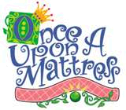

***Music by:*** Mary Rodgers ***Lyrics by:*** Marshall Barer

***Book Authored by:*** Marshall Barer, Dean Fuller, Jay Thompson

***Premiered:*** Monday, May 11, 1959 at the Phoenix Theatre, New York

directed by

*Content Maxwell*

April 10, 2008

**Once upon a time. . .**

. . . in the summer of 1958, a young lady and her friends (Rodgers, Barer, and Thompson) at a summer resort in the Poconos mountains of New York wrote a one-act musical play based on a fairytale by Danish poet and author, Hans Christian Andersen--*The Princess and the Pea*. They created the play in 3 weeks, but the characters were created out of circumstance of who could play what. The King was rendered mute because the actor could not sing. A diva was playing the Queen and insisted on having the most lines. When Broadway designers and producers saw the play encouraged the writers to expand the script into a full-length musical. After rewriting the story and a title change, *Once Upon a Mattress* opened in New York City in May 1959. A year later, it was playing on Broadway and during its run, had 460 performances. Since then, it has been televised in 1964, 1972, and 2005, was revived on Broadway in 1996, and is now on DVD.

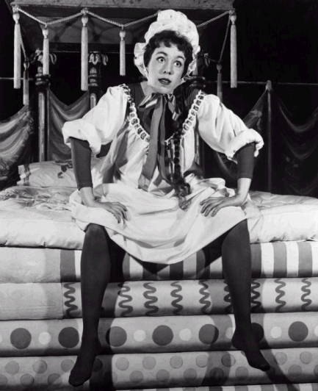 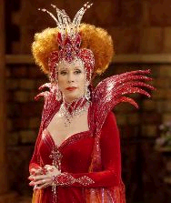

Carol Burnett performed in *Once Upon A Mattress* four times and played both Aggravain and Winnifred, one in the first production and one in the last. What year did she play which role?Which picture matches which role?

What is a Wizard?

A wizard is a sorcerer or a person who uses or

practices magic that derives from supernatural

or occult sources. They are common figures in *(paste picture here)*

fantasy literature and in mythology, legends,

and folklore. In medieval chivalric romance,

the wizard often appears as a wise old man

and acts as a mentor. Other witches and

magicians can appear as villains, as hostile to

the hero as ogres and other monsters.

What is a Minstrel?

Historically, a minstrel was a storyteller and a musician. He often performed songs that told stories about places far, far away--sometimes real places and sometimes imaginary. The events might be historical or pretend. Minstrels would write their own songs or sing other people’s songs. They made their living by traveling from town singing to the people they met and who would toss coins to pay for the entertainment; sometimes they performed for the Court and were paid by the royalty.

What is a Jester?

A jester is a clown from long ago.

*(paste picture here)* Jesters entertained the king and

queen and other members of the

Court by telling jokes, performing

tricks, and telling stories. A jester

was one of the few members of the

court who could speak freely in front

of royalty. They also made fun of

people who were a part of the court.

**The Cast**

The Minstrel Josh Cooper

Prince Dauntless Jacob Meldrum

Princess Winnifred Jessica Johnson

Queen Aggravain Marissa Memmott

King Sextimus, the Silent Josh Thompson

The Wizard Megan Straw

The Jester Josh Bolding

Lady Larken Kelsey Moss

Sir Harry Matthew Christensen

Princess Number Twelve Michelle Williams

Ladies-in-Waiting: Lady Phinga Carson McFarland

Lady Lyke Michelle Briggs

Lady Luk Tikla Brown

Knights of the Castle: Sir Lee Austin La Banc

Sir Loine Andrew Foree

Sir Mone Shawn Frenza

**Musicians**

Pianist Krista Holmes

Cellist & Penny Whistle Jennifer Chandler

Violinist Charlotte Capron

**Technical Crew**

Stage Manager Marti Hansen

Dramaturgs Elizabeth Lund

Heather Burgess

Choreographer Sarina Thomas

Costume Designers Mary Haddock

Rachel Herrick

Julie Nielson

Beard Mathew Leavitt

Spot Light Amy Roskelley

Light Board Katie Dahl

Sound Board Christina Tibbitts

Stage Hands Brianna Beatse, Meagan Wright

**Director’s Note**

Children can find adventure and wonder in even the smallest thing. Their imaginations are far more entertaining than even the best movie. They love and accept others, and they know they are of worth. Their inner worth is a gift that should always be nurtured and valued.

One way to foster imagination and worth is to give children the opportunity to attend and to participate in theatre. Children of all ages (3 ~ 93+) benefit from such experience. It is educational and a tool everyone to expand horizons, reach for the stars. Theatre rounds out a child’s education and helps develop talents as well as an appreciation for the arts. It also builds confidence, perception, and understanding.

As a theatre practitioner, I have the responsibility to provide theatrical opportunities to children so they can grow, and foster their self-esteem. That is why this today’s production have been created. we have invited children to see *Once Upon A Mattress*. I invite everyone in the audience to find the child within, and leap into a land of fantasy and fairytales, expand your horizons, and learn that you, too, are of great worth.

**What do you think?**

**What did you learn from this play?**

**What does Winnifred have that Dauntless did not have?**

**How does Winnifred help Dauntless?**

**What does Dauntless accomplish at the end of the play?**

**How can we value others and ourselves for who we are?**

**When you feel good about yourself, what can you do?**

**Why is it important to know that *you* have value?**

**How are you special?**

“The world would have you believe that you are of worth only if you have money, a certain physical appearance, stylish clothes, or social position. Over and over again, the Lord assures us of our worth and value to him.”

~ Elaine L. Jack, *Ensign Magazine*, June 1995

“Each [of us ] is a beloved spirit son of daughter of heavenly parents, and as such, each has a divine nature and destiny.”

~ *The Proclamation to the World*

**Are you a real prince or a princess?**

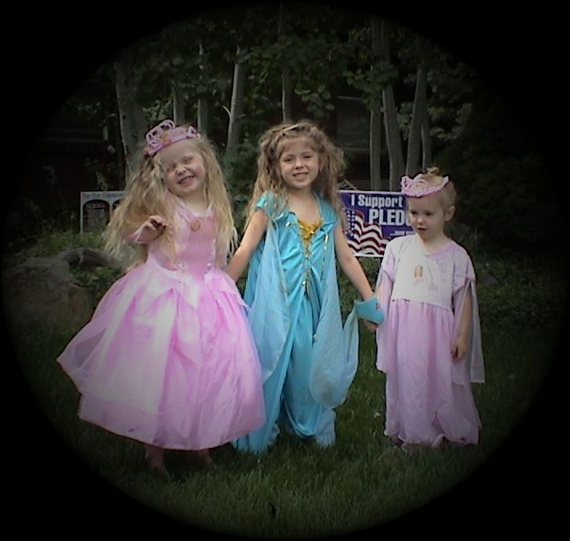

Answer:

______ _______ ______

**How is the story of** *The Princess and the Pea* **different from our play?**

**Bibligraphy**

<http://www.answers.com/topic/once-upon-a-mattress>

<http://en.wikipedia.org/wiki/H._C._Andersen>

<http://en.wikipedia.org/wiki/Once_Upon_a_Mattress>

Haugaard, Erik Christian. *Portrait of a Poet: Hans Christian Andersen, and his Fairytales*.

Washington, Library of Congress, 1973.

Toch, Ernst. *The Princess and the Pea: A Fairy Tale in one Act*. Translation by Marion J.

Farquhar. New York: Associated Music Publishers. 1953

Preeo, Max O. *Once Upon A Mattress,* the Broadway Gold, MCA Classics. Universal City, 1993.

**. . . in a far off land . . .**

Hans Christian Andersen was born on April 2, 1805

in Odense, Denmark. In Denmark,, he is referred to *(paste picture here)*

as merely "H. C. Andersen." He showed intelligence

and imagination as a young boy. He made himself a

small toy-theatre and made clothes for his puppets,

and reading all the plays that he could. Throughout

his childhood, he had a passionate love for literature.

After a short career on stage, he turned to writing. In

1835, Anderson published his first volume of fairytales

in which *The Princess and the* Pea was written. At the

time of his death in 1875, he had become an interna-

tionally renown poet and author.

**. . . there lived a princess . . .**

A prince wanted to marry a princess, but she *(paste picture here)* must be a real Princess. He travelled the world but could not find a real princess. So at last he returned home, but he was very sad. One evening there was a terrible storm. A knock at the town gate, and the old King himself sent to open it. A girl stood there in the rain. The water streamed down her hair and her clothes, but she said that she was a real princess. 'Well, we shall see,' thought the old Queen as she went to the bedroom and laid a pea under twenty mattresses with twenty featherbeds. The girl slept there. In the morning, when asked her how she slept, the princess said, 'I hardly closed my eyes the whole night! My whole body is black and blue!' They all knew that she must be a real princess. Nobody but a real princess could

be so delicate . So the prince took her to wife, for he was sure that he had found a real princess. The pea was put into the Museum, where it may still be seen if no one has stolen it.

**Pictures to be pasted in the program before printing.**

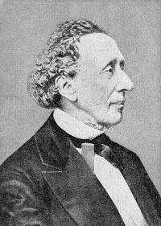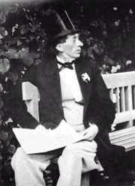 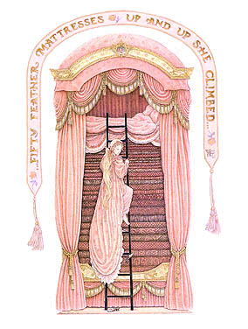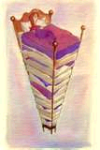 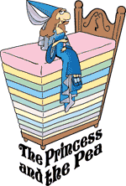 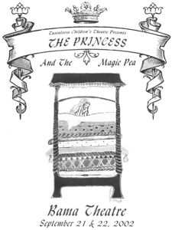

 Watermark to be placed behind center page t