**Midsummer Night's Dream - Directors' Concepts**

**Resource:** <http://www.lib.washington.edu/Subject/Drama/msndconcepts.html>

A director's concept changes the look and feel of a play. The following are examples of different directors' concepts.

**19th and early 20th century**

[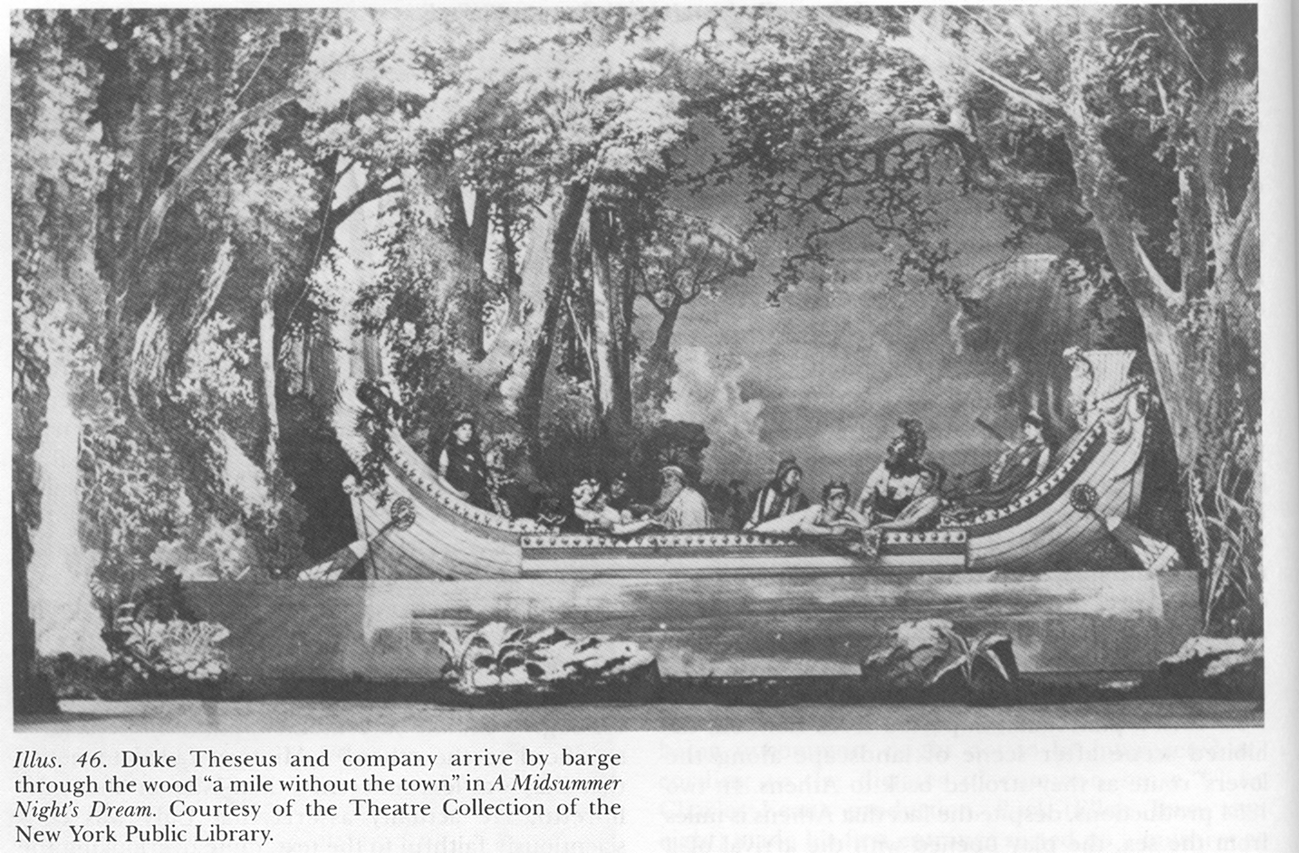](http://www.lib.washington.edu/Subject/Drama/image/msnd-rom1-large.gif)[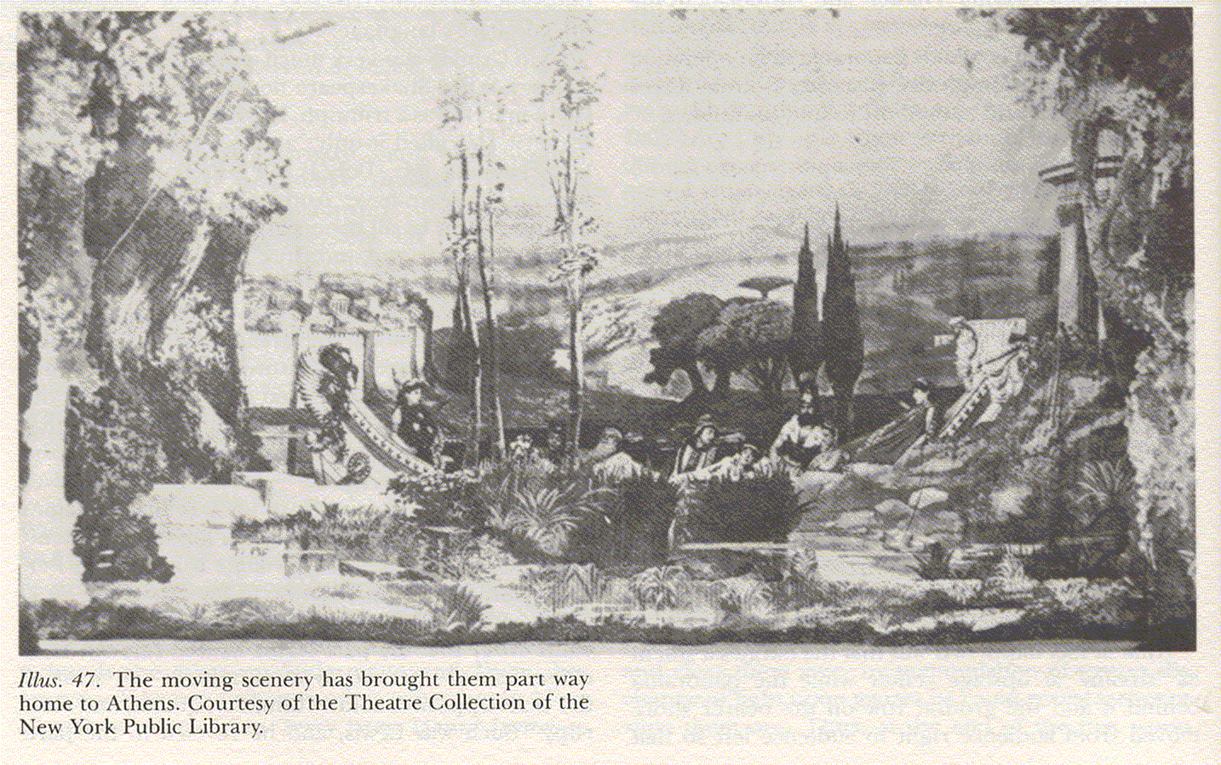](http://www.lib.washington.edu/Subject/Drama/image/msnd-rom2-large.gif)

Daly's 1867 production in New York with moving panorama of Theseus and Hippolyta's arrival Resource: Shattuck, Charles Harlen. *Shakespeare on the American stage : from the Hallams to Edwin Booth.* Folger Shakespeare Library, 1976. vols. 1-2. illus. 46 and 47

[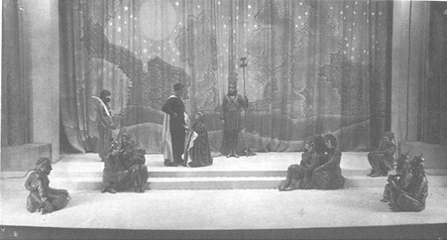](http://www.lib.washington.edu/Subject/Drama/image/msnd-barker.gif)

Granville Barker's 1914 production at the Savoy Resource: Griffiths, Trevor R. *Shakespeare in production: A Midsummer Night's Dream* Cambridge University Press, 1996. ill. 4 **Expressionism**

[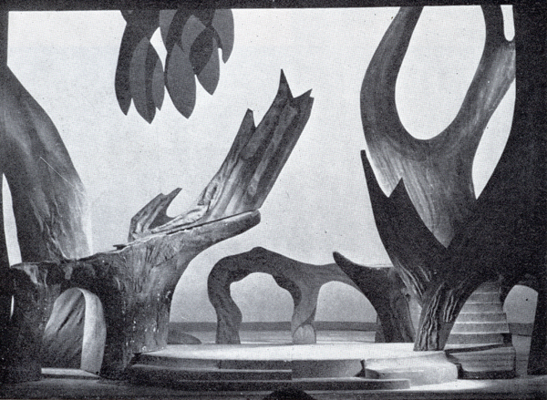](http://www.lib.washington.edu/Subject/Drama/image/msnd-morner1.gif)

Morner's 1956 production at the Kungliga Teatern in Stockholm Resource: Hainaux, René. *Stage design throughout the world since 1950*. ITS Publications, 1964. p.210

**Traditional vs. Outdoor Stagings** [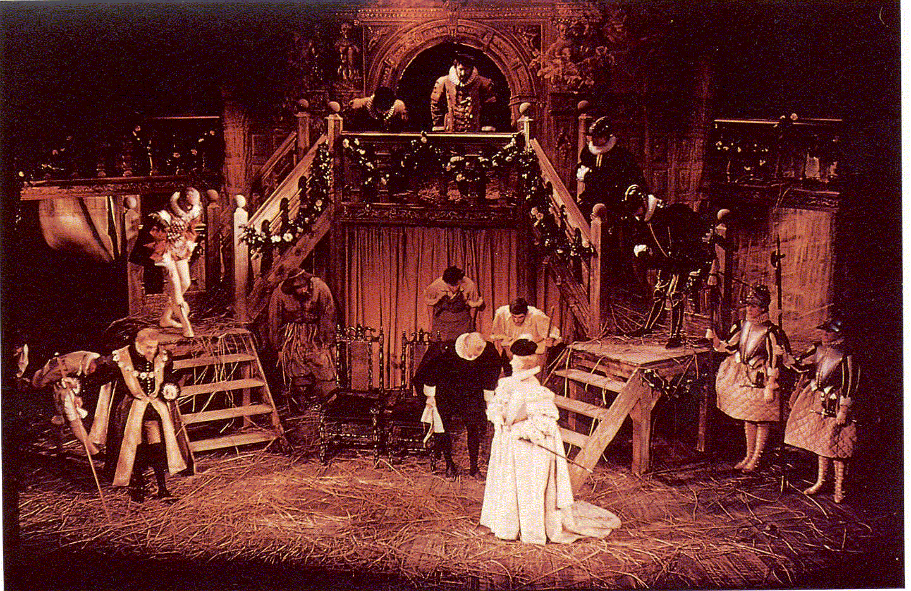](http://www.lib.washington.edu/Subject/Drama/image/msnd-hall2.gif)

Peter Hall's 1959 staging in Stratford Resource: Kennedy, Dennis. *Looking at Shakespeare: a visual history of twentieth-century performance*. Cambridge University Press, 1993. ill. 7

[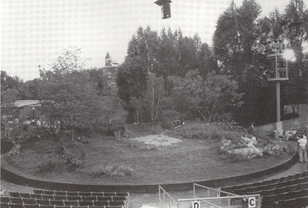](http://www.lib.washington.edu/Subject/Drama/image/msnd-nysf.gif)

James Lapine's 1988 production at the Delacorte Theater (New York Shakespeare Festival)

**Bird Motif**

[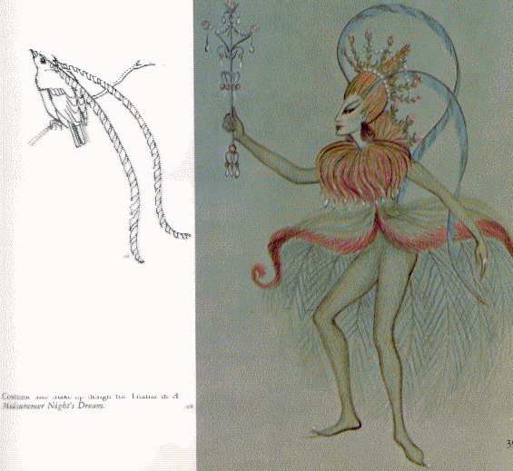](http://www.lib.washington.edu/Subject/Drama/image/msnd-4.gif)[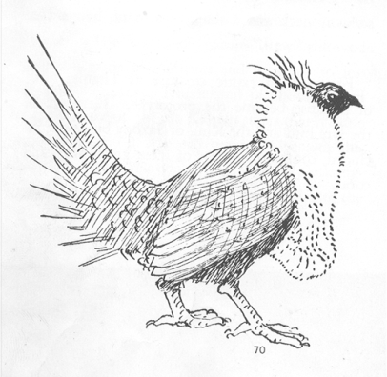](http://www.lib.washington.edu/Subject/Drama/image/msnd-5.gif)[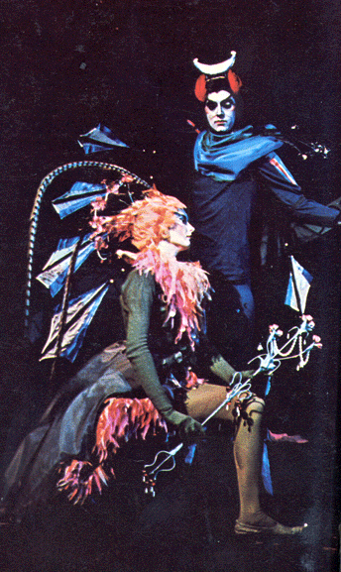](http://www.lib.washington.edu/Subject/Drama/image/msnd-6.gif)

Titania with elements of the lyre bird; Oberon as a grouse

[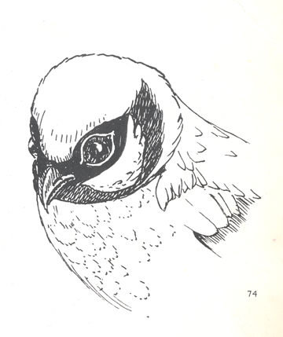](http://www.lib.washington.edu/Subject/Drama/image/msnd-8.gif)[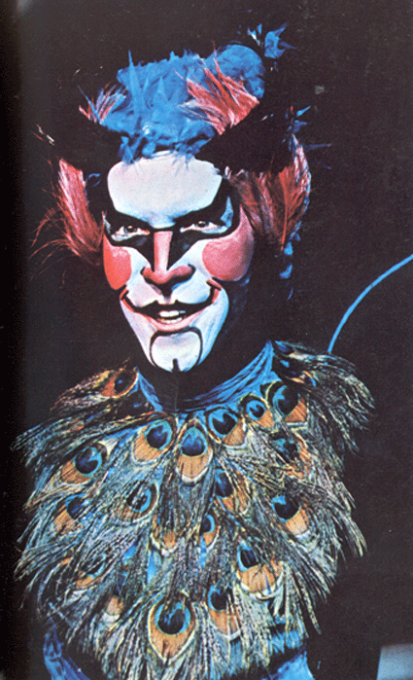](http://www.lib.washington.edu/Subject/Drama/image/msnd-7.gif)

Puck as a tanager Resource: Corey, Irene.

*The mask of reality; an approach to* ***design for theatre.* Anchorage Press, 1968. illus. 69-73**

**Peter Brook's 1970 Production[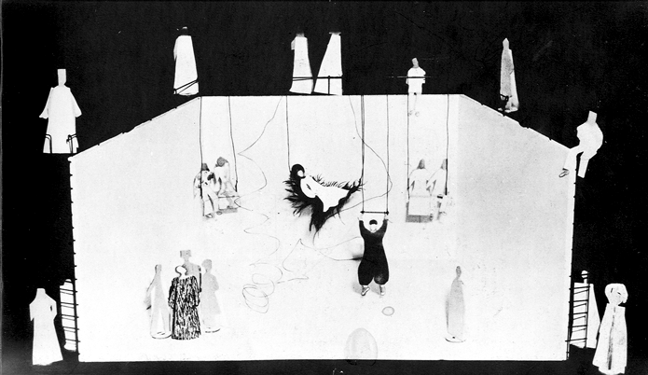](http://www.lib.washington.edu/Subject/Drama/image/msnd-brook5.gif)**

Set designed by Sally Jacobs Resource: Hainaux, René.

*Stage design throughout the world since 1960.* Theatre Arts Books, 1972. ill. 63

[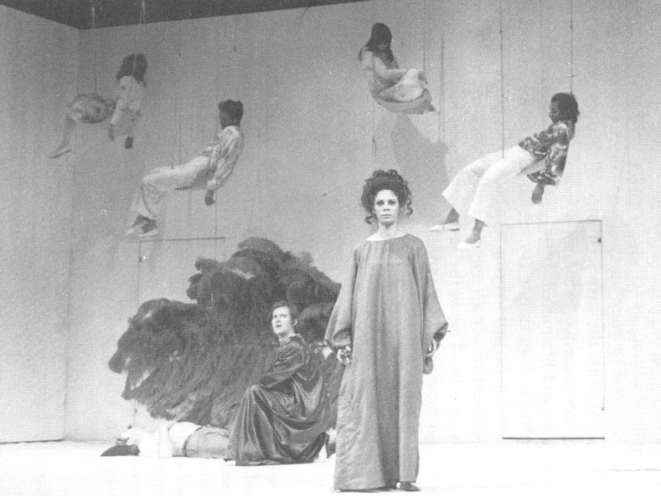](http://www.lib.washington.edu/Subject/Drama/image/msnd-oberon.gif) Oberon, Titania and the sleeping lovers;   
Resource: Selbourne, David. *The making of A Midsummer Night's Dream: an eye-witness account of Peter Brook's production from first rehearsal to first night.* Methuen, c1982. illus. 17, 23

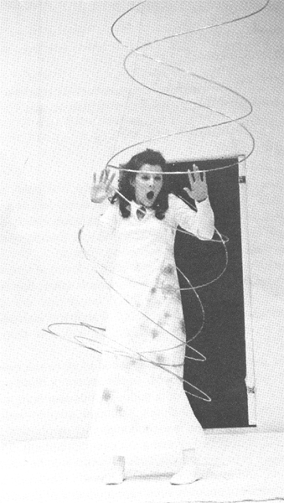.[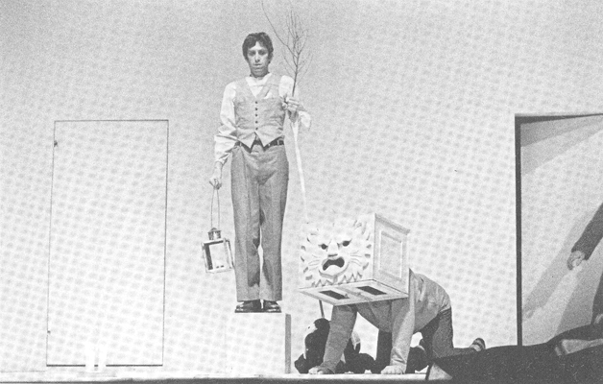](http://www.lib.washington.edu/Subject/Drama/image/msnd-bottom1.gif)

Enter the lion.

Hermia in the forest   
Resource: *Peter Brook's production of William Shakespeare's A Midsummer Night's Dream for the Royal Shakespeare Company*. Royal Shakespeare Company ; Dramatic Pub. Co., 1974. p. 76

Bottom and friends

[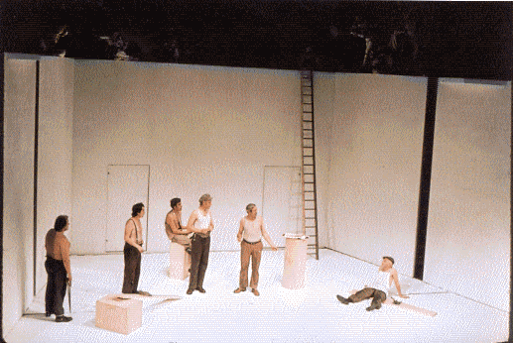](http://www.lib.washington.edu/Subject/Drama/image/msnd-brook1.gif)[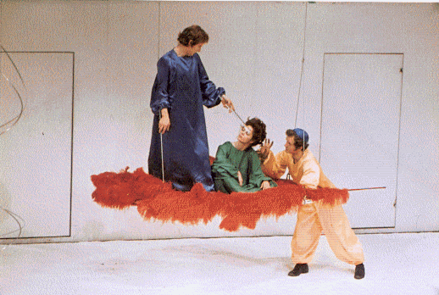](http://www.lib.washington.edu/Subject/Drama/image/msnd-brook2.gif)

Oberon puts Titania to sleep with a wand while Puck watches   
Resource: Kennedy, Dennis. *Looking at Shakespeare : a visual history of twentieth-century Performance.* Cambridge University Press, 1993. illus. 9, 10

**Other Productions**

[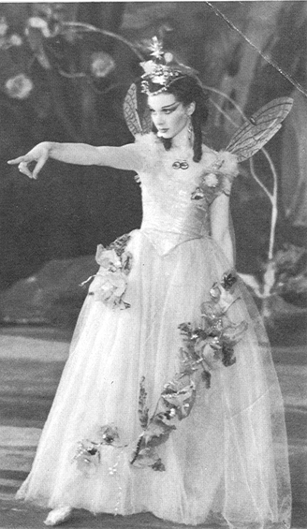](http://www.lib.washington.edu/Subject/Drama/image/msnd-leigh.gif)[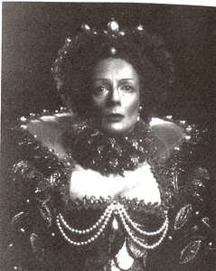](http://www.lib.washington.edu/Subject/Drama/image/msnd-smith.gif)

Maggie Smith as Hippolyta in Robin Phillips's production, Stratford, Ontario, 1977 Resource: Warren, Roger. *A Midsummer Night's Dream : text and performance.* Macmillan, 1983. ill. 5

Vivian Leigh as Titania in Sir Tyrone Guthrie's production, Old Vic, 1937 Resource: Speaight, Robert. *Shakespeare on the stage; an illustrated history of Shakespearian performance*. Little, Brown [1973] p. 157