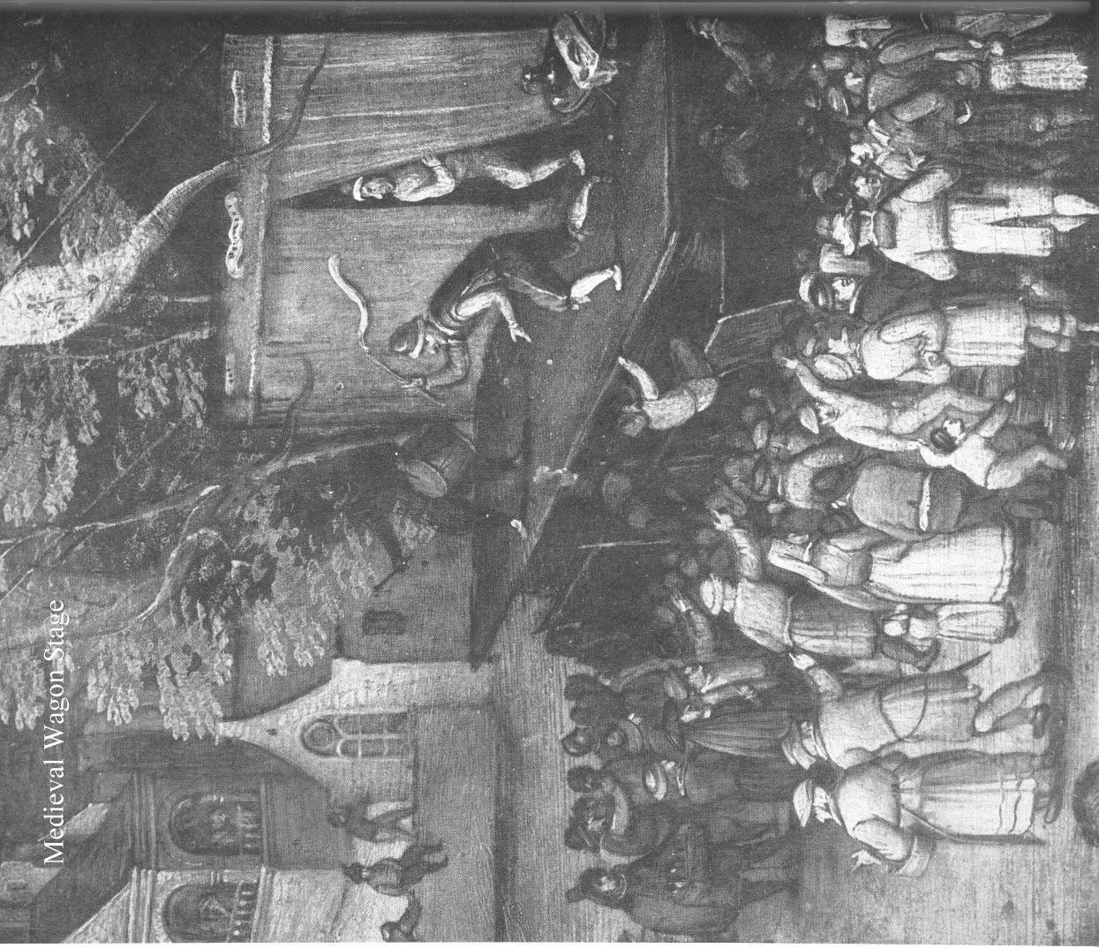

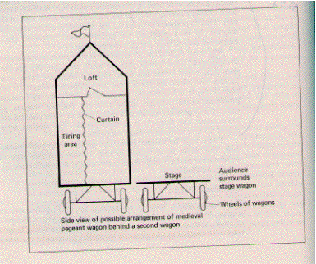

1. Mary is visited by an angel

2. Joseph is visited by an angel

3. Joseph and very pregnant Mary go to Bethlehem

4. Mary gives Birth

5. Three Wisemen see the star and come

6. The Sheppards see the angels

Vocabulary words

Medieval Era/Middle Ages

Mystery play

Miracle Play

Morality play

Passion play

Everyman

Corpus Christi

Key Elements & Themes of Morality Plays
Morality plays held several elements in common:
- The hero represents Mankind or Everyman.
- Among the other characters are personifications of virtues, vices and Death, as well as angels and demons who battle for the possession of the soul of man.
- The psychomachia, the battle for the soul
- A character known as the Vice often played the role of the tempter in a fashion both sinister and comic.
Certain themes found a home in the morality plays:
- The theme of the Seven Deadly Sins
- The theme of Mercy and Peace pleading before God for man's soul against Truth and Righteousness; and
- The Dance of Death, which focuses on Death as God's messenger come to summon all, high and low.

