Name ____________________________________________ Period __________
Stage Terms
There are clues on the other side of this page. You must come up with the answers to the clues and write them in the appropriately numbered spaces.

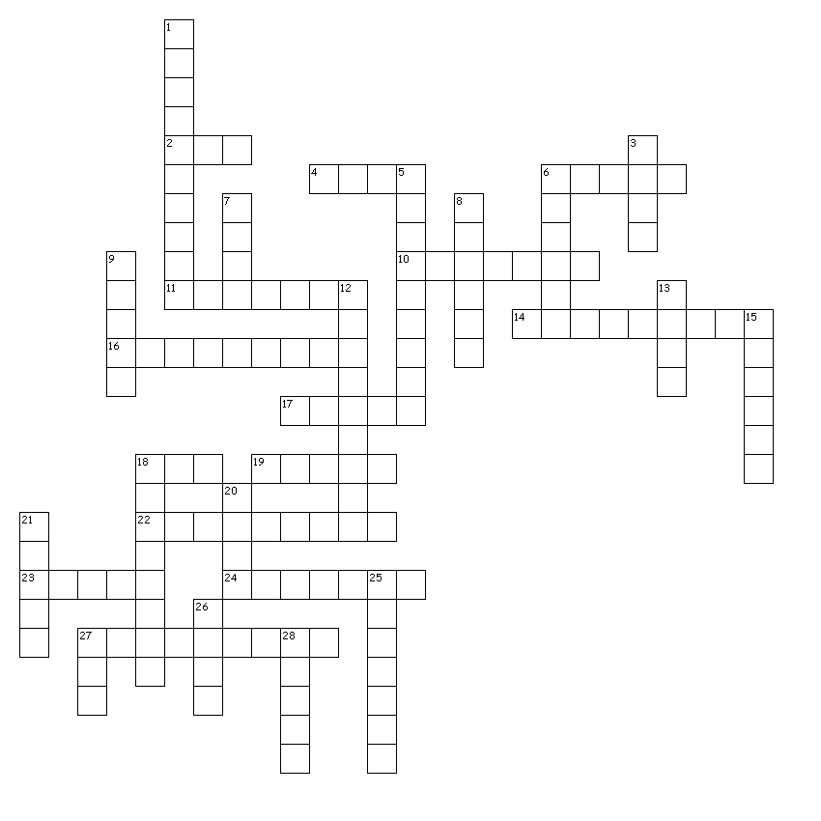

Across
2. A signal to do something.
4. Slant or set something at an angle.
6. A curtain that the audience can see through if lit from behind.
10. Curtains are used as backdrops for this type of set.
11. Covering the backstage area.
14. This set stays in place for the duration of the production and can be used for different locations.
16. The angle from the front, corner seats of the audience to the stage.
17. The sides of the stage where actors wait to enter.
18. Usually this set has three walls and sometimes a ceiling.
19. The front of the stage in front of the main curtain.
22. A back curtain usually used for lighting effects.
23. The front, main curtain.
24. Long, horizontal curtains that mask the electrics.
27. A birds-eye view of set design.

Down
1. The audience sits on one side of this stage.
3. Turn off the lights.
5. Battens from which lights are hung directly over the stage.
6. Take apart a set.
7. Tall, vertical curtains hung on the sides of the stage.
8. 2 or 3-fold screens are used to create the backdrop for this set.
9. The area where the audience sits.
12. A backstage waiting area for actors.
13. Different set pieces are used in various ways to create this set.
15. The audience sits on three sides of this stage.
18. Fabric hung at the back of the stage and painted to show a scene.
20. A fake wall.
21. A flat or platform on wheels.
25. A stage device, usually circular, that rotates the set.
26. Someone who shifts the scenery.
27. The system used for dropping in set pieces and lights.
28. The audience surrounds this type of stage.

