Name ____________________________________________ Period __________
Stage Terms
There are clues on the other side of this page. You must come up with the answers to the clues and write them in the appropriately numbered spaces.
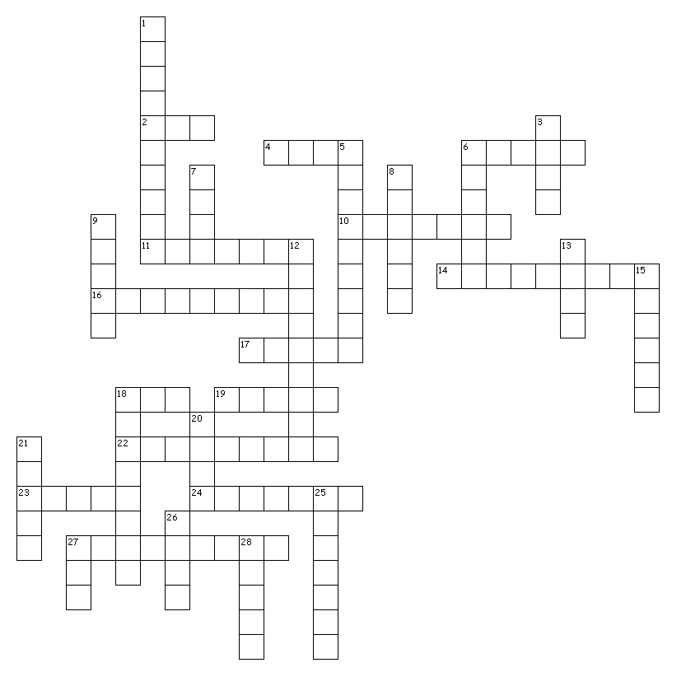

Across
2. A signal to do something. CUE
4. Slant or set something at an angle. RAKE
6. A curtain that the audience can see through if lit from behind. SCRIM
10. Curtains are used as backdrops for this type of set. CURTAIN
11. Covering the backstage area. MASKING
14. This set stays in place for the duration of the production and can be used for different locations. PERMANENT
16. The angle from the front, corner seats of the audience to the stage. SIGHTLINE
17. The sides of the stage where actors wait to enter.
18. Usually this set has three walls and sometimes a ceiling. BOX
19. The front of the stage in front of the main curtain. APRON
22. A back curtain usually used for lighting effects. CYCLORAMA
23. The front, main curtain. GRAND
24. Long, horizontal curtains that mask the electrics. TEASERS
27. A birds-eye view of set design. FLOORPLAN

Down
1. The audience sits on one side of this stage. PROSCENIUM
3. Turn off the lights. KILL
5. Battens from which lights are hung directly over the stage. ELECTRICS
6. Take apart a set. STRIKE
7. Tall, vertical curtains hung on the sides of the stage. LEGS
8. 2 or 3-fold screens are used to create the backdrop for this set. SCREEN
9. The area where the audience sits. HOUSE
12. A backstage waiting area for actors. GREENROOM
13. Different set pieces are used in various ways to create this set. UNIT
15. The audience sits on three sides of this stage. THRUST
18. Fabric hung at the back of the stage and painted to show a scene. BACKDROP
20. A fake wall. FLAT
21. A flat or platform on wheels. WAGON
25. A stage device, usually circular, that rotates the set. REVOLVE
26. Someone who shifts the scenery. GRIP
27. The system used for dropping in set pieces and lights. FLY
28. The audience surrounds this type of stage. ARENA

