PUZZLE

The six puzzle pieces shown below can be combined into a symmetrical “plus” sign.

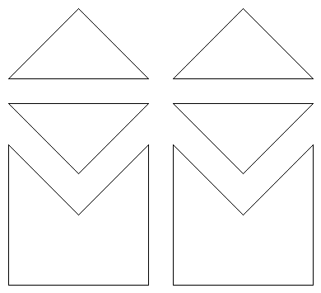

How can this be done?

PUZZLE ANSWER

