**Examples for Lesson 3: The Casebook and The World of the Play (**To be shown during demonstration; point out that content will vary greatly from play to play, but format is the same.)

**TKAM Title page Example:**

A Dramaturgical Packet for Brigham Young University’s Production of

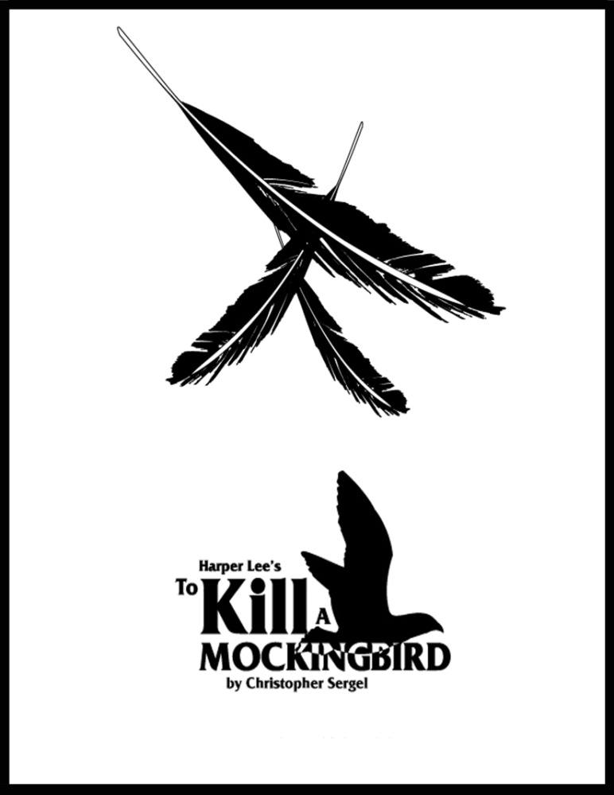

Dramaturg: Anne Flinders

**TKAM Table of Contents Example** [page numbers will vary but should be included in an actual casebook]:

Introduction

Letter to the Director

Section I: History

Author Biography--Nelle and Scout

A Brief History of the Novel--From Pen to Page

Impact of the Novel *To Kill a Mockingbird*

Playwright Biography--Christopher Sergel

History of the Play in Performance

Impact of the Play *To Kill a Mockingbird*

*To Kill a Mockingbird*: The Film--From Page to the Silver Screen

Section II: The Play’s the Thing

A Conceptual Framework

Themes, Symbolism, Characters and Language

Jim Crow

What is “Jim Crow”?

The Civil Rights “War” in the 1950s and ‘60s

Emmett Till and *To Kill a Mockingbird*

The World of Alabama, USA, 1935

News At Large--The World and the USA

The Great Depression

What a Buck Can Getcha in 1935/2012

Education: Its Value and Availability

Getting Around In Monroeville, AL, in 1935

Housing and Houses in Monroeville, AL, in 1935

Morphine--What It Is and What It Does to the Neighbors

Top Songs of 1935

Top Movies of 1935

Section III

Glossary of Terms

Works Cited

**Playwright Bio Example:**

**THE PLAYWRIGHT** / CHRISTOPHER SERGEL



**Christopher Sergel’s** interests and talents led him on many adventures throughout the world. As captain of the schooner *Chance*, he spent two years in the South Pacific; as a writer for *Sports Afield* magazine, he lived in the African bush for a year; as a lieutenant commander during WWII, he taught celestial navigation; as a playwright, his adaptation of Sherwood Anderson’s *Winesburg, Ohio* was seen on Broadway.

Throughout his life, Christopher’s greatest adventure and deepest love was his work with Dramatic Publishing, where he served as president from 1970-1993. During this time, he wrote adaptations of *To Kill a Mockingbird,* *Cheaper by the Dozen, The Mouse That Roared,* *Up the Down Staircase, Fame, Black Elk Speaks* and many more.

His love of theatre and his caring for writers made him a generous and spirited mentor to many playwrights here and around the world. His inspiration and integrity attracted to the company fine writers including C. P. Taylor, Timberlake Wertenbaker, Arthur Miller, Roald Dahl and E. B. White, to name just a few. He once said he hoped to be remembered as E. B. White described Charlotte: “…a true friend and a good writer.”

BIOGRAPHY FROM DRAMATIC PUBLISHING

**Ideas/Examples of Articles for the Body of the Casebook:**

***Prior Productions/Reviews:***

Deseret News

BYU'S `TO KILL A MOCKINGBIRD' DRAWS AUDIENCE RIGHT INTO 1935

By Sharon Haddock, Staff Writer

Published: Saturday, Nov. 18 1995 12:00 a.m. MST

BYU's production of "To Kill A Mockingbird," does justice to a classic story with a timeless message about blind prejudice, even if the jury does not.

A uniformly strong cast along with marvelous staging draws the audience into 1935 and into the town of Macomb almost without awareness. This is a show that goes by quickly. The weathered frame houses, badly in need of paint and wheeled on one at a time in front of a line of ancient homes suspended in mid-air, quickly set up a feel for life in Macomb - dusty, settled into its ways, resistant to change and new ideas.

Effective lighting enhances scenes that could otherwise be fairly mundane. The storm scene with the wind howling and eerie lights glowing is especially haunting and well done.

Costuming is understated but wonderfully kept in period and in character.

In fact, all of the peripheral elements blend together beautifully to provide a seamless backdrop to some truly outstanding acting. More productions should be so blessed.

Scout, played by fourth-grader Hunter Lassetter from Pleasant Grove, is saucy, outspoken, completely without guile and just undisciplined enough to endear herself to the audience while slightly frustrating her father throughout.

She's balanced by her cousin Dill, Kennan J. Liston, also a fourth-grade child from Spanish Fork, complete with skinny legs, short pants, slicked-down hair and almost as many questions.

Her big brother Jem, played by Devin Felix, is the child more than a little embarrassed by his father who's curiously uninterested in guns and football but defending the town's colored population.

Since much of the play's imagery and pace depends on the trio of children, the choice of these three shows some good discernment on the part of the casting director.

In fact, the touch of Charles Metten is evident throughout the show with attention paid to detail (the windows in the courtroom are streaked and the flag hanging behind the judge is badly faded) and every cast member is completely into his or her character throughout.

Atticus, played by M. Scott Wilkinson, handles his part with a deft touch, making it clear early on that he knows his case is probably lost. He explains to Scout and himself that if things are ever to change, each argument and effort cannot go unmade.

A stand-out is Richard J. Clifford playing Bob Ewell, ragged, mean, unscrupulous and ruthless. His mannerisms are dead on. He never loses that poor white trash mentality, an edge to his character that really makes him disgusting as a man.

His daughter, Mayella, played by Emilie de Azevedo Brown, does as well. She's believeable, desperate and committed to seeing herself saved at the expense of an innocent man.

The story is compelling, and in light of the recent O.J. Simpson trial, especially interesting.

Copyright 2012, Deseret News Publishing Company

***Social issues:***

*Examples of Jim Crow Laws*

*Created by Martin Luther King, Jr.,* [National Historic Site](http://www.nps.gov/malu/) *Interpretive Staff.*

*Web editor: Vernellia R. Randall, Professor of Law, The University of Dayton*

From the 1880s into the 1960s, a majority of American states enforced segregation through "Jim Crow" laws (so called after a black character in minstrel shows). From Delaware to California, and from North Dakota to Texas, many states (and cities, too) could impose legal punishments on people for consorting with members of another race. The most common types of laws forbade intermarriage and ordered business owners and public institutions to keep their black and white clientele separated.

Here is a sampling of laws from various states:

**Transportation** The...Utilities Commission...is empowered and directed to require the establishment of separate waiting rooms at all stations for the white and colored races. *North Carolina*

**Buses** All passenger stations in this state operated by any motor transportation company shall have separate waiting rooms or space and separate ticket windows for the white and colored races. *Alabama*

**Restaurants** All persons licensed to conduct a restaurant, shall serve either white people exclusively or colored people exclusively and shall not sell to the two races within the same room or serve the two races anywhere under the same license. *Georgia*



**Parks** It shall be unlawful for colored people to frequent any park owned or maintained by the city for the benefit, use and enjoyment of white persons...and unlawful for any white person to frequent any park owned or maintained by the city for the use and benefit of colored persons. *Georgia*

http://www.ferris.edu/jimcrow/fountain.jpg

***Cultural issues related to the play (Scout and Jem are superstitious):***

**Common Myths**



**& Folklore**

**~ If an** [**Owl**](http://www.squidoo.com/divine-birds) **looks in your window or if you see one in the daylight bad luck and death awaits you.  
  
~ If a bird flies through your house, it indicates important news. If it can't get out, the news will be death.  
  
~ If a bird flies towards you, bad fortune is imminent.  
  
~ Crows are viewed as a bad omen, often foretelling death. If they "caw", death is very near.  
  
~ If the flame of a candle flickers and then turns blue, there's a spirit in the room.  
  
~ If you feel a chill up your spine, someone is walking on your future grave.  
  
~ You must hold your breath when you go past a cemetery or else you will breathe in the soul of someone who has recently died.  
  
~ You must knock on wood 3 times after mentioning good fortune or the evil spirits will ruin things for you.  
  
~ A bat in the house is a sign of death.  
  
~ If your left palm itches, it means you will soon receive money; if you’re right palm itches, it means that you will lose or have to pay money.  
  
~ Cats can physically see spirits, so they make excellent guardians against evil spirits. They also love to play with friendly or beneficial spirits.  
  
~ A hat on a bed will bring bad luck.  
  
~ Open an umbrella indoors and bad luck will "rain" on you.**  
  
***Source:*** halloween-website.com/superstitions

***History within the play:***

**What Events Happened in 1935**

**Germany:**

The **Luftwaffe is created** as Germany's air force and Germany announces rearmament in violation of the Versailles Treaty.

**Iran**

**Persia** is renamed as Iran

**Pakistan**

**Earthquake** destroys Quetta in modern-day Pakistan - **26,000 dead**

**United Kingdom**

Compulsory **Driving Test is introduced** in England

**United States of America**

* **Amelia Earhart** flies solo across the Pacific
* President Roosevelt signs the **US Social Security Act** Providing Unemployment compensation and pensions for the elderly.
* President Roosevelt **Revenue Act** often referred to as the Wealth Tax Act begins
* U.S.
* The great Labor Day Category 5 Hurricane with winds approaching 185 mph strikes Florida Keys on [**September 2nd**](http://www.thepeoplehistory.com/september2nd.html)
* Sir Malcolm Campbell breaks the 300 mph barrier to set a new land speed world record
* The China Clipper makes the first Pacific Airmail delivery
* The **Emergency Relief Appropriation Act** on [**April 8th**](http://www.thepeoplehistory.com/april8th.html) creates The WPA or Works Progress Administration to create millions of jobs
* 1,200,000 people face **starvation** in Illinois due to lack of funding.
* **First Public Housing Project** launched in New York
* First **Orange Bowl**

**Technology**

**Germany**

**The Peoples car** (Volkswagen Beetle) is launched in Germany

**United Kingdom**

First **Experimental Radar** for Aircraft (Scotland by Robert Watson-Watt) is developed

**United States of America**

GE Starts selling the **first Fluorescent Tube** for light

First **Parking Meters** in Oklahoma City designed by Carl C Magee

**Helicopter Invented** by Igor I. Sikorsky

***(Partial) Bibliography Example:***

Works Cited

"Christopher Sergel." *Dramatists Publishers*. Dramatists Publishers, n.d. Web. 17 Feb. 2012. <www.doollee.com/PlaywrightsS/sergel-christopher.html >.

Crowe, Chris. *Getting away with murder: the true story of the Emmett Till case*. New York: Dial Books for Young Readers, 2003. Print.

Dirks, Tim . "Greatest Films of 1935." *Greatest Films - The Best Movies in Cinematic History*. AMC, n.d. Web. 28 Feb. 2012. <http://www.filmsite.org/1935.html>.

Feldman, Glenn. "Benjamin Meek Miller." *Encyclopedia of Alabama*. Encyclopedia of Alabama, 12 May 2008. Web. 26 Feb. 2012. < <http://encyclopediaofalabama.org/face/Article.jsp?id=h-1527>>.

Feldman, Glenn. “Poverty in Alabama." *Encyclopedia of Alabama*. Auburn University, n.d. Web. 28 Feb. 2012. <encyclopediaofalabama.org/face/Article.jsp?id=h-1527 >.

Foster, Thomas C.. *Twenty-five books that shaped America: how white whales, green lights, and restless spirits forged our national identity*. New York: Harper, 2011. Print.

Haddock, Sharon. "BYU's To Kill A Mockingbird Draws Audience Right Into 1935." *Deseret News*. Deseret News Publishing Company, 18 Nov. 1995. Web. 23 Feb. 2012. <www.deseretnews.com/article/print/451495/BYUS-TO-KILL-A-MOCKINGBIRD-DRAWS-AUDIENCE-RIGHT-INTO-1935.html >.