Unit: Playwrights and Contemporary Performance Practices

By: Laura Taylor

Unit Objective: Students will be able to identify many playwrights of the dramatic canon, as well as some of their most influential works by participating in research and analysis about the individual and performing one of their most famous works. Students will also broaden their understanding of playwriting and what makes a playwright by briefly researching some contemporary performance groups, and participating in contemporary performance practices/playwriting.

Enduring Understandings: Theatre artists exist in a variety of appearances, including students. Theatre artists can create new meaning from old text via contemporary performance practices.

Essential Questions: What does it mean to be a playwright, or a theatre practitioner? What qualifies as “good work?” How can we relate to those who have come before us? Should we? How can plays or the work we create transcend time? How can we create new meaning in old texts?

Prior Experience: Students do not need any prior performance experience to complete this unit, although it is helpful if they at least have class monologue/scene performance experience.

2014 National Core Arts Theatre Standards: TH:Cr2.1.HSI a. Explore the function of history and culture in the development of a dramatic concept through a critical analysis of original ideas in a drama/theatre work.
TH:Cr2.1.HSII a. Refine a dramatic concept to demonstrate a critical understanding of historical and cultural influences of original ideas applied to a drama/theatre work.
TH:Cr2.1.HSIII a. Develop and synthesize original ideas in a drama/theatre work utilizing critical analysis, historical and cultural context, research, and western or non-western theatre traditions.
TH:Pr6.1.HSI a. Perform a scripted drama/theatre work for a specific audience.
TH:Re7.1.HSII a. Demonstrate an understanding of multiple interpretations of artistic criteria and how each might be used to influence future artistic choices of a drama/theatre work.
Advanced TH:Re7.1.HSIII a. Use historical and cultural context to structure and justify personal responses to a drama/theatre work.
TH:Re8.1.HSI a. Analyze and compare artistic choices developed from personal experiences in multiple drama/theatre works. b. Identify and compare cultural perspectives and contexts that may influence the evaluation of a drama/theatre work.
TH:Re9.1.HSI a. Examine a drama/ theatre work using supporting evidence and criteria, while considering art forms, history, culture, and other disciplines. c. Formulate a deeper understanding and appreciation of a drama/ theatre work by considering its specific purpose or intended audience.
TH:Cn10.1.HSI a. Investigate how cultural perspectives, community ideas and personal beliefs impact a drama/theatre work.
TH:Cn11.2.HSI b. Use basic theatre research methods to better understand the social and cultural background of a drama/theatre work.

1994 National Standards: Content Standard #1: Script writing through improvising, writing, and refining scripts based on personal experience and heritage, imagination, literature, and history
Content Standard #2: Acting by developing, communicating, and sustaining characters in improvisations and informal or formal productions
Content Standard #4: Directing by interpreting dramatic texts and organizing and conducting rehearsals for informal or formal productions
Content Standard #5: Researching by evaluating and synthesizing cultural and historical information to support artistic choices
Content Standard #6: Comparing and integrating art forms by analyzing traditional theatre, dance, music, visual arts, and new art forms
Content Standard #7: Analyzing, critiquing, and constructing meanings from informal and formal theatre, film, television, and electronic media productions
Content Standard #8: Understanding context by analyzing the role of theatre, film, television, and electronic media in the past and the present

Outline: 11 lessons for a beginning-intermediate theatre class

Grade level: 10-12th grade

Understandings:  Students will understand that……  The definition of what a playwright is can exist in many different forms (both contemporary and traditional). They’ll also understand that “good work” also exists in a variety of forms, but is relatable, and transcends time. Additionally, students understand that they, too, are playwrights. | Essential Questions:  What does it mean to be a playwright, or a theatre practitioner? What qualifies as “good work?” How can we relate to those who have come before us? Should we? How can plays or work we create transcend time? How can we create new meaning in old texts?
Students will know…  Students will know many different influential playwrights and plays, many different contemporary performance groups and practices, and they’ll know how to critically analyze new meaning that can be created through contemporary work. | Students will be able to…  Understand how to apply contemporary performance practices to a traditional show to create new meaning, analyze meaning and content, and they will be able to collaboratively devise a contemporary scene.
Learning Activities:
-Presentation of famous plays/playwrights
-Presentation of contemporary performance groups
-Media mini-workshop
-Class discussions
-Brainstorming worksheet
-Analysis of performance choices
-Peer reviews and responses
-Unit reflection

Lesson 1: Choosing Strong Work and Playwright Bio

Unit: Intro to Playwrights

Grade Level: 10-12 grade, 77 minutes

National Standards:
Content Standard #2: Acting by developing, communicating, and sustaining characters in improvisations and informal or formal productions
Content Standard #7: Analyzing, critiquing, and constructing meanings from informal and formal theatre, film, television, and electronic media productions
Content Standard #8: Understanding context by analyzing the role of theatre, film, television, and electronic media in the past and the present

Materials Needed: The monologues “And Turning, Stay,” and “Bargaining” by Kellie Powell (or some other “bad monologue”), an example of a “good” monologue, scripts from example playwright for students to read as a class, scripts from desired playwrights for students to choose from for their scenes, demonstration of a presentation for example playwright, and info sheet detailing the assignment requirements.

Learning Objective: Students will begin to think about and understand the role various influential playwrights have made on both American drama and drama as a whole. They will also critically analyze important things to look for when choosing “good work” to perform or audition with and think about how this reflects on the work of the playwright.

Teaching Presentation:
Hook (10 minutes): Ask students how many of them have ever performed a scene or monologue before? How many of you have ever been in a play? What were some of your favorite pieces that you performed from? (Monologues, scenes, plays?) Why did you like those works? What about them was appealing or engaging to you? What made them memorable or special? What types of pieces/scenes do you stay away from? Talk about what determines or distinguishes work they like to perform, as opposed to monologues they don’t like to perform.

Discussion (5-7 Minutes): So what makes “good work,” and what makes “bad work?” Allow students to comment on their thoughts about this.

Some things to think about when choosing “good work,” or material that is strong for performance/audition/competition:
-Shows off your talents and strengths as an actor
-Is this piece appropriate for where it will be performed?
-Generally avoid excessive explicit language in audition/competition pieces.
-Is the piece relatable to others?
-Do you emotionally connect with the piece?
- Do you relate to the piece?
-Does it allow you to take risks?
-Does it have a strong objective(s) you can play?
-Do you see multiple sides/facets to the character? Do you see them change throughout the piece?
-What kind of physicality does the piece allow? Is it manageable or does it ask too much?
-Does the piece display your emotional range? Does it challenge you?
-Is it accessible, or is it stuffy/boring?
-Do you understand what your character is saying/feeling?
-Does it have conflict?
-Is there a clear beginning, middle, and end?

Discuss that in large part what makes work “good” or “bad” is totally opinion based. You have to choose the right work for you, but there are some things to think about, and be aware/cautious of.

Activity 1 (20-25 minutes): Read “And Turning, Stay” by Kellie Powell. Is this an example of good work, or bad work? Have everyone who thinks it’s good work go to the left side of the room, and everyone who thinks it’s bad go to the right side of the room. Let the kids offer some explanations regarding whether they think they’re good or not. Do they meet the requirements that we listed earlier? If students become swayed one way or another they may move to the other side of the room.

I think this is a bad monologue. Now this isn’t to say that a very talented actress couldn’t find some deep meaning and pull out a great performance, but the text isn’t really doing you any favors. It’s histrionic, and seems like the rants of a whiny teenage girl. It seems to lack true depth, and professionalism. While love and loss are very important themes to write about and perform, this seems poorly written. Again, this doesn’t mean that someone couldn’t perform it beautifully. It’s important to pick work that you relate to and find compelling, but it’s also important to pick strong work that will make others take you seriously as a true professional.

Read Sonya’s monologue from Uncle Vanya. Is this good work, or bad work? Again, have students who think it’s good go to the left, and students who think it’s bad go to the right. Does it meet the requirements from our list? Play devil’s advocate and have a true debate and discussion about this. I think this is good work because it is well written, takes the audience/actor on a journey, it’s motivated, relatable (we all experience grief and pain, and we all try to overcome it), and it has depth. However, if you can’t connect to this monologue then it would not be a good choice for you. If it seems repetitive is there a way you could cut, or alter it? Is there a way you could make this text come alive? Why might the world think this piece is “good work,” given the fact that it came from Chekhov's Uncle Vanya?

Repeat the process again with “Bargaining.” Again, I find this to be bad work. It’s reminiscent of Twilight, and seems to have no real deep issues of importance or relatability for people to connect to. Other than being lovesick. The character seems a little flat, and tells a story for most of the monologue. It’s also far, far too long for anyone to ever audition with this piece. It’s not well written, and doesn’t have compelling universal themes. But, admittedly, with a strong cutting it is possible that someone might be able to make this woman’s journey work.

So think about the work you do when you audition or perform. Does it age you in a negative way? Does it seem professional? Is it relatable and compelling? Does it meet the requirements from our list?

Transition (3-5 minutes): Now that we’ve talked about what makes good work let’s talk about people that make great work: playwrights. There are many amazing playwrights of the past and present that aren’t incredibly famous, and it’s important to remember that you don’t have to be famous to make good work. However, it’s also important that we do know about the playwrights that changed theatre for our country, and for the world.

Activity 2 (10 minutes): Introduce the playwrights assignment by passing out the rubric/information sheet. Students will learn about influential contemporary playwrights by choosing one from the list, giving us a brief sketch of their biographical background, detail some of their most famous works, describe their genre, their contributions/influence on playwriting and the theatre world, as well as perform a scene from one of their greatest works. This should also include a description about how various influential works may have impacted society/theatre.

Playwrights include:

Anton Chekhov- scene from The Cherry Orchard
Arthur Miller- scene from Death of a Salesman
Neil Simon- scene from The Star-Spangled Girl
Tennessee Williams- scene from A Streetcar Named Desire
August Wilson- scene from Fences
Eugene Ionesco- scene from Rhinoceros
Eugene O’Neill- scene from Long Day’s Journey Into Night
Bertolt Brecht- scene from The Good Person of Szechwan
Moliere- scene from Tartuffe
Henrik Ibsen- scene from Hedda Gabler
August Strindberg- scene from Miss Julie
Oscar Wilde- scene from The Importance of Being Earnest
Frederico Garcia Lorca- scene from The House of Bernarda Alba
Samuel Beckett- scene from Waiting for Godot
Lorraine Hansberry- scene from A Raisin in the Sun
Wole Soyinka- scene from Death and the King’s Horsemen

Authors, scenes, and plays could change according to instructor’s preference.

Scenes must be completely memorized, and after they perform they must give a brief analysis to the class detailing why the play (from the scene they’re performing) is “good work.” (Students should give context to the scene before performing.) Students can choose a different scene by the author, but they must submit it for instructor approval. Scenes should be about 5 minutes long. If students choose to use the desired cutting they will need to pick what portion of the excerpt they wish to perform. All group members must perform. Additionally, since this class centers around performance, students should think about performance techniques as they present their report. Students should be engaging and informative, and shouldn’t be reading word-for-word from a screen or paper. The playwright presentation can be presented digitally (powerpoint, Prezi, short film, etc.), or as a traditional report. The presentations + the scene should not be longer than 10 minutes. Students may complete an additional report/performance for extra credit. Answer any questions the students have.

Activity 3 (15 minutes): Present students the example presentation. This will be Tony Kushner. He’s a great one to do as an example because of his explicit, controversial content. It’s important that students know him and Angels in America, but also important that you control the content that they have access to in a school setting.

Pass out scripts and assign roles to students. This models the scene performance. Is this “good work?” Clearly it is widely deemed so, but why? Do you agree with the hype this piece has gotten, so far as you understand it? You can see how much of this piece is blacked through. Is it appropriate for an audition piece? (I would say yes as long as there’s nothing explicit or graphic. It’s ok to censor the piece a little bit.)

Activity 4 (10-20 minutes): Take about 5 minutes and give a brief synopsis of each of the shows that the students are picking from. Give them about 10 minutes to look at the scripts, and pick their groups. Groups must sign up for which playwright they will pick. No group may do the same playwright.

Transition/Wrap-Up (5-10 minutes): Remember to think about what makes strong, compelling work that actors want to perform, and directors and audiences want to see. Make sure the pieces you choose compliment your talent. As you work with these scripts the next few days think about how you can tailor the piece to best highlight your talents. What can you relate to? Why is it considered “good” work? Next class period you will be in the computer lab researching your playwrights, as well as preparing your presentations. This will be your only class time to work on that. The next class period you will be given time to rehearse.

Allow students any extra time to read through their scripts in groups.

Getting to Know You: Playwrights

Presentation
Students will get a chance to learn about influential playwrights by choosing a famous playwright and giving a presentation. They should give us a brief sketch of their biographical background, as well as detail some of the author’s most famous works, their genre, and their contributions/influence on playwriting and the theatre world. This should also include a description about how various influential works may have impacted society/theatre. All of these playwrights have written influential works. Additionally, presentations should be engaging and informative, and shouldn’t be reading word-for-word from a screen or paper! It can be presented digitally (powerpoint, Prezi, short film, etc.), or as a traditional report. It’s up to you!

Performance
In addition to giving a brief presentation, students will also perform a scene from one of their playwright’s greatest works. Scenes must be completely memorized, and after students perform they must give a brief analysis to the class detailing why the play (from the scene they’re performing) is “good work.” Scenes should be about 5 minutes long, but the entire presentation+performance should be no longer than 10 minutes. If students choose to use the desired cutting from Ms. Taylor they will need to pick what portion of the excerpt they wish to perform. All group members must perform!

Performances will take place on __________________.

Extra Credit
Students may complete an additional report/performance for extra credit.

Grading
___/30 Presentation
- Students give a charismatic, engaging presentation
- Group doesn’t read word-for-word from a screen/paper
- Brief biographical sketch is included
- Details the playwright’s most famous works and why they’re influential
- Description of playwright’s genre and contributions to both theatre performance and playwriting world

___/20 Performance
- Scenes are completely memorized
- Students analyze as a group why the piece from their play is considered “good work”
- All members in the group perform
- Performance is about 5 minutes long

Playwright Group Sign Up

Anton Chekhov:___________________________
Arthur Miller:____________________________
Neil Simon:______________________________
Tennessee Williams:________________________
August Wilson:____________________________
Eugene Ionesco:___________________________
Eugene O’Neill:____________________________
Bertolt Brecht:____________________________
Moliere:________________________________
Henrik Ibsen:_____________________________
August Strindberg:_________________________
Oscar Wilde:_____________________________
Frederico Garcia Lorca:______________________
Lorraine Hansberry:________________________
Wole Soyinka:____________________________

Lesson 2: Presentation Research Day

Unit: Intro to Playwrights

Grade Level: 10-12 grade, 77 minutes

National Standards:
Content Standard #7: Analyzing, critiquing, and constructing meanings from informal and formal theatre, film, television, and electronic media productions
Content Standard #8: Understanding context by analyzing the role of theatre, film, television, and electronic media in the past and the present

Materials Needed: Computer lab, scripts (kids already have them)

Learning Objective: Students will learn more about their chosen playwright, his/her influence, and influential works by researching them in the computer lab and synthesizing that information for their presentations.

Teaching Presentation:
Announcements/Housekeeping (5-10 minutes): Today students will be spending the class period in the computer lab. They have a lot to research and write. They’re working in groups so they will be talking, so just remember that.

Activity 1 (80 minutes): Go ahead and hand out the half sheets that detail what the kids should be doing during the period. Their assignment sheet clearly says what they need to do, but we want them to stay on task. Make sure you’re walking through the aisles throughout the class period so they’re not goofing off, and we can make sure that they’re working. They should have plenty to do between researching, and creating their presentation. If they are making a powerpoint, oral report, or Prezi they should have plenty of time to start (if not finish) that in class.

If you can tell that the class is getting rowdy and off topic because they all claim to be done, then bring them back to the classroom and let them start rehearsing their scenes.

Wrap-Up (2-3 Minutes): Remind them that next time we meet they will be spending the day rehearsing. They must have all their lines memorized when they perform!! Additionally, if anyone in their scenes is planning to play someone of the opposite sex they will need to explain to me what accommodations they are planning to make. (This will happen during our next class period.) They should think about how changing the gender might change the meaning of the scene. What statements might changing the gender make? Make sure they know this and are ready for it!
Things To Be Doing for Playwrights Project

1) Research author’s brief biographical sketch
2) Research his/hers most influential/well-known works. What are they about?
3) Analyze how these plays affect society/theatre/playwriting/art/etc.?
4) Analyze how the playwright affected society/theatre/playwriting/art/etc.
5) Research and analyze the author’s genre/style.
6) Consult assignment sheet for any questions
7) Begin preparing (or finish!) your amazing presentation

Things To Be Doing for Playwrights Project

1) Research author’s brief biographical sketch
2) Research his/hers most influential/well-known works. What are they about?
3) Analyze how these plays affect society/theatre/playwriting/art/etc.?
4) Analyze how the playwright affected society/theatre/playwriting/art/etc.
5) Research and analyze the author’s genre/style.
6) consult assignment sheet for any questions
7) Begin preparing (or finish!) your amazing presentation

Lesson 3: Rehearsing With Famous Playwrights

Unit: Intro to Playwrights

Grade Level: 10-12 grade, 77 minutes

National Standards:
Content Standard #2: Acting by developing, communicating, and sustaining characters in improvisations and informal or formal productions
Content Standard #4: Directing by interpreting dramatic texts and organizing and conducting rehearsals for informal or formal productions
Content Standard #7: Analyzing, critiquing, and constructing meanings from informal and formal theatre, film, television, and electronic media productions
Content Standard #8: Understanding context by analyzing the role of theatre, film, television, and electronic media in the past and the present

Materials Needed: The students will need to have their scripts

Learning Objective: Students will contextualize what they’ve learned about their playwrights by performing a scene from one of their most famous works. While students rehearse and perform their scenes they’ll think about their connection to the work, and analyze why it’s “good work,” and why it became so famous.

Teaching Presentation:
Hook (5 minutes): Remind students that we’ll begin the presentations+performances next class period and that for full points the scene has to be memorized. All group members will receive the same grade, so at least one person from each group needs to have the assignment description/rubric. Remember that your group is in charge of cutting the scene. The presentation+performance shouldn’t be more than 10 minutes.

Additionally, remind students that you’ll be coming around to observe each group as they rehearse. If the gender of a character has been changed they’ll need to justify the choice, and explain how it changes the meaning of the scene. And remind them that while they rehearse they should be thinking about why the play is considered “good work,” and why it’s a member of the dramatic canon. Why was the play important at its production, and why is it important now? (Students should think about how this might apply to several plays if there are several of the playwright’s plays that are historically/culturally influential.) What does their genre and style say about the time period?

Activity 1 (70 minutes): Have the students break up into their groups and begin rehearsing. Move from group to group every 5-6 minutes to monitor the groups’ progress. Ask them to defend their choices if they’re changing the gender of a character. Help them with any problems they may be encountering, and make sure they’re thinking about the questions posed to them at the end of the hook.

Ask students to work up until the end of the class period. There’s no reason for them to finish early. If they feel prepared for their performance they can rehearse their presentations.

Lesson 4: Playwright Presentations and Performances

Unit: Intro to Playwrights

Grade Level: 10-12 grade, 77 minutes

National Standards:
Content Standard #2: Acting by developing, communicating, and sustaining characters in improvisations and informal or formal productions
Content Standard #4: Directing by interpreting dramatic texts and organizing and conducting rehearsals for informal or formal productions
Content Standard #7: Analyzing, critiquing, and constructing meanings from informal and formal theatre, film, television, and electronic media productions
Content Standard #8: Understanding context by analyzing the role of theatre, film, television, and electronic media in the past and the present

Materials Needed: Rubrics (the information sheets), and students will need their presentation materials and anything they might want for their performances.

Learning Objective: In groups students will give their presentations on their specific playwrights where they will show that they have analyzed and evaluated how the playwright and their work(s) affected both the past and present. Students will also perform scenes from one of the playwright’s most famous plays where they will also analyze why the play is considered a masterpiece.

Teaching Presentation:
Hook (5 minutes): It’s time to show us all what you’ve learned! You have 5 minutes to meet with your group members and get anything together that you need for your presentations+performances.

Activity 1 (70 minutes): Groups will now all take turns presenting their Playwright presentations. The presentations and the performances shouldn’t take longer than 10 minutes (give them a one minute warning).
Pay close attention to what the other groups perform because you’ll have to use what you’ve learned later. While they’re watching the other groups’ presentations+performances they should write down:
1) The playwright’s most famous works
2) Why were they (and their plays) culturally/historically significant to the time period/profession?
3) Why is the play performed “good work,” and why is it still relevant and significant today?

Plan to get through 6-8 groups during one class period.

Getting to Know You: Playwrights

Grading
___/30 Presentation
- Students give a charismatic, engaging presentation
- Group doesn’t read word-for-word from a screen/paper
- Brief biographical sketch is included
- Details the playwright’s most famous works and why they’re influential
- Description of playwright’s genre and contributions to both theatre performance and playwriting world

___/20 Performance
- Scenes are completely memorized
- Students analyze as a group why the piece from their play is considered “good work”
- All members in the group perform
- Performance is about 5 minutes long

Name:__________
Date:_____
Period:____
Playwright Worksheet

During the presentations and performances you will think about and respond to 3 different questions per group:
1) What are the playwright’s most famous works?
2) Why were they (and their plays) culturally/historically significant to the time period/profession?
3) Why is the play performed “good work,” and why is it still relevant and significant today?

You should complete this entire worksheet, including the entry for your playwright.

Neil Simon
1)
2)

3)

Tennessee Williams
1)
2)

3)

August Wilson
1)
2)

3)

Eugene Ionesco
1)
2)

3)

Moliere
1)
2)

3)

Henrik Ibsen
1)
2)

3)

Oscar Wilde
1)
2)

3)

Frederico Garcia Lorca
1)
2)

3)

Lorraine Hansberry
1)
2)

3)

Samuel Beckett
1)
2)

3)

Arthur Miller
1)
2)

3)

Lesson 5: What Contemporary Performance Artists Do

Unit: An Introduction to Playwrights and Their Work

Grade Level: 10-12 grade, 77 minutes

National Standards:
Content Standard #1: Script writing through improvising, writing, and refining scripts based on personal experience and heritage, imagination, literature, and history
Content Standard #2: Acting by developing, communicating, and sustaining characters in improvisations and informal or formal productions
Content Standard #4: Directing by interpreting dramatic texts and organizing and conducting rehearsals for informal or formal productions
Content Standard #7: Analyzing, critiquing, and constructing meanings from informal and formal theatre, film, television, and electronic media productions
Content Standard #8: Understanding context by analyzing the role of theatre, film, television, and electronic media in the past and the present

Materials Needed: Notecards

Learning Objective: Students will broaden their interpretation and understanding of performance (specifically in relation to famous works of the dramatic canon) by creating modern, devised adaptations of the scenes they just saw performed. Students will also achieve this new understanding, application, and interpretation of theatre by watching and discussing some of the work and practices that experimental contemporary playwrights and performance groups use to give traditional works new meaning.

Hook (5-10 minutes): Have students turn in their worksheets, and then spend a few minutes asking the students what they thought about the performances over the past few days. Be honest! Did you like the plays? Which were your favorites? Were there any that were boring? These plays were written between 60 and over 300 years ago. Are they “good,” or even as “great” as they are said to be?

Activity 1 (35-40 minutes): Let’s see if we can’t make these plays a little more personal and interesting! Each group will join up with one other group, and together they will pick a scene (that they did not perform from) and devise a modern adaptation of the scene. (Meaning that the scene is set in modern day, and uses modern language.) Groups will have 15 minutes to come up with 3 minute scenes- if students are seen not working we will perform sooner!

After time is up have students come back together and sit down. Give each student a note card. Have them place their name at the top, and then number from 1-5. As each group performs they should 1) Anything they liked about the performance 2) Why/how it was a modern adaptation. This will help keep the students engaged during the other performances.

Allow each group to perform.

Activity 2 (15-20 minutes): Have students form a circle for the discussion.
First talk about the performances we just saw. What did you think? What did you like? Did you like these performances better than the originals? Worse? Did you feel more or less connected to these performances, or the original ones? Why? How did the modern additions help or hurt the scenes? How did it change them? What was the effect? Did they add to our understanding of the original works?

What about some of the non-traditional performances we saw of the original performances.

Let’s talk about the A Raisin in the Sun group. Ask the group to remind the class what the play is about, and how they performed their scene. (All 3 of the students were white.) How did this change or enhance the meaning of the scene? How did it add or take away from the original play? Does their performance help us understand the play and/or some of its themes more clearly, or broadly?

What about The House of Bernarda Alba? This play is a famously all female production, yet one of your actors was male. How did this change your production? What the choice motivated? Did it add to our understanding of the show or of its themes? How does it change the meaning of the play? (While this might have been acceptable for the terms of our class, it may be inappropriate for the professional world.)

When we make changes like these we can make very powerful statements or additions to the original show. They are thoughtful and respectful. But if there is little thought in an adaptation, chances are its disrespectful and it won’t work. You shouldn’t change a character’s gender/race/etc. without a reason and a purpose.

Ask the students if anyone else who made changes to their scripts would like to share their experiences and thoughts. The Rhinoceros group performed a fascinating all female scene, and many other groups made choices similar to these.

Wrap-up (3-5 minutes): Explain that the very work that the students did in their original scenes and in their modern adaptations is the same thing that many professional theatre groups are doing to create new meaning for classic works. These groups devise, or collaboratively make up scripts, just as the students did today. They make changes like setting, time period, race, and gender to add new meaning and insights to classic plays and stories. They are playwrights, too, and their work is just as respected as the work of the playwright’s we’ve studied. You guys have been working like contemporary playwrights!

As we begin to really work with contemporary performance groups and their practices keep thinking about the techniques and methods that these groups use to create new meaning. Think about the methods that we’ve used so far. Ask yourself: what has changed? What was added? How? How did it change the original work? Has it helped us understand it better, or differently? We will practice doing this for different shows next time.

Lesson 6: Thinking Like a Contemporary Performance Group

Unit: An Introduction to Playwrights and Their Work

Grade Level: 10-12 grade, 72 minutes

National Standards:
Content Standard #5: Researching by evaluating and synthesizing cultural and historical information to support artistic choices
Content Standard #6: Comparing and integrating art forms by analyzing traditional theatre, dance, music, visual arts, and new art forms
Content Standard #7: Analyzing, critiquing, and constructing meanings from informal and formal theatre, film, television, and electronic media productions
Content Standard #8: Understanding context by analyzing the role of theatre, film, television, and electronic media in the past and the present

Materials Needed: Clips of Mies Julie, The Wooster Group’s Hamlet, the New Orleans production of Waiting for Godot and handouts over The Wooster Group, The Civilians, Elevator Repair Service, The Tectonic Theatre Project, Punchdrunk, and Mary Zimmerman.

Learning Objective: Students will specifically learn what types of work and conventions different leading experimental contemporary performance groups practice by briefly researching them and presenting what they’ve learned to the class. They will also synthesize their understanding regarding what these groups do by coming up with 3 ways they/their school could implement these practices in their work.

Hook (15-20 minutes): Think back to our modern adaptation of the famous plays. I mentioned that there are contemporary performance groups that do work a lot like we did, but on a larger scale. Contemporary performance groups don’t only adapt and deconstruct famous plays from the dramatic canon (ask the students if they know what this phrase means), but it’s this work that we want to focus on right now.

Show clip of Mies Julie. Before it starts explain a brief background to the play. After clip finishes ask: how does this deconstruction change the meaning of the play? (It’s a deconstruction because the story is kept the same, yet the context is different as it’s now set in a different time period and social setting. Changing the focus of a storyline, like making the play take place from Jean’s point of view, would qualify as a deconstruction, as well.) How does the addition of race and time period change our understanding of the show? Does it add to the original?

Show clip of Hamlet. Before playing the clip give a little context.

The Wooster Group has this to say about the performance:
In The Wooster Group's HAMLET, Shakespeare's classic tragedy is re-imagined by mixing and repurposing Richard Burton's 1964 Broadway production, directed by John Gielgud. The Burton production was recorded in live performance from 17 camera angles and edited into a film that was shown as a special event for only two days in nearly 1,000 movie houses across the U.S. The idea of bringing a live theater experience to thousands of simultaneous viewers in different cities was trumpeted as a new form called "Theatrofilm," made possible through "the miracle of Electronovision." The Wooster Group attempts to reverse the process, reconstructing a hypothetical theater piece from the fragmentary evidence of the edited film. We channel the ghost of the legendary 1964 performance, descending into a kind of madness, intentionally replacing our own spirit with the spirit of another.

Notice their inclusion of media into their performance while the original script is kept totally the same. What do you think they’re trying to say with this piece? What does the media add? How else have they adapted this piece? (The set pieces seem sterile to me, and the costumes a little more modern. They are more stylized in the very least.) What are they trying to say/do? How do they change our meaning, or understanding of the piece? Do they add to it? What can the addition of media do for a production?

Last, show the clip of Waiting for Godot. How is this production significant? How was the meaning of the original show changed? Did they add to the original meaning/understanding, or take away from it? How does the setting and time period change the play? For me this production is much, much stronger than the original version on its own. Modern (or other) adaptations can allow themes of the original show to shine through more clearly that we might have noticed initially. They can also make the play more powerful and relatable, like this production does for me.

Activity 1 (15-20 minutes): Split the class up into 6 groups. Distribute the informational handouts to each group- every group should have a different performance company.

Give the groups about 10-15 minutes to read through their handout and discuss them as a group. They will present their information to the class and should do 2 things:
1) Tell us why these are considered contemporary performance practices. Meaning, what about this group or individual’s approach to writing/production is untraditional?
2) 3 ways we could implement their practices into our work. This could include personally, as a class, and/or as a school.

If students have smart phones or other devices to connect them to the internet they may use them to look up additional information if they wish.

Make sure to be going around to each group and monitor their progress. Answer any questions students may have- this type of thinking is likely out of their comfort zone. If students begin to get off task then it is time to move on.

Activity 2 (15-20 minutes): Have each group tell us about their performance group or individual. Make sure they detail both requirements in their mini-presentations.

Wrap-Up (5 minutes): Next class period we’re going to delve deeper into practicing how we can specifically apply these practices as we look back at some of the other classic scenes we saw performed (not the ones that we did modern adaptations for). Ask the class if they had a favorite performance group that was presented. Why?

Assessment: Have students take the last 10 minutes of class to write a response to their experiences of the day. Responses could answer questions like: what did you learn? What did you like? Did you have a favorite group you heard about, or a least favorite? How comfortable do you feel with this process?

The assessment is to just get them thinking and reflecting on the process and their experience.

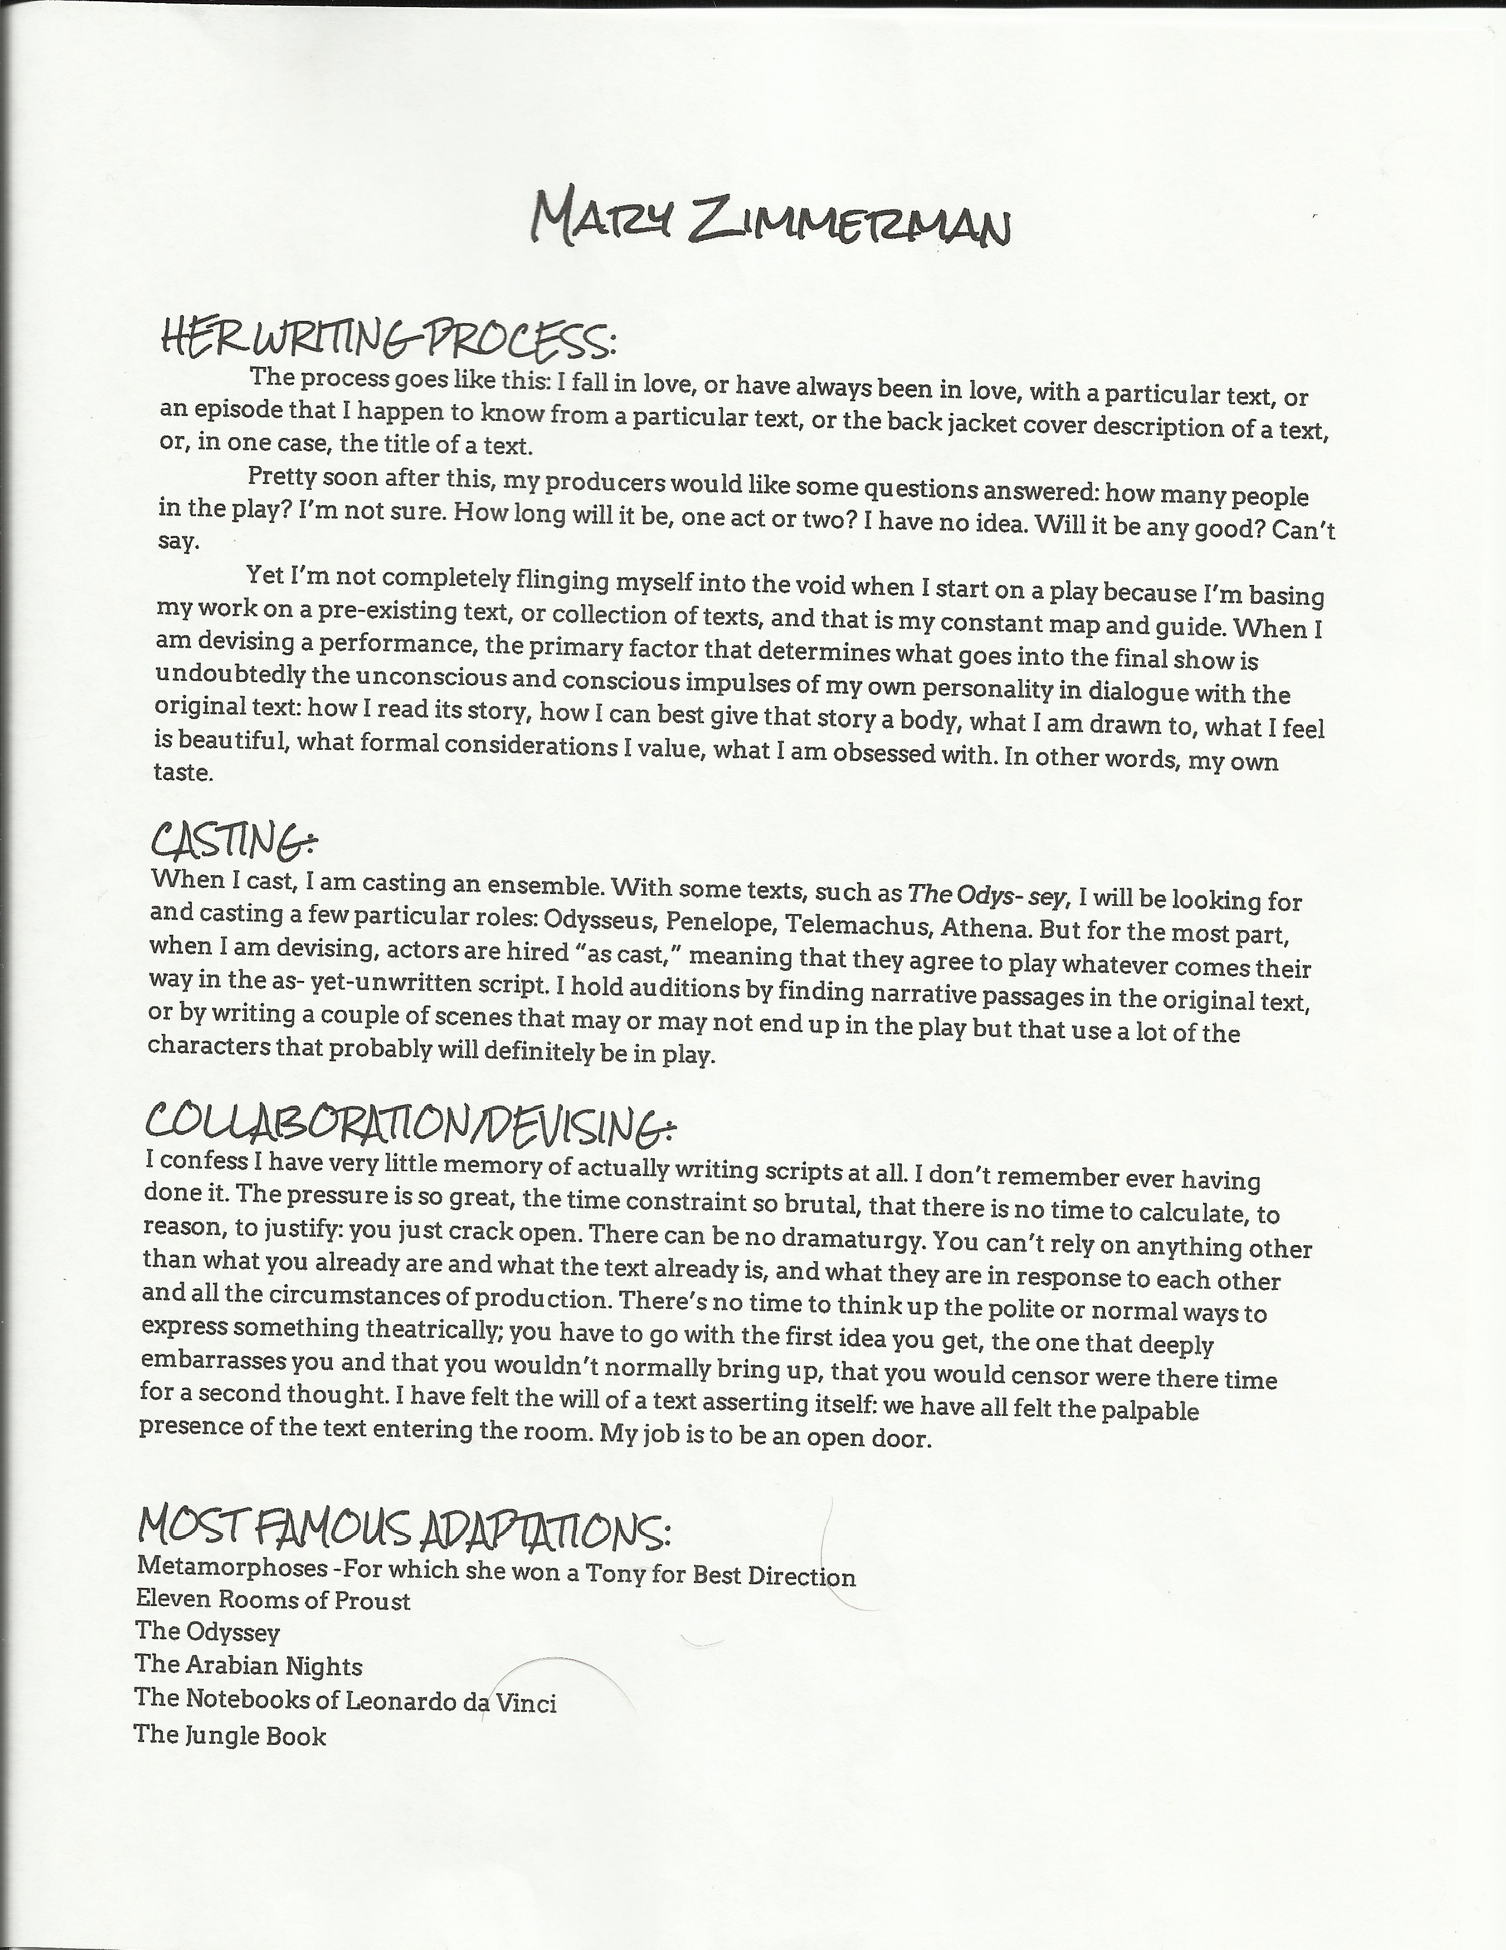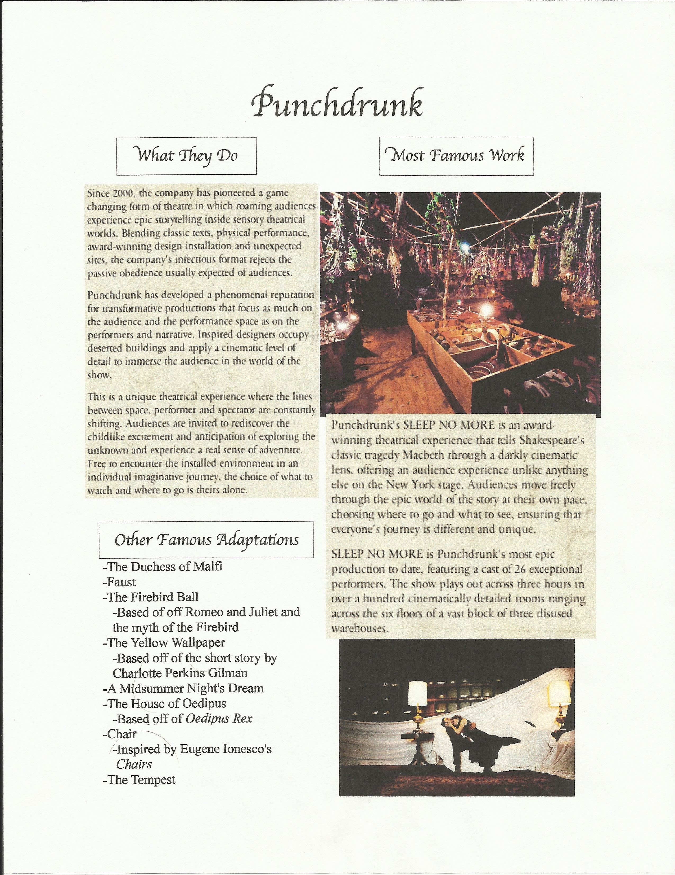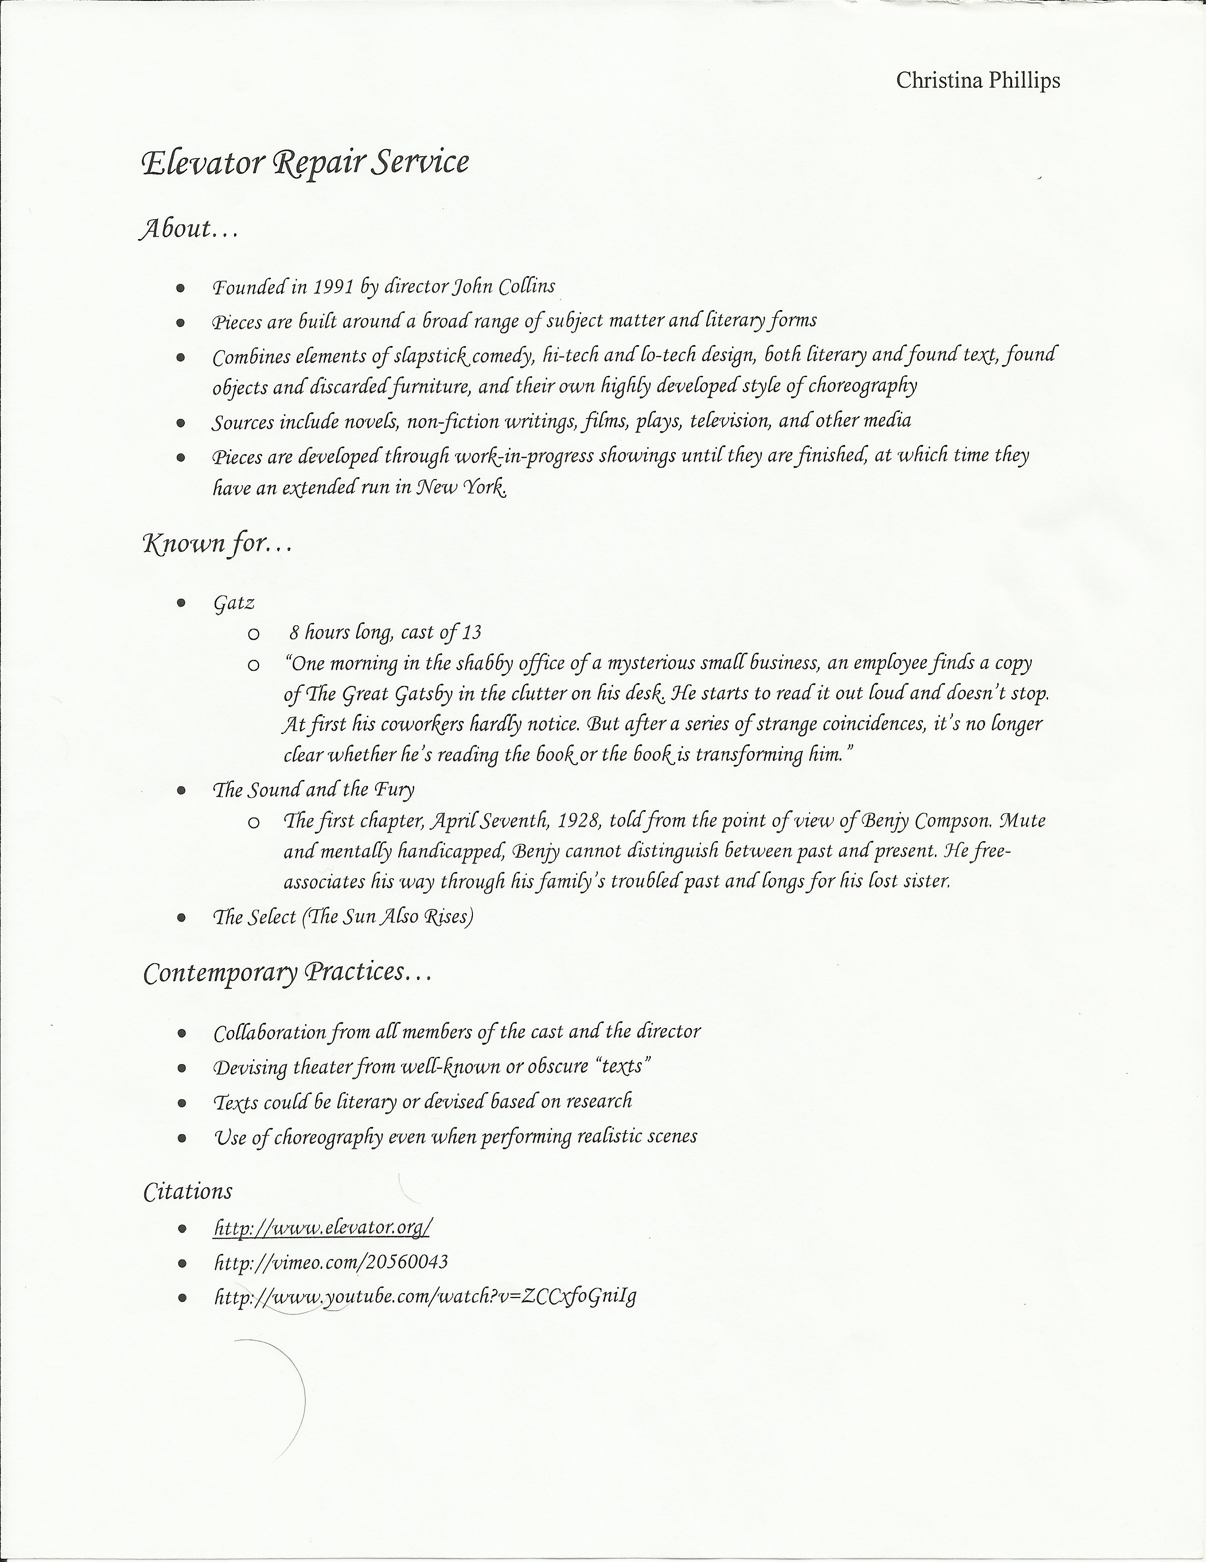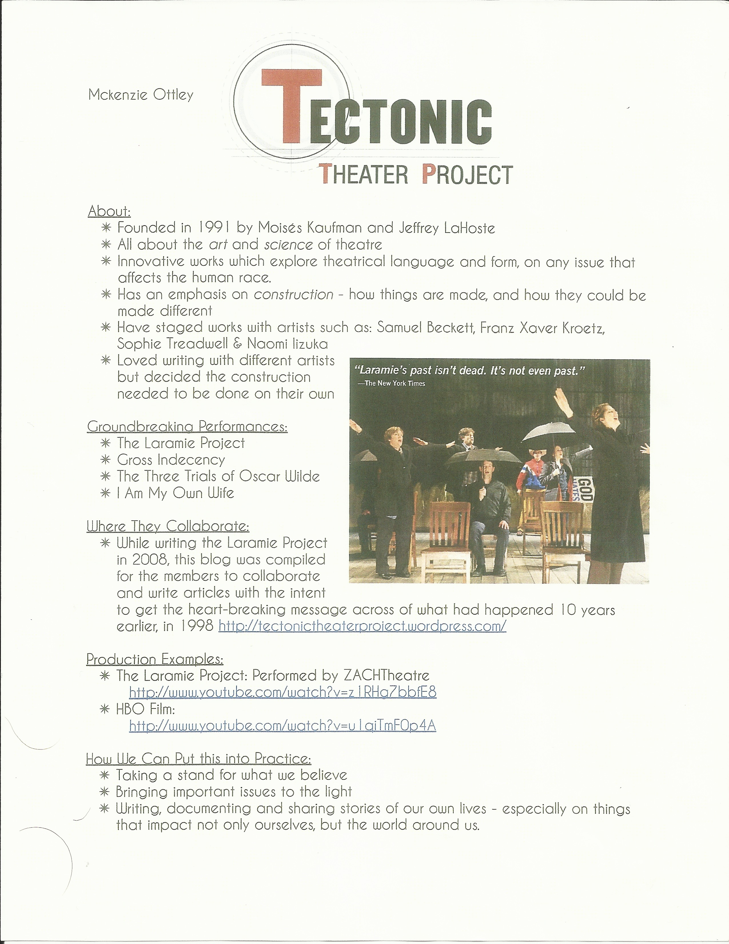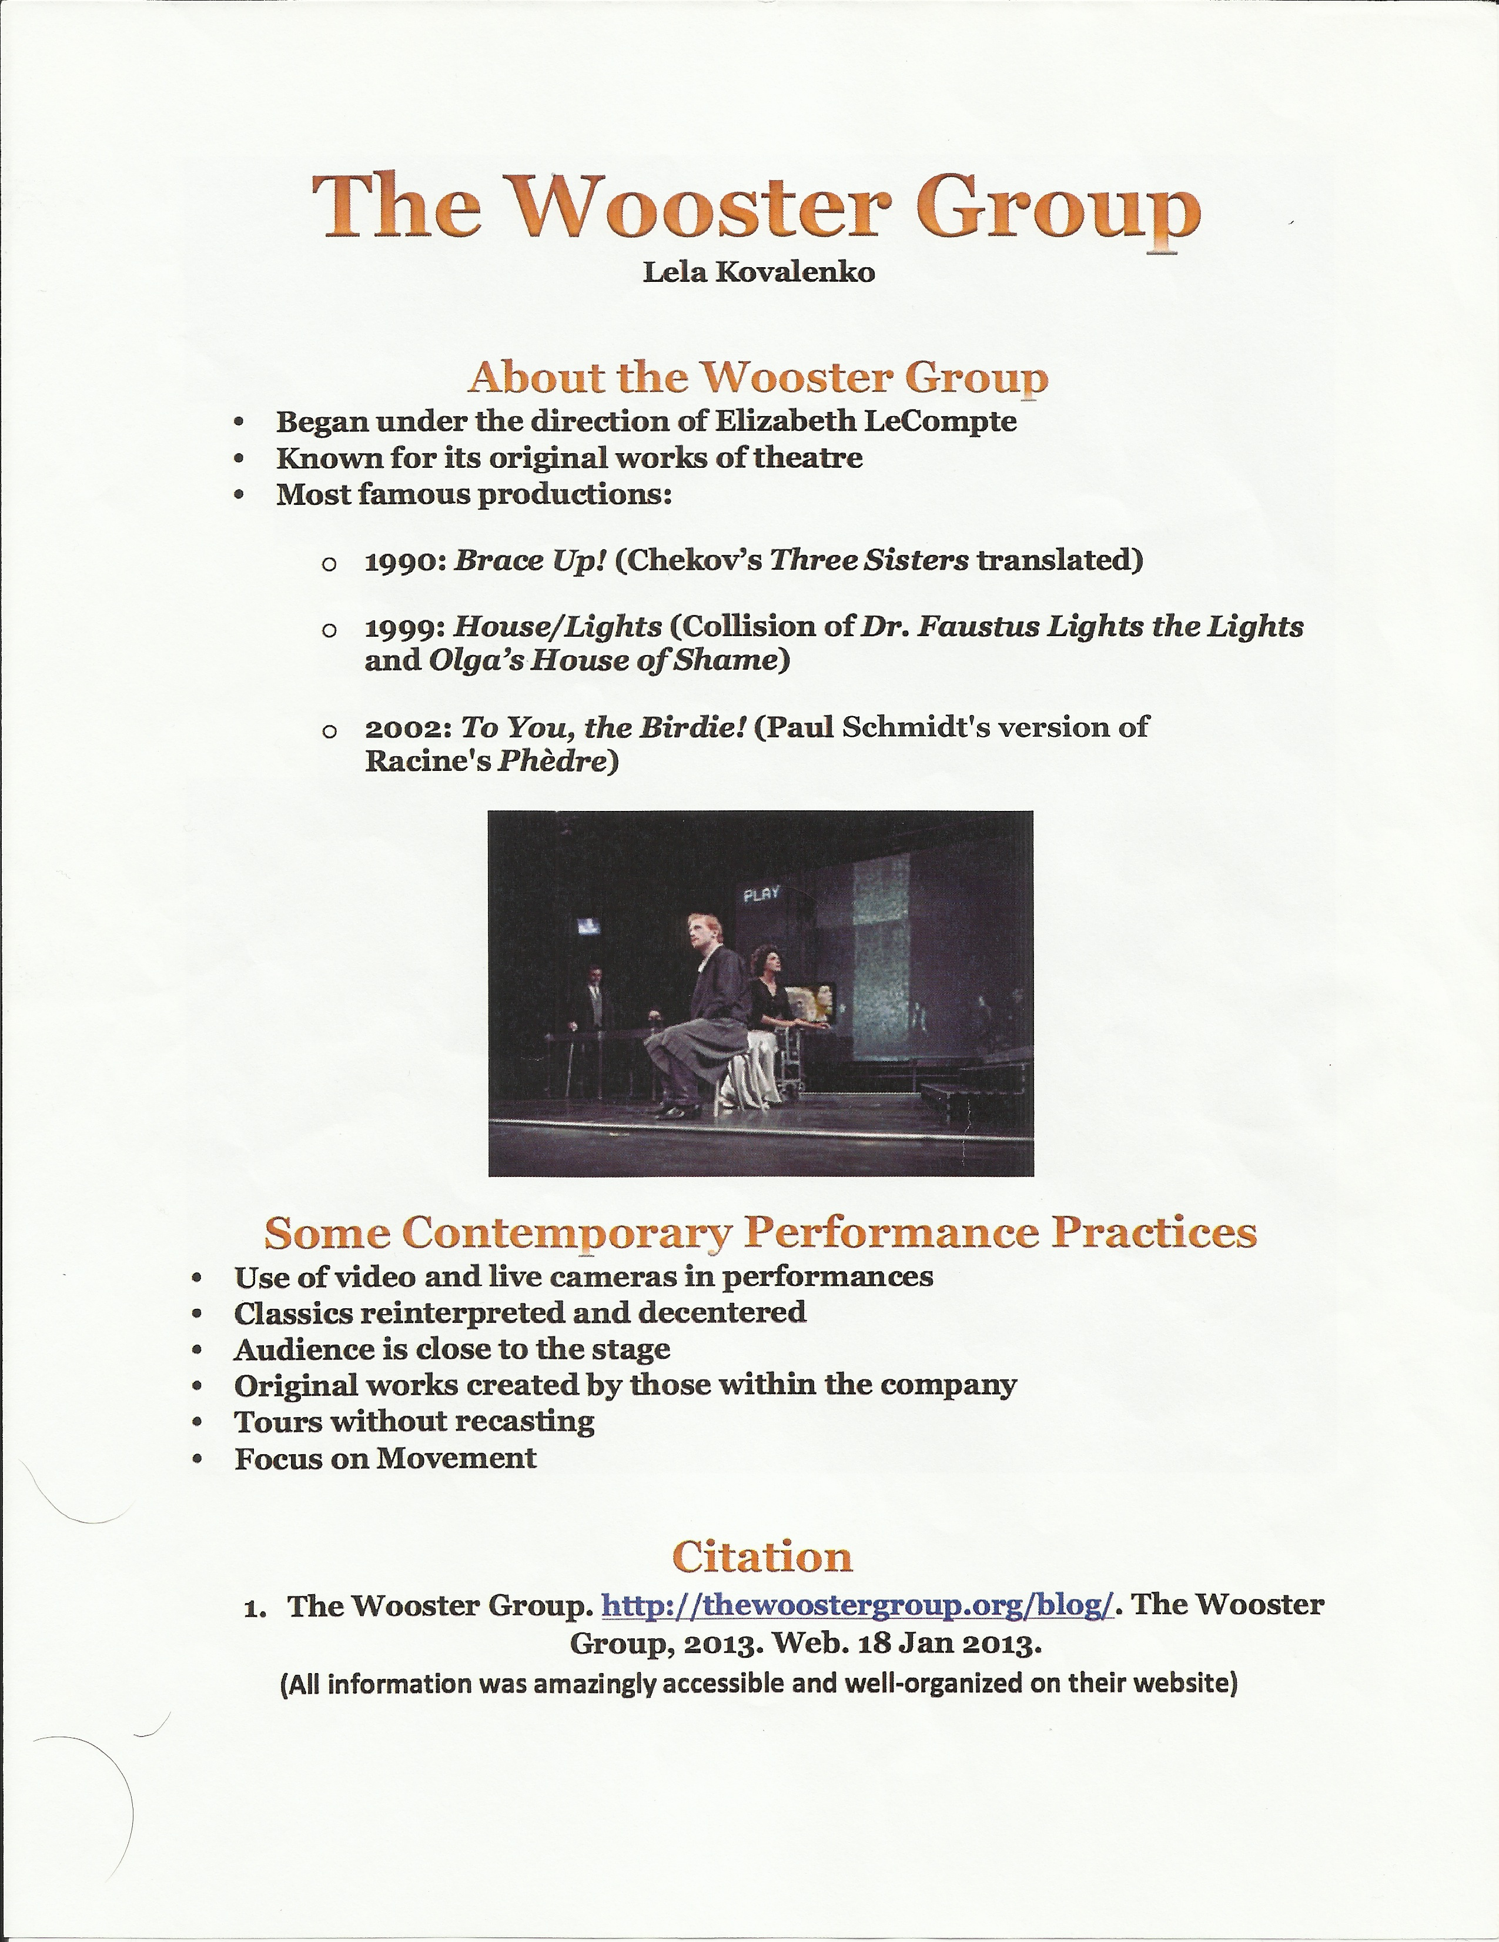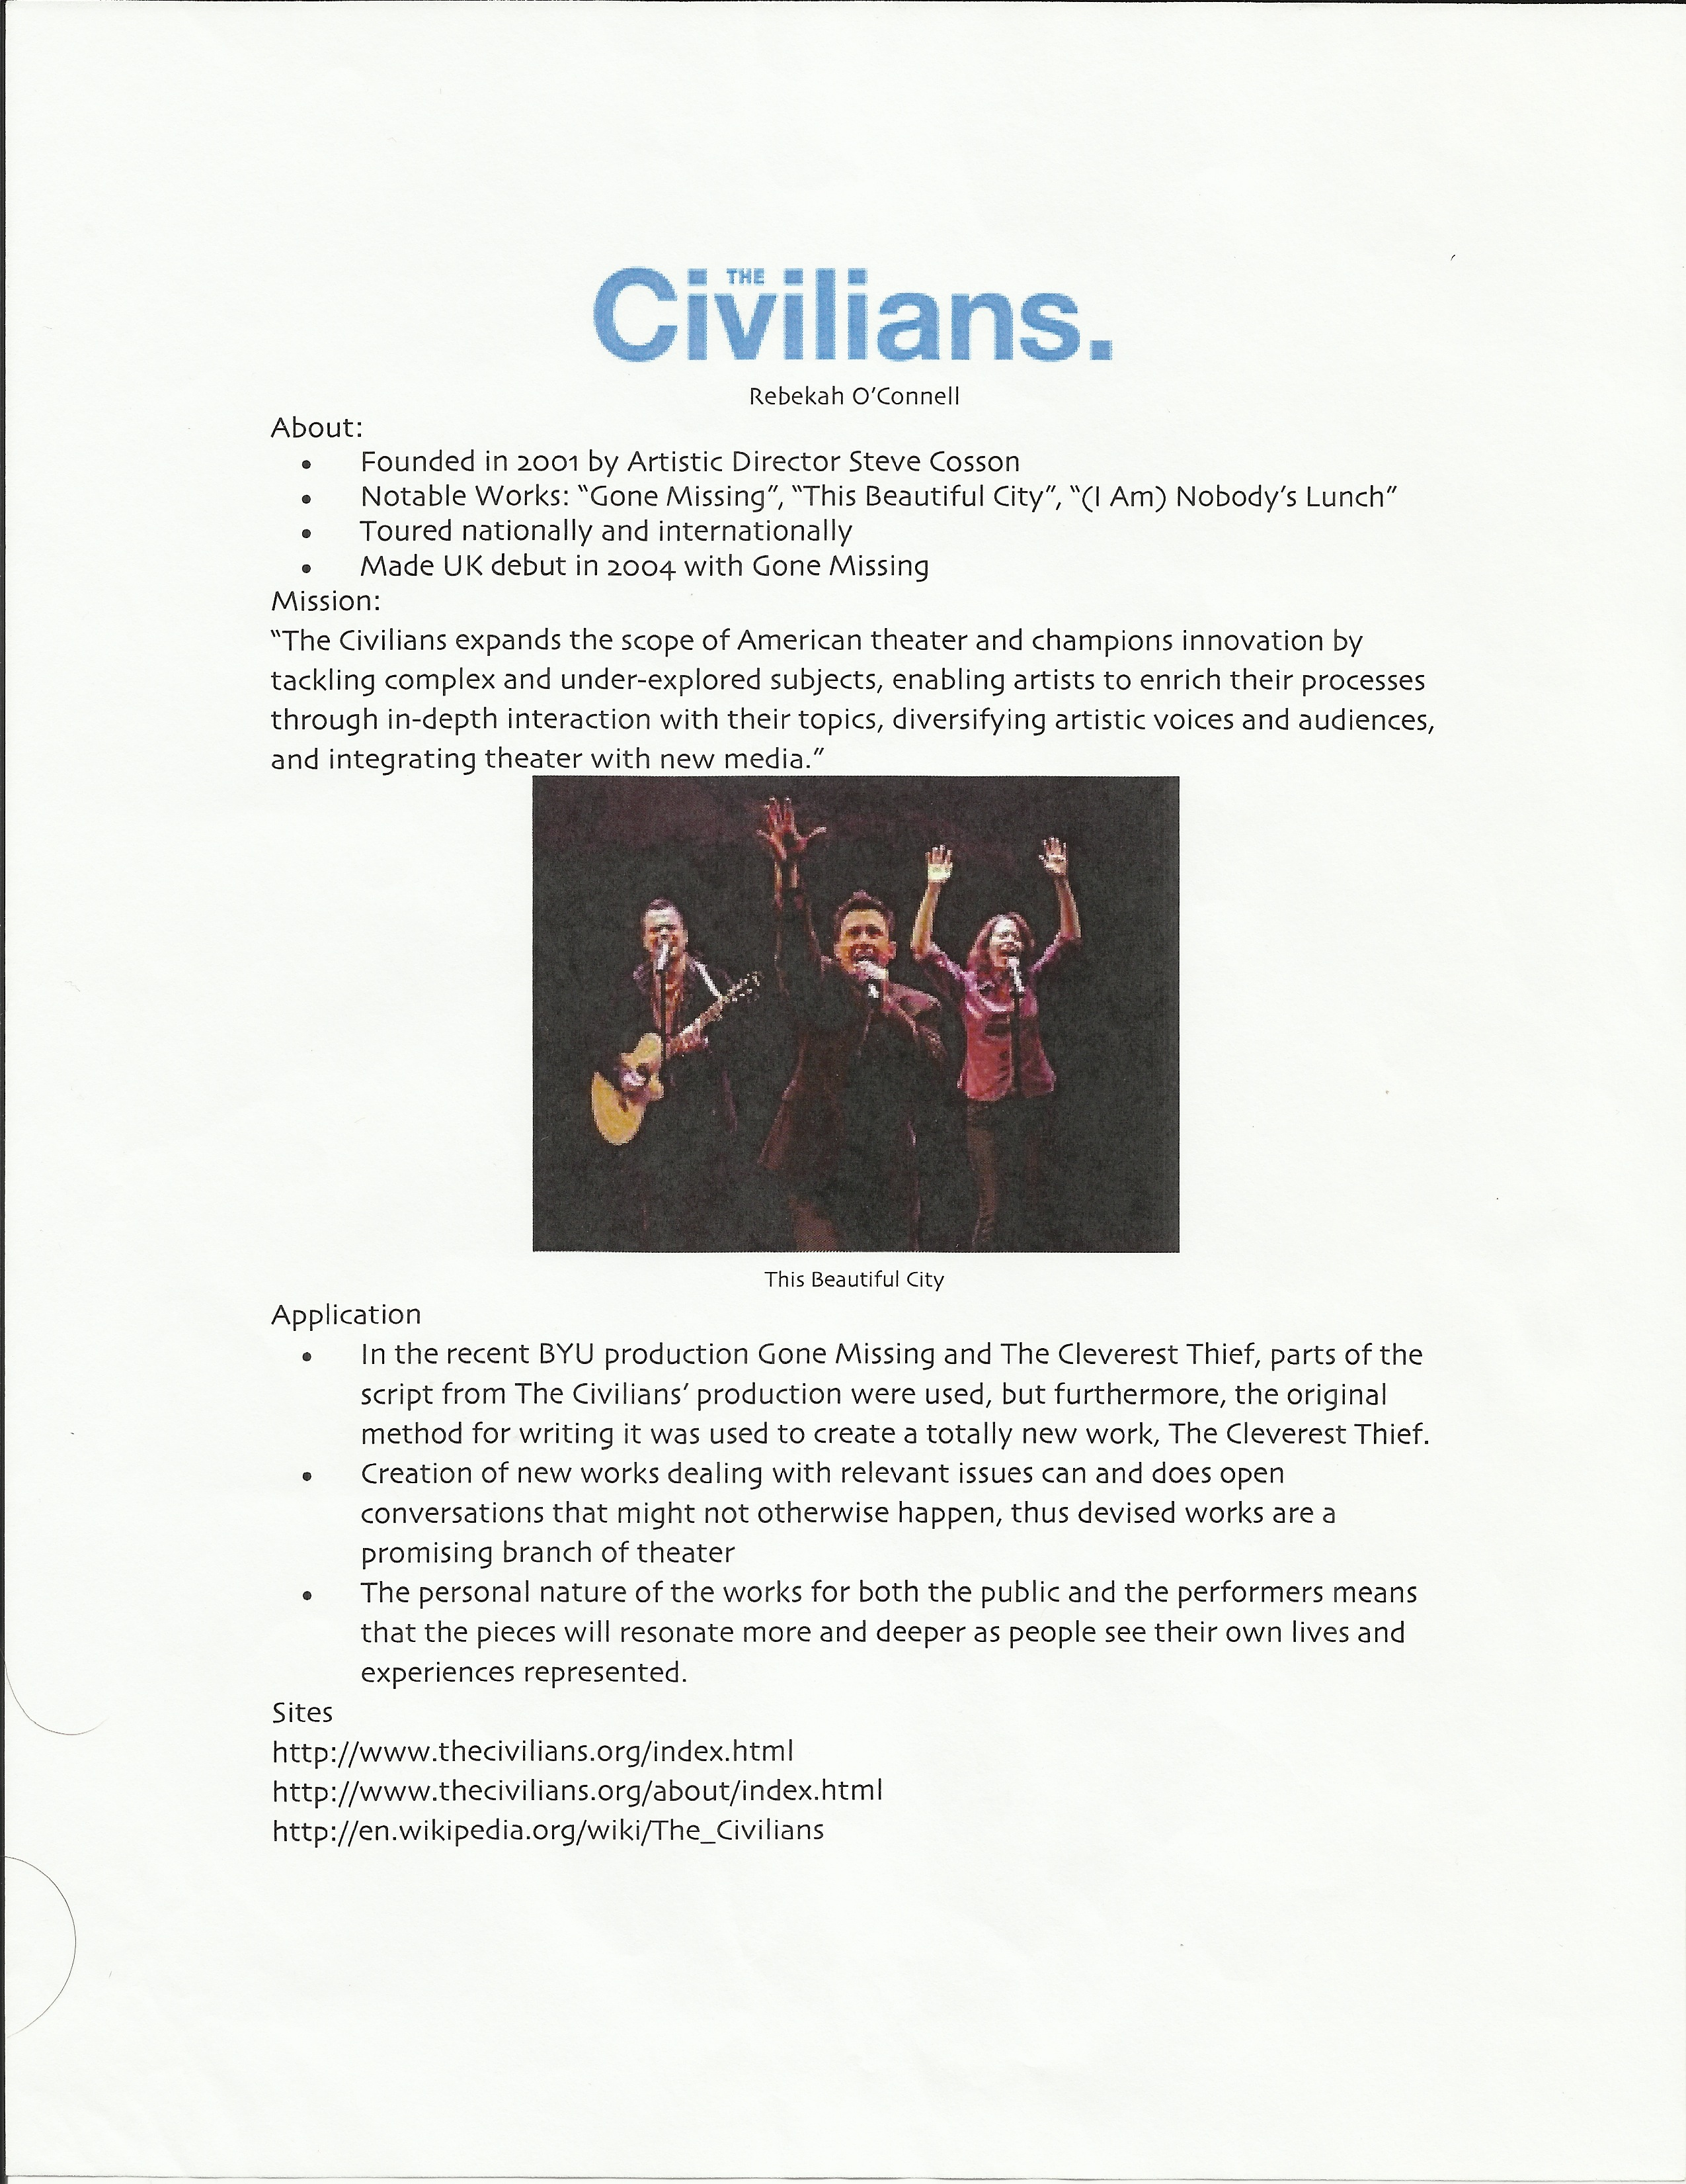

Lesson 7: Getting in the Contemporary Performance Practice Mindset

Unit: An Introduction to Playwrights and Their Work

Grade Level: 10-12 grade, 77 minutes

National Standards:
Content Standard #1: Script writing through improvising, writing, and refining scripts based on personal experience and heritage, imagination, literature, and history
Content Standard #2: Acting by developing, communicating, and sustaining characters in improvisations and informal or formal productions
Content Standard #4: Directing by interpreting dramatic texts and organizing and conducting rehearsals for informal or formal productions
Content Standard #6: Comparing and integrating art forms by analyzing traditional theatre, dance, music, visual arts, and new art forms
Content Standard #7: Analyzing, critiquing, and constructing meanings from informal and formal theatre, film, television, and electronic media productions
Content Standard #8: Understanding context by analyzing the role of theatre, film, television, and electronic media in the past and the present

Materials Needed: Brainstorm worksheet, teacher answer sheet, Harlem Shake clip

Learning Objective: Students will practice applying the performance practices they just learned about by coming up with ways they could apply them to the famous scenes they recently saw performed. Students will also discuss and analyze how these performances should give new perspective and interpretation to the original plays.

Hook (3-5 minutes): Briefly review the discussion from the class period before. What did you like, what didn’t you like? Did any of the performance groups stick with you? Were you particularly interested or disinterested in any of the groups? Why? If you didn’t like them, what should they do differently?

Transition: Can you think of ways to implement their practices?

Activity 1 (40-45 minutes): Pass out the brainstorm worksheet. Everyone will turn this in today for a grade, so make sure you’re working. Get in small groups and one by one we’re going to go through 5 different shows that we saw our class members perform. You’ll have about 3-5 minutes to discuss as a group how you could perform or adapt the original play using the techniques we’ve been discussing over the past several days. Let’s start with Neil Simon’s play The Star-Spangled Girl. Can anyone remind us what the scene was about? Can the performers remind us what the entire show is about? Your ideas could have to do with the scene specifically, or even the entire show. Tell students that after each brainstorm round we’ll be briefly sharing and discussing, and where I will be calling on different people/groups to share. So you’d better be prepared!

Allow students 3-5 minutes to discuss in groups ways that they could perform these shows/scenes using contemporary performance/playwriting practices that we’ve been discussing. After time is up call on 2-3 different students to share some of the ideas that their groups came up with. You can also ask after each round if any group has any really great ideas that they’re dying to share. After this, especially if the students are stumped, share some of the “teacher ideas.” The idea is to get students thinking in this way so that they are prepared for their next major assessment.

Repeat this process for the other 4 plays/playwrights listed. (August Wilson, Moliere, Frederico Garcia Lorca, and Samuel Beckett are left.) Again, the students should all be familiar with these scenes/shows from our recent presentations.

Activity 2 (30 minutes): Contemporary Performance Workshop/Challenge!
Students will make a participate in a mini contemporary performance practice workshop. Last class period they were most resistant to the use of media in performance so that’s what we’ll specifically practice today. Students will make a short performance around one of the most popular viral trends of 2013: the Harlem Shake video. There is a wide variety to pick from, but the one the students will watch is one of the original videos featuring the Norwegian army.

Watch the video, and then split them up into 4 groups. Give them about 15 minutes to work and tell them to come up with performances that are about 2-3 minutes long at most. This doesn’t mean that they should come up with their own Harlem Shake video, but rather their performance could feature the video in some way, deconstruct it, interpret possible themes, create a story behind it, etc. This activity also doubles as an informal assessment as they will be implementing the thinking process that they’ve been practicing all class period. It’s a challenge because a) there isn’t an inherent story behind the Harlem Shake videos so they’ll have to get creative b) the group with the best performance wins a prize!

Allow the last 10-15 minutes of class for students to perform, and then declare the contemporary performance (media edition) winner!

Wrap-up (1 minute): Thank you so much for your hard work today, and keep thinking about how we can apply these performance practices into our everyday work!

Contemporary Performance Practice Brainstorm Worksheet

In what ways could you adapt these performances using contemporary performance practices? Analyze how these performances should give new perspective and interpretation to the original plays.
Keep these things in mind as you brainstorm:
-Time period -Use of media -Setting
-Documentary theatre -Race/Gender -Dance/Choreography
-Separation of 4th wall -Interpretation of themes

Neil Simon (The Star-Spangled Girl):

August Wilson (Fences):

Moliere (Tartuffe):

Frederico Garcia Lorca (House of Bernarda Alba):

Samuel Beckett (Waiting for Godot):

Contemporary Performance Practice Brainstorm Worksheet

In what ways could you adapt these performances using contemporary performance practices? Analyze how these performances should give new perspective and interpretation to the original plays.
Keep these things in mind as you brainstorm:
-Time period -Use of media -Setting
-Documentary theatre -Race/Gender -Dance/Choreography
-Separation of 4th wall -Interpretation of themes

Neil Simon (The Star-Spangled Girl):
-Perhaps Norman is always on his phone and addicted to media. Perhaps he has difficulty communicating to Sophie because he doesn’t know how to speak to people in person due to his reliance on media consumption

-Make Norman and Andy women and Sophie a man- see how dynamics of the play changes when gender is reversed. What are the differences between men fighting over women, and women fighting over men? Are they the same?

-Documentary theatre piece interviewing dozens of people about break-ups, lost love, or crushes that weren’t reciprocated. Make a piece that takes the idea/themes of The Star-Spangled Girl but makes it much more real and personal.

August Wilson (Fences):
-How would this change if instead of discrimination against race it was discrimination against gender, or even discrimination against something absurd like hair color. Perhaps that would emphasize how dehumanizing hatred/discrimination can be (especially racism). It would emphasize how senseless it is.

-Documentary theatre about all the ways people are discriminated against? Or perhaps instead of The Laramie Project something like The Trayvon Martin Project? Both crimes ended in death, but the latter is still under debate over whether or not he was killed because of his race.

Moliere (Tartuffe):
-What if instead of Tartuffe being a priest he’s a politician. And whenever he’s being hypocritical or lying with that perfect mask of piety that he wears perhaps you could roll footage of different politician’s shmoozing or acting a certain way to win popularity. Both Bill Clinton and Richard Nixon would have some particularly great clips to show of their hypocrisy

-A cool idea would be to see Tartuffe but with Tartuffe more at the center and maybe more as a narrator. Maybe he’s showing the audience like a seminar on how to trick people or get away with things, and we get to see more of his inner monologue behind all that he does. You could involve media by maybe adding cheesy music or showing his face on big screens while he “gives the inside scoop” to mirror training videos or something

Frederico Garcia Lorca (House of Bernarda Alba):
-An easy adaptation to make would be to change the genders from an all female cast to an all male cast. How would this change the dynamics of the show?

-I keep thinking how this is an iconic show that famously features only women. What if you devised a show based on a town with only women. What would that look like? What would that feel like?

-Something else really cool and fascinating would be to do Bernarda Alba through the ages. Like this play is set in Spain during around the Spanish Civil War. What if we see portions of this play reenacted during several different time periods- like 1800’s, early 1900’s, 50’s, 80’s, 90’s, now, etc. How would it change the show and dynamics? I think it would show the universal themes and relatability of the show. It may change the characters marginally from time period to time period, but I think honor, truth, pain, jealousy, and sibling rivalry would still ring true.

-Documentary theatre about sibling relationships. Or about sisters and mothers.

Samuel Beckett (Waiting for Godot):
- I would love to do something with media or technology about miscommunication. Maybe Godot doesn’t come because they forgot to hit ‘send’ on the text. Or maybe since they didn’t communicate in person they got the times mixed up

-I’ve tried to think of ways to involve that stupid video “What does the fox say?” It seems to be about nothing, and you keep waiting to figure out what’s going on or what the fox does say and you get nothing. Waiting for Godot feels like this. I feel confused about what’s happening and what they’re saying sometimes, and I’m just waiting (along with them). But I’m not sure how to make this idea work.

Lesson 8: Making Contemporary Performance Practices a Reality in Our Work

Unit: An Introduction to Playwrights and Their Work

Grade Level: 10-12 grade, 77 minutes

National Standards:
Content Standard #2: Acting by developing, communicating, and sustaining characters in improvisations and informal or formal productions
Content Standard #4: Directing by interpreting dramatic texts and organizing and conducting rehearsals for informal or formal productions
Content Standard #7: Analyzing, critiquing, and constructing meanings from informal and formal theatre, film, television, and electronic media productions
Content Standard #8: Understanding context by analyzing the role of theatre, film, television, and electronic media in the past and the present

Materials Needed: Excerpts from the canon that you’d like the students to use- this lesson will use A Doll’s House, Our Town, Pygmalion, Death and the King’s Horsemen, Long Day’s Journey Into Night, The Good Person of Szechwan, and The Cherry Orchard.

Learning Objective: Students will apply what they’ve learned about contemporary experimental performance groups, their processes, and work as they analyze and synthesize the relationship between playwrights/work from the dramatic canon and non-traditional contemporary plays/playwriting practices by picking a play of a traditional playwright and creating a performance using contemporary non-traditional practices.

Hook (5 minutes): It’s the moment you’ve all been waiting for! It’s time to pick your groups for your contemporary performances! Each group should be 5-6 people, and then you will be assigned a play from a different famous, classic playwright of the dramatic canon that we haven’t studied yet. Get in your groups!

Activity 1 (10 minutes): Pass out the assignment sheet to each group. Briefly go over the schedule for the rest of the unit so students know what’s expected of them. They will be continuing the same practices that we’ve been using for the last few class periods. Before assigning the plays let students know that they are being given a scene from a script. They can either work from this scene to create their contemporary performance, or the entire play in general. Assign a play to each group.

Activity 2 (65 minutes): Allow students to begin brainstorming and working on their performances. By the end of the period they must turn in a brainstorming sheet with possible ways to perform their scenes. Students may use their smart phones to research the plays more in-depth if they’d like, but if they do they should be monitored.

Wrap-Up: Turn in your brainstorm sheets and be ready to continue working on Tuesday!

Create Your Own Contemporary Performance Scene!

Using the techniques and practices we’ve learned over the past several class periods, students will collaboratively devise contemporary scenes based off of classic scenes/plays from the dramatic canon. Students should consider these things as they work:
-Time period -Use of media -Setting
-Documentary theatre -Race/Gender -Dance/Choreography
-Separation of 4th wall -Interpretation of themes

Timeline:
___________: Pick groups and plays, and begin brainstorming+rehearsing
___________:Rehearse and submit write-up of what contemporary performance practices your group will be using, and how they affect or change the original work. What do they add?
___________:Perform a peer-preview in class in front of 2-3 other groups
___________:Performances!/TBA
___________:TBA

Performance Requirements:
- Must use at least one contemporary performance practice that we’ve studied in class
- Performance choices must be thoughtful and purposeful, adding to the original meaning of the show
- Every member of the group performs
- Company makes use of costuming choices to enhance their performance
- Scene is between 3 and 5 minutes maximum
- Performance is polished and shows student preparation
- Cast members have no stumbles throughout their performance

______/80

Reflection:

The reflection is worth 30 points, and specifications will be given later

Lesson 9: Justifying and Practicing Thoughtful Performance Practices

Unit: An Introduction to Playwrights and Their Work

Grade Level: 10-12 grade, 77 minutes

National Standards:
Content Standard #1: Script writing through improvising, writing, and refining scripts based on personal experience and heritage, imagination, literature, and history
Content Standard #2: Acting by developing, communicating, and sustaining characters in improvisations and informal or formal productions
Content Standard #4: Directing by interpreting dramatic texts and organizing and conducting rehearsals for informal or formal productions
Content Standard #6: Comparing and integrating art forms by analyzing traditional theatre, dance, music, visual arts, and new art forms
Content Standard #7: Analyzing, critiquing, and constructing meanings from informal and formal theatre, film, television, and electronic media productions
Content Standard #8: Understanding context by analyzing the role of theatre, film, television, and electronic media in the past and the present

Materials Needed: A piece of paper to complete the analysis

Learning Objective: Students will practice applying contemporary performance practices to their work by carefully analyzing, evaluating, and interpreting choices/techniques that will best create new meaning for their work. They will show this process by writing an analysis of the choices they’ve made detailing why they chose them, how they benefit the piece, and what new meaning or understanding they bring to the work.

Hook (5 minutes): Brainstorming time is over and it’s time to get to work! By the end of this class period everyone needs to be up on their feet rehearsing! But like we discussed, your group also needs to write up and submit a one page (written) analysis explaining and defending your performance choices. You should also detail how they benefit and add new meaning to the piece. This should be written collaboratively and handed in before the end of the class period. Also, remember that next class period is your peer performances in front of the other groups.

Activity 1 (70 minutes): Allow students time to rehearse and write their analysis paper for the remainder of the class period.

Wrap-up (2 minutes): Turn in your analyses and make sure you’re ready to perform tomorrow at the beginning of class! Make sure you have something to work with!

Lesson 10: Peer Performance Review for Group Progress

Unit: An Introduction to Playwrights and Their Work

Grade Level: 10-12 grade, 77 minutes

National Standards:
Content Standard #2: Acting by developing, communicating, and sustaining characters in improvisations and informal or formal productions
Content Standard #4: Directing by interpreting dramatic texts and organizing and conducting rehearsals for informal or formal productions
Content Standard #7: Analyzing, critiquing, and constructing meanings from informal and formal theatre, film, television, and electronic media productions
Content Standard #8: Understanding context by analyzing the role of theatre, film, television, and electronic media in the past and the present

Materials Needed: Any props or costumes the groups want to use, and the peer review sheets

Learning Objective: Students will evaluate the effectiveness of their work and choices by performing a preview for 1-2 other groups where they will self-evaluate, receive feedback, and give feedback to other groups.

Hook (5-10 minutes): Pass back the analysis that the groups handed in the class period before complete with teacher feedback. Have students read the feedback and decide if they want to make any changes to their performances.

Activity 1 (25 minutes): Give students 5 minutes to prepare their scenes, and then pair them up with another group. Students should watch the group perform and then fill out the performance review sheet. (5 minutes.) Take 5 minutes to talk about and discuss the performance with the group. Switch and then repeat the process with the other group. Both groups should have performed and discussed the performances, and each student should have completed a performance review sheet for a different group.

Activity 2 (40 minutes): Students should take the remainder of the class period to take the feedback they’ve been given and apply it to their performances via the rehearsal process. They should NOT be sitting down talking the remainder of the class period.

Wrap-up (2 minutes): Remind students there is only one more class period to rehearse their work before performances! Consult your handout with performance details to remind you what’s expected of you!

Name:______
Group Reviewing:____________

Peer Review of Contemporary Scenes
Watch 1 other group perform what they have created so far for their contemporary performance scene. Evaluate the following items as you watch:

Does the performance seem polished and well rehearsed? Explain.

Can you tell that the group has made deliberate “contemporary” choices? (How have they dealt with race, gender, time period, setting, documentary theatre, 4th wall, etc.?) What are they?

Does it seem choices been thoughtfully made? Why or why not?

Do their additions make sense? Do they add to our original meaning and understanding of the show? Why or why not?

What’s your favorite part about the performance?

What could be improved?

Lesson 11: Contemporary Performances and Reflection

Unit: An Introduction to Playwrights and Their Work

Grade Level: 10-12 grade, 77 minutes

National Standards:
Content Standard #2: Acting by developing, communicating, and sustaining characters in improvisations and informal or formal productions
Content Standard #4: Directing by interpreting dramatic texts and organizing and conducting rehearsals for informal or formal productions
Content Standard #7: Analyzing, critiquing, and constructing meanings from informal and formal theatre, film, television, and electronic media productions
Content Standard #8: Understanding context by analyzing the role of theatre, film, television, and electronic media in the past and the present

Materials Needed: Performance rubrics, reflection handout, performance evaluation worksheet, and any props/costumes the students plan to use.

Learning Objective: Students will show their understanding of the importance/influence of both traditional and contemporary playwrights and playwriting by performing a piece they’ve created that applies contemporary performance practices to a work of the dramatic canon, critiquing themselves and the other groups, participating in a discussion, and by turning in a reflection.

Hook (3-5 minutes): Hand out the reflection description and go over what’s expected of them for that assignment. It will be due the following class period. Also briefly review the rubric for their performances so they know what they should be thinking about in the short time they have to prepare.

Activity 1 (5-10 minutes): Tell students they have about 5 minutes to get ready and prepare their scenes. Order of performance will be decided randomly and all groups should be ready to perform. This means all students should already have all their props ready and be in costume.

Activity 2 (45 minutes): Tell groups to come back together and pass out the performance evaluation sheets. Students should be paying close attention to each other’s performances in order to fill out the worksheet. They should look for things the group did well, as well as things they could improve on. It’s important to think deeply about the work we see and create. Each group should also evaluate themselves.

Wrap-up (10 minutes): Take the remainder of the class period to briefly discuss what each group did well, and what the students have learned from the unit. This will also help them think of ideas for what they should be writing for their reflections. What have you learned from this unit? How do you view theatre differently, or do you? How has your view of what a playwright is changed? What is the value of these original works from the dramatic canon versus contemporary productions of them?

Performance Requirements: Each criteria is worth 10 points
- Must use at least one contemporary performance practice that we’ve studied in class
- Performance choices must be thoughtful and purposeful, adding to the original meaning of the show
- Every member of the group performs
- Cast makes use of costuming choices to enhance their performance
- Scene is between 3 and 5 minutes (max)
- Performance is polished and shows student preparation
- Performance shows progress over our rehearsal process
- Cast members have no stumbles or awkward pauses throughout their performance

______/80 points

Performance Requirements: Each criteria is worth 10 points
- Must use at least one contemporary performance practice that we’ve studied in class
- Performance choices must be thoughtful and purposeful, adding to the original meaning of the show
- Every member of the group performs
- Cast makes use of costuming choices to enhance their performance
- Scene is between 3 and 5 minutes (max)
- Performance is polished and shows student preparation
- Performance shows progress over our rehearsal process
- Cast members have no stumbles or awkward pauses throughout their performance

______/80 points

Name___________
Contemporary Performance Evaluation
(Including Your Own)
Is their choice of the contemporary performance practices they used clear? Do they help contribute to or add to the original understanding of the play?

The Good Person of Szechwan
3 things they did well:

3 things they could improve on:

A Doll’s House
3 things they did well:

3 things they could improve on:

Long Day’s Journey Into Night
3 things they did well:

3 things they could improve on:

Our Town
3 things they did well

3 things they could improve on

Pygmalion
3 things they did well:

3 things they could improve on:

Death and the King’s Horseman
3 things they did well:

3 things they could improve on:

See How They Run
3 things they did well:

3 things they could improve on:

Playwrights and Contemporary Performance Unit Reflection
Complete a one page typed reflection over our unit on famous playwrights/plays and contemporary performance practices.
5 points each:
- 1 full page (typed), double spaced, 1 in margins, Times New Roman font
- Paper has been proofread and does not contain spelling or grammar errors
- Paper has an introduction, body, and conclusion
- Paper discusses what you’ve learned/experienced throughout this unit. What did you like, or not like? Where could you have improved?
- Paper discusses what you’ve learned about famous playwrights, good work, and famous plays in the dramatic canon
- Paper discusses what you’ve learned about contemporary performances and using contemporary playwriting practices

_____/30 points

Playwrights and Contemporary Performance Unit Reflection
Complete a one page typed reflection over our unit on famous playwrights/plays and contemporary performance practices.
5 points each:
- 1 full page (typed), double spaced, 1 in margins, Times New Roman font
- Paper has been proofread and does not contain spelling or grammar errors
- Paper has an introduction, body, and conclusion
- Paper discusses what you’ve learned throughout this unit
- Paper discusses what you’ve learned about famous playwrights, good work, and famous plays in the dramatic canon
- Paper discusses what you’ve learned about contemporary performances and using contemporary playwriting practices

_____/30 points

