NAME:_______________________

Festival of Knowledge: Greek Amphitheatre

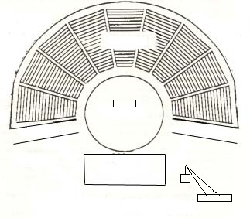

Label the following parts of the Greek Amphitheatre. Be able to explain what their purpose was.

Theatron Machina Parados (HINT: there are two)

Skene Thymele

Orchestra Deus ex machina